LEADERSHIP COACHING AND MENTORING –PACK
August 2022
Established in 2006
Welcome to this month’s edition.
Damian Piper CBE our Resilience Coach starts this month edition with: Too busy to break? “The summer months for many mark the point in the year when they take a well-earned break from work. Whilst I’m seeing more worrying examples (at least to me) of people wanting to take their work with them on holiday, I’d say there is still more acceptance that taking an extended break is important and beneficial……”
I am again pleased to be able to share another article written especially for our Leadership Pack by Jonny Rudge the Head of Fundraising for Thera Trust www.thera.co.uk “Vampires Part 2 – Listening and Being Open to Changing Your Mind” “…….I found myself in leadership roles fairly early on in my career, largely because I was self-employed and then in a partnership, growing a team to develop that business. In those early days, people wanted me to make decisions rather than canvass their opinions…….”
From me: ‘The fourth leadership lesson I learned ‘Self – Respect’ “Have you ever started a journey and you are not sure how it will end? On the 12th of September 1972, I boarded a specially commissioned train at Darlington Station for Kings Cross in London. I was one of hundreds of 15 and 16-year-olds joining the Army that day. We were heading for various Junior Leaders Battalions…….”
Another one from me: ‘Bettina’s approach to Decision Making’ When interviewing candidates for www.dosh.org I am always willing them to respond with the perfect answers which will help them achieve maximum points. Sitting across from a candidate during a recent series of interviews, I asked the question “what is your approach to decision making?” – on paper it looks straight forward as we probably make more than 100 decisions a day without analysing our approach on how we make those decisions, so perhaps this is the reason some of our candidates get a stuck on a response. As I ask the question, I wonder how I would respond if I was the candidate?
Steve Raw FinstLM, FCMI, GCGI
Email: steve.raw@dosh.org
Blog: www.leadershipintheraw.org
Instagram: @stephenraw6 Twitter: @SteveRaw836
LinkedIn: https://www.linkedin.com/in/steve-raw-72454721/
Facebook: https://www.facebook.com/steve.raw.771/
It’s not about how good you are
It’s how Good You want to be
Too busy to break?
The summer months for many mark the point in the year when they take a well-earned break from work. Whilst I’m seeing more worrying examples (at least to me) of people wanting to take their work with them on holiday, I’d say there is still more acceptance that taking an extended break is important and beneficial. It helps recharge the batteries, bring greater objectivity and ease the stresses of daily life. What is perhaps of more concern is the growing trend of people not taking shorter breaks during the day. As an example, the once staple of the hour lunch break being seen more as a perk or luxury than an important part of performing at our best. The ‘work-through’ being seen as a status symbol in many workplaces.
A study by Ipos Mori found that 82% of UK workers do not take a full hour for lunch; with the average time being just 28 minutes. This study follows a pattern of decline over the last decade or two. [For transparency and honesty, I would include myself in the stats as someone who at best is inconsistent with lunch breaks.] Why is it important to take breaks? Here’s three reasons which I suspect we already know but are worthy of a reminder.
- Your body keeps score. Breaks allow the body and mind to recharge and recalibrate. Many people have become adept at pushing on. Some may jokingly quote the “lunch is for wimps’ line from Gordon Gecko in the movie Wall Street. What comes with this approach is the body driving us on with increases of adrenalin and cortisol. Okish if this is an occasional occurrence. However, when it’s the norm this leaves us vulnerable to a range of things that are not so great including chronic stress, sleep disorders and cardiovascular diseases. Ouch.
- Decision fatigue. Constantly making decisions throughout the day is challenging for the mind and body. There are the big decisions we could point to each day. However, we mustn’t lose sight of the totality of decisions we are making. Research by Eva Krockow, a lecturer at Leicester University, estimates we are making upward of 35,000 decisions per day. The majority of these we are not even conscious of. The quality of decisions is another factor. A study by Columbia Business School looked at a group of US judges and found a steady decline in the percentage of favourable rulings. The research showed a gradual decline from ≈65% to nearly zero within each decision session. Perhaps most impactful is that after a break there was an abrupt return to ≈65%. I guess we’d like to think that our decisions are consistent throughout the day. Without breaks this research strongly suggest that’s not the case. I hope to never find myself being sentenced by a US judge but if I were I’d definitely rather be at the start of a session than the end.
- A better version of you. Last but certainly not least. As we navigate our way through the day without breaks there is a decent chance, we enter a steadily less great version of ourselves. You may find yourself becoming more irritable with yourself and others or overreacting to situations as they arise. We might find in the workplace we keep ourselves in check only to find when we leave we let all that pent up frustration out at the ones we most care about.

Whether you take breaks or not is of a course personal choice. Perhaps the next time you think a break is a luxury or you are too busy to break, you might want to consider these points. You may just conclude you are too busy not to break if you want to be a high performer.
Damian
damian@effectivechallenge.com
Damian Piper CBE
Change and Resilience Coach
www.effectivechallenge.com
www.effectivechallenge.com/podcast

“The best time to plant a tree is 20 years ago; the second-best time is today.”
Chinese proverb
Vampires Part 2 – Listening and Being Open to Changing Your Mind

The last piece I wrote had vampires in the title and used a music reference to make a point. It’s always risky trying to repeat the same trick twice, but I’m going to do it anyway!
I found myself in leadership roles fairly early on in my career, largely because I was self-employed and then in a partnership, growing a team to develop that business. In those early days, people wanted me to make decisions rather than canvass their opinions.
But I’ve learned to putting myself in a position where I openly invite challenge by others, holding a position where I’m willing to have my mind changed in the face of new information.
When I took on a charity Board role in my early 30s, it took me time to find the approach I was most comfortable with to ensure I provided sound leadership for that organisation.
There were some strong, experienced voices on that Board, but I found that by going in with an open mind, I could offer meaningful contributions by analysing and processing opposing views before delivering better informed comment further into the debate. Had I spoken first, I would have had more limited information to draw upon as I didn’t have the experience of the others.
As for the music, I really do listen to the lyrics in the music I love very carefully. They add a whole new dimension to something I would have enjoyed anyway, so it’s no surprise that some of my favourite musicians are very strong in the lyrics department too.
And so, in listening to Vampire Weekend’s excellent self-titled first album, full of smart lyrics and a broad set of influences, and in particular the track I Stand Corrected, I started thinking about pride and willingness to change position/admit fault:
You've been checking on my facts
And I admit I have been lax
In double-screening what I say
It wasn't funny anyway
I stand corrected
I stand corrected
No one cares when you are wrong
But I've been at this far too long
To act like that when we should be
In perfect harmony
I stand corrected
I, oh, I stand corrected
It feels to me as though we are living in a world where admitting you’ve changed your mind is increasingly seen a sign of weakness. People are inflexible with their opinions, afraid of being called out, and very quick to go on the defensive when they are.
We are seeing people splinter into ideologically aligned groups, not just in politics, which ultimately means surrounding ourselves with people who hold very similar opinions to us. Whilst this may seem like a comfortable space to inhabit, it ultimately stifles debate, creativity and progress.
It is right that leaders need to be strong at times and take difficult decisions in the strategic interest. But if you commit to a position, in the face of overwhelming information which points to the opposite, then you are at risk of allowing pride/stubbornness to become your primary decision-making lens.
Leaders need to be ready to explain those decisions and be challenged on them, because if you can’t justify them, should you have taken them in the first place?
It isn’t always a comfortable journey as you start to leave yourself open to scrutiny, or to hold back on taking a position until you’ve heard what others have to say. But it’s a journey that is well worth committing too as those around will respect you more for it and pull together behind a common cause if they feel their opinion matters and decisions can be explained and justified.
Some people try to portray themselves as leaders in group environments by being the first to speak or taking a position early in a debate, then debating it passionately and defending that position to the bitter end.
Every discussion or debate needs someone to speak first. But being a leader doesn’t mean you have to be the one who does that every time. Leading can mean setting the example that it’s OK to let others air their opinions, as you absorb and compare what is being discussed.
Opinions and information need to be brought to discussions to allow a decision or direction to be arrived at. But being a leader doesn’t mean bringing opinions so entrenched that, even in the face of opposing opinion or information,
Test yourself: A good test of your willingness to embrace (or at least tolerate!) opposing opinion is to choose a subject you know relatively well and hold a particular opinion on, then actively seek an opposing opinion to yours, or spend time really reading and trying to understand counterpoints to your own.
You may well feel the urge to belittle those counterpoints, or dismiss them altogether, but they often didn’t form by accident. If you aren’t open to exploring why they did form, you are likely missing out on an opportunity for progression yourself, because the world is rarely black and white, and there is a lot of potential for progress hiding in the grey areas if only we were willing explore them in the first place.
And if you find a counterpoint which does change your opinion, then be willing to say to yourself ‘I stand corrected!’
Source: Jonny Rudge - Head of Fundraising Thera Trust

Ted.com – Presentation
- How to build a business that last 100 years – Martin Reeves https://www.ted.com/talks/martin_reeves_how_to_build_a_business_that_lasts_100_years
If you want to build a business that lasts, there may be no better place to look for inspiration than your own immune system. Join strategist Martin Reeves as he shares startling statistics about shrinking corporate life spans and explains how executives can apply six principles from living organisms to build resilient businesses that flourish in the face of change

The fourth leadership lesson I learned ‘Self – Respect’
Have you ever started a journey and you are not sure how it will end? On the 12^{th of} September 1972, I boarded a specially commissioned train at Darlington Station for Kings Cross in London. I was one of hundreds of 15 and 16-year-olds* joining the Army that day. We were heading for various Junior Leaders Battalions.
I hadn’t given much thought about what was waiting for me at the other end of the train journey. Needless to say, there was a fierce looking Sergeant called Fred Green, waiting for me and he was keen to tell me that “I am going to be your mother now”.

Dettingen Barracks, Deepcut (accommodation blocks we lived in and the parade square we marched on)
During those 18 months of intense (and often brutal) training, my days started very early. After my ablutions I readied my kit and room for an early barrack room inspection, followed by a day of highly concentrated military training. The evening was spent polishing my boots and shining the brasses on my belt. There was a speck of polish I was trying to remove from one of the brass buckles on my belt, which was posing a problem, so I approached a Corporal and asked, “do you think the Platoon Sergeant will notice?” His response was: “It doesn’t matter if he does or doesn’t, you already have, it is about your self-respect”

‘All present and correct’ an example of a barrack room inspection
‘Self-Respect!’ it was the first time I had heard this term. What the corporal said had an instant impact on me. It challenged my thinking in all sorts of ways. Did it matter to me? How would I feel if I ignored what he said? In those early weeks, I had been thinking about what kind of man I wanted to become, and this was more food for thought.
In hindsight the Corporal had been quite subtle. He had not shouted, instructed, or ordered me to remove the polish from my belt buckle. Much better, he had challenged my character and how I thought of myself. 50 years later I can still clearly remember the Corporal’s challenge, it was the 4th Leadership Lesson I learned.
Related:
- The first leadership lesson I learned – It is about others before you – Leadership in the Raw
- The second leadership lesson I learned – Self Discipline – Leadership in the Raw
- The 3rd Leadership Lesson I learned – Surround yourself with Talent – Leadership in the Raw
For me ‘self-respect’ is:
- Having a sense of honour and dignity about yourself
- Treating others well and knowing that by doing so, others will treat you well in return.
- Setting the highest standards for yourself and maintaining them even in the most adverse conditions. This included having a ‘wet shave’ in the morning on exercise in the Arctic Circle or finding a stream in the evening to clean up after getting covered in mud after the first day of a mountain marathon in the Brecon Beacons.
- Being the best you can be, even when you think no one is watching
- Setting boundaries for yourself - not falling into the trap of letting someone convince you to do something you don’t think is right.
How self-respect has sustained my wellbeing and mental health:
- Self Esteem – having confidence in my own abilities (and recognising my limits)
- Reinvention. If I don’t like something about myself, I change it. You control how you present yourself, who you are and who you become, and how you’ll evolve throughout your life. You can change aspects of yourself at any time, providing that it’ll help you reach the next version of yourself.
Related: https://leadershipintheraw.org/2015/11/24/the-art-of-reinvention/
- Having a sense of personal worth - knowing you are a worthy person: as a colleague, a family member, and a member of your community. So, avoid putting yourself down
- An appreciation for the positions you hold. Being a good father for my daughters is incredibly important to me and something I work on every day.
- Always try to do the right thing. That doesn’t mean you’re perfect or even a perfectionist. It means that you aim to have good habits and values to be a trustworthy person. Living up to your values.
Related: https://leadershipintheraw.org/2021/09/17/values-in-action/

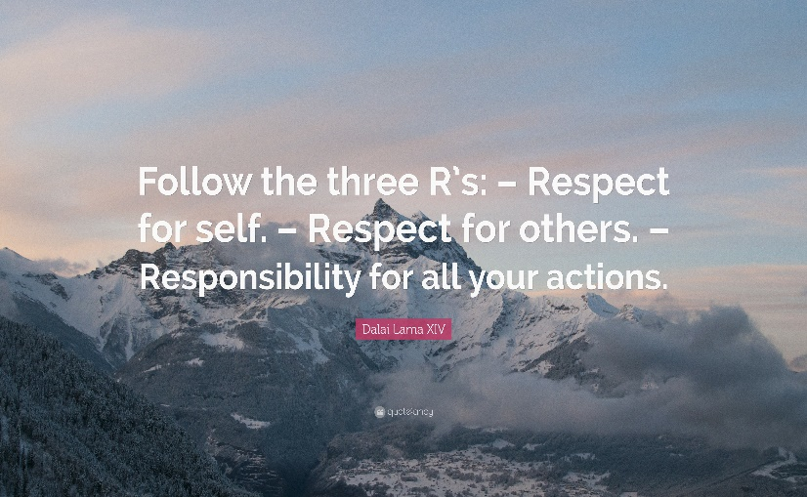
50 years ago, stepping off the train at Brookwood station in Surrey, then being herded on to a bus for my first day in the Army, I had no idea of what I would be capable of, who I was, and what I could achieve. I’d had a good upbringing and the best mum a boy (and a man) could wish for, however, as I was soon to find out, I was deficient in a number of areas, too long a list to go into in this article. At the end of my 18 months in the Junior Leaders Battalion I had become self-sufficient in all aspects of my personal life (nobody has ironed my clothes in the last 50 years!) but above all I had self-respect.
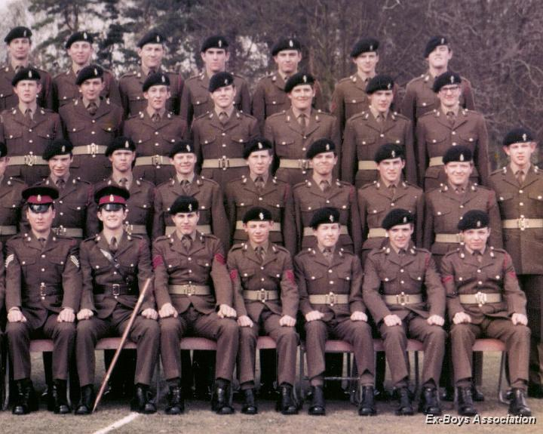
After 18 months training my mum didn’t recognise me when she turned up for my ‘Passing Out Parade’ – I am 4th right second row from the front. She told me she preferred the new version of me.

*1972 – 1972’s Education Act raised the school leaving age to 16. September 1972 was the last time you could join the Army at 15.
Source: Steve Raw www.leadershipintheraw.org
CARROT POWER
Reward your team members with a daily does of recognition

GET THEM INVOLVED

The next time you meet for a high-level strategy session, ask to invite an outstanding team member to participate. Sometimes the best recognition is involvement in meetings that impact the team member’s work. It shows you respect their ideas and talents and gives them personal ownership in the company overall direction. When your opinion matters, you matter, and the more engaged you’ll be

From A carrot a day by Adrian Gostick and Chester Elton

(I do this for Dosh Board Meetings it is so important)

HELPING OTHERS

You will gain three main benefits from helping others:

- You will change the world. By helping just one other person, you change their world, for good. By asking them to help others, you change someone else’s world, as well
- You change your world. It feels great to help others – we feel a better and braver person – and why not?
- What we sow, we reap. Huge irony here – the more you give to others, the more you receive in return. If you want to get-get-get, then give-give-give.

From the ‘Naked Coach’ by David Taylor

TEN WAYS TO……
Win more Business

1. Know your field
2. Offer consistent quality
3. Market astutely
4. Deliver on time
5. Get feedback from commissioners
6. …….and act on it
7. Set the right price
8. Have a decent website
9. Network
10. Think: do we need more?
Management Today

Being Bettina’s Dad – Bettina’s approach to Decision Making
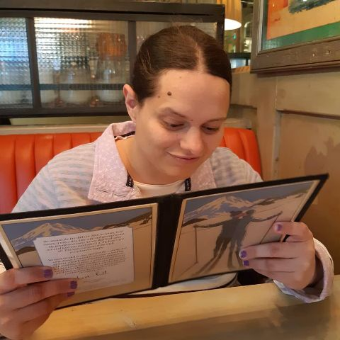
My next thought is, I know someone who has a number of different strategies for making decisions and if ever I am asked this interview question and want to score the maximum points, I think I will ‘borrow’ Bettina’s approach.
Bettina lives at home with her family, and we spend lots of time with her every day, however, during this weekend I have given it extra thought, observing Bettina’s approach to decision making. Some of these strategies may not come as a surprise to you; although some may give you pause for thought.
Bettina’s 5 Approaches to Decision Making:
- Bettina uses her senses
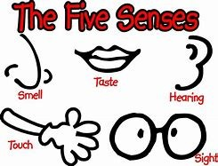
I observe how Bettina uses her five senses:
- At the dinner table, especially if Joyce has created something we have not had before (this is not unusual as Joyce is an amazing cook and baker). All 5 senses are in play, including hearing: what are the others saying around the table about our meal?
- To multitask. Sitting on the sofa with Bettina watching YouTube videos together, I can see by the tilt of her head she is listening for movement from the kitchen, she can smell cooking, so Bettina knows soon we are both going to be called into the dining room. Before this happens though we continue watching YouTube videos as well as watching the TV in the background (is there a better option on view for Bettina?). At any moment Bettina will make her decision to stand up, remove her spectacles, and be ready to be first in the dining room. (I would get knocked over in the rush if I tried to compete!)
- Trust – in the people who are significant in her life to support you with a decision
We often need those people who are significant in our lives to help us make decisions. Bettina is no different; she places great importance in ‘Trust’ before she will allow you into her decision-making process. Trust is something to be earned:
Reliability.Someone whom you can believe in and rely on
Honesty– By being honest, she becomes confident in you and your support.
Responsibility – You take your obligations to Bettina seriously – she is incredibly vulnerable so you can never let her down
Consistency – As Joyce tells me, stick with the plan! If you say you are going somewhere with Bettina and you have communicated each stage of the plan with her, you must always stick to it
Belief – You demonstrate that you believe in Bettina – her hopes, dreams and expectations
- Trusts her instinct
Bettina has always lived by her instincts which are also part of her survival mechanism living in a world that can be confusing, at times distressing, and often frustrating. (Read more about Bettina’s 5 lessons in trust)
Bettina relies on her instinct to make quick, (sometimes) impulsive decision(s), respond to emergencies and perceived dangers based on:
- Experience
- Self-belief
- The right to make a mistake
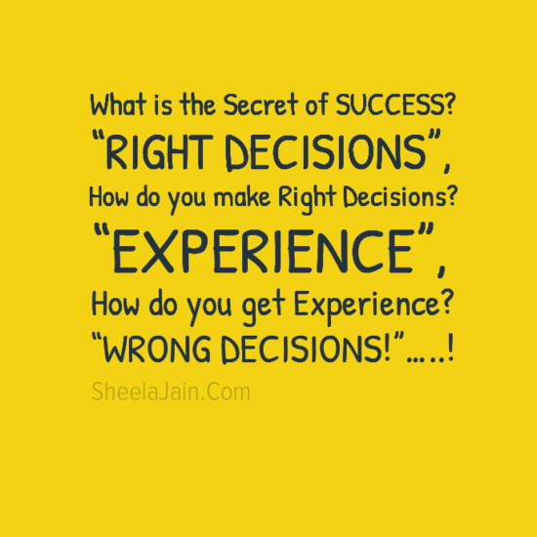
- Procrastinates on Purpose
There are ‘decisions’ Bettina knows she needs to make but doesn’t feel she needs to make them right now. Bettina refuses to be pressured by others.
Bettina will procrastinate on purpose when:
- She feels she does not have all the information or facts in front of her to make her decision
- She doesn’t feel the decision is important and/or urgent
- Bettina has other priorities that she needs to work through first
- It is possible the decision will no longer need to be made and the issue simply goes away
- It is an opportunity to delegate e.g., if I can leave it long enough my dad will do it for me.
- Bettina ‘shapes the ground’ if the occasion demands it – and only when the ground is shaped to her satisfaction, will Bettina make the decision.
Without prior warning Bettina often makes the decision because the time is right for her.
“When I feel lost & can’t make a decision, I just stop & get quiet. I take time out” Kim Cattrall
- Commits to the decision
Whether Bettina makes an impulsive decision or whether she has taken her time, once she has made the decision, she commits to it totally and there is no going back.
Bettina brings concentration and relentless focus to her decision:
- Getting her game face on – a look that I recognise that says that mentally she is getting into her positive mind-set.
- I could almost hear her brain ticking as she makes her plan and what her priorities are going to be
- Her body language (and her facial expression) is clear and open. She does not want to be disturbed until she has finished.
- She repeats a mantra to her herself. She does this often and I believe it helps her concentration and keeps her focused on the decision she has made
- Bettina brings all her thoughts to bear on the activity, fixing her attention and efforts on the decision, not allowing anything to distract her until she has fulfilled her objective
(Read more about Bettina’s lessons in concentration and focus.)
Always go with the choice that scares you the most, because that’s the one that is going to help you grow.” Caroline Myss
Bettina’s Five ‘Quick Tips’ for an approach to Decision Making
- Don’t be rushed into making a decision until you are ready
- You can only make the best decision with the information in front of you – so don’t second guess
- Just because it is urgent for someone else, it doesn’t necessarily mean it is urgent for you
- Don’t make their problem your problem
- Have you made this decision before? Did it work out ok? Then do it again. No point in reinventing the wheel
- Is the decision the best one not just for you but also for the people who are significant in your life?
- Once you have made the decision, commit to it.
Bettina makes a decision for me……..
Bettina takes a step back in front of me and examines both shirts I am holding up. “That one” Bettina is pointing to the shirt in my left hand. We are both in a ‘Crew Clothing’ shop in Southwold (Suffolk, UK) and I couldn’t make up my mind which shirt to buy. I’ve always trusted Bettina’s judgement!
There are times when it is ok to take a break from decision making, well that was my excuse. Thanks Bettina you made the right decision (for me!)
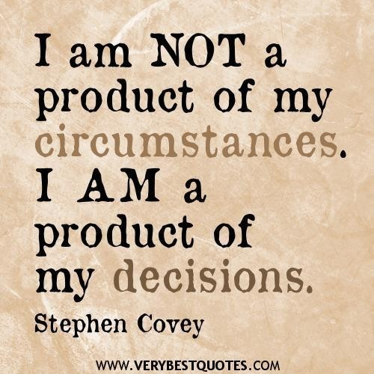

Source: Steve Raw www.leadershipintheraw.org and www.dosh.org
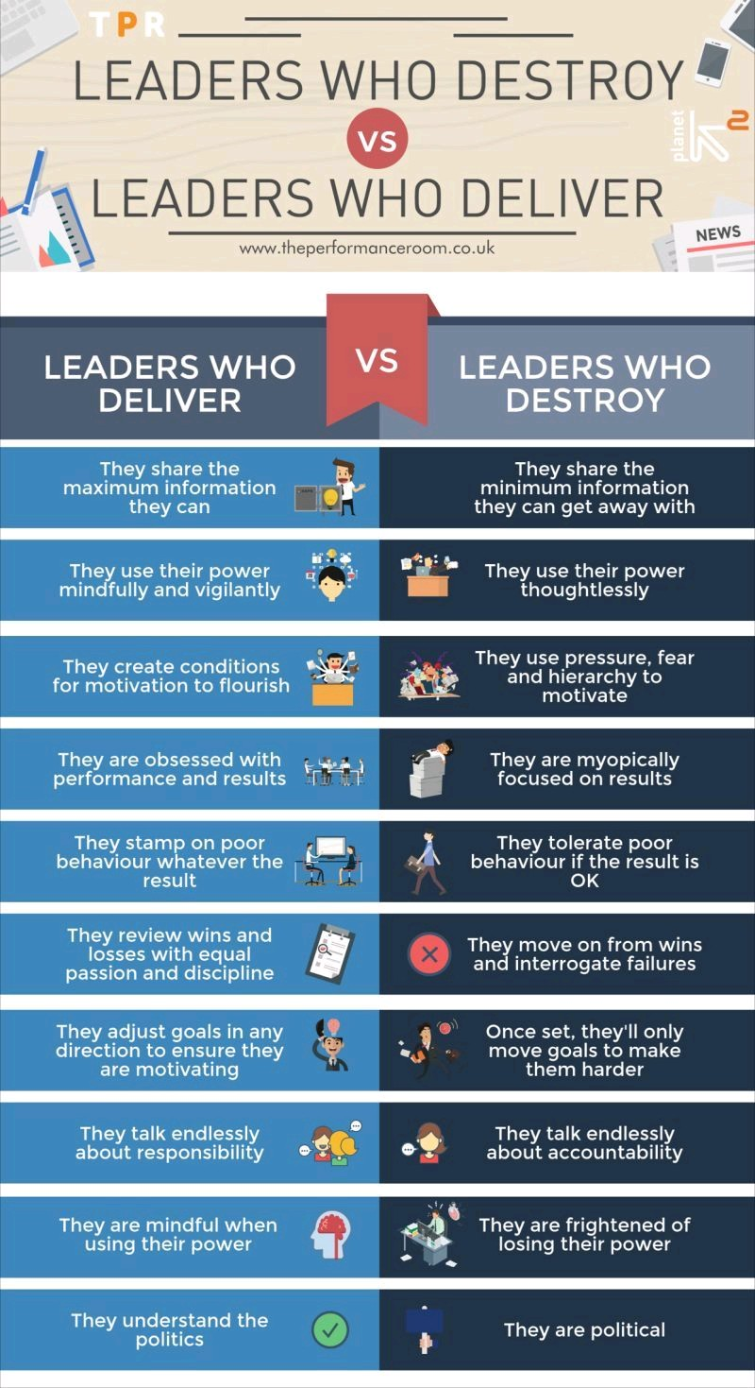
The Scariest Training For Any Presenter
Time to read: 2 minutes

Dear Steve
Is to go speak at a school…now that we can again
Trust me, if you feel you can stand on stage in front of over a hundred kids who have no interest in you or what you are about to say, then you are a very brave person who has no need of my advice!
However, having learned the hard way…I suggest:
Choose a school where you are not known, where you do not know any of the children personally.
Choose a smallish school – ideally a junior school. The sort of school where you will get out alive, as long as you don’t take along photos of your last holiday to anywhere.
Write to the school, say what you do and the message you can convey to young people. Say that you are keen to “give something back” in your work, and if they are ever looking for a speaker “for 15 minutes” at assembly to give you a call. And make sure you have any clearance that you might need to be working with young people.
Have one clear message you want to get across, tell them the message at the start, then tell an amusing personal story relating to the message and then conclude by what the message means for them in their lives.
If you have 15 minutes allocated – speak for 7 and then ask if anyone has any questions.
Trust me – they will!
And above all – if you feel relaxed, confident and ready for anything then go for it
And if you don’t – go for it anyway
With my love and best wishes
David
@nakedleader across all social media
www.davidtaylorsblog.com
www.thorlhome.com
“The only thing that’s the end of the world is the end of the world”
Barack Obama
#Perspective
CAREER MASTERCLASS
WIN AN ARGUMENT
Let them speak first. Listen, identify their concerns (getting promoted, closing a deal) and then tailor an irresistible argument.
Give them credit. Ask questions that guide them to your conclusion. Who’d reject an idea they’ve come up with themselves?
Stay calm. Focus on what your opponents are saying rather than what you think of them as a result of it (they’re a fool). Calm a rising temperature by asking yourself what you want to achieve and how you can make it happen.
Be prepared. Write down every challenge your argument could provoke, hone your answers, and then practise delivering them.
Don’t bamboozle. Most people would rather reject an idea than admit confusion. Break your argument into bite-size chunks, simplify and clarify. Make it fool proof.
Strike a match. Feeling a connection with others makes us more open to their ideas. Give natural synergy a nudge with body language. Adopt their posture, laugh when they laugh.
Reason with them. Of the nine major influencing tactics, logical reasoning is the most effective: saying ‘because’ after a statement increases the percentage of those converted by 50%. Reinforce your argument with accurate facts and figures.
Get emotional. Logic not working. Go for the heartstrings. After your argument with your opponent’s values and aspirations, paint a glowing picture of the future you want.
Flatter. ‘I know that you of all people will be able to cope with the new process I’m suggesting.’ Just don’t overdo it.
Use your allies. Refer to someone they respect. The more it appears you’re widely supported, the harder it will be to reject.
Believe. If you’re not convinced, why should they be?
Source: The Mind Gym: Relationships is published by Little, Brown at £12.99 – www.themindgym.com/books

5 WAYS TO…….COPE IN THE HEAT

1. Drink plenty of water.

2. Breathe deeply: heat and tempers rise in sync

3. Know that mornings will be productive…. And afternoons less so

4. Keep tissues for sweaty hands

5. Use deodorant Management Today

Why a sense of humour is essential?

- Passing the sense of humour test should be mandatory for Managers and Team Leaders. The test occurs, on days when one unbelievable disaster follows another. If now it feels like the world is going to cave in, you can still step back and see the whole nightmare in perspective, you’ve passed the test

- If you lose your rag, you’ve failed. Failing the test leads to behaviour that upsets everyone else, makes things worse and sends the day into a death spiral. Enough perspective and a sense of the bizarre can help defuse the tension. There is a fighting chance of stepping back from the brink.

- Next time the outrageous happens, remember to tell yourself. ‘I think this is a sense of humour test.’ Just saying it increases your chances of regaining perspective and passing. Of course, once you have said it, you can also decide to fail the test and to go down with all guns blazing.

- Lack of humour is not to do with reality, but with culture, senior management like to be seen as serious and to be dealing with weighty issues with appropriate gravitas. Slapstick is out, although the occasional dry witticism that reflects conventional wisdom is safe. It can show you are intellectually smart if the witticism is clever enough.

- Lack of humour is a shame. The bizarre world of management deserves respect, perspective, and humour if it is to be valued properly.

From Management stripped bare by Jo Owen

When you get into a tight place and everything goes against you,
till it seems as though you could not hold on a minute longer,
never give up then,
for that is just the place and time that the tide will turn.

Harriet Beecher Stowe

