LEADERSHIP AND WELLBEING PACK
November 2024
Established in 2006
I am planning to re-launch and publish my monthly leadership pack on Monday 2nd December. My regular guest writers have kindly offered to write new articles exclusively for our leadership & wellbeing pack. For this edition I have included some popular articles I’ve shared over recent years.
From June 2024: ‘One thing leads to another’ This article sets out to explain what being a student of leadership means to me. Why do I write about leadership? Why do I write about ‘Being Bettina’s Dad’? And what did I hope to achieve by sharing my monthly Leadership Magazine, blog, and articles.
From December 2018: Being Bettina’s Dad: ‘What is Courage without Fear?’ “Hello…….Is there anyone there?”
From September 2018: Damian Piper (Effective Challenge http://effectivechallenge.com ) ‘A moment to reflect - pressure on our shoulders’
From February 2021: ‘6 Domains of Resilience’. Rebecca Alexander from ‘The Coaching Studio “the question I’ve heard most often when coaching teams and individual clients has been ‘how can I improve my emotional wellbeing?’ In my search for answers, I dug into the field of resilience. In the past 20 years there has been an explosion in resilience knowledge – what it is, how it functions, and how to develop it……….”
From March 2019 (an article about the company I was MD for up until June this year) TRUST ‘doing what is right over doing what is easy’ We believe that we had significantly grown in the last 15 years because people who engage with our company, trust Dosh www.dosh.org – “For us trust in our company is having a ‘confident belief’ in what we do.”
There are lots more in this month’s edition so let’s dive in together……
Steve Raw FIoL, FCMI, GCGI
Email: steve.raw@thera.co.uk
Blog: www.leadershipintheraw.org
Instagram: @stephenraw6
Twitter: @SteveRaw836
LinkedIn: https://www.linkedin.com/in/steve-raw-72454721/
Facebook: https://www.facebook.com/steve.raw.771/

It’s not about how good you are.
It’s how Good You want to be.
One thing led to another.
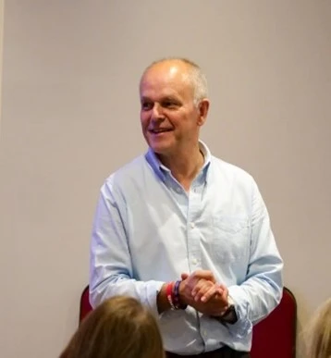
In training mode
I was in the middle of a management conference when I received a phone call from my previous line manager who had subsequently joined Thera (www.thera.co.uk) as a director, “Hi Steve are you ready to join our organisation?” “Yes” was my immediate response. Although she did not have a formal job role for me, she did want me to introduce leadership, coaching and mentoring to my new organisation. Then one thing led to another!
Within weeks I had written the content for a series of leadership workshops which would become accredited with a national leadership & management institute. Then came a monthly leadership magazine I would curate for the next 18 years. Ten years ago, Thera’s Communications Team approached me (Clare Malkin and Alison Freestone) asking me if I would start a blog, they even produced the name ‘Leadershipintheraw’ I just had to produce the content. One thing led to another and there is now a website with over 335 articles, and it has had 45,000 + views from around the world.
Writing about leadership is not my ‘day job’. For the last 28 years I have been supporting people with a learning disability and I have had the honour of being the Managing Director for Dosh (Financial Advocacy) Ltd www.dosh.org for the last 15 years, but then that was also a case of one thing leading to another.
So why?
My first career was in the Army and from the outset I had been fascinated by how leadership worked. How were people inspired to do stuff they really did not want to do? From the moment I joined my first unit, I considered myself to be a student of leadership and I always wanted to be a better leader.
In the 1980s our youngest daughter, Bettina, came into our lives. Bettina copes with a learning disability and autism and to add to her challenges - epilepsy too. Bettina is a constant source of inspiration (and love) and we quickly learned that we could all learn from ‘B’ and how she faces up to life with courage, perseverance, and a smile.
This article sets out to explain what being a student of leadership means to me. Why do I write about leadership? Why do I write about ‘Being Bettina’s Dad’? And what did I hope to achieve by sharing my monthly Leadership Magazine, blog, and articles (some of which friends and colleagues have specially written for the website).
“In periods where there is no leadership, society stands still. Progress occurs when courageous, skilful leaders seize the opportunity to change things for the better.”
Former U.S. President Harry Truman
What being a student of leadership means to me?
- Understanding that no matter how experienced and knowledgeable you think you are, there is a whole world of learning that you still need to acquire.
- That rarely a day goes by that you cannot learn something new to add to your portfolio of experiences.
- That you do not just learn from books. You can learn from simply observing others in leadership roles no matter what their age or background.
- Learning what works and what does not.
- You can learn from your successes and failures in equal measure.
Related: Fail and fail big! – Leadership in the Raw
“A person always doing his or her best becomes a natural leader, just by example.”
Joe DiMaggio
Why do I write about leadership?
This is something I have enjoyed doing over the years because:
- It is has helped me reflect my own leadership style and how I can continually develop as a leader.
- It is part of my continued professional development (CPD) when I choose a subject, I first must research it.
- I am inspired to write more after receiving feedback from those who have read my articles and how my experiences have helped them on their journey.
- To support colleagues who have asked me to write about a subject that fits with their goals and objectives e.g. ‘My Happiness Project’ – ‘A Family Members Perspective’ – Leadership in the Raw
- To help future leaders on their leadership journey. One of the joys of both my careers has been able to play a part in bringing forward new leaders and managers, this has often been through 1-1 coaching and mentoring,

Why the ‘Being Bettina’s Dad series.
Although I write the majority of Bettina’s stories, I could not do this without Bettina’s tiger mum, Joyce who screens the subject and content, edits, proofreads, and adds to my articles. There is a ‘Being Bettina’s mum series too:
Related: Being Bettina’s Mum: Care to Communicate? – Leadership in the Raw
When Bettina was first diagnosed with autism and a learning disability in the early 1990s, we found there was little education about her condition we could access. Any stories or articles in newspapers & social media were always negative and pessimistic – which still happens. We wanted to change this narrative for other family carers, deciding we were going to share stories that:
- Would inspire parents. To see light at the end of the tunnel, even though it may be hard to imagine at the moment.
- Provide tips, techniques, and ideas. What worked for Bettina might work for your daughter or son.
- Since 1996 I have worked for organisations supporting people with a learning disability – the stories I write from a parent’s perspective hopefully adds an additional dimension to peoples’ support.
- Provide a positive image of someone with a learning disability and autism – and how they can influence your life and those they come into contact with.
Related: Being Bettina’s Dad. Leading when you are not holding a Leadership Position. – Leadership in the Raw
- The lessons I constantly learn about life (and leadership) and how they have influenced my approach to work and my personal life. Some of those lessons I share may help others.

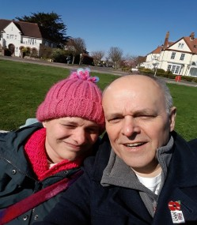
Bettina with her dad in Frinton on Sea

What I hoped I have achieved by sharing my blog, leadership training, articles, and publications?
- Making leadership more accessible. I have often found books about leadership can border on the academic. This can be a turn off for busy people, whether you are an experienced leader and manager or you are just starting out in life.
- For busy people my articles are filled with quick reads, bullet points that include ideas, tips, and recommendations.
- For busy people my leadership workshops & presentations involved 10-minute segments – with the aim of holding someone’s attention until the next subject or idea.
- To inspire and, on occasion, move people. Everything I share is always intended to be positive and supportive.
- Choosing subjects that I knew were challenging and important to colleagues. They were and are important to me too.
- Sharing my experiences, the lessons I had learned and sometimes the mistakes I had made. I am a strong believer in ‘It is better to learn from a warning than a mistake.’

“Leadership consists of nothing but taking responsibility for everything that goes wrong and giving your subordinates credit for everything that goes well.”

U.S. President Dwight D. Eisenhower
One thing leads to another.
I retired from Dosh after 15 wonderful years and draw the curtain on a 28-year career in Social Care, but this is not the end of my writing and sharing the lessons I have learned because one thing leads to another. Joyce and I are looking forward to sharing our experiences, the lessons we learn, especially from Bettina, with a focus on wellbeing and wellness. We hope we will inspire you and support you in your future endeavours.
Steve Raw www.leadershipintheraw.org
"A truly happy person is one who can enjoy the scenery while on a detour." ~ Unknown

One of my favourite Ted.com presentations
We should aim for perfection and stop fearing failure:
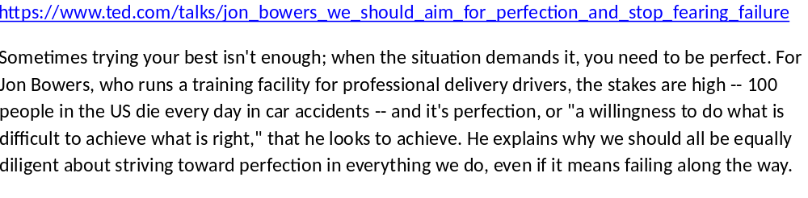
Being Bettina’s Dad: What is Courage without Fear?
“Hello…….Is there anyone there?”
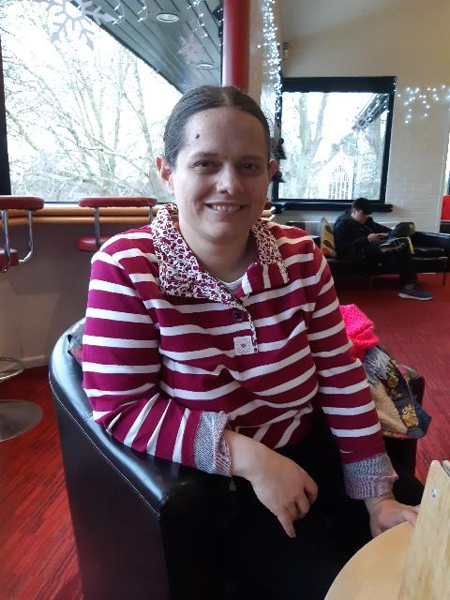
Bettina is calling from upstairs and looking over the banister. Our home can be noisy, and the atmosphere is always filled with laughter and chatter 99.9% of the time - there are, after all, four adults living together in Bettina’s house. This evening our house is unusually quiet, two of the adults are somewhere else in the country. Joyce rushes to reassure Bettina - “it is ok, Mum is here” - once again we are reminded of Bettina’s greatest fear, which is to be left on her own.
Supposing you had just arrived on earth for the first time, how would you feel? You see people looking at you and they are trying to communicate with you, but you are not sure what they are communicating. You hear noises that hurt your ears and when people give you eye contact it feels like a burning inside side of you. You think about telling those around you how you are feeling but you are not sure how to do it and will they understand anyway?
Now imagine all these sensations happening to you all at the same time, every minute of your day, each day with no end in sight. Bettina copes with Autism and a learning disability and with her inherent courage she faces down her fears every day. After all what is courage without fear?
Fear: Distress or alarm caused by impending danger or pain. An awareness of dread. Terrifying
Courage: The ability to face danger or pain without fear. Bravery
“Courage is never to let your actions be influenced by your fears” Arthur Koestler
For me, I did not understand real fear and what it meant to be afraid until I had witnessed seeing Bettina having her first seizure. It was unexpected as she was yet to have her epilepsy diagnosed. I had supported many people with seizures prior to Bettina’s, but the shock and fear I felt when I witnessed this is something that has stayed with me, even after 15 years since it first happened.
I share with you the stories from ‘Being Bettina’s Dad’ series on my blog and in my monthly leadership pack to inspire readers to look at the world a little differently and help people on their leadership journey and, most importantly, to learn as I do from Bettina. Bettina teaches her family and friends so much about life and what is courage without fear is a good example for me. I personally do not worry about feeling fear but what worries me is how I will perform and respond to fear on each occasion (will I let people down?). So it is helpful for me to revisit Bettina’s code and coping mechanisms:
From Fear to Courage – Bettina’s code
- Bettina conquers almost any fear by making a conscious decision to do so
- Bettina recognises if she gives into fear, she will always be frightened.
- Once she has made up her mind up, this diminishes her fear.
- Bettina knows she is not able rid herself of her fears, so she chooses to harness and master them instead.
- Bettina faces her fears by surrounding herself with those she loves and trusts as she faces her danger.
- With each distress or alarm Bettina feels, she conquers her perceived pain and acknowledges her success by giving a thumbs up and says “you did it” then she moves on to her next challenge.
Bettina’s coping mechanisms:
- Bettina does not allow herself to stay in a fearful state, she immediately plunges straight back into action. (It is that kind of courage that her family admire in Bettina so much)
- Bettina keeps her focus and concentration on the main prize – everything else is a distraction.
Also mentioned in ‘Bettina’s lessons in concentration and focus’ https://leadershipintheraw.org/2016/11/10/being-bettinas-dad-bettinas-lessons-in-concentration-and-focus/ :
- She repeats a mantra to her herself. She does this often and I believe it helps her concentration and keeps her focused.
- Bettina brings all her thoughts to bear on the activity, fixing her attention and efforts on her task, not allowing anything to distract her until she has fulfilled her objective.
Bettina can often be frightened, but this does not stop her from living her courageous life. Go Bettina!
“Hello…….Is there anyone there?”
We are Bettina, and we always will be.
Source: Steve Raw www.leadershipintheraw.org

A moment to reflect - pressure on our shoulders.
There’s a lot written and talked about when it comes to taking responsibility for the situations we face. I’m an advocate of that myself. There is, however, a tricky trap which we can get caught out by. I’ve been working on a couple of projects recently where I’ve seen a few people getting caught by this. I call this the ‘it’s all about me’ trap.
There are situations when stepping up and taking responsibility that we can get confused that all the work and or solutions need to come from us as individuals. This often results in our thinking narrowing and our time often being spent in ever decreasing circles of effectiveness. So, what are the indicators of falling into the trap and what can you do to intervene before they get a grip? Here are three common things you might want to look out for:
1) We are repeating the same activities with ineffective results
2) Over-commitment that your solutions are the right ones
3) Lack of connection with others.
Repeating the same things over with ineffective results
Einstein suggested that a theory of insanity is doing the same thing over and over again and expecting a different response. In this context, this applies readily. Failing to make progress with a project and keeping going with the same activities. There’s a judgement call here. As sometimes we need to give an approach a chance to work (not everything happens overnight). There is, however, a tipping point. Raising our awareness that we need to use this judgement and do something different is worth practising. This leads to the next indicator.
Over-commitment that your solutions are the right ones
Like the situation above there’s a judgement call to practice here. The judgement call is particularly important when we have responsibility for leading others. It can be incredibly frustrating to work for someone who is constantly changing their mind. That said, if we are overly invested in a particular solution that isn’t working, we can find that our ego gets in the way of progress. We can begin to search for all the evidence no matter how small that we are on the right track and get blinkered to all the contrary evidence.
Lack of connection with others
Having the right support team to help you deal with situations is something that is worth your investment. They can certainly help assess your evidence of how things are going. Evaluating where you could have blind spots and or having different creative input is a great place to start. Again, the ego can kick in here. Some people I’ve worked with describe involving others as a sign of weakness or something someone does when they lack confidence. The critical difference for me is the intent you have to engage different people.
I’ve been fortunate to work with some work class individuals in business, the military and sport and one of the things that resonate for me is there never-ending quest to involve others to improve situations and performance. I’ve come to see the ability to keep asking great questions as a sign of confidence and strength. This takes real humility and an open mind. The first thing is to know is who are in your group. And ensure you are actively keeping it fresh.
I've not seen a situation where a leader who carries all their pressures on their shoulders be happy and perform optimally. Think about challenges you might be facing and assess if you’ve fallen into the ‘its all about me’ trap. And perhaps more importantly decide what you could do differently to help. As always, I’m interested in what you do as a result.

Damian Piper CBE
Coach & Facilitator
https://www.linkedin.com/in/damian-piper/
https://www.instagram.com/damian_effective_challenge/
www.effectivechallenge.com
www.effectivechallenge.com/podcast

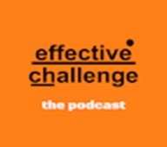

6 Domains of Resilience
The past year has been challenging for us all, and the question I’ve heard most often when coaching teams and individual clients has been ‘how can I improve my emotional wellbeing?’
In my search for answers, I dug into the field of resilience. In the past 20 years there has been an explosion in resilience knowledge – what it is, how it functions, and how to develop it. Overall, resilience can help us to stay calm, stay focused on our goals, and to build better relationships and better sleep and health habits. Even better, there are many achievable ways to increase our own resilience.
What is resilience?
Resilience helps us to turn adversity into advantage – not only do we bounce back from setbacks, we move forward. This is what enables us to lead a meaningful and fulfilling life, despite the challenges we face.
Resilience isn’t just important for the ‘big stuff’ in life – major changes, loss, upheaval. It’s just as important for the small stuff – work stress, daily challenges and frustrations and so on. A great way to check your resilience level is to gauge your response to these small stressors. On a good day, when your resilience is high, you can most likely shrug or even laugh them off, and get on with your plans. But when resilience is low, those small frustrations can feel like impossible setbacks, and it can take time to get back on your feet. It’s a tell-tale sign that your resilience is not where it could be. The great news is that our resilience level isn’t static, we can work on and improve it.
A tale of two brains
Our brains are equipped with a great warning system which enables us to spot threats and respond quickly. This is the limbic system or ‘impulsive brain’, and its default reactions to stress are ‘fight, flight or freeze’ – great if you’re on the savannah facing an animal predator, but fairly hopeless for a typical workday problem such as IT failure, bad traffic, or an irritable (or irritating) boss. This is when we need our ‘smart brain’ - the area in our prefrontal cortex known for its decision-making and reasoning capacities. Much of resilience training is about downregulating our limbic system and upregulating our smart brain. So, how do we do it?
The six domains
Research identifies six key areas which make up resilience. Whatever your level, undertaking small daily activities in each domain can vastly improve your resilience, and I’ve included some suggestions below.
Vision
We’re at our most positive when we have clear goals which we’re actively working towards and which don’t conflict with each other. Conversely, without clear goals we can feel frustrated and demotivated, and small things can easily knock us off course. Vision provides a bigger picture – something to inspire and motivate us even when the day-to-day is tough. So, a starting point for raising resilience is to set clear and meaningful goals, however small. How you do this is up to you. You could work with a goal-setting app, with a buddy, with a manager or with a coach. Aim to identify one or two goals that feel authentic to you and which would make a positive impact on your life. Then start taking the steps you need to reach them.
Composure
When we’re composed, we’re better able to stay calm in the face of difficult situations. It helps our smart brain to turn down the volume on our pesky limbic brain – a keystone of resilience. A bit like a muscle, composure takes regular practice so that it’s there for us when we need it, but it need only take a few minutes. Composure strategies include deep breathing techniques, labelling emotions, finding activities that calm and relax you, and challenging negative thinking. Find one or two habits that appeal to you and aim to practice them daily.
Reasoning
This domain is all about our ability to anticipate, plan and problem solve. The best way to expand this capacity is by widening our knowledge – through reading, training courses or podcasts – and working on our strengths. You could also hold a forward planning session with your team to help you all rehearse some problem-solving skills.
Tenacity
This is what many people think of when they think of resilience - the ability to stick with a goal even when it’s tough. A great approach is ‘realistic optimism’, when you know the path will be tough, but you’re hopeful regardless. Research shows this is a more successful outlook than blind optimism or total negativity. If you’re struggling with motivation, try the ‘5, 4, 3, 2,1, GO!’ method. Start a countdown on the agreement with yourself that when you reach GO! you will do it.
Collaboration
We are social beings, and few things boost our resilience as much as the support and connection of those around us. Covid restrictions might mean we have to be physically distant, but we can still be socially close. Make time to connect with others and show extra patience and understanding as many people are struggling right now – even if they’re hiding it. Perhaps reach out to someone you haven’t been in touch with for a while and say hello. Asking for and offering support is another way to deepen existing relationships.
Health
This is a new addition to the study of resilience, as researchers continue to uncover the huge impact our physical health has on our mental health. I’m not going to lecture you on how to improve your physical health – you probably already have a good idea of what you’re doing well and where you could improve. One of my fellow coaches uses the SHED acronym as a handy reminder of the key areas – Sleep, Hydration (water, not alcohol!), Exercise and Diet. Take an honest look over your schedule and identify one or two small positive changes you can make today.
Even if you choose only one of the six domains to work on, you’ll notice your resilience levels improve. Research suggests that the Vision domain is the most important, so it can be a good place to start. But listen to yourself and work out what feels most manageable for you right now. Follow the philosophy of small solutions – transformation doesn’t always need require big and daunting steps. Small, daily changes are easier to incorporate and have a huge impact over time.

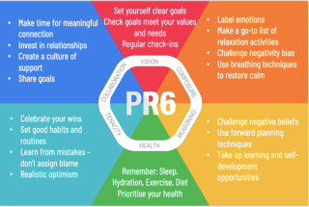
For more advice and suggestions, try www.home.hellodriven.com – from the creators of the Six Domain model. The same organisation also offers a resilience app if you fancy a deeper dive and daily reminders for your resilience journey.
Rebecca Alexander
‘Leadership coach and facilitator at The Coaching Studio’



In 2017
TRUST ‘doing what is right over doing what is easy’
On a recent long journey to conduct recruitment and selection of new team members, I listened to a USA magazine Success CD from 2012, the discussion was about ‘Trust’. The interview was with David Horsager and what David said resonated with me. Trust is an attribute which the Dosh business model is built on.
Dosh Ltd www.dosh.org is a non-profit organisation that supports people with a learning disability to be in control of their money. Dosh provides corporate appointeeship, financial advocacy, account management and money check services for 1000 people, partnering with nearly 200 different care and support providers across England, Scotland, and Wales.
We believe that we have significantly grown in the last 10 years because people who engage with our company trust Dosh – we currently receive (on average) over 20 referrals a month. For us trust in our company is having a ‘confident belief’ in what we do.
For our Business Plan for 2019/20 we have made commitments and endeavours to the people we support and those who have a stake in our company. During this business year we will enhance our ‘Trust Edge’ as part of our ‘Competitive Advantage’.
Some people think trust is a soft skill, but if an organisation makes a serious mistake through a breach of trust it can easily become a commercial crisis or even a disaster which, without exception, will hit your bottom line! Still think it is a soft skill.
Here are our 8 pillars of Trust, adapting the headings from the ‘Success’ magazine interview:
1. Character
For Dosh this means doing what is right over what is easy, and each team member has this characteristic, staying true to our values, doing what is right. There are often occasions when colleagues are up against it and the situations can feel insurmountable, it is always at this point they find the energy and determination to persevere, to get the best outcome for the people they support.
We are also honest about our failures and successes and learn from them. This is part of our leadership way: https://leadershipintheraw.org/2014/09/25/leadership-the-dosh-way/
2. Compassion
All team members think beyond themselves when they think about their work and how they will support people and their colleagues. They care! Our team members write stories for our Board of Directors (and we share them on our website) about how they have made a difference in another person’s life through their work.
3. Clarity
We are clear about what our mission is: “to support people to be more independent and have more control over their money” and we share our ‘Dosh Promise’: https://www.youtube.com/watch?v=0vAJbvcnvug a set of standards by people with learning a learning disability and which we are assessed on by the people we support as part of our Annual Review. People know what is included in our service and we detail this in our Information Guide and on our website. All our policies, procedures, fact sheets and protocols are written in plain English format to make it accessible to everyone.
We are clear about the benefits of our support and service to people with a learning disability.
4. Consistency
I was sitting in an international renowned fast-food outlet this morning (you know the one), thinking about the importance of consistency and trust. I thought about my visits to their restaurants in: Hong Kong, Singapore, Berlin, Belfast, Brussels, and Colchester. When I eat their mini apple pie, they always consistently burn my mouth! I trust them to do this.
Dosh work to a number of key performance indicators (KPIs) which our team members regularly report on and which our Board of Directors monitor and evaluate. We think the KPIs are based on what people we support think are important to them. Working in this way ensures we consistently support people across the country to deliver the same service.
I have found people trust sameness. Little things done the same can have the biggest impact – they all add up.
5. Competency
You will not be surprised to read that supporting people with welfare benefits is complex. Government changes are fluid and if we are to support people to maximise their money, it is important our team members are not just recruited for their values and positive attitudes, they must be competent and therefore having the knowledge to do something really well.
Our Financial Advocates often come from a Banking and or Benefits background. They take their continued professional development seriously: staying fresh, relevant and capable. They know how to share their learning with those they support.
As a company we publish a (free) quarterly Dosh Newsletter to those who have an interest in supporting people with their money: https://leadershipintheraw.org/2019/01/02/dosh-winter-newsletter-2018/
6. Contribution
It is not enough to just be busy. To build trust you need to contribute, and our team members’ contributions are their results for the people they support:
- During our Annual Reviews in 2018 – 97% of people we support said they were happy with Dosh Support and 98% of people told us they can choose how they spend their money to do the things they want.
- Migrating from Disability Living Allowance (DLA) to Person Independent Payments (PIP) the team has gone up by 350K for people supported.
- The weekly income for new people supported have risen by £51.62 per week
- And their savings increase by £4,616, in their first year of support with Dosh.
7. Connection
It is not enough to just communicate with people; we also need to connect with them. So, we prioritise building trust with the people and communities we work with. We devote time to building relationships which we hope will last for many years. We do this by becoming part of a person’s circle of support (their network) and we speak up for people when they cannot speak for themselves.
We also seek out collaborations with other organisations.
8. Commitment
Our team members have a selfless commitment to the people they support, standing with them through adversity. They care about what is really needed and as a company we find ways to measure this trust through our Annual Reviews.
In addition to our Business Plan, we are going to launch a major project in April – ‘Project 2000’, part of our five-year strategic direction. We will carry on building on our Eight Pillars of Trust.
How to put this into practice
(With thanks and gratitude to ‘Civil Society Futures – Independent Enquiry’)
Maximise trust:
- Notice when you’re taking or avoiding risks. Ask what you would do in that situation if you were ten times braver.
- Understand how to gain trust and acceptance within different spaces and communities.
- Make time to seek out different perspectives and views and to listen deeply.
- Admit when you don’t know and ask for support.
More thoughts on ‘Trust’
By Damian Piper, Effective Challenge why does it matter? There are multiple reasons why this topic merits consideration. Quality of relationships, personal & team resilience and the quality of decision-making are just a few. In my experience when first asked the question about levels of trust and openness within a team, people can feel awkward about saying what they really believe. This results in an over estimation of how good things really are. So how can you become more informed?https://leadershipintheraw.org/2016/03/15/team-trust-and-openness-awkward-topic-or-team-enabler/

Bettina, my youngest daughter, copes with a learning disability and autism. Bettina will always need to have someone by her side, so how did our relationship evolve over the years so that new experiences no longer faze her? I believe it had everything to do with ‘Trust’………. https://leadershipintheraw.org/2015/07/28/being-bettinas-dad-trust-is-a-gift-you-must-earn/

