LEADERSHIP AND WELLBEING PACK
February 2025
Established in 2006
Welcome to this month’s edition. Highlights include:
Damian Piper CBE our Resilience Coach starts this month edition with: Abandon Irrelevance: Lighten Your Load for 2025 “As we progress into February 2025, many of us carry mental and emotional baggage that no longer serves us. Whether it's outdated goals (jeez we only set them in January ), unhelpful habits, or even relationships and commitments that once felt essential but now feel like weights holding us back, these "irrelevances" can quietly sap our energy, focus, and potential.”
Another excellent article from Rebecca Alexander from the Coaching Studio: What Are You Not Saying—And What Is It Costing You? “Have you ever walked out of a meeting with an unspoken idea still lingering in your mind? Or held back feedback that could have changed the course of a project? Silence isn’t just the absence of words—it’s a missed opportunity to contribute, connect, and create impact. …”
Three articles from me: No1 ‘Being Bettina’s Dad – A work in Progress.’ No2 ‘Setting: Goals – Objectives – Commitments’ and if you are considering changing careers: No3 ‘Do the work you were always meant to do.’
‘Impact Management’ by Meike Beckford. Mieke is now Managing Director for Dosh Ltd www.dosh.org and asks What is impact?

Graham Belgum has two important messages from his new series of ‘Thought for the week ahead’…. ‘Listening’ and ‘Being uncomfortable’.
There are lots more in this month’s edition so let’s dive in together……
Steve Raw FIoL, FCMI, GCGI
Email: stephenraw6@gmail.com
Blog: www.leadershipintheraw.org
Instagram: @stephenraw6
Twitter: @SteveRaw836
Blue Sky: https://bsky.app/profile/steveraw.bsky.social
LinkedIn: https://www.linkedin.com/in/steve-raw-72454721/
Facebook: https://www.facebook.com/steve.raw.771/
It’s not about how good you are.
It’s how Good You want to be.
Abandon Irrelevance: Lighten Your Load for 2025
As we progress into February 2025, many of us carry mental and emotional baggage that no longer serves us. Whether it's outdated goals (jeez we only set them in January ), unhelpful habits, or even relationships and commitments that once felt essential but now feel like weights holding us back, these "irrelevances" can quietly sap our energy, focus, and potential.
Much like clearing out a cluttered drawer, abandoning irrelevance requires intention and effort—but the rewards are worth it. By letting go of what no longer aligns with who we are or where we want to go, we create space for clarity, growth, and purpose.
Why we hold onto irrelevance.
Irrelevance doesn’t always appear irrelevant at first. A habit that once helped us thrive may now hinder progress. A relationship or responsibility we took on in good faith might no longer be healthy or productive. Often, we hold onto these things out of guilt, nostalgia, or fear of change. However, the cost of holding on—missed opportunities, lack of focus, or simply burnout—can outweigh the comfort of the familiar.
2025 is the perfect time to reassess. With a fresh start, we can align ourselves more intentionally with what truly matters, letting go of the rest.
Practical Questions to Help Abandon Irrelevance
To decide what to let go of, start by asking yourself these questions:
- Does this still align with my values and goals?
Perhaps a goal, activity, or commitment made sense when your priorities were different. Ask yourself: Is this contributing to who I want to be in 2025? If not, it might be time to let it go.

- Am I holding onto this out of habit or guilt?
Sometimes, we continue with activities or relationships because "we’ve always done it this way." Reflect on whether you're maintaining something out of obligation rather than genuine desire.

- What impact does this have on my energy and focus?
Consider whether a particular task, thought pattern, or relationship energises or drains you. If it's consistently taking more than it gives, re-evaluate its place in your life.

- What would my life look like without this?
Imagine what would happen if you let go of the irrelevant item or commitment. Would it leave a gap, or would it free up time and energy for what matters most?

- Is this weighing me down emotionally?
Emotional baggage, like unresolved conflicts or lingering guilt, can be just as distracting as physical or mental clutter. If something is a constant source of worry, consider addressing or releasing it.

Letting go with purpose.
Abandoning irrelevance doesn’t mean recklessly cutting ties or shirking responsibilities. It means taking a thoughtful, purposeful approach to streamline your life. Start small if the process feels daunting: remove one irrelevant commitment, thought, or habit at a time.
Here are a few strategies to help:
- Declutter Your Schedule: Look for meetings, commitments, or projects that no longer serve a clear purpose and politely decline or delegate.

- Reassess Goals: Revisit your goals for 2025 and beyond. Are they still relevant? If not, revise or replace them.

- Clear Mental Space: Practice mindfulness to identify and release recurring thoughts that no longer serve you. Journaling can help uncover patterns.

- Simplify Physical Spaces: Sometimes, clearing your physical environment can serve as a symbolic and literal act of letting go.

Moving Forward
When we hold onto irrelevance, we risk missing out on opportunities that truly matter. By letting go of what no longer serves us, we free ourselves to focus on what does.
As you look ahead to the Spring, take some time to consider the things that weigh you down or no longer fit. Abandon irrelevance and step into the year with clarity, lightness, and purpose. Your future self will thank you.
As always, I’m interested in how you get on or any questions, I can help you answer.
Damian
Damian Piper CBE
Performance and Resilience Coach
✆ +44 7837 648035

Let’s connect on socials: LinkedIn | Instagram
 Effective Challenge Podcast
 www.effectivechallenge.com


What Are You Not Saying—And What Is It Costing You?
Have you ever walked out of a meeting with an unspoken idea still lingering in your mind? Or held back feedback that could have changed the course of a project? Silence isn’t just the absence of words—it’s a missed opportunity to contribute, connect, and create impact.
Maybe at home, you’ve disagreed with a family decision or felt hurt or sidelined but chose not to speak up, fearing you’d upset a loved one or disrupt the peace.
For many of us, staying silent isn’t a conscious choice—it’s a habit. It’s shaped by workplace culture, family norms, past experiences, or fear of conflict. But what if unlearning silence was the key to stronger leadership, better decisions, and more authentic relationships?
In her book Unlearning Silence, Elaine Lin Hering challenges us to examine when and why we hold back—and how we can reclaim our voices.
Why Is Speaking Up So Hard?
It’s not as simple as just ‘speaking up’. For many, that idea feels unnatural, as if confidence should come easily when challenging others. But think back to your earliest days at school or home. Were you praised for keeping the peace? Encouraged to go along with things to avoid conflict? Told to stop asking so many questions?
Over time, these experiences teach us that our voice doesn’t matter—or that keeping the group happy is more important than expressing our views. The longer we stay silent, the harder it becomes to break the habit.
We see this in workplace "corridor talk"—where employees discuss their frustrations privately instead of raising concerns in meetings. Speaking up in the moment feels risky. What if it damages our reputation, workplace relationships, or even our job security?
How to Unmute Yourself
If this sounds familiar, there are ways to start using your voice.
1. Recognize when you stay silent. Ask yourself: Why did I hold back? Was it habit, fear of conflict, lack of confidence, or past experience?
2. Consider the cost of silence. How does it impact your relationships, work environment, or even your happiness? Repeatedly withholding your voice can hinder collaboration, prevent real connection, and stall important conversations.
3. Start small. If speaking up feels intimidating, begin in low-risk situations. At home, voice a preference for a movie or a dinner spot. At work, suggest a lunch location or offer a minor piece of input in a meeting.
4. Observe and learn. Notice who speaks up in your workplace and how they do it. What strategies can you adopt or refine?
5. If you're a leader, foster a culture of openness. Praise those who share their perspectives and encourage quieter team members to contribute. Pay attention to the way you ask for input—questions like, "What do you think?" can be too open and might deter different views. Instead, try: "What works or doesn’t work about this idea?", "What concerns do you have?", or “What have I missed?”.
A Choice, Not a Habit
Over time, speaking up—and encouraging others to do the same—will start to feel more natural. Of course, there will be moments when choosing silence is the right decision. But the key difference is that it will be a choice, not just an automatic habit.
And when you do speak up, acknowledge your progress. Stepping out of your comfort zone isn’t easy. Surround yourself with people who support your voice and reflect on any positives that have come about from the fact that you spoke up. Because the conversations we avoid today might be the ones we need the most.
Rebecca Alexander
Executive Coach rebecca@coaching-studio.co.uk
"What seems to us as bitter trials are often blessings in disguise." – Oscar Wilde
Being Bettina’s Dad – A work in Progress
Having waited patiently for her Hot Chocolate, Bettina (aka ‘B’) grabs the wafer biscuits she was supposed to share with her mum (Joyce). ‘B’ laughs at Joyce’s expression; she knows what she is doing, and she knows she will happily share but for now she is going to tease her mum because she can. Bettina’s parents and her big sister, Jennifer, could have only ever dreamed about this engagement in 1992.
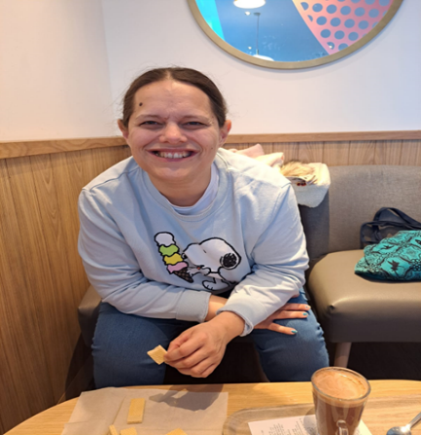
Bettina enjoying her mum’s reaction in Costa.
Flashback to 1992, we are on annual leave staying at my parents’ home. They have just wall papered the guest bedroom, where we will sleep. Bettina is at the height of her severe autism and learning disability and spotted a small corner of the paper which has not pasted down. We wake up to find Bettina has pulled down a complete strip of wallpaper. We should have expected this as she had recently unravelled a large section of her bedroom carpet and left the taps running in the bathroom - flooding the landing. In a strange way we thought this was progress for Bettina when we compared these experiences with her first two years. ‘B’ was obviously trying to communicate something; we would just have to figure out what that was (this would be our progress journey).
Related: Being Bettina’s Dad and being married to Bettina’s Whisperer – Leadership in the Raw
This article was going to be about how Bettina ‘contributes’ and takes ‘responsibility’ within her family and life in general. Then I read a piece on LinkedIn by Damian Piper CBE, and I thought this is Bettina.
An extract from Damian’s LinkedIn post: ‘let’s talk progress.’
“…………. Here is the thing: progress does not demand perfection. There’s still time to take a step, even if it is smaller than we originally imagined. Sometimes, we need to recalibrate our expectations and focus on what can be achieved rather than what we hoped to do.”
“The week is not over yet. Let us finish it with intention, no matter how imperfect the progress might feel.”
damian@effectivechallenge.com | www.linkedin.com/in/damian-piper
When Joyce and I sat around the dinner table discussing our aspirations for Bettina we were always going to look for progress, not perfection, for Bettina. It mattered not how small that progress would be, we were and are in it for the long haul.
What has progress meant for Bettina?
- From being non-verbal until the age of 10 years old, to having a limited vocabulary which she can use to communicate her needs with profound effect.
- Being able to cope with affection. We are a loving family so it was extremely hard for her parents and sister when we could see a hug caused her discomfort and pain. Then to progressing to a point where she welcomes this attention (on her terms).
- Not being able to tell us how she feels. This was our greatest concern and sadness. Bettina is now able to tell us she is “so happy” and it “hurts” when she has a headache and sometimes she can warn us that she is about to have a (epileptic) seizure.
- Locked in her own world, where we believed she was not truly aware of those around her, to feeling empathy, sensing if we are worried or upset about a situation.
- Learning to read, which has continued to open her world, reading is something Bettina is constantly looking to progress, from her weekly visits to our local library to spending time in her bedroom in the evening reading the numerous books she has accumulated.
- To being an integral part of her family instead of a person who just needs to be cared for. Week on week, month on month and year on year Bettina makes a ‘contribution’ to family life within our household. Bettina takes ‘responsibility’ for tasks and chores which nobody has asked her to do.
What have I learned from Bettina’s progress?
- To manage my expectations. Just because they are my expectations it does not necessarily mean they are shared by Bettina.
Related: https://leadershipintheraw.org/2023/05/04/being-bettinas-dad-managing-my-expectations/
- To be patient. Have a vision of where you want to get to but know it will take time and not to be surprised when you do not get it right first time.
Related: https://leadershipintheraw.org/2021/02/16/being-bettinas-dad-patience-is-a-leadership-virtue/
- To be optimistic about your progress. In our hearts and minds we are always optimistic for Bettina. Related: https://leadershipintheraw.org/2017/04/04/being-bettinas-mum-dad-ogres-of-optimism/
- To reflect and remember how it was. We are often too quick to move on to the next challenge and opportunity. Or we can feel down about a setback or a perceived failure. I have found remembering how it was for Bettina in her early years gives me perspective and a feeling of gratitude.
- The compound effect, a little progress each day (and/or week) can add up to something big and special.
- Celebrate successes together. Progress is rarely achieved on your own, so celebrate together with those who have supported you.
Five tips to make Progress:
- Think Big. Be Ambitious and Back Yourself.
- Defining what aspects of your life and work you wish to progress.
- Progress should be personal to you. You are the best person to judge what progress has been achieved when it comes to your success criteria.
- Set Goals. Related: Setting: Goals – Objectives – Commitments – Leadership in the Raw
- Progress often involves changes to your routines, goals, and plans. So be flexible.
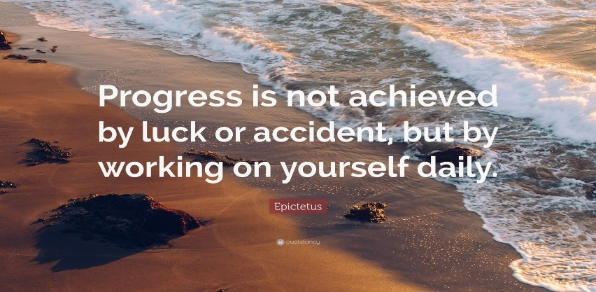

Summary
My favourite coaching question is: ‘If I was to meet up with you this time next year, what would make you feel satisfied with your progress?’ Often, we define success on meeting a goal or objective, then feel we have in some way failed if we have not arrived at our destination. Progress for Bettina and me means we have onward movement towards a destination. As Joyce says: we are both a work in progress.

Acknowledgements:
My thanks to Damian Piper CBE damian@effectivechallenge.com | www.linkedin.com/in/damian-piper for your support and allowing me to use your ‘progress’ message.
My thanks to Bettina for allowing us to be part of your exciting journey – you rock your parents and sister’s world.
Source: Steve Raw www.leadershipintheraw.org

Thoughts for the week ahead… Listening
Whatever job you do there will be frustrations. You will never have all you need to succeed, your original plan will need to change, and you will hit obstacles you never expected.
As you and your team (colleagues) work through these, you all need to put time aside to listen to each other. As you explore the frustrations you will find ways to cope with them and find new or alternative solutions.
This will lead to positive actions and behaviours which mitigate many of those frustrations.
They also allow positive upward communication of the help required to solve those things you and your team really can’t solve (and what you are already doing about those things you can).

Source: Graham Belgum
Fortescue Zero https://zero.fortescue.com/en and Non-Exec Director for Thera South West www.thera.co.uk

Setting: Goals – Objectives – Commitments

Writing down my next set of objectives
The end of this year feels a little different for me. During previous festive seasons, I took the opportunity to write my companies annual Business Plan which included a set of commitments (objectives) for the forthcoming year. This was an opportunity to shape the strategic & operational direction for our company.
I recently retired from being a Managing Director for Dosh Ltd where I had the honour of being their MD for 15 years. Dosh supports people with a learning disability to have better control over their money.
So, while I will not be writing a Business Plan, I will be setting my personal objectives for the forthcoming year. As the CEO of my life, it is important I continue to have a strategic direction and a good framework for my operational plan.
I hope this article (and my experiences) will:
- Inspire you.
- Provide a framework.
- Keep those objectives alive.
- Help you to be more organised.
Related: The Fifth Leadership Lesson I learned – Be more organised – Leadership in the Raw
1. Goals.
A goal is: A goal is an achievable outcome that is, broad and longer term.
‘If you have a goal, write it down, if you do not write it down, you do not have a goal - you have a wish.’ Steve Maraboli
Writing down your goals forces you to be clear about what you want. Use a pen and paper (you can transfer it to your laptop later). That simple physical act helps cement the desire in your brain.
Are your goals, S.M.A.R.T?
Specific – be specific in your definition: ‘who’ ‘what’ ‘where’ and ‘why.’
Measurable – how are you going to track your progress.
Achievable – Do you have the current resources and skills to achieve your goal? Don’t set yourself up for failure by including objectives you cannot realistically achieve.
Relevant – are they relevant to your values and long-term objectives? For my company objectives and commitments, I checked if they were relevant to my parent organisation’s three-year planning assumptions.
Timebound – set a realistic deadline for completion. Manage expectations. If you think or know you will achieve your goal (or objective) by a certain month, then add an additional month on to the deadline as a contingency for unexpected obstacles and or events. If it is ‘met’ before, you will look good.
Backward Goal Setting.
Start with the end in mind. (I do something similar for my objectives and or commitments):
- Visualise your ‘North Star.’ What will your end goal look like?
- Describe your ‘North Star’ in detail within your plan.
- Work backwards from your end goal by identifying the project goal phases so that you meet your success criteria.
- Identify the resources and assign times to each phase and milestone.
- Now start from the beginning and work through each stage until you reach your North Star.’
(this process is referred to, as a ‘Path’ which I followed, when supporting people with a learning disability on their person-centred plan (PCP).
We adapted the Path, to set our company three-year business strategy)

2. Objectives
An objective is shorter term and defines measurable actions to achieve an overall goal.
My Top 10 Tips - Building your objectives.
- Make your objectives SMART.
- Group your objectives under the following headings: Short-Term (1-3 months) Medium-Term (4-8 months) and Long-Term (9-12).
- I often find friends and colleagues can struggle to produce objectives. If you arrange them under categories, it becomes so much easier. My categories include: Work, Continued Professional Development (CPD), ‘Added Value’: The 8th Leadership Lesson I learned – Add Value – Leadership in the Raw Personal’ (often connected to my running). I usually assign 3 or 5 objectives to each heading.
- Involve others. Identify who needs to support you with your objective – one person rarely meets an objective. Share your objectives with those who are supporting you to achieve your desired outcome, they will feel part of the plan.
- Use a traffic light system to track your progress with each objective e.g. Green (you have ‘met’ the objective) Amber (‘part-met’) Red (you have ‘not met,’ or you have not started on this objective yet).
- Buddy Up. Even if you do not share the same goal, having a “success buddy” can keep you accountable. Meet weekly (in person or by phone/video) to check in on and encourage each other (they will also keep your feet to the fire).
- Take baby steps every day. Even small steps taken toward your goal consistently will move you in the right direction. Once you experience small wins, taking bigger steps becomes easier.
- Take BIG steps. Do not take all year to do what you can accomplish in a day. Once you have written down your list of objectives for the year, figure out which goals could be accomplished this month-or even today.
- Celebrate your successes. Every time you reach a milestone, acknowledge your accomplishments in a positive way. For example, if you drop a dress size, buy a new outfit. If you pick up a new customer, have dinner with a mentor. Celebrating your success will keep you focused on the larger goal.
- Do everything with intent, so why not change your ‘objectives’ to ‘commitments.’
3. Commitments
“We make ‘commitments’ because we are committed to doing what we say we will do. (we are not in the business of ‘wishing’ or ‘hoping’).
We ‘Endeavour to show real intent, to see things through to the end because ‘trying’ doesn’t cut it.”
Source: 2024/25 Dosh’s 10 Commitments – Dosh – Financial Advocacy
By calling them ‘Commitments’ the very word means that you are going to commit to a course of action (there is no going back!)
A framework for a ‘commitment’:
- A description of the commitment
- ‘We will’ (the action you will take to achieve your goal and what you have committed to do)
- Goal
- Detail of goal
- What will success look like?
We worked on our commitments daily and reported on our progress weekly.
Related: MAKE 2025 THE BEST YEAR YET – Leadership in the Raw
Considering your aims and objectives can be a chore, but it does not have to be that way!

Source: Steve Raw www.leadershipintheraw.org
Thoughts for the week ahead…. Being uncomfortable
If you want to outperform your competitors or be a disrupter you have to set targets (objectives) that are beyond your reach.
Then you need to work with your team (colleagues) to discover those innovative ideas/ways of achieving them.
On day one they will seem impossible, and you and your team will naturally feel most uncomfortable. Then as you begin to succeed you will get a powerful sense of relief and strong belief you will achieve them. Then you do!
It is at that moment that you need to reset your targets and become uncomfortable again. Knowing you got their before gives you the strength of character to go again.
Being uncomfortable is a good thing so long as you use it positively to drive for those stretched targets.
Source: Graham Belgum
Fortescue Zero https://zero.fortescue.com/en and Non-Exec Director for Thera South West www.thera.co.uk
SERVANT LEADERSHIP
If serving is beneath you, then leadership is beyond you.” – Rory Vaden. The British Army’s Servant Leadership philosophy embodies the paradox of Serve to Lead. Leadership is a balancing act, commanding tasks while supporting teams.
https://x.com/Army_Leadership
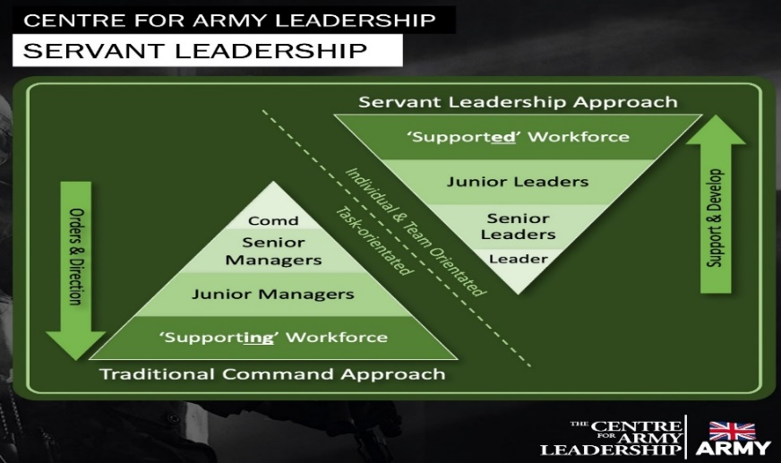
Source: Centre for Army Leadership
Do the work you were always meant to do.
My stiff shirt collar is chaffing against my neck as I rush to work (I’m late) and through the Victorian Shop Arcade that leads to our offices. Now I am at the end of the arcade, up a few steps, turn immediately right and, as I push through the door, I am greeted by my team. I am the Chief Clerk of a firm of solicitors. This is the field of work I was obviously never meant to enter, as this is part of a recurring dream I have had for many years.
Why a Chief Clerk in a firm of Solicitors? Arriving in Colchester, I still had 7 years to do in the Army (my first career) and I started to imagine that this would be the kind of work I would be doing when I retired from my army career. I thought this would be my future and I started looking into this line of work, but it was work I was not destined to do. I am sure it would have been a good job, but it was not going to get me out of bed each morning eager for work, and it certainly was not going to be another career. It was only in the last year of my military service that I made up my mind up to support people with learning disabilities.
I had fulfilled my boyhood dream of joining the Army and lived that dream for 24 years, could I have another career that would last the same amount of time and perhaps even longer? I needed to find out.
Life is short and as my wife, Joyce, often reminds me, you are a long time at work, so it is important that you are happy doing what you do. So, before it is too late for you to do the work you were always meant to do, here is what to do (if you are not already doing it):
5 Questions to ask yourself.
What is it that you are passionate about?
Do you want your work to make a difference?
What will it take to make you feel fulfilled?
What skills, experiences, knowledge, gifts and capabilities do you have?
Do you want a job or a career? Both are good but it is important for your expectations that you know so that what you decide is what you really want to do.
5 steps to take.
Volunteer to do voluntary work in your chosen field. It will give you a taster, help you to make a firm decision, and show commitment to those you may work with in the future.
Do your research about the work so you don’t go in cold. This will help you to see what you are letting yourself in for and, again, shows commitment.
Talk to people who have done something similar to what you are considering – what are the highs and the lows – so there are no surprises.
Find out what training and qualifications you will need to help you reach your goal. By doing what you can now, it will save time in the future and also will look good on your CV.
Find the right organisations that meet your values and aspirations. The work might be what you are looking for, but the organisation might not be the right fit for you.
1 Take Away
For my older readers, it is never too late to do the work you were always meant to do. A few years ago, I came across an article from one of my boyhood football heroes (David Craig) a full back for Newcastle Utd during the late 1960s and 1970s. David had been a businessman too and he had become involved in supporting people with learning disabilities in his sixties as a support worker. He described how fulfilling it was and wished he had done it earlier.
Summary
I hope these tips cover any field you might consider to be your dream job, but if you are looking to do what I loved doing for 28 years, send me a message and I will point you in the right direction, or, alternatively, you could have a look at my previous company’s website www.dosh.org and their parent organisation www.thera.co.uk
Source: Steve Raw www.leadershipintheraw.org
Watch with glittering eyes the whole world around you because the greatest secrets are hidden in the most unlikely places.” - Roald Dahl

YOUR ROUTE TO THE TOP
WORK OVERLOAD

Stop and think It’s easy to panic and launch yourself at the task without considering the most sensible course of action. A few moments’ reflection and planning pay off.

Break the situation down into chunks. Picturing the whole task makes it look terrifying; small steps are manageable.

Delegate. There may well be people around you who can help and offer expertise – take it.

Manage expectations. You may need to explain to others that the end result might be different from initial expectations. Better to bite the bullet early on and enlist help than give people a nasty surprise when you pass the point of no return.

Consider urgency and importance. The danger is to rush around doing the urgent things but ignoring the important ones. If something is both urgent and important, act. If not, prioritise.

Start small. Focus on getting some quick results, as this will give you momentum.

Develop a contingency plan. Even in the most difficult situations there are other options.

Go for the 80/20 rule. Build the stadium without the roof; write the report without the annotated footnotes.

Don’t be too hard on yourself. Having decided what to focus on, don’t worry about things you’re not going to do. Put your energies into finishing everything else to a high standard.

Talk to your team. If everybody knows what is happening, less time will be spent on unproductive action. Consider creating a war room where people know action is being taken.

Communicate to interested parties. It’s better to lead the communication of a crisis than being forced to respond to someone else’s interpretations.

Remember it will pass. Life is bigger than a wobbly project.

Learn from the situation for next time. Patterns can turn into habits. If you’re aware of what led to the situation, you can catch it before it happens again.

The Mind Gym

“Ninety – Nine per cent of failures come from people who have the habit of making excuses” George W Carver

Impact Management, by Meike Beckford

originally published 8th July 2021 in www.leadershipintheraw.org

I have recently started a new role as Head of Impact Management for the Thera Group (www.thera.co.uk), which is an exciting new role for me and the Group. A common theme from messages of congratulations from colleagues, family and friends was “don’t really know what that is or what you’ll be doing, but I’m sure you’ll be great!” Whilst I appreciated the vote of confidence, it also told me what my first priority had to be – working out what I was doing and telling everyone else what that was!

What is impact?

Simply put, impact is having an effect, or making a difference, through an activity, project or other action. It is a noticeable change. It is also the reason many of us do things, such as choosing a certain career, or volunteering for a cause, we want to make a difference for someone or something; however cheesy that may sound!

How do we know we are having an impact?

This is where impact measurement comes in – using data and information that tells us what difference we have made. That could include a range of things like the numbers of people attending an event, measures of people’s attitudes or wellbeing before and after a project, or personal stories where people reflect on their journey and the changes they have experienced. There is of course lots of good practice and research out there on the best ways to get this information, the most reliable methods and questions etc. Then there’s the question of how you collect, process and use the data to translate it into information you can understand.

What then is impact management?

Measurement is a big part of impact – you may think you are making difference by doing x, but do know that’s the case? Impact measurement allows you to be more confident in knowing what you are doing and where to focus your efforts. But you can take this further – going beyond just a retrospective ‘did it work?’ to thinking proactively about and planning for impact. We can ask:

- What impact do we want to have?
- How do we think that will happen?
- How will we know that has happened?

The first question feeds into and strengthens your strategic planning. Thinking about the end result and the wider impact that is intended to have, helps you focus on the key measures that will really make a difference. Using the 2nd and 3rd questions, you can then take your strategy from just an aspirational statement or picture of an ideal future to a considered and manageable plan to actually make it happen and check that it did. Building in measures to check whether we are having the effect we hope is also a brave thing to do – it’s easier to just focus on and celebrate the inputs – all the efforts you and your team are putting in – than to make yourself open to hearing what may be uncomfortable feedback and results if you’re not quite as great as you think you are.

So why do impact management?

If it is harder, and scarier, that continuing with business-as-usual, why make the effort? Here are my first thoughts, impact management enables us to:

- Actually, achieve our vision and mission.
- Make a real difference for people.
- Understand what works and what doesn’t.
- Be leaders and innovators in the sector and beyond.
- Challenge ourselves to improve.
- Win funding, tenders, and contracts.
- Build a positive profile.
- Create new opportunities.

Impact management is more than ‘nice to have’. If you are serious about achieving your organisational mission, you need to know whether what you’re currently doing is working. Where it is, great – share that so others can benefit; celebrate it with your teams; and use it to evidence why you should be funded/supported to do more of this great work. Where it’s not working as well as you hoped, that’s ok too – use it to learn where you can get better; involve everyone in finding new ways to understand a problem and tackle it differently; create opportunities for change and innovation.

Embedding a culture of impact management in your organisation means embedding a culture of continuous learning and improvement – you will never get it all right and there will always be more you can do. What used to work may also change as issues evolve. Embrace that and enjoy the process of learning and developing together with everyone involved in and touched by your organisation, on your shared journey to making a difference.

And my last piece of advice (based on all of 3 weeks’ experience in the role, but it’s what I have to keep reminding myself!) – start small. I have found that it’s easy to get caught up in so many exciting ideas and see the very best examples of rigorous research and well-developed impact programmes and think you need to do it all now. Start with the basics in the 3 questions I list earlier and perhaps just one measure for each of your key impact goals. You can learn and build from there.

I look forward to seeing the impact you make. Good luck!

To read more on social impact, try:

- www.goodfinance.org.uk/measuring-social-impact
- www.communityscot.org.uk/social-impact-pledge/what-social-impact/
- www.researchtoaction.org/2016/02/what-do-we-mean-by-impact/
- https://impactmanagementproject.com/
- www.inspiringimpact.org/

To learn about Thera’s impact so far, check out our Social Impact Reports, including the recently published 2019-20 report: www.thera.co.uk/investors/

Connect with me on twitter to hear more sporadic ramblings on impact: @MeikeB88

