LEADERSHIP AND WELLBEING PACK
March 2025
Established in 2006
Welcome to this month’s edition. Highlights include:
Damian Piper CBE our Resilience Coach starts this month edition with: Culture Carrier or Crasher? How Workplace Culture Shapes Success “Imagine this: It's a typical Monday morning, and as you walk into the office, the vibe is unmistakable. People are either energised and collaborating or quietly disengaged at their desks. That unspoken feeling? That’s culture in action…….”
From me: Taking the Time to Time Manage (my top 20 Time Management Tips) “Unlike talent, or money, or luck, there is one resource that is distributed to every one of us equally. We each get 24 hours a day and it is how we use those 24 hours that sets people apart. Change the way you use your time, and you change your life……”
Rebecca Alexander has exclusively written for us: ‘Coaching Skills for Leaders’ “Many leaders would like to develop their coaching skills, and for good reasons – it can foster better connections with your team, encourage people to challenge themselves, and as you develop your team’s capabilities, they will become less dependent on you…...”
BEING BETTINA’S DAD AND BEING YOUR AUTHENTIC SELF something I have previously written about my daughter Bettina who copes with a learning disability & autism. So, what have I learned from her authenticity and what it takes to be as authentic as Bettina?
Graham Belgum has two important messages from his new series of ‘Thought for the week ahead’ Integrity and Innovation.
There are lots more in this month’s edition so let’s dive in together……
Steve Raw FIoL, FCMI, GCGI
Email: stephenraw6@gmail.com
Blog: www.leadershipintheraw.org
Instagram: @stephenraw6
Twitter: @SteveRaw836
Blue Sky: https://bsky.app/profile/steveraw.bsky.social
LinkedIn: https://www.linkedin.com/in/steve-raw-72454721/
Facebook: https://www.facebook.com/steve.raw.771/

It’s not about how good you are.
It’s how Good You want to be.
Culture Carrier or Crasher? How Workplace Culture Shapes Success

Imagine this: It's a typical Monday morning, and as you walk into the office, the vibe is unmistakable. People are either energised and collaborating or quietly disengaged at their desks. That unspoken feeling? That’s culture in action.

As we approach spring—a season of renewal—it's a great time to reflect on the culture within your workplace or team. Is it thriving, or could it use a refresh? More importantly, what role do you play: are you carrying that culture forward, or unintentionally crashing it?

Workplace culture often evolves without deliberate effort, yet it influences everything—from employee engagement to organisational performance. Organisational theorist Edgar Schein highlights that culture isn't just about visible actions; it's layered, deeply rooted in shared beliefs and values. I first encountered Schein’s influential work during my MBA studies in the noughties, and it has remained a guiding framework in understanding how culture shapes organisations.

The Hidden Layers of Workplace Culture
Schein’s Organisational Culture Model breaks culture into three interconnected layers:
- Artifacts: These are the visible and tangible elements of culture—office layout, dress codes, rituals, and even the stories teams share. Think of awards ceremonies, team-building events, or symbols like company logos and branded swag. For example, a monthly "wins" meeting where successes are openly celebrated can boost morale and team cohesion.
- Espoused Values: These are the stated values and beliefs an organisation claims to uphold. They show up in mission statements, leadership behaviours, and company policies. For example, a company that values innovation might encourage open brainstorming sessions and fund experimental projects.
- Basic Assumptions: The deepest level—these are unconscious beliefs, perceptions, and feelings that truly drive behaviour. They’re often unspoken but shape everything, like trust in leadership or assumptions about work-life balance. For instance, if employees believe that working late is the only way to show commitment, that belief will influence behaviour, regardless of official policies promoting balance.

Assessing Your Culture Through Schein’s Lens
Beyond Schein’s foundational model, additional cultural elements can be assessed through these layers:
- Norms and Expectations: These reflect both artifacts (visible routines and rituals) and basic assumptions (unspoken social rules). Ask yourself: Are the informal rules in your team supportive or restrictive?
- Leadership Style: This often manifests through espoused values and artifacts. Does your leadership walk the talk? Are collaboration and innovation genuinely encouraged?
- Communication Styles: This touches on all three layers. Are there open dialogues, or is communication overly formal and hierarchical?
- Decision-Making Processes: Do decision-making practices reflect the espoused values of inclusivity and fairness? Are these processes transparent?
- Recognition and Reward Systems: How are achievements recognised? Does the system align with the organisation’s stated values, and do artifacts (like awards) reflect this?
- Diversity and Inclusion: Are inclusivity efforts visible in your artifacts (representation in leadership) and supported by espoused values?
- Physical Environment: Is the workspace designed to reflect and support your culture? Does it embody collaboration, focus, or innovation?
- Work-Life Balance and Wellbeing: Are the basic assumptions supporting a healthy balance, or is there an underlying expectation of overwork?

Is Your Culture Carrying You Forward—or Holding You Back?
The influence of culture on organisational performance is profound. Studies consistently show that high-performing cultures correlate with increased employee satisfaction, productivity, and retention. Conversely, toxic cultures are linked to higher turnover, poor morale, and reduced output.

The challenge is that culture isn’t always easy to see—until it becomes a problem. This is why regular reflection matters. Are the stories told in your workplace uplifting or draining? Do routines foster collaboration, or are they holding people back?

Can You Change Workplace Culture? Absolutely
Changing culture can be challenging, especially when deep-rooted beliefs are involved. However, deliberate interventions can make a real difference, and change doesn’t always have to be slow. Some shifts—especially those tied to routines, recognition, or leadership behaviours—can create immediate, visible impact.

Here are some strategies for refreshing your workplace culture:
- Clarify Core Values: Make sure your team understands and embodies the organisation’s core values—not just in words but in actions. Talk about how you are using the values. Values framed and on the wall are not enough. People go numb to that, if they are not seeing them lived out every day.
- Tell New Stories: Shift the narrative by celebrating small wins and sharing stories that reflect the desired culture. One team I worked with had a Teams Channel specifically for ‘Swins of the week’.
- Reinforce Positive Behaviours: Recognise those who embody the best of your culture. Public acknowledgement can inspire others. It might be clunky at first, stick with it.
- Challenge Toxic Norms: Don’t let outdated or negative behaviours persist. Speak up when norms clash with the culture you want to cultivate. You get what you tolerate.
- Empower Leaders at Every Level: Everyone, regardless of title, can lead by example. Authentic leadership often comes from those who model the desired behaviours. Leadership is a mindset as much as position on an org chart.

Are You a Culture Carrier or Crasher?
This brings us to personal responsibility. Culture isn’t just shaped by leadership—it’s influenced by everyone in the organisation. Every interaction, decision, and piece of feedback contributes to the overall environment.
So, consider:
- Are you carrying the culture forward with positive actions?
- Are you unintentionally crashing it through clumsy behaviour or negativity?
- Or, perhaps, are you deliberately challenging a negative culture that needs to shift?

Spring Forward: A Time for Cultural Refresh
As the season of renewal begins, there’s no better time to reflect on your role in shaping your team’s culture. It doesn’t always require grand gestures—small, consistent actions can create momentum for positive change.

Whether you’re leading a team, collaborating with colleagues, or just starting out in a new role, remember: culture isn’t just something you experience—it’s something you help create every day. Will you be a carrier or a crasher?

The choice, as always, is yours.

So, what story will you contribute today?

As always, I am interested in how you get on or any questions you might have.

Damian
damian@effectivechallenge.com | effective challenge podcast | LinkedIn | Instagram


Thoughts for the week ahead…. Integrity
How often in our lives does someone not do what they have committed to do?
Sometime this is because the situation has changed or is out of their control. If this happens then that person needs to bring those impacted together and let them know. Then try and come up with a plan to meet that commitment, even if delayed. Being transparent and working to find a solution means their integrity is upheld. Trust in them is retained.
However, if they knew they could not do it (or had no intention of doing it) when they made the commitment then that is an integrity issue. Those that act like this will never be trusted and those around them will always be finding work arounds to avoid them.
Bottom line, only commit to what you can do and if you no longer can, let everyone know why (humility) and work to find a way to get it done.
Source: Graham Belgum. Fortescue Zero https://zero.fortescue.com/en and Non-Exec Director for Thera South West www.thera.co.uk
Taking the Time to Time Manage
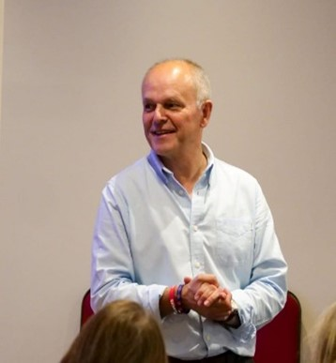
Taking the time to deliver a presentation on Time Management to Team managers.
Unlike talent, or money, or luck, there is one resource that is distributed to every one of us equally. We each get 24 hours a day and it is how we use those 24 hours that sets people apart. Change the way you use your time, and you change your life.
I love life and even though I am about to retire (and perhaps when you read this post, I will have already retired) there is so much I want to do and achieve in the time I have.
“All we have to decide is what to do with the time that is given to us”.
J.R.R. Tolkien
My 20 top tips from 50+ years’ work experience in two careers (Army & Social Care) and from 40+ years of marriage to Joyce Raw. (Joyce is my coach and mentor especially when it comes to time management).
1. Eat the Frog! What is the most challenging, but potentially rewarding task that you can do today? Don’t put it off doing it until the end of the day – you’ll waste time doing less important things and worrying about how you still must “eat the frog”. Write it down. Make it your first task of the day and then relax!
“If it is your job to eat a frog, it’s best to do it first thing in the morning.
And if it’s your job to eat two frogs, it’s best to eat the biggest one first”.
Mark Twain
2. Appointments: Call ahead to make sure people are on schedule if you have an appointment with them and if they cancel appointments with you, have alternative plans for that time slot. Cancelled Appointments? Leave them in your calendar and use it for some creative work if you don’t someone with access to your online calendar will fill it for you.
3. Commuting: Check the weather forecast at least the day before your commute so you can prepare your mode of travel and what you need to wear rather than leave it to the last minute. Organise commuting time; share rides or rehearse speeches and presentations. On my long journeys I would listen to management & leadership podcasts.
4. Turn up early: It is much better to turn up 30 minutes early for a meeting than try to get there just in time. You can always check your emails while you are waiting to go into your meeting.
5. Interruptions: Stand up when interrupted. My wife Joyce puts her finger on the word she was reading if I interrupt her. Telephone Interruptions: Do not ask open-ended questions. Unless someone leaves a voice mail, I do not get back to them. Telephone Interruptions: I have a routine that I only check my phone four times a day. People who regularly phone you will soon recognise this routine. Think before you interrupt anyone: Their time is as valuable as yours
6. Write a to-do list every day: Always write your plans in pencil. I put an exclamation mark against the jobs I must do today. I then codify them with a ‘Significance Factor’ how important & urgent will this task be for my organisation and our stakeholders? Score each ‘to do task’ out of five with five being the most significant.
7. “Take something with you!” In the ‘Raw’ family, if you are going upstairs, there is an expectation that you will take something with you e.g. after weekly shop, Joyce may have put some toiletries on the stairs for our bathroom. Woe betides you, if you ignore them when you are going upstairs for another reason.
8. Planning: Spend ten minutes at the beginning of each day, planning. At the end of the day review your success by asking: ‘What have I done today to move towards my goals?’
9. Clock watching: If you work in an office, position a clock in your office so it is visible to you and to visitors.
10. Tactics: Do not sit down if you are followed into your office. Keep all chance meetings short by standing as it will then be easier to get away.
11. Pressing: I have two weeks’ worth of kit pressed so I am never caught out. It means I can crack on with urgent work early in the morning or if I am back late because of a long journey.
12. Recognising when you are at your most productive: We all have our peak times. Do you know yours? My peak is early in the morning, so that is when I complete my most important, urgent, and complex tasks.
13. Have a purpose: If it is not going to make a difference to your job, the people you support, or your organisation then don’t do it! Time management is often about eliminating waste in your day.
14. Sweat the small stuff: Identify a potential problem, issue, or concern when it is small and deal with it. If you think you haven’t got the time to deal with it now, you will have to find the time when it has become big and awry.
Related: The 9th Leadership Lesson I learned – Sweat the Small Stuff – Leadership in the Raw
15. Go for a walk: Go for a walk when you have a difficult problem to resolve. This gives the time to reflect you will not get sitting at your desk. It will get things into perspective, I promise.
16 Starting your day Do everything with intent. If you endeavour to do something, this indicates intent. First 30 minutes of the day, do stuff for you, not others so you are working to your agenda not someone else's. 5 before 11: I write down five jobs to do before 11am. The compound effect! See how many jobs you will have accumulated over a week, a month!
17. The way you begin a call affects the way you end it: You can start a phone call by saying "Hi Susan, I only have 5 minutes to talk, but I wanted to let you know that......”
18. For each work task, set deadline for completion. So, you don’t drift or allow yourself to be distracted. I find setting a time to complete a task helps keep me focused, my competitive bent makes me try and beat the deadline. I set one hour to prepare this Time Management Presentation.
19. Do what you can today, that will save you time tomorrow. I picked this one up as a young soldier from an officer I worked for. When I said I would do the task the next day, he said you don’t not know what you may face in the morning, if you do it now, it will save you time tomorrow.
20. Work out your Boss timetable. Knowing when your boss is at their most receptive to giving you the response you need, I found it helpful, knowing what her timetable was. I had worked for her, over 20 years and had worked out she checked her emails at 0830hrs, so that was the time I would send my message so it would come in at the top of her inbox.
And a bonus. My favourite Time Management presentation
How to gain control of your free time?
https://www.ted.com/talks/laura_vanderkam_how_to_gain_control_of_your_free_time
Laura Vanderkam
Source: Steve Raw www.leadershipintheraw.org

“The power of accurate observation is commonly called cynicism by those who have not got it”
George Bernard Shaw



Coaching Skills for Leaders
Many leaders would like to develop their coaching skills, and for good reasons – it can foster better connections with your team, encourage people to challenge themselves, and as you develop your team’s capabilities, they will become less dependent on you.
And contrary to many people’s beliefs, coaching doesn’t have to be that difficult or take that long. One particular coach - Michael Bungay Stanier, or MBS as he’s known - has been working to demystify the coaching process and make it accessible to everyone. His book The Coaching Habit is a great place to start. Here’s an overview of the key points:
Tame your advice monster. MBS is spot on when he points out that giving advice is often our default mode as leaders. But that’s a bit like giving someone a fish rather than teaching them how to fish. Instead, try staying curious a little bit longer and rushing to advice-giving a bit more slowly.
You can coach someone in 10 minutes or less.
Coaching doesn’t have to be a big, formal, ‘event’. Try to make it a regular and informal – 10 minutes here or there can have a big impact, and is easier to fit in.
Check that the other person wants to be coached.
This isn’t in the book, but I think it’s key. A simple “Would it be helpful to talk about X?”, or “I notice you seem concerned/excited about Y, would now be a good time to talk about it?” will work fine. Respect the other person’s response.
Know how to ask questions. MBS gives a great masterclass in his book – here are just a few:
Pick a good question (see below for ideas)
- Ask it.
- Just ask it once
- Don’t add other questions.
- Once you’ve asked the question, shut up, and genuinely listen to the answer.
- Get comfortable with silence.
- Respond appropriately, perhaps with another question, or a simple acknowledgement.
And now to the actual questions. It’s easy to get hung up on thinking of the perfect question, framed in exactly the right way. Yet this often serves us more than the person we’re speaking to. When I’m coaching, I often find that that the shortest questions produce the biggest breakthroughs. MBS has this 7-step formula:

The Kickstart Question – What’s on your mind?
This helps start any conversation in a way that’s both focused and open, while keeping it natural
The AWE question - And What Else?
AWE stops you jumping in with advice and it gives the other person permission to dive deeper into what’s really on their mind (it’s rarely the first thing they mention). Use AWE throughout the conversation.
The Focus Question – What’s the REAL challenge here for you?
This helps the other person get to the heart of their challenge and stops them circling.
The Foundation Question – What do you want?
Another question that gets to the heart of the challenge, while generating positivity about a possible solution.
The Lazy Question – How can I help?
This asks the other person to think about what they need, and whether and how you can help them. It saves you some effort and stops you from offering unwanted suggestions.
The Strategic Question - If you’re saying yes to this, what are you saying no to?
Helps you and the other person work out what’s feasible given current resources and demands.
The Learning Question – What was most useful to you?
This can feel like you’re looking for compliments, but it genuinely helps the other person to extract and summarise their key takeaways from your conversation.
Rebecca Alexander
Executive Coach rebecca@coaching-studio.co.uk
Thought for the week ahead …. Innovation
As you ponder the week ahead, I am sure you will start with many unresolved problems.
Here is where innovation comes in. Ask your team and wider colleagues (maybe even your suppliers and customers) to help you find solutions to your problems. Do not limit them in their thinking as often an ‘out of the box’ idea can be a game changer.
Then come together and share the ideas, discuss their pros and cons (cost, time, quality (performance/value)) and agree those that will most likely become your winners.
Then firm these ideas up into robust solutions so that you have a high level of certainty they will succeed (you will never normally get to a 100%).
Now get them approved (if required) and implement them quickly and reward (celebrate) those who came up with them.
Source: Graham Belgum Fortescue Zero https://zero.fortescue.com/en and Non-Exec Director for Thera South West www.thera.co.uk
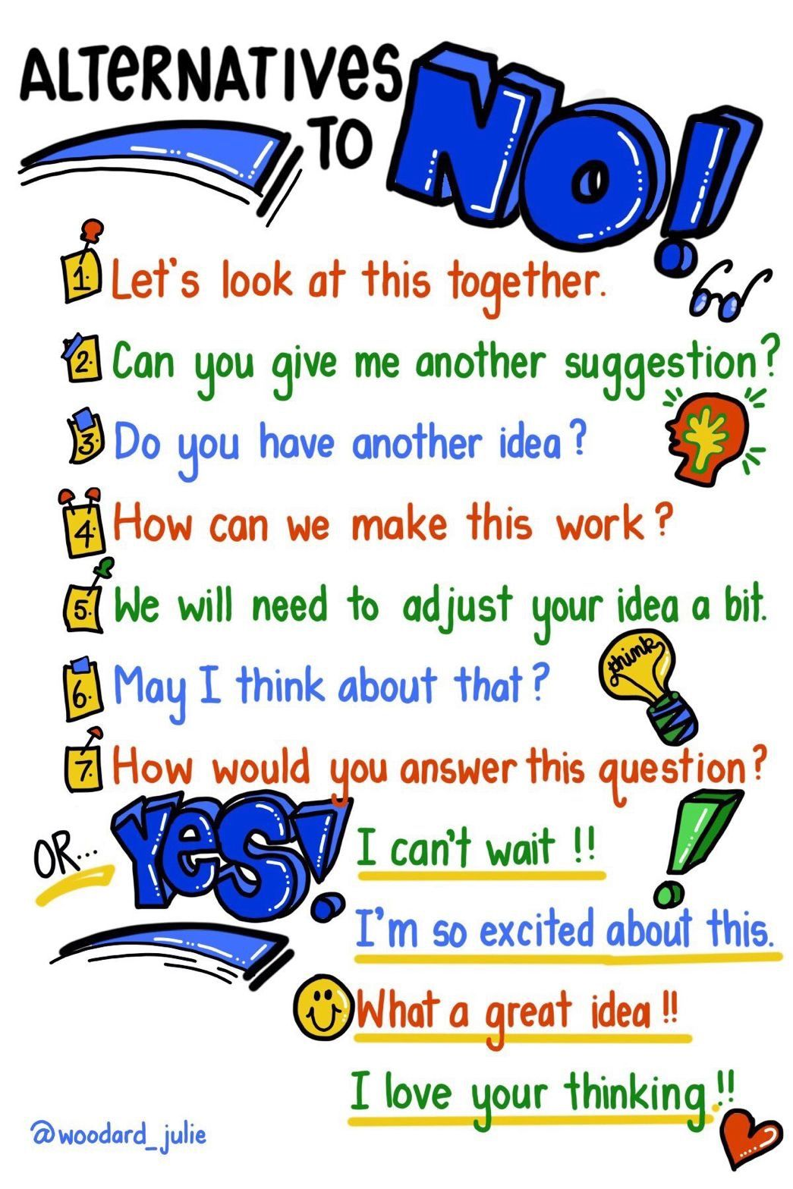

KNOWING WHEN YOU’RE WRONG
- Take a step back. Do you feel defensive? Emotions will cloud your judgement.
- Explain your argument in three sentences to an impartial person.
- Does it sound reasonable?
- Look for the common dominator. If you’re always right and constantly disagreeing with people, maybe it’s you.
- Don’t selectively seek out facts to back your argument. Try to see the other point of view.
- Swallow your pride. Say you’re sorry and move on, with the respect of your colleagues. No one’s always right
Source: Modern Management

BEING BETTINA’S DAD AND BEING YOUR AUTHENTIC SELF

It is a Sunday evening, and I am just coming towards the end of another terrific weekend. I love my job and I truly believe it is a great honour to work for my organisation and while I do some work at the weekends (usually before my family wake) I do see the weekend as ‘me’ time. My time is when I get to spend lots of time with my family, walking with them, listening to them, and having lots of laughter together. Other than running, I have no real interest in being on my own.
However, if there is one thing I like to insist on over a weekend, it is that I get to be the one who looks after our daughter Bettina when we are out. We actually compete within our family on who looks after her as she is such fun to be with. This weekend we were together on Saturday and Sunday shopping. I love her company and Bettina loves being with the guy who buys her anything her heart desires!
There was a time in Bettina’s early years, because of her Autism and her coming to terms with that condition, when she could not cope with a cuddle unless you were standing up. More often than not she pushed my face away, she avoided eye contact (unless it was on her terms) and there were many sounds she could not cope with (and still can’t). With her courage and her family’s love she has progressed and evolved into the wonderful woman she is today. There is one description of Bettina though that has not changed and that she is ‘authentic’.
Bettina has always been true to herself – she doesn’t compromise on being authentic. Regular readers of my blog series ‘Being Bettina’s Dad’ will know that I have learned so much from how she acts and moves within her world. To me she is unique, I have never met anybody like her, and I know I never will.
So, what have I learned from her authenticity and what it takes to be as authentic as Bettina?
- Bettina’s nature is consistent, and she remains true to her beliefs no matter what situation she finds herself in.
- Bettina builds honest relationships with both her family and also those who support her. Bettina is straightforward and always deals in an honest way with the people who are involved in her life.
- Bettina is always open with people who are significant in her life. Bettina does not have hidden agendas and, like her big sister Jennifer, what you see is what you get.
- Bettina knows and recognises her fears and anxieties and what coping mechanisms she needs to adopt (and does adopt)
- Bettina always does the right thing for the people who she associates with and who come into contact with her on a day-to-day basis.
“Authenticity requires a certain measure of vulnerability, transparency, and integrity.” Janet
Louise Stephenson
The roots of authentic leadership come from ancient Greek philosophy that focuses on the development of core, or cardinal, virtues. These virtues are Prudence (fair-mindedness, wisdom, seeing all possible courses of action), Temperance (being emotionally balanced and in control), Justice (being fair in dealings with others), and Fortitude (courage to do the right thing).
Becoming an authentic leader is not easy. It takes a great deal of self-reflection and always having the courage to do the right thing. Like Bettina it involves a degree of selflessness.
” Authenticity is more than speaking; Authenticity is also about doing. Every decision we make says something about who we are.” Simon Sinek
So, my 6 take aways from Bettina on becoming an Authentic Leader:
- Know who you are and what is important to you.
- Always be true to yourself (no matter what the current trend or fashion is)
- Don’t hide your fears and anxieties and ask for help when you need it.
- Be consistent in what you believe in and what you stand for
- Through your example and role modelling, share with others what it means to be authentic.
- Be optimistic (Sir Ernest Shackleton the polar explorer said being optimistic is true moral courage).
A word of caution though, you can be a little too authentic! One area of Bettina’s life is that she loves slap stick humour, so if someone slips on a banana skin, she thinks they are doing this to amuse her. In Café Nero’s the other day a smart businessman slid on the slippery floor and cried out “whoa, “whoa” Bettina burst out laughing. Her family put their fingers to their lips to signal not to laugh out loud, but Bettina just looked at us with a facial expression of “why”? I am just being authentic.
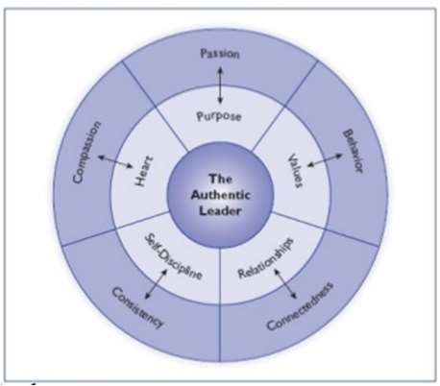
‘Bill George’s Authentic Leadership Model ‘- Five Characteristics of Authentic Leadership http://sites.psu.edu/leadership/2017/04/09/15415/
“I had no idea that being your authentic self could make me as rich as I’ve become. If I had, I’d have done it a lot earlier.” Oprah Winfrey
Source: Steve Raw www.leadershipintheraw.org
You make life more difficult for yourself when you take upon you the responsibility to think for others. - Jerry Corstens
YOUR ROUTE TO THE TOP
HANDLE TRICKY PEOPLE
Get to the heart. Whether it’s a colleague, client or boss, it’s better to try to understand tricky people than to avoid them. Work out how they see things and then find a way to work comfortably with them.
Control the control freak. If your boss is the anxious type, pre-empt his concerns. To stop him jumping in as your finger reaches for the send button, share your ideas upfront.
Don’t get dumped on. If your manager tends to deliver ‘top priority’ tasks for ‘urgent’ projects and then disappear, help her to focus. Ask her to describe her ideal result: what, when, and how does she want it? By forcing her to think it through, you’ll avoid unreasonable last-minute changes.
Silence the sceptic. When presenting the new talent-management plan, ask questions to understand what makes the doubters tick. Listen carefully. Identify the root of their problem and you can address their real concerns.
Help shy people shine. A silent figure in the team meeting may be confident on a 1-1 basis. If they’re brimming with ideas but can’t articulate in a group setting, why not brainstorm instead? Find a way to communicate that works for them.
Calm the stress cadet. If your colleague is in regular meltdown, concentrate her attention on what can be done here and now. Battling a presentation, pitch and project work? Small steps will lead to significant results.
Resist charmers. Don’t get taken in by empty, eloquent flair. Ask tough questions to keep them on track. Try: ‘What does that mean in practice?’ Help them distinguish between dreams and reality and you’ll get the best of both.
Look again. Whatever behaviour we’re up against, we must be aware of our own impact. Feeling brave? Write a character profile of yourself – which tactics would work for you?
The Mind Gym: Relationships

TEN WAYS TO…… MAXIMISE YOUR IMPACT
1. Know your goals
2. Trust your strengths
3. Fine-tune your talent radar
4. Build a special culture
5. Network
6. Work the web like a pro
7. Market shrewdly
8. Reward success
9. Dare to be different….
10. …. but be realistic.
Live for the sensation of life, not for the story you tell about your life”.
Philosopher John Gray

TEN WAYS TO….BE INDISPENSABLE
- Show commitment – go beyond your basic duties.
- Publicise your achievements.
- Figure out where the business is going….
- ….and make yourself an essential part of it.
- Take the initiative.
- Ask for feedback.
- Pay attention. Anticipate what else your company needs.
- Be versatile.
- Network, both inside and outside the company
- Be likeable.
Source: Modern Management magazine.

“If you don’t like the road, you’re walking start paving another one”.
Dolly Parton
HOW TO COMMAND PERSONAL PRESENCE AND GRAVITAS AT WORK
Remember, it’s a gift from followers linked to the role. Charisma or presence is not so much about what qualities you have but about what other people think you have. Charisma originally defined as a gift from God has been shown in research to be more about a gift from followers – a gift that often comes with senior roles.
Be comfortable, be authentic. It’s true to say that charismatic leaders are often seen to be different from the norm, perhaps slightly unconventional in some way. There are workshops available that will teach you how be more charismatic, sometimes involving wearing a new hat, some odd socks, anything that makes you seem unconventional. But these are best avoided. What’s most important is to be clear and confident about your own identity, comfortable in your own skin and with your own sense of self.
Be personal, switch on the charm. Effective leaders appear to have a very high level of social awareness. They can both read a room and work it. They can sense individual moods and changes in moods, so in an event of 100 plus people, they make it feel as if they are only talking to you; they’ll be able to move around a room making everyone feel they’ve had particular attention. Charm, like charisma, can be switched on – it’s about paying attention to others and making them feel highly valued by someone with perceived personal or positional power.
Paint a picture of success that is personally desirable. Charismatic leaders make people believe they can achieve more and give people the motivation to want to achieve more. That clarity of vision and ability to make the future look engaging and attractive is all-important in improving performance and steering organisations through periods of change or budget cuts.
Source: Dr Steve Kempster, director of the Lancaster Leadership Centre, Lancaster University Management School, www.lums.lancs.ac.uk and read in my Edge Magazine www.i-l-m.com

CRASH COURSE – WORK PAST 60
There was a time when you expected to retire early, but now it looks as if you are going to be working into your late 60s. So how are you going to keep on top of your game and avoid being put out to grass?
Keep fit. Your job may not involve hauling bricks but being physically fit pays dividends: it can help you avoid health problems, keep a psychological edge, stay alert and give you more energy, as well as influence how people think of you. ‘Management can be pretty sedentary, and you need to make a positive effort to keep yourself in shape,’ says Cary Cooper, professor of organisational psychology at Lancaster University Management School.
Never stop learning. Organisations have a tendency to give up on training people beyond their fifth decade says Chris Brooks, policy adviser at Age UK ‘Identify the skills you need now and, in the future, and make it clear that you expect to continue your personal development.’ Cognitive stimulation helps keep you mentally agile, says Cooper. ‘Go to conferences, meet people and show others that you are in learning mode and haven’t given up.’
Present yourself. Out-of-date clothes and grooming send people a message that you are out of touch. ‘Invest in haircut and smart clothes, and above all take care that you don’t look dowdy,’ says Peter Shaw, executive coach at Praesta Partners.
Show some attitude. Make sure your demeanour is positive and be open to innovation.
Take the initiative and show others you are still a force to be reckoned with, says Shaw.
‘Offer to chair that meeting, take responsibility for a project, offer to do things,’ he says.
“The moment you are on the back foot you’re dead.’
Play to your strengths. You may struggle to compete with the young turks on every front, but you have knowledge and experience that are of great value to your organisation. ‘Mentoring employees can be key to retaining talent, and will earn you credibility,’ says Cooper.
Think flexible. See if you can negotiate more flexible hours and even work some of the time at home. ‘Pace yourself,’ says Cooper ‘Prioritise what matters and don’t consistently work long hours.’
Tweet. Technology is moving fast and it’s essential to stay up to date with developments such as social media, even if you’re aware of their limitations.
Know your rights. Perception and performance are most important in protecting your employability but know your legal position. ‘Under the Age Discrimination Act, employers can’t treat you differently because of your age, for example, denying you training.’ Says Brooks. You can’t be made redundant because of age, so it’s important you put up a good case on other criteria.
Source Alexander Garrett in MT Management Today

