LEADERSHIP AND WELLBEING PACK
May 2025
Established in 2006
Welcome to this month’s edition. Highlights include:
Damian Piper CBE our Resilience Coach starts this month edition with: The Brutiful Truth: Finding Beauty in the Brutal Honesty of Feedback “Feedback. The very word can elicit a range of reactions, from a nervous flutter to a defensive stance. We often approach it with trepidation, as givers and receivers. It feels inherently… well, brutal………”
From me: Ready for the Next Challenge (Rocking Retirement). What prompted me to write this article was an email I received from a valued former colleague: “you need to tell me all about retirement - It is something I am considering!” My motivation for retirement was Bettina aka ‘B,’ having a seizure and I was not there to help ‘B’ and support Joyce, my wife. As much as I enjoyed working with my military colleagues and being part of something special, I wanted to be there for Bettina’s next seizure……
From my Being Bettina’s Dad series: Building a Relationship For several years Bettina and I had lots of fun and adventures, at an outdoor pursuits centre in Wales. It was a terrific opportunity to bond and build trust on what was already a close relationship. This is what we did and how we inspired someone to do something similar with their daughter ……
Graham Belgum has two important messages from his excellent series of ‘Thought for the week ahead’ Purpose and Do not be a Victim. I highly recommend Graham’s weekly posts on LinkedIn.
There are lots more in this month’s edition so let’s dive in together……
Steve Raw FIoL, FCMI, GCGI
Email: stephenraw6@gmail.com
Blog: www.leadershipintheraw.org
Instagram: @stephenraw6
Twitter: @SteveRaw836
Blue Sky: https://bsky.app/profile/steveraw.bsky.social
LinkedIn: https://www.linkedin.com/in/steve-raw-72454721/
Facebook: https://www.facebook.com/steve.raw.771/

It’s not about how good you are.
It’s how Good You want to be.

The Brutiful Truth: Finding Beauty in the Brutal Honesty of Feedback
Feedback. The very word can elicit a range of reactions, from a nervous flutter to a defensive stance. We often approach it with trepidation, as givers and receivers. It feels inherently… well, brutal. It can expose shortcomings, highlight missteps, and challenge our self-perceptions. Yet, within this potentially uncomfortable exchange lies a profound beauty – the opportunity for growth and positive change. This is the realm of the ‘brutiful’ truth: the sometimes harsh reality of feedback that, when delivered and received with care, blossoms into something truly valuable.
Why is feedback so often perceived as brutal? Perhaps it’s the inherent vulnerability. To offer it risks hurt feelings and damaged relationships. To receive it is to confront our imperfections. This vulnerability is amplified by clumsy delivery. Feedback given without empathy or specific examples can feel like a blunt instrument. A rushed comment about a presentation being “a bit rubbish” is brutal without beauty; it wounds without offering improvement.
The beauty emerges when feedback is approached with intention and skill. It’s about recognising the value in helping someone grow, even if the message requires directness. Think of a sculptor’s chisel – seemingly harsh actions revealing a beautiful form. Similarly, well-crafted feedback, though pointing out areas for refinement, is essential for shaping our skills and potential. It helps us see blind spots and identify pathways to excellence.
Empathy is paramount. We rarely know the full picture of what someone else is experiencing. Remember you're communicating with another human, with their own feelings and sensitivities. Frame feedback with positive intent, focusing on behaviour or output, not personal attacks. Begin by acknowledging their efforts and strengths to create a more receptive environment for constructive criticism. For instance, instead of "you don't listen," try "in team meetings, it could be helpful to hear others' opinions before offering your own. This ensures everyone feels heard and we gain diverse insights." While not always seamless (we've likely all experienced the clumsy 'sandwich technique'), this approach highlights the importance of balancing 'brutal' honesty with supportive framing.
Timing and context are crucial. Delivering critical feedback publicly or when someone is stressed is counterproductive. Choose a private setting and a receptive time. Ensure the feedback is relevant, timely and coming from a place of growth not point scoring. Raking over old mistakes rarely helps, in fact it is more likely to breed resentment not progress.
Receiving feedback, while challenging, is equally vital. It requires a growth mindset, seeing criticism as a potential input to learning, not a personal failing. Our initial reaction might be defensiveness. However, by actively listening, asking clarifying questions, and favouring reflection over immediate responses, we can extract valuable insights. Even with imperfect delivery, focus on the content and its potential merit. I am a strong believer most feedback is opinion not fact. So seeing it as such means we get to use our judgment about whether to act on it or not.
Long term, the ‘brutal’ honesty of well-intentioned feedback blossoms beautifully. It fosters a culture of continuous improvement, empowering individuals and teams to learn and strive for excellence. It builds trust, as people recognise feedback is given with their best interests at heart. It cultivates self-awareness, helping us see ourselves and our work objectively. This journey of reflection and positive change is the inherent beauty within the sometimes uncomfortable truth of feedback.
So, let us embrace the ‘brutiful’ nature of feedback. Let us strive to give it with clarity, empathy, and a genuine desire to help others grow. And let us learn to receive it with an open mind, recognising its potential to shape us. For within that sometimes-brutal honesty lie the seeds of true and lasting beauty.
As always I'm interested in any thoughts, comments or observations you might have.
Damian
Damian Piper CBE
Performance and Resilience Coach
✆ +44 7837 648035
🎧Effective Challenge Podcast
🌍 www.effectivechallenge.com
LinkedIn | Instagram
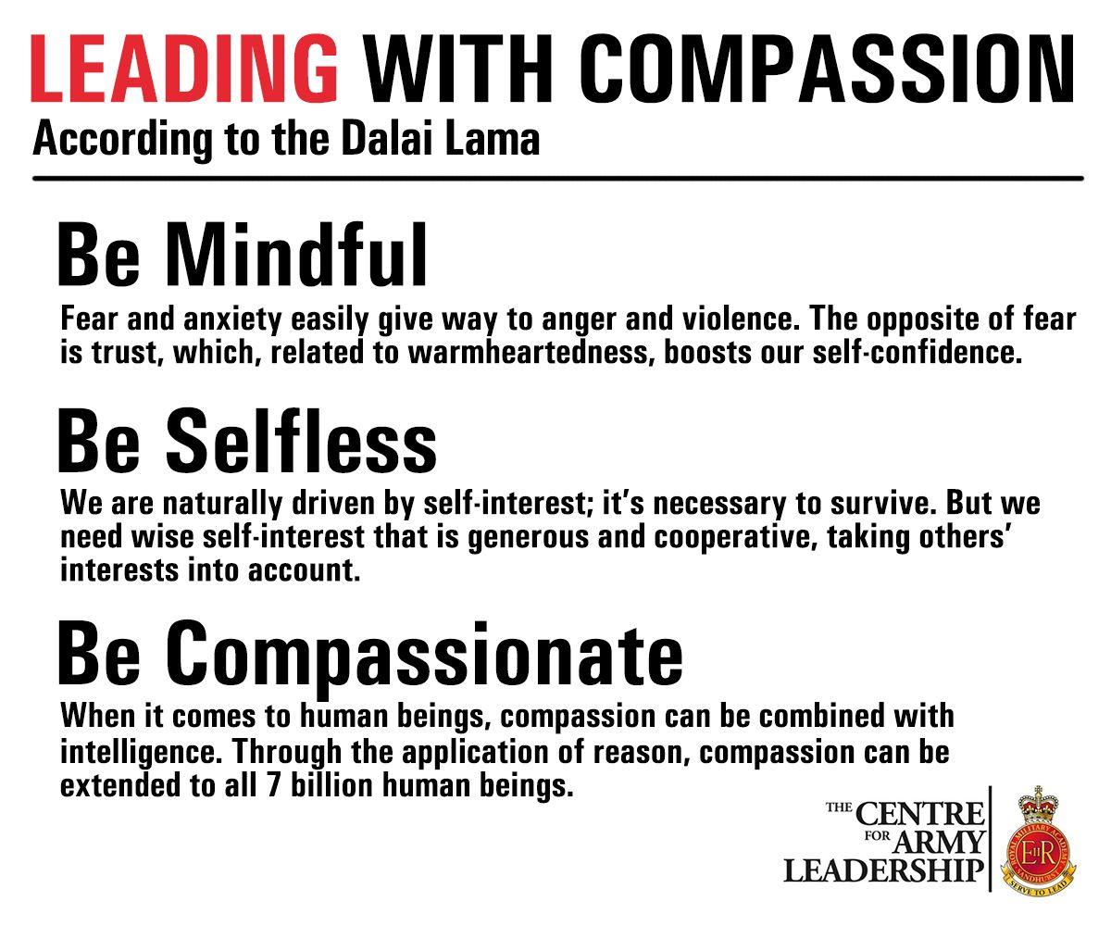
Ready for the Next Challenge (Rocking Retirement).
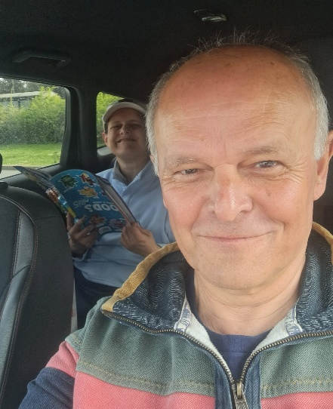
Retirement means more time with Bettina.
“Well, the day has finally come, Today I left my post with HQ 16 Air Assault Brigade Combat Team and formally retired. It has been a super experience.
A 24-year career with the Army followed by a second career in social care, supporting adults with a learning disability which lasted for 28 years. The highlight was 15 years as the Managing Director of Dosh (Financial Advocacy) Ltd www.dosh.org
Last year I had the opportunity of returning to the Army where I got to work with some amazing people. I am one lucky chap.
Picture HQ 16 Air Assault Brigade Combat Team. From work coffee mug to gardening coffee mug with Joyce (my wife, coach, and mentor).” (LinkedIn 28 February 2025).

What prompted me to write this article was an email I received from a valued former colleague: “you need to tell me all about retirement - It is something I am considering! “
My motivation for retirement was Bettina aka ‘B,’ having a seizure and I was not there to help ‘B’ and support Joyce, my wife. As much as I enjoyed working with my military colleagues and being part of something special, I wanted to be there for Bettina’s next seizure.
What Retirement looks like for me, or one thing leads to another?
- Stepping up and taking some of the load from Joyce with our caring responsibilities for Bettina and the housework. It is super important to me that Joyce feels the benefits of retirement too. (My retirement present from Joyce is a new hoover).
- Running 4 x sessions a week. My long-term goal is to be the fastest 70-year-old in Colchester over 5KM.
- Writing articles on www.leadershipintheraw.org weekly leadership & wellbeing newsletters and a monthly leadership publication which I share with my network, and on social media platforms (which Joyce regularly tells me I spend far too much time on!).
- Weekly day out with Joyce, tomorrow is Frinton on sea (Essex, UK).

a post-retirement trip to Frinton on Sea (Essex UK)
- “Gregging it” is now a thing! Having a Breakfast Bap and a coffee at Greggs. It happens on a Friday morning before Joyce and me do the weekly food shop.
Related: https://leadershipintheraw.org/2024/06/14/one-thing-led-to-another/
Still Contributing and Making a Difference
Retiring does not mean you need to give up ‘work.’ I have found you can still have influence and can still contribute:
- Coaching and Mentoring. I feel honoured to be asked to coach and or mentor several former colleagues. This is something I do monthly. It is an opportunity to support people who went the extra mile for me during my careers.
- Sharing knowledge and experiences I enjoy writing articles about Leadership and the lessons in life I have learned from my youngest daughter Bettina (‘Being Bettina’s Dad series) on my blog.
- Having a social media presence. This involvement is on a wide range of social media platforms, it enables me to maintain relationships with my previous professional networks, opportunities to promote the organisations I worked for so more people know about the difference they make and keep up to date with important topics I am interested in within Social Care, Defence and Leadership.
- Contributing and making a difference. Recently I was invited to meet local authority commissioners. They are planning to introduce a new day service for people with disabilities. I was able to contribute with my experiences as both a parent carer and my previous involvement in ‘community support’ for people with a learning disability. I was flattered to be asked.

Related: https://leadershipintheraw.org/2024/06/14/one-thing-led-to-another/
My top five retirement take aways.
- Prepare and Plan not just for now but in the future. I went into retirement with a plan that has aims and objectives. I also set five weekly objectives I want to achieve by the end of the week. They keep me focused and I enjoy the sense of achievement when I have met those priorities.
Related: https://leadershipintheraw.org/2024/12/20/setting-goals-objectives-commitments/
- Routines and Rituals. What a routine means to me? It stops me from going into ‘free fall’ (feeling that I do not have control) and it stops me from drifting aimlessly throughout my day. How often do we say there are not enough hours in the day to get stuff done? Over time our routines refine and improve our life efficiencies.
More on this take away on: https://leadershipintheraw.org/2024/10/27/the-importance-of-routine/ Set new rituals, did I mention ‘Gregging It? And on the 28th of each month Joyce and I have a ‘date lunch’ to celebrate retirement, we call it ‘Endex’.
- Eliminate waste. Now is a suitable time to self-audit. Over time you will have built up a lot of stuff in your home that you no longer need or use. With the additional free time, this is an opportunity to ‘get rid.’ The sense of freedom this feels is worth the effort.
- Fit and A Healthy Diet Maintaining your fitness and health could be the best investment you can make for yourself and those who are significant in your life. It will help you be more and do more. It is never too late to start.
- A youthful mindset My father and his generation felt they should fit a societal norm for older people whether it was their outlook on life or even how they dressed. This is no longer the case, you can continue to stay relevant whether you have retired or not. My mantras continue to be ‘look smart – feel smart’ & ‘look the part – feel the part.’ So yes, I am going to continue to buy my clothes from ‘Fatface’ and ‘Crew Clothing.’
And if you are not ready for retirement yet and instead you wish to change careers as I did from the Army to Social Care then my personal tips may help you too: https://leadershipintheraw.org/2018/07/20/transitioning-from-one-career-or-job-to-another/
Source: Steve Raw www.leadershipintheraw.org
Thoughts for the week ahead……. Purpose
I have the privilege to mentor some amazing people. The one question they ask frequently is what is the purpose of life.
I answer it with the following four Ps:
Professionally: To make the best use of all your abilities (gifts); be it to lead (support) others to exceed their own expectations or to protect/create new things (innovations) that improve the lives of others. There are many more but I hope you get the picture.
Personally:
To take care of your own health and well being so you are best placed physically and mentally to face the challenges life will throw at you.
To explore and learn as much as you can about the world we live in (digitally and physically). To appreciate and value all that diversity and find ways to protect and support it so future generations can enjoy it to. If we all did just one thing to help, imagine what we could do collectively.
Publicly: To care for one another (especially your family and friends). To be kind and thoughtful. If we all just helped one person each week imagine what we could do collectively.
Posterity: To accomplish things over your lifetime that build up to a lasting legacy (sum of the other three Ps). Many small things done frequently add up!
We must make the most of this life everyday for none of us know how long or short that life will be.
Source: Graham Belgum. Fortescue Zero https://zero.fortescue.com/en and Non-Exec Director for Thera South West www.thera.co.uk
"The beautiful thing about learning is that nobody can take it away from you." – B.B. King
Problem Solving - McKinsey v The Obvious
Time To Read: 42 Seconds
Dear Steve
Problem Solving - McKinsey v The Obvious
McKinsey
1. Define the problem
2. Structure the Problem
3. Prioritize Issues
4. Develop a Work Plan
5. Conduct Analysis
6. Synthesize Findings
7. Develop Recommendations
8. Communicate Results
Source : https://www.linkedin.com/in/timvipond
The Obvious
1. Define the problem
Its people – every single problem in every organisation is always a personal/people issue, often dressed up as something else entirely.
2. The Solution
The Holy Grail of Leadership – ensure that all your people actively choose to do what you really need them to do, and they love doing so. Get the people sorted, focused and above all, happy, and your success will be inevitable.
3. Save a Fortune in Time, Money and Sanity.
For a Copy of Naked Leader’s 32 Real Reasons People Do What They Do – Or Don’t Do email me davidultra@nakedleader.com
David (David Taylor @nakedleader across all social media)

The world exists as you perceive it. It is not what you see; it is how you see it. It is not what you hear, but how you hear it.
It is not what you feel, but how you feel it.
Rumi
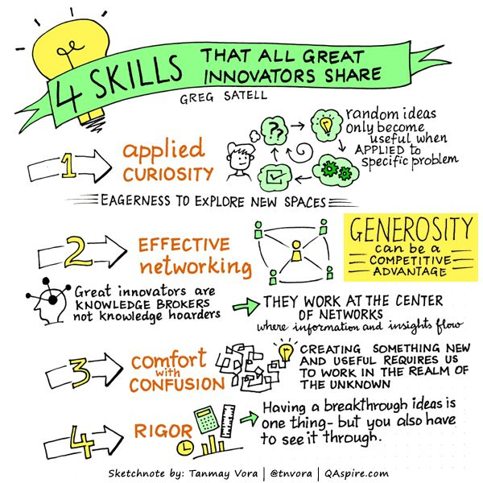

INHALE THE FUTURE
EXHALE THE PAST
Thoughts for the week ahead… Do not be a victim
Whatever job you do there are things in your control and things outside your control.
The victim will use the things they cannot control as an excuse for not being able to do their job. A blame culture creeps in.
However, in reality there is much that is outside your control that you can influence.
First you must make sure what is in your control is being focussed on (others will be reluctant to support you if you are not delivering on what is in your control). Then to be clear on what the impact is of what is outside your control.
You can then bring together those people (often senior leaders) who own things outside your control to explain this impact and secure their support (influence their decision making).
Critical to this is data (facts) - objective not subjective. Do your homework and present it with simplicity and clarity so it is easily understood. Break it down task by task/function by function.
Sometimes it takes an impact (delay, cost overrrun, shortfall in performance etc) to occur for the direction to change (busy complex businesses have lots going on). The challenge is to anticipate this and have options/mitigations to recover/minimise.
A victim will claim they are not empowered but in reality there is nothing stopping any of us raising an issue and asking for help; this in itself is empowering. But it must be done constructively and frequently until understood. Furthermore, if the impact is accepted don’t dwell on the past, focus on the future.

Source: Graham Belgum. Fortescue Zero https://zero.fortescue.com/en and Non-Exec Director for Thera South West www.thera.co.uk
“Don’t wait for everything to be perfect before you decide to enjoy your life”
Joyce Meyer
DEAL WITH CRITICISM
Ask for it. Avoid an ambush by having regular performance catchups with your manager. The truth may hurt, but the sooner you hear it, the sooner you can fix it.
Keep calm and quiet. Don’t interrupt critics with excuses (you’ll look defensive) and don’t glower (you could stop them sharing a crucial insight). Instead, be neutral and encouraging and focus on hearing and memorising everything they say.
Reframe. See criticism as proof the other person cares. Why else would he spend time and energy telling you how to improve?
Clarify. The more specific criticism is, the more helpful it is. If you don’t agree or understand, delve deeper with questions. Find out exactly what you did and how it caused a problem, then summarise back to show you’ve taken it all in.
Pick your battles. Criticism is rarely groundless but often exaggerated. From the hyperbolic overview (‘your client meetings are never successful’), select the elements you have the power to change (‘you’re often unprepared’).
Say thank you. Welcoming feedback not only means you’ll receive more (and so improve faster) but your popularity will be boosted. It shows confidence, dedication, and grace, too.
Ask critics for advice. If you can stomach the home truths, turning your critic into your coach will fend off future attacks.
Switch on your filter. If a critic’s comments seem irrational or emotional, ignore them. You are not a punch bag
Bounce back. Spend time with someone who thinks you’re great, whether it’s an old client, colleague, or adoring partner.
Learn. How will you handle criticism next time? Write down three things you have learnt. Remember them. Move on.
The Mind Gym. Relationships is published by Little, Brown
‘A good scare is worth more than good advice.’
Horace, Roman poet
THREE WAYS TO ADD VALUE
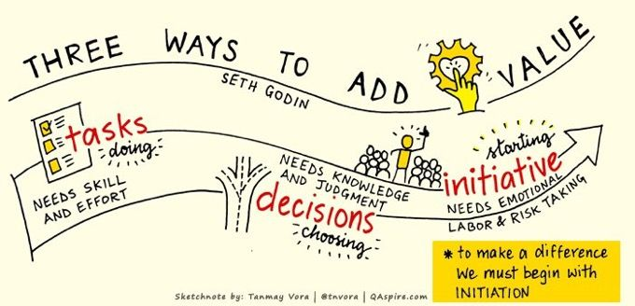

Out With The Old – In With The You
Time To Read: 75 Seconds
Dear Steve
Out With The Old – In With The You
They told you change had to be endless
They told you leadership had to be complicated.
They told you that you weren’t ready — because they needed you to believe it.
The truth?
You already have everything you need inside your organisation, and inside yourself.
The good news - there is an alternative to endless change, fluffy coaching, and dependency-driven consulting:
You
Inside your people, right now, have everything you need to achieve anything you want.
What’s missing isn’t capability – it’s the ‘how’ – and that’s not your fault. Traditional consultancy thrives on keeping you dependent, confused, and in the dark. Enough. It’s time for impact over advisory, simplicity over complexity, and freedom over external control.
The future belongs to those who back themselves.
Out with the old ways – in with the only way that truly works: you.
David
@nakedleader across all social media

Being Bettina’s Dad – Building a Relationship
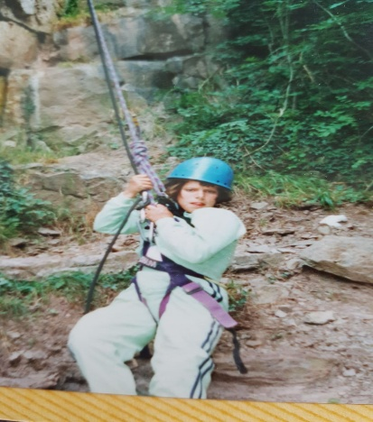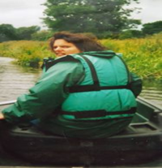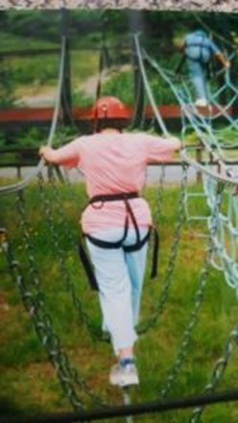
I had tied Bettina’s kayak to mine as we paddled across the lake. I was working hard, and Bettina was lying back with her arms folded behind her head wearing a satisfied smile. I then did my party trick to amuse her performing ‘eskimo roles’, disappearing under the water then coming up again, twisting and turning the kayak upright. The muddy water was going up my nose and each time I did this Bettina would say “again Dad” what could I do? Bettina had only just started using verbal communication and I just wanted to please her, as Joyce says, “if she can say it, she can have it”.
We were in mid Wales near Welshpool and a few days before we had booked into the Outdoor Activity Centre ‘Redridge’ http://www.redridgecentre.co.uk/ at the end of the 1990s, a place Bettina and I were to visit annually for a number of years where we rock climbed, abseiled, trekked, canoed and even walked up a mountain together.
This was something special for the both of us. I had done lots of outdoor pursuits in the Army (we called it Adventure Training). The Army’s justification for this training was that it created confidence in people, enhanced teamwork, let off steam and helped build relationships. I was already proud of my relationships with both my daughters (and still am) and worked hard at building our relationship every day, although it doesn’t feel like work, with both my daughters.
I was not going to get complacent with our relationship or rest on my laurels either. Bettina was entering an important phase in her life as she had become a teenager, and I wanted us to bond. I felt doing something like this would enhance and build our relationship as well as having lots of fun together.
Spending time with Bettina on our visits to Redridge, I learned so much from her about relationships. How to maintain them, how they build, the trust that comes from sharing challenges and sharing the scary bits.
So, as in my blog posts about “Being Bettina’s Dad”, I share with you the lessons Bettina has taught me and five lessons I picked up during our outdoor pursuit holidays. I hope they help you in your professional and personal life:
Bettina’s 5 imperatives for building a relationship:
1. Random Acts of Kindness. As a family we love doing things for each other, usually impulsive, when the other is least expecting it. We give our time no matter what we are in the middle of. Bettina often offered me her sweets and during meals she went out of her way to look for things she knew I liked. I supported her with some of her personal care – I prided myself on combing her hair and tying a ribbon in the way she liked it.
2. Doing something just for the hell of it. During the evenings there were scheduled activities, but I knew if I offered Bettina a choice she would opt for a drive into town (5 miles away) to chill out, eat lots of ice cream and buy comics, oh, and decorate our room with lots of balloons on our return.
3. Building Trust. I am not sure she would have climbed up that rock or joined me in the Canadian Canoe or abseiled (when she had never done this before) if she did not have absolute trust in me. The true test came when we were pot holing in a very dark cave. I had to crawl down feet first so she could look into my face to see if I was frightened! I made sure I had my best smile on, and she was then ok to follow me down.
4. Making a connection: For Bettina this is about sharing your emotions and that it is okay to show them without being judged.
5. Looking out for each other. For Bettina it is about enjoying each other’s company and while I am always tempted to wrap my daughters (and wife!) in cotton wool, I do try to support Bettina in avoiding mistakes. Giving people the answers can save a lot of grief!
Result = a bond that can last forever
My older daughter Jennifer wrote in a (much treasured) Father’s Day card “I wonder what our next adventure together will be?” Relationships are also about sharing adventures.
Final Note…
I have shared some of the photographs from some of the trips to Redridge with this blog post. I have some wonderful memories from our time there, but perhaps one of the best memories connected to our breaks was at one of Bettina school term reviews.
Following the review with the teachers, we were just leaving the school when I was stopped by a Deputy Head Teacher. He wanted to thank Bettina and me for inspiring him to arrange a similar holiday for him and his teenage daughter. He told me how they really bonded during their break together. This meant a lot to me as we had influenced someone’s relationships in a positive way. I hope this story has a similar effect for you.
Source: Steve Raw www.leadershipintheraw.org
The world exists as you perceive it. It is not what you see; it is how you see it. It is not what you hear, but how you hear it. It is not what you feel, but how you feel it. Rumi
Ten Ways to Ask Questions
1. Begin broad………………
2. …. but keep your core query in mind
3. Build rapport
4. Watch your tone
5. Don’t try to be clever
6. Keep it simple
7. Avoid too many ‘whys’
8. Be sincere
9. Listen
10. Be ready for unexpected answers
Source: Modern Management
“It is easier to build strong children than to repair broken men” Frederick Douglass
CONTAGIOUS SMILES
I begin most of my lectures by asking the audience to break up into pairs. Then I say this:
“Over the course of your life, you will have excelled in part because of your impressive self-discipline. I want you to take all of the self-discipline you’ve been cultivating for the past couple of decades to do the following. For the next seven seconds no matter what our partner says or does, I want you to show absolutely no emotional reaction. Go completely blank.”
I then ask the other person to simply look into his or her partner’s eyes and smile. I have done this experiment hundreds of times in corporate settings across the world, with everyone from nervous newbies to cantankerous lifers. The result is always the same. Virtually no one can refrain from returning their partner’s smile and most break into laughter almost immediately.
The mysterious force is the foundation of the ripple effect – the idea that your positive attitude and behaviour quickly ripple out, increasing the happiness of everyone around you, changing the way your colleagues work and eventually shaping your entire organisation.
Try this out for yourself. Spend a day smiling genuinely at every person you pass. Take note of their responses and watch the happiness factor spread throughout the room.
Source: Shawn Achor author of ‘Before Happiness” from USA’s Success Magazine

YOUR ROUTE TO THE TOP - GO FROM BUDDY TO BOSS
Face facts. The sooner you accept that you’re no longer ‘one of the gang’ the sooner you will flourish in your new role.
Make a deal. Create verbal contracts with ex-buddies early on. Set ground rules for working together and discuss likely problems. Cement your new dynamic by leading the conversation.
Be fair. According to psychologists, impartiality is a challenge for new managers. If a friend demands special treatments, ask yourself if you’d do the same for others. If not, say no. Firmly.
Keep it in. Disastrous meeting? Impossible targets? Feel like ranting at a friend? Tough. Emotional outburst erodes credibility and respect. Save the tears and tantrums for home.
Fill the void. Your new role will mean withdrawing from familiar behaviour. Combat uncertainty by recognising what you miss (brainstorms) and what it provided (a stimulating exchange of ideas), then find a substitute (a book club).
Watch your ego. Author Jim Collins found that the most successful companies have a humble CEO. Engage your new team by welcoming their views and publicly praising their contributions. Remember: you’re the manager, not the messiah.
Tame your talk. There’s a fine line between sharing information and compromising confidentiality. If chats become inappropriate, remind the group of your position. If it’s you who has the loose tongue, stop talking and get out.
Recapture confidence. Plagued by self-doubt? Write down five things’ people have praised you for in your new role and reread whenever you need a boost
Remember the bad times. It’s easy to look back with rose tinted lenses. List the frustrations of your old role, then what you love about the new one. Still miss the good old days?
Celebrate. You got this job because you deserve it.
Source: The Mind Gym
You cannot avoid pain, but you can choose to overcome it.
Paul Coelho
YOUR ROUTE TO THE TOP
SMART NEGOTIATION
Talk to the big cheeses. Negotiations are pointless without the right people present. Find out who holds the real power and make sure they (or their best alternatives) are at the table.
Listen up. Small talk reveals big issues. As you settle, ask questions to gather facts about their business, motivations and challenges.
Grow the pie. Present your ideas as a starting point to improve on together, not something you have to defend. Find opportunities for mutual gain to seal the relationship.
Dig deep. Explore both parties’ interests in detail. You decide it’s time to overhaul your direct marketing system, they show you that your real needs are more reliable contact information and to save time and money by cleaning up your database.
Show your human side. Mention a hobby, reveal a concern, make a joke. Rapport and trust oil the wheels of negotiation.
Use your negotiables. First, concede things that are of high perceived value to the other party but low value to you. Hold back on what you plan to offer, otherwise your concession is made. Instead, frame the concession as: ‘if you…then I will…’
Show them your options. Build up your best alternative to the negotiation and play this back to the other party.
Keep schtum. The first to break the silence is usually the first to concede
Source: The Mind Gym
Liberty means responsibility. That is why most men dread it. –
George Bernard Shaw
CRASH COURSE IN……..
LEADING BY EXAMPLE
As Albert Einstein put it: ‘Setting an example is not the main means of influencing another, it is the only means.’ Willie Walsh is asking BA staff to follow him in working a month unpaid, and leaders are now expected to offer model behaviour. So how do you lead by example?
You don’t have a choice. ‘From the moment you take up a leadership role, people will be watching you,’ says Donna Ladkin, senior lecturer in organisational learning at Cranfield School of
Management. ‘So, you are leading by example; the question is whether it’s the example you want to set.’
Be strategic. Identify the behaviours you want people to emulate. Some of these are driven by your organisation’s values, others by the business context. ‘If you ask your people to work unpaid, they’ll expect to see that this is consistent with a broader business strategy and not a fad,’ says Andrew Day, an organisational psychologist at Ashridge Business School. “They need to see a rationale, and that this is not just a heroic gesture.’
Walk the talk. Leading by example means you don’t ask others to do what you are not prepared to do yourself’ says Steve Newhall, vice president of talent management consultancy DDI. “The whole idea is heavily linked to integrity and people’s antennae are tuned to hypocrisy right now”
Show your tough side. It’s not all about self-sacrifice. Says Day: giving tough feedback to people who are not performing – in a developmental way – may be the behaviour you want people to emulate.
Be visible. ‘Leaders need to lead,’ says Day. ‘It’s not enough to retreat to the office/boardroom and tell people what you want them to do. You need to meet people face to face, rather than avoiding anxiety-provoking situations.’
Validate. ‘The best way to find out what people are really thinking is to talk to them’
Do say: ‘The leadership that we show now during hard times will be remembered for years to come.’
Don’t say: ‘I’m going to be holidaying in Tuscany instead of the Caribbean this year and I expect you all to do the same’
Source: Alexander Garrett - Modern Management

