LEADERSHIP AND WELLBEING PACK
July 2025
Established in 2006
Welcome to this month’s edition. Highlights include:
Damian Piper CBE our Resilience Coach starts this month edition with: Is it work-life balance we are looking for – I think that’s the wrong pursuit? “In the relentless pursuit of an ideal existence, the phrase “work-life balance” has become a ubiquitous mantra, a seemingly noble aspiration plastered across self-help books, corporate mission statements, and LinkedIn profiles……”
‘A Thera queuetic Practice’ By Joyce Raw originally published in 2016 and I have only just become aware of! “An odd thing to admit to, I know, is that I have always enjoyed observing others. It started at an early age and probably stems from the need of a child from a large northern family to know when to pitch in, and when to stand back….”
The 11th Leadership Lesson I learned – Being (and staying) Grounded. A senior management conference I attended a couple of years ago included an ‘Icebreaker’ which involved writing one word to describe the person sitting on your right. The person to my left was an Executive Director, a person of few words (and someone who last gave me a compliment 15 years ago) and it was therefore with some trepidation that I turned over the post- it to see the word that best described me as ‘Grounded’.
‘Being Bettina’s Dad: Bettina transforming my life with mindfulness’ I am looking out to the North Sea from the beach at Frinton in Essex with Bettina. My hands are cold and so are my feet and I am squinting because the wind and sea spray (not to mention the rain) is blowing in my face. Yet, for me, this is as close to heaven as you can get. I am with Bettina.
Graham Belgum has two important messages from his excellent series of ‘Thought for the week ahead: Holding myself to account and Empowerment I highly recommend Graham’s weekly posts on LinkedIn.
Steve Raw FIoL, FCMI, GCGI
Email: stephenraw6@gmail.com
Blog: www.leadershipintheraw.org
Instagram: @stephenraw6
Twitter: @SteveRaw836
Blue Sky: https://bsky.app/profile/steveraw.bsky.social
LinkedIn: https://www.linkedin.com/in/steve-raw-72454721/
Facebook: https://www.facebook.com/steve.raw.771/
It’s not about how good you are.
It’s how Good You want to be.
Is it work-life balance we are looking for – I think that’s the wrong pursuit?
In the relentless pursuit of an ideal existence, the phrase “work-life balance” has become a ubiquitous mantra, a seemingly noble aspiration plastered across self-help books, corporate mission statements, and LinkedIn profiles. It conjures an image of perfectly weighted scales, with professional ambition on one side and personal fulfilment on the other, both harmoniously poised. But what if this cherished concept, far from being a helpful guide, is actually a subtly damaging myth? I’ve always felt its an overly simplistic statement. Also does it mean when we are working we are not living?
For many, the idea that "life" – the realm beyond the office walls – is inherently less stressful, a sanctuary of calm and repose, is simply not true. Let's be honest: life is messy, demanding, and often profoundly challenging. While work might bring deadlines, difficult colleagues, and performance reviews, life outside work can present a whirlwind of responsibilities that are equally, if not more, taxing.
Consider the parent juggling childcare, school runs, and extracurricular activities, often on little sleep and a constant low hum of anxiety about their children's well-being. Is that less stressful than a quarterly report? Seriously! What about the individual caring for elderly relatives, navigating complex healthcare systems and dealing with the emotional toll of their loved one's decline? And the rub with sibblings who have a different view of what’s necessary. Is that less stressful than a demanding client? Or the person struggling with financial insecurity, facing mounting bills and the constant pressure of making ends meet? Is that a picture of serenity? I could go on. And on. Hopefully you get what I mean.
The work-life balance narrative inadvertently fosters a binary view of our existence: work equals stress, life equals relaxation. This is a dangerous oversimplification that fails to acknowledge the multifaceted nature of human experience. It implies that if you're not working, you should be blissfully unwinding, and if you’re not, you’ve somehow failed to achieve the mythical balance. This can lead to feelings of guilt and inadequacy when our non-work lives are, as they so often are, replete with their own unique pressures.
Instead of chasing this often-illusory balance, perhaps it's time to reframe our understanding of well-being altogether. What if, instead of pitting "work" against "life," we focused on the more fundamental, universal human experiences of pressure and relaxation?
Pressure is an inescapable part of life, both inside and outside of work. It can manifest as the urgency of a project deadline, the emotional weight of a family crisis, or the physical strain of an intense workout. Pressure, in itself, is not inherently bad. It can be a motivator, a catalyst for growth, and a sign that we are engaged with the world. The problem arises when pressure becomes chronic, overwhelming, and without adequate periods of respite.
Relaxation, on the other hand, is the antidote to excessive pressure. It's not necessarily about being completely passive or doing nothing. Relaxation can take many forms: genuine rest, yes, but also engaging in hobbies, spending time with loved ones, exercising, pursuing creative endeavours, or simply finding moments of mindful stillness amidst the chaos. The key is that these activities are restorative, allowing us to replenish our physical and mental reserves.
By focusing on the interplay between pressure and relaxation, we move away from the reductive "work vs. life" dichotomy. We acknowledge that pressure can arise from any facet of our existence, and that the need for relaxation is a fundamental human requirement, irrespective of where that pressure originates.
This shift in perspective offers several advantages. Firstly, it normalises the reality that "life" often brings its own set of significant challenges. It validates the experiences of those whose personal lives are far from a blissful idyll and allows for a more compassionate understanding of their struggles. And compassion for ourselves.
Secondly, it empowers individuals to identify and manage pressure wherever it arises. Instead of trying to carve out a separate, stress-free "life" sphere, we can ask ourselves: Where am I experiencing pressure right now? Is it work-related, family-related, financial, social? And crucially, how can I intentionally incorporate more moments of genuine relaxation and restoration into my day, regardless of the source of the pressure?
Thirdly, it promotes a more holistic view of well-being. It encourages us to access our resilience, develop coping mechanisms, and seek support for all forms of pressure we encounter. It moves beyond the idea that self-care is something we do only when we’re not working, and instead positions it as an ongoing, essential practice for navigating the complexities of modern living.
The concept of work-life balance, while well-intentioned, My take is that it’s become an unhelpful and often misleading ideal. It sets an unrealistic expectation that our non-work lives are inherently serene, ignoring the substantial pressures many individuals face outside the professional sphere. By reframing our understanding around the more accurate and universal concepts of pressure and relaxation, we can foster a more realistic, compassionate, and ultimately more effective approach to well-being. Let's abandon the myth of the perfectly balanced scales and instead focus on building lives that, while undoubtedly full of pressure, are also intentionally rich in moments of genuine, restorative relaxation, wherever and however we find them. I call that the effective challenge. What’s your take?
As always I’m interested in what you have to say.
Damian
damian@effectivechallenge.com | effective challenge podcast | LinkedIn | Instagram
Damian Piper CBE
Performance and Resilience Coach
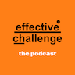
Thoughts for the week ahead…Holding myself to account.
I have had the privilege of being appointed as CEO of a fantastic company (press release next week).
I started my handover last week and I am holding myself to account on the following dozen challenges:
1. To increase the value and free cash flow of the company.
2. To build trust, lead and support the team.
3. Empower and enable the team to succeed.
4. Listen and listen again, my team know the issues and have the answers.
5. Create the customer first focussed vision, mission, objectives and targets together so that everyone buys into them (ownership).
6. Build the values together and adhere to them.
7. Be transparent and communicate openly and honestly on a regular basis.
8. Treat everyone fairly (no favourites or bias) and promote/reward on merit.
9. Ensure everyone has a clear role and responsibilities aligned to the mission/objectives.
10. Employ diverse and smarter people than me and let them do their job.
11. Help the team solve their problems (eat the elephant in bite size chunks) with foresight, through critical path analysis.
12. Do the right thing (which might be to compromise) no matter how hard it is.
Source: Graham Belgum. CEO Helix https://www.ehelix.com/ and Non-Exec Director for Thera South West www.thera.co.uk
"The real test is not whether you avoid this failure, because you won't. It's whether you let it harden or shame you into inaction, or whether you learn from it; whether you choose to persevere." - Barack Obama
A Theraqueuetic Practice
(originally published in 2016)

An odd thing to admit to, I know, is that I have always enjoyed observing others. It started at an early age and probably stems from the need of a child from a large northern family to know when to pitch in, and when to stand back. In adults this is recognised as a “survival tactic” and has probably saved many lives. However, if you come from a large family yourself, this will most certainly resonate with you - and I apologise now if this brings to the surface some forgotten traumatic events from your past!
As a child in a large family, you have to know your place and you need to know when to pitch in and when to stay silent (or, as in the case of my oldest sister, know when to hide!). In order to perfect this choice you also need to make a quick judgement, and this can only be based on experience through observation, observation and more observation.
It is always greeted with huge guffaws when I tell people that the strong, confident, opinionated and determined woman they know today was once a shy, quiet, gentle wallflower who grew up in the shadow of her numerous strong, willful and athletic siblings! Even my own husband and daughters find it hard to believe, and friends are just completely dismissive of the idea. Some would question that if this was the case, then how did I transform into what I am now? The answer is simple - the art of observation honed into an enviable skill.

Observing others is a great aid to recognising behaviour patterns and their outcomes. Whilst I am not a qualified therapist on any level, I am sure that this does form part of their training. For my own part, I have moved through observing my siblings as we were all growing up; watching people communicate in social settings; making mental notes of how work colleagues interact with each other (especially during times of stress and tension) to helping others trying to cope with similar adversities to my own.
However, one of the most interesting practices I have observed is how people will very often use total strangers as therapists, and the weirdest thing is that it is not frowned upon nor unwelcome! People do not mind that you may not be a qualified therapist, all they seem to need is for you to listen and your advice, whether based on training or experience, is welcome - although whether or not it is taken is another matter! What amazes me most about this practice is that some people will move through a queue imparting their woes to each member of the line without a single concern that they are disclosing some of their innermost secrets to perfect strangers. This is what I call “thera-queue-tic” (therapeutic, get it?). I am sure that the qualified amongst you will recognise this as a basic need for human comfort, or a need to communicate with someone who does not have a stake in the situation, or even an indication that the need to seek validation is stronger than the need for personal boundaries. And I am sure that there will be some long-established or long-departed respected therapy guru who has recognised and labelled this practice under a long, unpronounceable medical term.

I have observed that, for their part, the recipient of the disclosure ranges according to the amount of time and effort, or interest, they can expend on the matter. Some people will listen intently to the problem, offer sympathy or even empathy (“the same happened to a friend of mine”) closing with either a referral (“go and see ____ they are very good on this sort of thing”) or a placating hand of solace (“there, there”). Some people will try a distraction tactic so they do not have to hear the whole tale (a non-committal “hmmm, I see”) or be placed in a situation which will distract them from the task in hand, or indeed put them in the line of fire (tears, meltdowns, aggression). Sadly, some people are so bogged down with their own worries that they make it clear that they are not interested in participating in the conversation, and are unable to take on board someone else’s dilemmas, which is perfectly understandable.
What is also interesting to note is how the “professional” recipients handle this practice. By “professional” I am not referring to qualified therapists, but the unqualified ones such as hairdressers, shopkeepers, receptionists etc. They appear to listen intently at all times, even participating in the conversation, but how many similar conversations have they had during their day? Is their advice a one-size-fits-all prescription? A couple of weeks ago I had the opportunity to ask my hairdresser about this observation and asked how she coped/did not cope with this on a daily basis. Her response was that she did not attempt to give advice, as this had a tendency to come back to bite you, but was prepared to listen and let the customer come to his/her own conclusion on the matter, with her own personal rider that the next time she saw the customer it would be as if the conversation had never taken place! Both tactful and practicable.

So, bearing all this in mind, and based on my own observations, I have come up with a few (hopefully) helpful tips as I feel that helping others is always the right thing to do:

- Always acknowledge the conversation, even if you feel uncomfortable or are in a hurry
- Keep calm, even if they appear distressed or angry
- Do not pass judgement on what is being said, but do nod to confirm that you are listening
- Accept that the person may not be in need of your sage wisdom, only your ears
- Try to assess whether the person is in need of further support, i.e. someone who is confused (dementia or disability), and not just looking to offload their angst
- Always finish the conversation with eye contact and a “well, take care, see you again…”
Observation of human life in all its forms is a wonderful teacher and can become very addictive!

Until next time,
Cheers

Joyce

Joyce Raw https://livelikearaw.wordpress.com/

The 11th Leadership Lesson I learned – Being (and staying) Grounded.
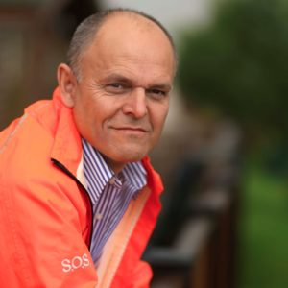
A senior management conference I attended a couple of years ago included an ‘Icebreaker’ which involved writing one word to describe the person sitting on your right. The person to my left was an Executive Director, a person of few words (and someone who last gave me a compliment 15 years ago) and it was therefore with some trepidation that I turned over the post- it to see the word that best described me as ‘Grounded’.
I was not sure if this was a compliment, or what it meant, but for now I was going to take it as a ‘win.’ I could always wait until I got home to ask Joyce, my wife, coach, and mentor.
I dug deeper into what being grounded means and how it can be perceived as a leadership attribute, and this is what I found……
Staying grounded means:
A grounded person is firmly rooted in their own reality, able to navigate life’s challenges with a clear mind and a sense of emotional resilience. At its core, staying grounded is about having the confidence to maintain a sense of inner calm and stability, even during uncertainty or disruptive moments.
The meaning of staying grounded is a journey of self-discovery and self-care. If you can learn to anchor yourself in the present moment, you can cultivate greater emotional regulation, deeper connections with others, and a more fulfilling, purposeful life.
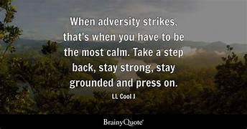
Being Bettina’s Dad and how ‘B’ has helped me stay grounded.

Bettina is our youngest daughter who copes with a learning disability and autism. She relies on her parents to be consistent, calm, and dependable. With Bettina you do not get away with trying to be somebody you are not. So, lesson number one, you must always be authentic. Related: https://leadershipintheraw.org/2018/03/29/being-bettinas-dad-be-your-authentic-self/
Here are some more ways that Bettina keeps me grounded:
- Knowing there will always be someone dependant on you for all their needs.
- Bettina (and her sister Jennifer) will be your purpose in life. (this is a shared purpose with Joyce and one which we cherish).
- Never taking anything for granted. I am always striving to meet Bettina’s expectations in the full knowledge I will need to win her respect every day.
- That a title and status mean nothing to Bettina, but your kindness and care does. I had been a Warrant Officer in my first career in the Army and a Managing Director in my second career in Social Care. To Bettina I am just “Daddy Steve” or “good boy.”
Related: https://leadershipintheraw.org/2025/06/07/being-bettinas-dad-bettina-transforming-my-life-with-mindfulness-2/
What I have learned from leaders who are grounded (and how I have tried to apply this to my leadership style)
They:
- Are modest about their success and achievements – they are humble.
- Are inspirational with an authentic message.
- Create a culture of total accountability. holding themselves and others totally accountable for thinking, behaviour, and performance.
- Have a fundamental understanding that it is not about them. It is about serving others.
- Have tremendous influence within their organisation and their communities, where others look up to them.
- Take a pragmatic approach to life.
- Have a steady confident presence not swayed by stress and emotions.
- Are consistent and easy to read, I always knew how they would show up for work.
The first question I asked Joyce when I arrived home from the conference, is being grounded a good thing? “Of course, it is Steve, and we will be doing our very best to keep it that way.
I have found being grounded is imperative for both my happiness and success. It allows me to approach life in a calm and measured way (unless the IT has gone down). I plan for success, but I am not surprised by failure. One of my favourite quotes is “If you’re in a bad situation, don’t worry it’ll change. If you are in a good situation, don’t worry it’ll change” John A Simone Sr
Related: ‘Leadership Lessons I learned’ 1- 10 can be are on www.leadershipintheraw.org home page.
Source: Steve Raw www.leadershipintheraw.org
Thoughts for the week ahead …. Empowerment
When you examine a successful business, you will find empowerment at its heart.
The senior leaders listen to their expert team and support them to be successful. When asked for help they find a way to provide it.
For empowerment to be really effective, senior leaders must ensure transparency (not secrecy) plus clarity of objectives, roles & responsibilities and priorities.
Those empowered must then step up to the mark and work collaboratively to solve problems, generate new ideas and stay focused on the objectives.
Source: Graham Belgum. CEO Helix https://www.ehelix.com/ and Non-Exec Director for Thera South West www.thera.co.uk
“Why fit in when you were born to stand out” Dr Seuss
Ditch The Amber
Time to Read: 18 Seconds
Dear Steve
Ditch The Amber
In project traffic lights, red means stop, green means go… but amber?
What does that even mean?
Half-stuck? Half-hopeful? Or a combination of the two!
A project is either done and live, or it’s not
Let’s stop pretending with in-between signals
Clarity wins – it’s time to ditch the amber – for good
Of course, you may disagree – please do so…
With my thanks to my great friend Paul Chandler
and my love and best wishes to you
David (David Taylor, author, broadcaster, presenter and trainer)
@nakedleader across all social media
“Attention is the rarest and purest form of generosity.”
Simone Weil, quoted in The Philadelphia Citizen
YOUR ROUTE TO THE TOP
BECOME A BRAVE LEADER
Feel the fear. Helen Keller once said: ‘Life is either a daring adventure, or nothing.’ Courageous leaders experience as much fear as others; they just don’t let it paralyse them. Replace ‘I can’t’ with ‘I will.’
Say it like it is. Authentic communication can be a challenge, especially when the message is tough, or you don’t believe in it. But what people want is the truth. This doesn’t mean being perfect, it just means doing your best to be real, warts and all.
Have hope. Randy Pausch, a professor at Carnegie Mellon University, was diagnosed with pancreatic cancer. His last lecture could have been a depressing experience; instead, it was life-affirming. Look to the future, no matter how turbulent the current circumstances. As Pausch himself said: ‘Brick walls are there to remind you how much you want something.’
Talk to yourself. Challenge your catastrophic fantasies. Give answers to your ‘what ifs?’ Scrutinise any unhelpful thoughts.
Don’t give up. From M&S’s Sir Stuart Rose to Pret’s Julian Metcalfe, turnaround champions and entrepreneurs alike agree on one thing: persistence lies at the heart of success.
Stand tall. In a world of consensus-building and endless collaboration, brave leaders inspire their followers with decisive action. To be brave is to be in control. Put an end to dithering and offer clear direction to your team.
Live a vital life. Great athletes tend to project enormous vitality. So do great leaders. Create an infectious mood and win over the cynics – as well as invigorating the evangelists.
Be humble with success. In his book ‘Good to Great’ Jim Collins demonstrates a negative correlation between the fame of a CEO and their business performance. Ask for honest feedback, let others shine and selectively share weaknesses. Top leaders build enduring greatness through professional will and personal humility.
‘The Mind Gym: Give me time’ is published by Time Warner Books
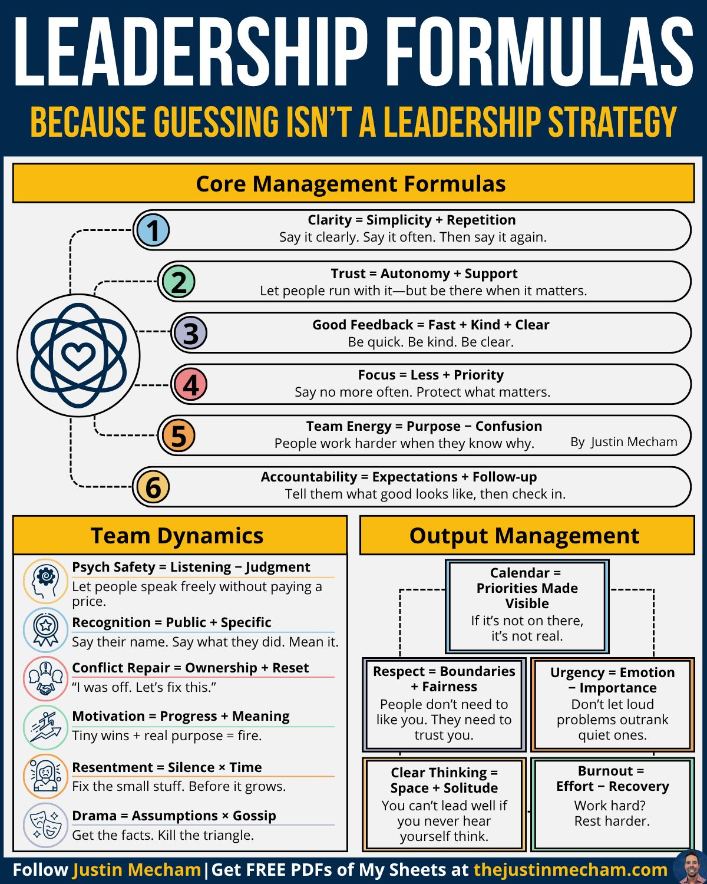
HOW TO IMPROVE YOUR MEMORY
- Talking to yourself can help you learn something new. As you go through a task – such as getting to grips with a computer programme – guide yourself by saying the instructions aloud.
- Quit smoking. Added to all its other harmful effects, smoking damages prospective memory: your ability to remember to carry out future tasks.
- Start going to bed earlier: the deeper you sleep, the more information you’ll be able to retain
- Clenching a fist can stimulate certain areas of the brain, according to recent research. To memorise the items on a shopping list, for example, clench your right fist for 90 seconds while reading them. When you want to recall them, clench your left fist for 90 seconds
- When trying to memorise information, it’s more effective to attempt to retrieve it than to just go over it again. Try asking yourself if you know it rather than revising.
Source: The Guardian
HOW TO COMBAT INSOMNIA
- Avoid computers, tablets, smartphones, and flat-screen TVs before you go to bed: they emit blue light, which stimulates the brain. If you must use a device, keep it at least 30cm away from your eyes and turn down the brightness
- Don’t drink alcohol just before going to bed. But you could try eating carbohydrates, such as a banana or a piece of toast.
- Getting regular exercise is important, of course. To really feel the effects, aim for at least 75 minutes of vigorous activity, such as running, each week. If you work out, time it for around 6 hours before bedtime.
- Try not to rely on rituals before you go to bed, or habits such as reading for a certain period of time. Obsessing over them can make you even more anxious about getting
- If you wake up in the night and can’t get back to sleep after 20 minutes, get out of bed for a while and do non-stimulating activity.
Source: The Guardian/The Sunday Times
7 Effective Ways to Make Others Feel Important
1 Use their name
2 Express sincere gratitude
3 Do more listening than talking
4 Talk more about them than about you
5 Be authentically interested
6 Be sincere in your praise
7 Show you care RoyT Bennett - The Light in the Heart
- 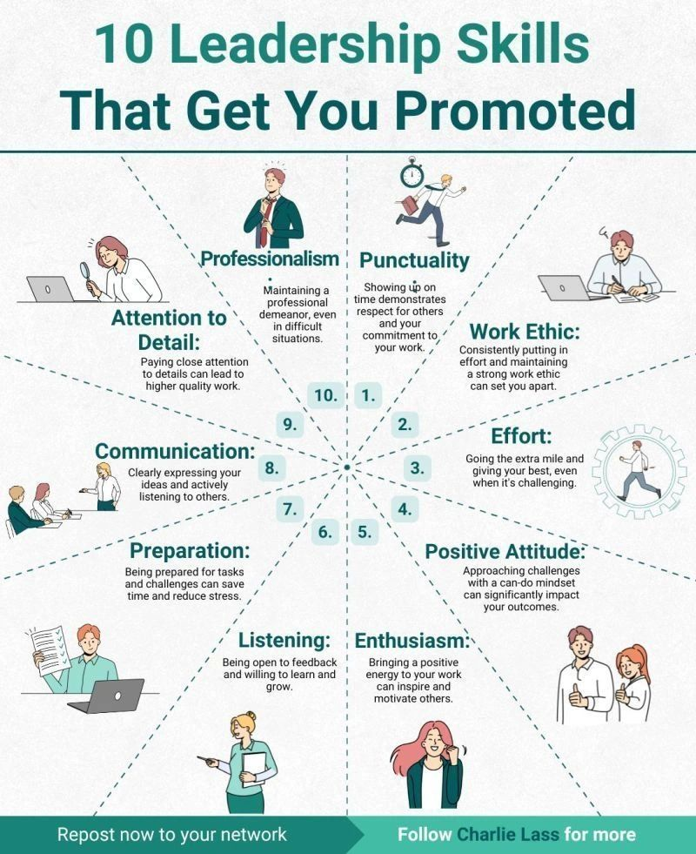

Being Bettina’s Dad: Bettina transforming my life with mindfulness
Mindfulness means paying attention on purpose, in the present moment, infused with qualities like kindness, curiosity and acceptance.

Frinton on Sea. Bettina at peace with her world
I am looking out to the North Sea from the beach at Frinton in Essex with Bettina. My hands are cold and so are my feet and I am squinting because the wind and sea spray (not to mention the rain) is blowing in my face. Yet, for me, this is as close to heaven as you can get. I am with Bettina.

Yesterday Joyce (my wife) said that Bettina had touched Joyce’s jaw to move it in time with Bettina’s speech; “beach tomorrow with Dad.” There was not going to be any negotiation with Bettina on what she wanted to do on Saturday. I could not wait!
I knew what was coming from spending a morning together – peace, elation, tranquillity, and contentment. All these emotions felt by just spending time with Bettina on a deserted beach on a winter’s day.
So many people who have been part of Bettina’s life have described the effect she has had on them just by being in her presence, so it is not just her proud parents who feel this way. We have described her as being “spiritual” without producing a profound understanding of what this means and what it is that she gives out. Until now!
Related: https://leadershipintheraw.org/2023/09/21/being-bettinas-dad-enchanting-by-being-fascinating-and-delightful-2/
I had heard of ‘Mindfulness’ without really knowing what it was so I bought several books to educate myself and see if this applied to the time I spend with Bettina.
Reading these chapters, I thought this is Bettina! Crikey, I reckon she was a Buddhist Monk in another life, and this is why I always feel peaceful, elated, tranquil and contented when we are together – especially when she is doing something she loves.
So how does Bettina act with Mindfulness?
- Bettina lives in the present in an enjoyable way. There is no past or future for her, only the here and now.
- I often observe Bettina standing or sitting quietly thinking. Recently there was no noise coming from her bedroom and it was noticeably quiet. We are used to hearing noise, usually laughter, so we were worried. Bettina copes with epilepsy so had she had a seizure? Joyce asked if she was ok (from outside her bedroom) she responded with “I am thinking.”
- Experiencing Nature. She explores her life with the intention of experiencing the unity of life: the sky, earth, trees, grass and flowers and the whole sense of life. With her ears she experiences the sounds of nature, whether it is birds singing or the breezes rustling her hair (which she loves).
- Bettina demands nothing from this world. I believe this reveals to her an extraordinary dimension of wonder. She practices being content with what she has. It is a sign of her inner wealth.
- Bettina expresses her creativity through her body in so many ways, such as music which she moves to, and I think gives her inner peace and which she finds uplifting and affects her mood. Bettina is also at one with the harmonious movement of Tai Chi which she loved and previously practiced to a high level.
- Walking mindfully. I do not think Bettina is thinking about her destination when she is walking. She is in the moment as she walks. Bettina feels the breeze and enjoys the steps she makes and feels the sensation on her feet – that’s mindfulness. Bettina’s mind is in the moment meditating as she walks.
So how does Bettina transform my life through her Mindfulness?
- Changes my relationship with daily life so that I feel more in tune with myself and others.
- Leaving behind and not worrying about the future. Being happy and content in the present (previously I have been obsessed with things and events, past, present, and future). I make the intention to stay calm and conscious throughout the entire day.
- Instead of hurrying from one thing to another, trying to do too many things at the same time, I now focus on the activity at hand. This is what Bettina does.
- Just as I have learned from Bettina, I too practice being content with what I have in my life. I feel so fortunate and have a sense of appreciation.
- I practise achieving stillness. I have observed that when Bettina is waiting to go out with her Personal Assistant, she sits still therefore not expending any energy. She is calm. I now try to be like Bettina not fidgeting, changing position, crossing, and uncrossing my legs or fiddling around with a pen. This will help me before my next Board Meeting!
- Developing an ‘Attitude of Gratitude.’ You are grateful when you are aware of what you do have rather than what you do not.
- I carefully select music in my car on my journeys, which is spiritually uplifting. I choose music that will give me waves of positive energy as I approach my destination and music that provides my inner peace after the event.
“That does not surprise me about Bettina – that focus on the here and now and thing in hand is I am sure what you see Bettina being great at every day. She has something to teach us all” Karen Boyce – Dawson
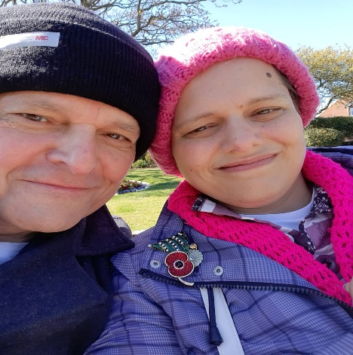 Bettina is a woman who copes with Learning Disabilities, Autism and Epilepsy. Just like her big sister Jennifer, she is as beautiful on the inside as she is on the outside. Related: https://leadershipintheraw.org/2021/12/24/being-bettinas-dad-bettinas-kind-heart/
Source: Steve Raw www.leadershipintheraw.org

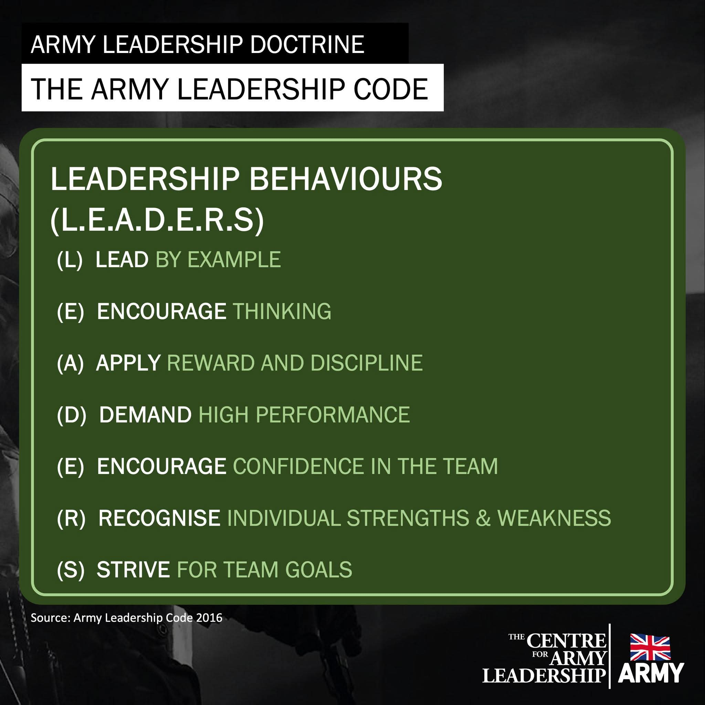
Here's a thought...
Time To Read: 42 Seconds
Dear Steve
Each one is a spark, a seed, a choice…
And here's the wild part: just one of those thoughts, if believed, owned and acted on, can change your entire life. One idea, one shift, one moment of courage.
It’s not about how many thoughts you have — it’s what you do with them. Are you using your thoughts to doubt yourself, or to drive your dreams?
Today, take one thought. Make it count. Because the content of a single thought has the power to make your dreams come true.
With my love and best wishes to you
David
@nakedleader across all social media
(David Taylor, Author, Trainer, Presenter and Broadcaster – I highly recommend David’s books, Steve)
sign up to receive David’s blog - unsubscribe anytime

What does Naked Leader Do?
We ensure your people actively choose to do what you really need them to do
And love doing it
What do you want/need your people to do differently?
Email us in confidence: rosalindhoward@nakedleader.com
No selling by us - No obligation on you

