LEADERSHIP AND WELLBEING PACK
August 2025
Established in 2006
Welcome to this month’s edition. Highlights include:
Damian Piper CBE our Resilience Coach starts this month edition with: “Damian Piper our Resilience Coach starts this month edition with: ‘Learning from toast’… ‘We’ve all done it. Forgotten the toast under the grill and ended up with something less than appetising. So, what leadership lesson can we learn from the humble slice of toast? …………”
‘Being Bettina’s Dad – Seeing the Good/Bringing out the best in people’ “During our recent holiday, Bettina and I are waiting patiently in a queue at a well-known national newsagent. The shop assistant at the cash till has a reputation for being abrupt…. “I am interested to see how she will engage with Bettina. Why? because Bettina sees the best in people and brings out the best in people”
Bettina’s Perseverance in the face of Adversity’ “Coming towards the end of a money awareness workshop, with my colleague Michaela, at Market Field School in Colchester http://www.marketfieldschool.co.uk/ I am approached by a member of the school staff who, I later learned, had especially come over to see me as she had heard that I had been talking about my youngest daughter Bettina…..”
Graham Belgum has two important messages from his excellent series of ‘Thought for the week ahead: ‘Foresight’ and ‘Self Belief’ I highly recommend Graham’s weekly posts on LinkedIn.
There is lots more in this month’s edition so let’s dive in together……

Steve Raw FIoL, FCMI, GCGI
Email: stephenraw6@gmail.com
Blog: www.leadershipintheraw.org
Instagram: @stephenraw6
Twitter: @SteveRaw836
Blue Sky: https://bsky.app/profile/steveraw.bsky.social
LinkedIn: https://www.linkedin.com/in/steve-raw-72454721/
Facebook: https://www.facebook.com/steve.raw.771/

It’s not about how good you are.
It’s how Good You want to be.
Learning from toast…
We’ve all done it. Forgotten the toast under the grill and ended up with something less than appetising. So, what leadership lesson can we learn from the humble slice of toast?
Making toast could never be described as difficult. Could it? Even for people with the most basic culinary skills. However just because it’s a relatively simple process doesn’t mean it’s easy to do. There are some basics you need to get right. Do that and you are almost guaranteed tasty toast every time.
All too often in leadership positions we overlook the most basic elements of what we and the people we work with need. Unfortunately, unlike burnt toast it’s not so obvious when things haven’t gone to plan. Have you experienced or witnessed any of these in your career?
- People left confused about where organisations are heading.
- People working on activity that doesn’t make sense to them. Or worse, they find out someone is doing the same thing elsewhere in the organisation. Or even worse, they find out someone in the same organisation is doing something in competition or conflict with their work.
- People not letting you know how they feel about something because their appraisal discussion is being conducted in the wrong environment.
So how can we check if we have the basics in place. Setting and being able to answer high-level questions is one way. Here’s three areas to illustrate. Don’t be fooled by the simplicity.
Quality of your vision
- Is it compelling and clear to the people it is meant to provide direction to?
- Is it long enough to be meaningful and short enough to be memorable?
- Could you use it to make decisions?
Agreeing objectives
- Are they aligned to the organisation’s goals?
- Is there agreement about what success looks like?
- Is there understanding about the steps towards success and what a sensible duration for them looks like?
Running an appraisal session with a member of your team.
- Are both parties clear on what is being appraised?
- Have you got the right physical or virtual environment for the conversation you need to have?
- Have you given the right attention to time: when, how long and balance between feeding back and feeding forward?
What’s more important than the number of questions is actually using them. To understand the basics at an intellectual level is not enough. It’s about the execution. You may well have your own version of what the basics are in the three examples above. I’d love to hear about them if you do.
As always, I’m interested in what you have to say.
Damian
damian@effectivechallenge.com | effective challenge podcast | LinkedIn | Instagram
Damian Piper CBE
Performance and Resilience Coach

www.effectivechallenge.com/podcast
RISK APPETITE
The only people who are really hungry for risk are those unfortunate sensation-seekers who need near-death experiences to brighten up their otherwise colourless lives, but this is not what risk managers mean by this increasingly popular phrase. Rather, their concern is how much risk you are prepared to bear to reach your goals. This is much more sensible but leads towards three nasty truths about risk. One is that we are lousy at-risk calculus. Even professionals who operate in the eye of risk blizzards, such as surgeons and politicians, find it hard to compute the loss/probability equation. Two, risk calculus requires you to have lots of observations to give you a meaningful statistic, yet many of the most important risks are one-offs. You can’t be 10% dead after surgery. Three, the more we want something, the more we are likely to adjust our risk assessments optimistically. Human passion, as ever, clouds the rational picture. Risk appetite? Just the starter and the cheese, please – make too much of a meal of it and you could wind up seriously sick.
Source: Nigel Nicholson is professor of organisational behaviour at the London Business School.
Being Bettina’s Dad – Seeing the Good/Bringing out the best in people

Introduction:
During our recent holiday, Bettina and I are waiting patiently in a queue at a well-known national newsagent. The shop assistant at the cash till has a reputation for being abrupt and almost angry with customers. As we move forward to be served, I am interested to see how she will engage with Bettina and me. Why? because Bettina sees the best in people and brings out the best in people.
Bettina steps forward to the counter and smiles at the shop assistant….

Bettina copes with a learning disability and autism, but these conditions do not define her, ultimately ‘B’ as her family and friends affectionately call her, is very much her own person. B doesn’t just understand the feelings of others, she genuinely feels for them, especially the person who is about to serve her.
So how Bettina sees the best in people?
Here are five ways she sees the best in people, although I could easily produce more:
- Bettina is the rarest of things, she is a human without prejudice. Bettina is not influenced by anybody else’s prejudice.
- People instinctively know they are not being judged by her, there is no need to pretend to be someone you are not with Bettina.
- Having a sunny disposition (Bettina chooses to be positive) often means those she encounters then have similar feelings. A sunny disposition is a common trait among those who consistently see the best in others.
- Bettina is not concerned with what has gone before, so it matters not that the shop assistant at the newsagent had been angry with several customers in the queue, she had not been angry with Bettina.
- Bettina is open-minded. Rather than jumping to conclusions or making snap judgments based on first impressions, Bettina is empathetic to others. It might be the shop assistant Bettina is about to encounter is tired, struggling with a family issue or coping with grief.
Related: ‘Bettina’s Kind Heart’ https://leadershipintheraw.org/2021/12/24/being-bettinas-dad-bettinas-kind-heart/
What I have learned from Bettina about seeing the best in people and getting the best out of people:
- A genuine appreciation for everyone you meet. This is not to say that Bettina is naive or blind to the flaws and shortcomings of others.
- Don’t hold grudges. Bettina does not hold grudges and is quick to move on. Life is too short.
- To always start from a position of trust. This allows Bettina to look beyond what might be immediate and apparent, delving deeper into the complex layers that define a person.
- To be curious by nature. Bettina has struggled all her life with understanding verbal communication and the clues which are inherent with what people are saying. This means ‘B’ has a genuine desire to know or learn something about the person in front of her. This is reflected in her active responses, and the pleasure she shows when someone tries to interact with her.
- Seeing the good in others is a simple but immensely powerful way to feel happier and more confident and become more loving and more productive in the world.
The shop assistant gives Bettina eye contact, return’s ‘Bs’ smiles and asks her what she would like today, then kindly remarks on her purchases “I used to enjoy reading that when I was younger, I hope you enjoy it sweetheart.” Once more Bettina has seen the good in a person and brought out the best in them. The customers behind us, who I imagine are ‘locals’ look on astonished!
Related: ‘Bettina, enchanting by being fascinating and delightful’: https://leadershipintheraw.org/2023/09/21/being-bettinas-dad-enchanting-by-being-fascinating-and-delightful-2/

Source: Steve Raw www.leadershipintheraw.org
Thoughts for the week ahead…. Foresight
We are often so engaged in fighting today’s fires that we do not put time aside to plan for the future. As a result, we often make short term decisions that compromise our future opportunities. We thus end up going from one fire to the next and not preventing them from occurring in the first place.
The role of the senior leadership team is critical here. No matter how pressed for time you need to put time aside to plan for the future and link it with today’s actions.
You can then assess the impact of your proposed short-term actions against the longer term outcomes. This then allows you to make the best possible decisions, especially around investment vs return and spend vs save initiatives.
You will never be able to do everything you want but you can select those that give you the greatest benefit (objectively not subjectively).
To complement this you need to create an agile organisation that can react quickly to external changes.
Thus sound foresight combines the three elements of linking today’s reality with tomorrow’s opportunity underpinned with the organisational agility to react quickly to change.

Source: Graham Belgum. CEO Helix https://www.ehelix.com/ and Non-Exec Director for Thera South West www.thera.co.uk

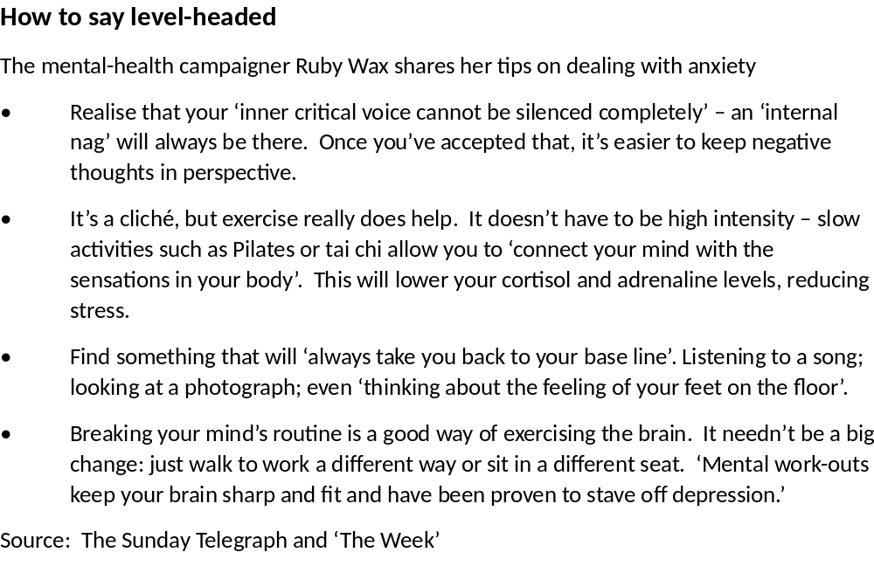
Great leaders don’t just tell people what to do, they explain why it matters.

When leaders communicate the purpose behind the task, the vision, or the mission, they inspire others to follow because they believe in it, not just because they have to.

The ‘why’ fosters trust, loyalty, and a deeper connection between leaders and their teams. It builds a shared belief and strengthens the bond that drives success.

So, next time you're leading a project or rallying your team, remember: as Simon Sinek puts it, "Start with why."
#Leadership #Inspiration #Motivation #PurposeDriven #LeadershipDevelopment #Teamwork

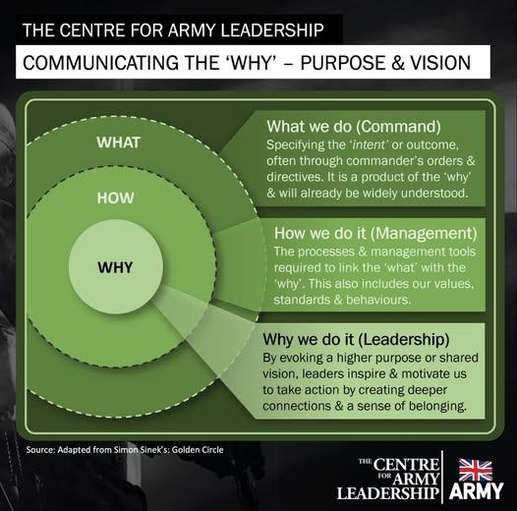
Something I wrote in 2016 about finding my ‘Why’ (Steve) https://leadershipintheraw.org/2016/01/11/finding-a-why/
Thoughts for the week ahead…. Self-Belief
Looking for a new job, being promoted, or starting a new role/project. All of these are daunting even for the most seasoned of people (so you are not alone).
The key is to build up your self-belief. Assess what you need to do, to succeed and prepare yourself for the journey ahead. Leave nothing to chance but at the same to be prepared to adapt (change) as the situation develops. Take advice, learn from others, have patience and be humble.
Celebrate each step of the way to remind yourself you are making progress. Do not worry if you have to take a pace backwards to go forwards - that is normal.
If you get stuck ask for help, you will be pleasantly surprised how many people around you want you to succeed.
If you are not able to convince yourself you will succeed then that is what will happen. Build the self-belief and go for it…
Two Definitions of ‘Simplicity’
Time to read: 50 Seconds
Dear Steve
I asked Chat GPT to share why simplicity is so important, in two ways – Academic and Child-Like:
I also got an optical illusion on word counts!!!
Academic Language (50 words)
The human brain exhibits a marked inclination toward cognitive efficiency, favoring simplified inputs that reduce neural processing demands. Predictive coding frameworks suggest that minimal complexity enhances pattern recognition, decision-making, and schema integration. This neurological predisposition toward parsimony informs educational strategies, design principles, and behavioral interventions seeking to optimize cognitive performance.
Child-Friendly Language (50 words)
Your brain loves it when things are easy to understand! When stuff is simple, your brain can think faster and better. If things are too tricky, it gets tired. Like a clean desk helps you find things, a simple idea helps your brain feel happy, calm, and ready to learn.
Why is this so important in our lives, with each other and our organisations?
‘We push away what we can never understand’ – ‘Hamilton’ musical Lin-Manuel Miranda
With my love and best wishes to you
David
@nakedleader across all social media
I have read four of these books and each one is excellent – I recommend them to you. Steve

“It’s a good maxim to trust a person entirely or not at all”
Henry Fielding

SIX WAYS TO SHINE IN THE SPOTLIGHT:

- Do your homework – minimise the risk of being blindsided in an important meeting by thinking in advance about the questions you are likely to be asked
- Buy time – win vital thinking space by asking for the question to be repeated, or repeating it back to the questioner as part of your answer
- Don’t make statements you can’t back up – you might get away with it the first time, but inaccuracies and falsehoods will catch you up eventually
- Ask questions back – is money an issue? What’s the timescale? What’s your ideal outcome? It can help to clarify your response.
- Be honest – if you don’t know something, admit it, or ask for more time to answer and move on.
- Don’t panic – breath slowly and deeply and stand up straight. Speak steadily and when you’ve made4 your point, stop talking

“One day you will look back and realise that you worried too much about things that don’t really matter”
Buddha’s Teaching & Science
CAREER MASTERCLASS
BEAT CHINESE WHISPERS
Polish your halo. A spotless reputation is the best defence against hearsay. Smash deadlines, exceed targets, honour promises and keep your nose clean. Rise above suspicion and watch the rumour mill bypass you.
Make a pre-emptive strike. Want a whisper-free workforce? Up your internal comms. Whether its weekly meetings, email newsletters or flyers on desks do whatever it takes to bring your team into the loop. They won’t huddle and hypothesis if they already know everything there is to know.
Stop stirrers. Identify them and ask them to explain themselves. If they’re genuinely worried (‘I just wanted to warn people about the restructure I think is coming’), reassure them; if they relish causing unrest, tell them enough is enough.
Distract them. If your team has time to gossip, perhaps their goals aren’t stretching enough. There’s nothing like a little pressure to focus minds and still wagging tongues.
Turn the tide. Psychologist Anthony Pratkanis argues the best way to kill a rumour is to ‘steal its thunder’. Spread a new (true) story, explaining why the rumour exists. If you can’t beat them…….
Share critical news early. Don’t wait until you have all the answers. That day may never come and in the meantime the whispers will be growing in number (and inaccuracy).
Ask the audience. Once you have delivered your message, encourage people to share their worries and ask questions. Be honest and if you don’t know something, promise to find out.
Keep talking. Stop a secondary wave of post-news whispers by making yourself readily available to your team. Make sure they share lingering concerns with you, not the water-cooler coven.
Rise above it. Sometimes, engaging with rumours (even to deny them) only fuels the fire. If the gossip circulating is petty enough to ignore, do just that. It will soon run its course.
The Mind Gym: Relationships is published by Little, Brown
Ten Ways to…. Boost your Productivity
1. Give yourself deadlines
2. Focus on one thing at a time…
3. ….and sit away from your computer if you have to
4. Tackle nasty tasks first….
5. ….then do something fun as a reward
6. Go outside at lunch time
7. Only check your email at specific times
8. If taking on another project will set you back, say no
9. Use headphones if it helps your concentration
10. Keep a stash of fruit at hand – and coffee
Source ‘Modern Management’ magazine
CAREER MASTERCLASS
HOW TO DELEGATE SO IT’S WORTH YOUR WHILE
Have strong foundations. Fully engage and inform those to whom you are delegating. Explain the task, set targets, then ask questions to help them plan (what problems might you face? Who else will you involve?). Check their understanding by asking them to summarise the brief. ‘OK, I’ve got it’ isn’t enough.
Choose carefully. Prioritise handing over projects where the best possible outcome is that nothing goes wrong (implementing a new email system, organising an office move). People will complain about mistakes and if all runs smoothly no one will notice.
Stay involved. Don’t try to fully delegate a pet project. Instead, divide tasks into ‘personal’ (you) and ‘practical’ (them): they present the new costings; you explain the new vision.
Find Mr or Ms Right. Look for both experience and confidence. A bold beginner will make mistakes by running before he can walk; an insecure expert will need constant encouragement. Find a self-assured expert or do it yourself.
Share the load. Delegation won’t work without support in place, but it needn’t all come from you. Offer guidance and feedback but save time by making resources (handbooks, blogs available, and recruiting a mentor to keep people on track.
Be careful. Make sure your delegation is justifiable. Freeing yourself up for projects that benefit the business, letting others shine or matching work to people’s strengths is one thing; laziness is another. Delegation that damages your relationships or your reputation is never worth your while.
Learn from it. If something goes wrong, help them to fix it quickly and limit the fallout, and then discuss what you will both do differently next time. You have just as much to learn as they do.
Think twice. Involved in a high-profile project with people you rate? Keep hold of it. Your direct reports need opportunities to shine – but so do you.
Source: The Mind Gym: Changing the way people think, feel, and behave
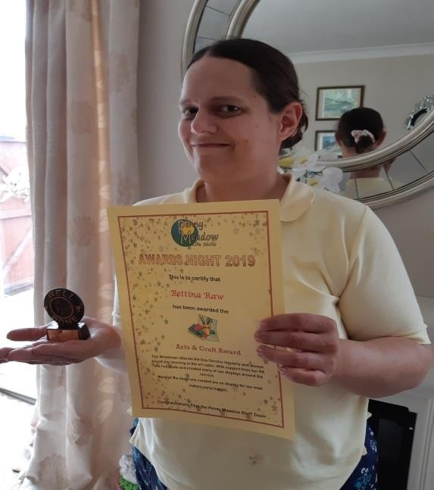

BEING BETTINA’S DAD – BETTINA’S PERSEVERANCE IN THE FACE OF ADVERSITY
Coming towards the end of a money awareness workshop, with my colleague Michaela, at Market Field School in Colchester http://www.marketfieldschool.co.uk/ I am approached by a member of the school staff who, I later learned, had especially come over to see me as she had heard that I had been talking about my youngest daughter Bettina.
Bettina is a former pupil of this wonderful school, moving on to Sixth Form 15 years ago. The member of staff remembered Bettina and was thrilled to see a picture of her on my desktop which was projected onto the screen. She recalled Bettina’s perseverance.
Have you seen the Disney film Lilo & Stitch? Until her second year in Market Field School, Bettina was ‘Stitch’ and, just like Stitch, she was someone who was not at one with her life or her surroundings, which the film depicts as being “lost”. https://www.youtube.com/watch?v=O_JyobhT34 (this link contains some funny moments from the film).
Despite Bettina having been diagnosed as having severe autism and a learning disability, her character is of fierce courage and a determination to persevere. From the beginning, her family recognised that it was going to take prolonged and patient perseverance; despite a significant amount of difficulties and obstacles, and that she would be continuously faced with fitting in, learning and contributing. However, Bettina was always going to be determined to have her voice heard - what a role model for those who are part of her life!
I have and continue to use her lessons in perseverance to achieve my objectives both at work with www.dosh.org and in my personal life too. So what are Bettina’s lessons in perseverance?
Bettina’s methods:
- Streamlining – Bettina streamlines the task, taking out unnecessary steps (& stages)
- Determination - Bettina has great enthusiasm, passion and a determination which inspires those around her to help her to succeed.
- Recognition - Bettina understands failure and uses it as her ‘rocket fuel’ to prove that she can achieve.
- Relentless focus – Bettina always deploys relentless focus to the task at hand. I love watching her getting on her ‘game face’ to do the most difficult jigsaw.
- Completion – Bettina cannot cope with unfinished tasks. If she runs out of time to complete a task before she leaves home with her Personal Assistant (PA) it will be first thing she completes when she returns at the end of her day.
- Vision of where she wants to go – Bettina always has a desired outcome in mind and she will find a way to share it with you.
Bettina keeps on improving and succeeding because of her perseverance by:
- Being surrounded by supporters who believe in what she is doing and what she is hoping to achieve.
- Always looking for new challenges to progress. The start of her verbal communication at the age of 10 followed by her reading skills. Bettina (constantly) perseveres with both her communication and her education. Bettina has her own library!
- Leading a disciplined life. The self-discipline required to do the things she does not feel like doing because she knows she should. She also brings order to her life with the systems and processes she creates for herself.
- Being open to new opportunities. Bettina does not have a closed mind. She can be frightened of dogs as their behaviour is unpredictable to her but this does not stop her interactions with animals.
- Ensuring the responsibility for her perseverance rests with her.
“If one dream should fall and break into a thousand pieces, never be afraid to pick one of those pieces up and begin again.” – Flavia Weedn
How I interpret Bettina’s lessons in perseverance:
- Reframe – if at first you do not succeed with your desired outcome you reframe your idea and if necessary redesign it.
- Patient “Patience and perseverance have a magical effect before which difficulties disappear and obstacles vanish.” – John Quincy Adams
- Persist – you are hard to get rid of, especially when you have an idea and an initiative you think will be for the greater good. You are not going to go away simply because someone has said no.
- Intentional – doing things with intention so everything you do is with a purpose (I have yet to see Bettina do anything that has not been on purpose)
- By being resilient. Bettina is incredibly quick to recover from setbacks, mistakes and her perceived failures. I must do the same too.
“Don’t be discouraged. It’s often the last key in the bunch that opens the lock.” – Author Unknown
When you think you cannot continue any longer and feel everything is against you, that is the time to persevere! Four months ago I developed inflammation in one of my knees and had difficulty bending my leg. It was incredibly painful, especially when I tried to go for a run. The temptation at 62 years old was to find excuses and reasons to stop running, perhaps for good.
Running has been a passion for nearly 40 years, so could I manage my life without it? No, I was going to be like Bettina and persevere – I needed to use all of the lessons ‘B’ has taught me. Now if I could get through the first mile of pain, could I do the next four or five miles? I did and now it only hurts for the first 100m and then I am away on another run,
Thank you Bettina, you inspire me (and your family) every day.
Source: Steve Raw www.leadershipintheraw.org
“So, what does perseverance mean? It means that one possesses persistence, tenacity, determination, and staying power. This in turn means, when applied to a problem or issue that
needs to be resolved, that the individual never gives up, never quits and never sees defeat until the problem, challenge, project, obstacle is resolved to a satisfactory level.”
Byron Pulsifer

It is not the critic who counts; not the man who points how the strong man stumbles, or where the doer of deeds could have done them better.
The credit belongs to the man who is actually in the arena, whose face is marred by dust and sweat and blood; who strives valiantly; who errs, who comes short again and again, because there is no effort without error and shortcoming; but who does actually strive to do the deeds; who knows great enthusiasms, the great devotions; who spends himself in a worthy cause; who at the best knows in the end the triumph of high achievement; and who at the worst, if he fails, at least fails while daring greatly….
Theodore Roosevelt

