LEADERSHIP AND WELLBEING PACK
September 2025
Established in 2006
Welcome to this month’s edition. Highlights include:
Damian Piper CBE our Resilience Coach starts this month edition with: The Back-to-School Mindset: Your September Opportunity… “September isn't just for kids heading back to school. For many of us, as we return from summer holidays and heading into Autumn it’s a natural time for a reset. It can carry the same energy as the new calendar year—a chance to get organised, refocus, and tackle new challenges……”
From me a new article in the Being Bettina’s Dad series: Make My Day “I was inspired to draft this article about making someone’s day following numerous messages I receive about Bettina and how she makes their day. Some of those people have never met her in person, but they feel they have a connection with her. Bettina reads all the comments said about her and from her smile and look of happiness, it has made her day too……”
From the ‘The Centre for Army Leadership’: Empathy and compassion are essential leadership skills, especially when it comes to 'knowing your people,' a cornerstone of the Army Leadership Framework. It’s about understanding others’ emotions and genuinely seeking to improve their situation.
Graham Belgum has two important messages from his excellent series of ‘Thought for the week ahead: ‘collaboration’ and ‘Positivity’. I highly recommend Graham’s weekly posts on LinkedIn.
There is lots more in this month’s edition so let’s dive in together……
Steve Raw FIoL, FCMI, GCGI
Email: stephenraw6@gmail.com
Blog: www.leadershipintheraw.org
Instagram: @stephenraw6
Twitter: @SteveRaw836
Blue Sky: https://bsky.app/profile/steveraw.bsky.social
LinkedIn: https://www.linkedin.com/in/steve-raw-72454721/
Facebook: https://www.facebook.com/steve.raw.771/

It’s not about how good you are.
It’s how Good You want to be.

The Back-to-School Mindset: Your September Opportunity
September isn't just for kids heading back to school. For many of us, as we return from summer holidays and heading into Autumn it’s a natural time for a reset. It can carry the same energy as the new calendar year—a chance to get organised, refocus, and tackle new challenges. So, what better time to master one of the most powerful skills: the art of saying no (or not yet…). And yes, this is art not science.
In our always-on world, it often feels like we're just managing an endless stream of requests, messages, and demands from all directions. There's a persistent, almost cultural pressure to be busy, to say "yes" to every opportunity or request, and to multitask our way to success. But in our heart of hearts, we know this path is a fast track to burnout and fragmented effort, not meaningful results. I know I’ve fallen into this trap in the past.
The real goal isn't to get everything done; it’s to get the right things done. Easy to write harder to do I hear you scream at your screen as you read this. I get it. I face the same challenges, and I certainly see it in the people I coach. Progress starts with more effort into working how we can be intentional about what you let into your day.

The Power of Pre-Prepared Responses
Saying "no" on the fly can be awkward. We worry about seeming unhelpful or letting someone down. The pressure to please or appease takes over. This is where a little preparation goes a long way. Instead of being caught off guard, have a few simple, pre-prepared responses ready to go. These aren’t about being dismissive; they're about being clear and respectful of both your time and the other person’s.
Here are a few examples you can adapt:
- For a new project request: "That sounds interesting. Before I can commit, can you help me understand how this aligns with our current priorities of [insert your key priorities]? I want to make sure I can give it the attention it deserves."
- For a meeting that doesn't seem relevant: "Thanks for the invitation. I'm not sure I'm the right person for this, as my current focus is on [insert your main project]. What outcome are you hoping to achieve, and can I help you connect with someone better suited to it?"
- For a last-minute request: "I'd love to help, but I'm committed at the moment focusing on [mention your current task]. I can revisit this with you later today if it's urgent, or we can look at a better time next week."
This approach helps you regain control and creates a healthy boundary without causing friction. You're not just rejecting an idea; you're showing you're thoughtful and deliberate about your time.

The Cost of the "Yes" Habit
Think about what you give up when you automatically say "yes." Every "yes" to a low-value task is a "no" to something else—to strategic planning, to developing your team, to taking a much-needed break. The myth of multitasking, where we jump from task to task, is one of the biggest productivity traps. Each switch comes with a mental cost, and we rarely return to the original task with the same focus. There are multiple studies that back this up and yet we still find ourselves doing it. I wonder in 50 years if we won’t look back on this period and think what were they doing. A bit like the health risks of smoking in the 1950s and 60s. It took way longer for this to get recognised and acted upon.
Ultimately, mastering the art of saying "no" isn't about being uncooperative; it’s about being a more effective and impactful at work and of course at home. It’s about protecting your energy, staying aligned with your purpose, and modelling the kind of focused productivity that will help you your entire team’ thrive.
What approaches do you use to help you say no?
As always, I’m interested in what you have to say.
Damian
damian@effectivechallenge.com | effective challenge podcast | LinkedIn | Instagram
Damian Piper CBE
Performance and Resilience Coach
www.effectivechallenge.com/podcast
“Although the world is full of suffering it is also full of overcoming it”
Helen Keller
Thoughts for the week ahead …… collaboration
The key to the success of any business is clarity on purpose - the why.
If everyone is clear on that then you can pull the individual strengths of your team together to find solutions.
The team need to feel safe to share ideas and challenge each other. To find the compromises that enables success (just enough nor perfect). To be able to lean on each other (trust).
Within this there is a need to be clear on who does what (structure - empowerment) and what the time line and budgetary/cost constraints are.
Success then breads success as your team become more adept at finding the right ways to communicate with each other and the rhythm. Collaboration then becomes becomes the norm.
Source: Graham Belgum. CEO Helix https://www.ehelix.com/ and Non-Exec Director for Thera South West www.thera.co.uk
Being Bettina’s Dad – Make My Day
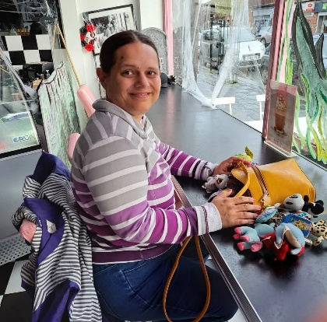 Sitting together in ‘Pop Pins’ a 1950/60’s themed coffee bar* in Finton on Sea on a Saturday morning with Bettina (aka ‘B’) is my idea of a perfect morning. Her beautiful smile makes my day. * https://www.facebook.com/poppinsfrinton
I was inspired to draft this article about making someone’s day following numerous messages I receive about Bettina and how she makes their day. Some of those people have never met her in person, but they feel they have a connection with her. Bettina reads all the comments said about her and from her smile and look of happiness, it has made her day too.
“A beautiful Bettina picture brightens up the dullest day.”
Standing in a long and slow-moving queue at a motorway service station on our way to our holiday destination, Bettina suddenly starts to kiss my arm and says, “love you Dad” and she has just made my day. The journey had been a little stressful with road works, traffic queues and being a sweltering day. Bettina had sensed how I felt and instantly this random act of kindness from her made me feel calm and happy.
While I am not suggesting you start kissing people’s arms, there are lots of other ways you can make someone’s day especially in these stressful times:
How Bettina makes her family’s day
- Saying something new. Bettina is a woman who copes with a learning disability and autism. Up until the age of 10 years old, Bettina was ‘non-verbal’. Her verbal communication is still limited and continues to be a challenge for ‘B’ so when she comes out with something we have not heard her say before at the lunch table, everyone stops what they are doing, and we look at each other miming: “WOW”.
- Her smile and laughter. To see Bettina’s beautiful smile and to hear her laughter is something to behold. It is wonderful when it is instantaneous but sometimes, her family cannot wait and often we compete to make her laugh and giggle.
- Making a choice on her own terms. This happened this morning, when she placed a piece of clothing her mum had chosen for her in our recycling bin and chose a new T-shirt to wear. This felt incredibly special, she would not have done that a couple of years ago. Each time Bettina shows her assertiveness, this feels like a big win..
- Taking responsibility for something within her home when we have not asked her to do it. Changing her big sister’s calendar at the beginning of the month or emptying the waste baskets and refreshing them with new bags is something she took upon herself to do.
- Seeing and reading about the impact Bettina has on people. Understanding the challenges & frustrations Bettina has experienced as she came to terms with her severe autism and learning disability it makes our day when people tell us she has made their day too, by just a smile or a greeting she has given them. We are so proud of her.
- When she says “I am so happy” Bettina is very economical with her words, we worry how she is feeling so when unprompted, she says “I am so happy” it means everything to us.
How you can make someone’s day
- A random act of kindness, doing something for someone and not expecting anything in return.
- A sincere compliment – recognising something they are doing, and you are specific about why they are being complimented.
- Helping someone through a challenging task and or situation especially when you can see they are up against it.
- Combat Road Rage! Let another driver go ahead of you, beckon a pedestrian to cross, hold off from honking when there’s a delay and thank the driver who stopped even though they have right of way.
- Contacting someone you have not been in in touch with for some time – e.g. you have seen something that may resonate with them.
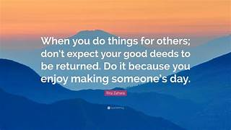
So, what makes my day?
- Someone who takes the time to send me a message about one of my blog posts or newsletters. This happened yesterday from a couple of former colleagues who told me what my articles meant to them. I was on a high for the rest of the day.
- Hearing Bettina’s ‘sing song’ chatter coming from her bedroom. Bettina is often telling herself stories, she always features in them and sometimes we feature in them too. Just hearing her voice makes my day.
- Joyce and Jennifer laughing at something I said (even if I did not mean it to be funny). Jennifer is ‘her mother’s daughter’ and there is a reason I call Joyce aka ‘Mrs Funny Bones’ It is not unusual for both to leave me in tears of laughter at our dinner table.
Related: https://leadershipintheraw.org/2023/03/01/being-married-to-mrs-funny-bones/
- When I hear or read about one of my former colleagues’ achievements and successes. I had the good fortune to be Managing Director for www.dosh.org supporting adults with a learning disability for 15 years, so when I read a story about one of their financial advocates making a difference in a person’s life or one of my former colleagues message me to tell me of a promotion or progress with their career, it makes my day.
- Someone laughing at one of my ‘Dad jokes’: I told my jokes to a mime artist, he was speechless. Ok that was not one of my best.
Bettina rushes over the bridge in Whitby to purchase a new bag at her favourite shop on the first day of our holiday. ‘B’ does not take her long to make her choice (knowing ‘B’ she will have remembered their stock from last year’s holiday). Seeing her joy has made my day.

“……after reading about Bettina, I just instantly feel calmer and more positive. Well done, Bettina! You are reaching more people than you think!”
Kathy Wales (a former colleague)
Have you made someone’s day today? If not today, perhaps tomorrow?
Source: Steve Raw www.leadershipintheraw.org

HURRYING AND WORRYING ARE NOT THE SAME AS STRENGTH
(Nigerian Proverb)

Your Biggest Challenge is to...
Time to read: 42 Seconds

Dear Steve
…fulfill your own ideas about yourself’
Hungarian chess grandmaster Judit Polgár
3 Ways to Do This:
1. Identity
“The greatest mystery of life is who we truly are’ – Alexandre Dumas
Who you decide to be is your choice – and this also critical in organisations, as lasting ‘change’ only happens at an identity level.
2. Purpose
“The two most important days in your life are the day you are born and the day you find out why.”- Mark Twain
Why are you here? What’s your reason for being? The research is conclusive - having a clear purpose in life is a powerful determinant of happiness, meaning and fulfillment.
3. Adventure
"Life is either a daring adventure or nothing at all." Helen Keller
Again, your choice – are you choosing to live your life adventure, or not?
David
@nakedleader across all social media
(David Taylor, author, broadcaster and presenter)
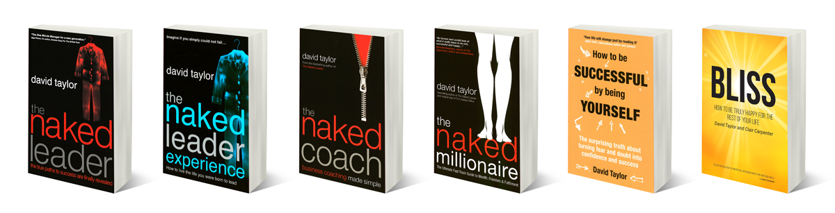
Thoughts for the week ahead…. Positivity
Life will throw many challenges at you and you can either face them down with a positive attitude or a negative one. Either way the challenge needs to be overcome.
As you embrace the next challenge, reflect and remind yourself how many previous ones you have overcome. Take heart and confidence from this.
Convince yourself that the challenges you now face can be overcome and provide that positive mental attitude to your team.
You will be surprised how infectious this approach is and others in your team will feed off your positivity and generate their own self belief.
As part of this be prepared to ask for help from your leaders . You will be surprised what they can bring to the table that you and your team may not have seen or maybe even have discarded as not acceptable.
Source: Graham Belgum. CEO Helix https://www.ehelix.com/ and Non-Exec Director for Thera South West www.thera.co.uk

Ten Ways to SELL AN IDEA
- Clearly identify what’s needed and why
- Sound out your idea to co-workers…
- ….even test it on a friend or relative
- Gather facts and data to support your argument
- When presenting, get straight to the point
- Keep succinct by avoiding jargon
- Make eye contact
- Memorise. Don’t read from a script
- …or worse, bombard listeners with PowerPoint slides
- Share the credit – acknowledge when others have helped

From Management Today

The Centre for Army Leadership

Empathy and compassion are essential leadership skills, especially when it comes to 'knowing your people,' a cornerstone of the Army Leadership Framework. It’s about understanding others’ emotions and genuinely seeking to improve their situation.

But there's more to it: familial care, the deep bonds formed in high-pressure environments like training and operations, which create a kinship between leaders, followers, and peers.

While there’s a leadership 'sweet spot' that balances empathy with rational decision-making, both are crucial when courageous action is needed.

How do you strike the right balance between empathy and decisive leadership?

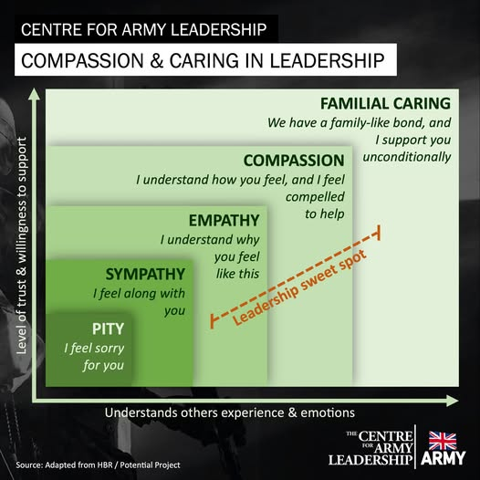

My Ted Talk Pick:
James Veitch – This is what happens when you reply to spam email
https://www.ted.com/talks/james_veitch_this_is_what_happens_when_you_reply_to_spam_email
Suspicious emails: unclaimed insurance bonds, diamond-encrusted safe deposit boxes, close friends marooned in a foreign country. They pop up in our inboxes, and standard procedure is to delete on sight. But what happens when you reply? Follow along as writer and comedian James Veitch narrates a hilarious, weeks-long exchange with a spammer who offered to cut him in on a hot deal.

HOW TO INFLUENCE
People specialists’ Learn Purple suggest managers should focus on two or three of the following characteristics each year to develop their influencing skills:

CLARITY: | Seeing the big picture and making sense of complex situations
DECISIVENESS: | taking decisions to force actions that will bring about progression
VISION: | looking forward in an enlightened and open-minded way
COURAGE: | being able to make the tough decisions
ACTION: | making things happen and bringing them to a conclusion
RESPECT: | giving and earning
POSITIVITY: | handling bad news in a way that makes people feel they’re in safe hands

FLEXIBILITY AND
ADAPTABILITY: being able to champion change
CONSISTENCY: | Staying calm and demonstrating emotional intelligence
SUPPORT: | being prepared to listen and ensuring people are given the best chance to succeed
CHARACTER: | being charismatic, aspirational and inspirational
TALENT-SPOTTING: | recruiting great people and putting together fantastic teams, including embracing those who are more talented than they are
EMPATHY: | having the ability to make people feel valued and important to the
 | success of the organisation

More on ‘influence’ can be found in my blog post ‘Being Bettina’s Dad – Influence a force for good’ https://leadershipintheraw.org/2017/08/15/being-bettinas-dad-influence-a-force-forgood/

“Knowing yourself is the beginning of all wisdom” Aristotle

Some excellent advice that I keep in my mind for workshops from David Taylor:
WHEN running a seminar, dress as an obvious expert. Have presence. Choose your clothes carefully; you don’t want to be dressed as though you are ready to do some gardening. Be well groomed. (Extract from The Naked Millionaire)
10 Quick Tips to Be a Better Boss
It takes more than one person to make a company successful—great businesses thrive because of outstanding teamwork. And it might be easy to bring a group of people together, but creating a cooperative and cohesive team of people, one that’s working for a common goal, isn’t so simple. It takes good leadership to help them be excited and effective. Like Henry Ford said, “If everyone is moving forward together, then success takes care of itself.”
People want to do a great job, to have their hard work acknowledged. When you treat your team members with honesty and respect and show a willingness to join them, you’re leading a culture of cooperation—and that’s a culture that produces enthusiastic and productive followers.
Do you want to lead your team to success? Do these 10 things:
- Lead by example.
Don’t ask your team to do something that you aren’t willing to do. If you never stay late to finish a project, you can’t expect them to give up their evenings.
- Provide the tools.
Do you know what your people need in order to succeed? Ask them and then listen—really listen. Maybe they need new software or special training. Whatever it is, show that you’re attentive and ready to support them.
- Don’t micromanage.
If you pick the right people, you can let them run with their own assignments. Checking on them causes frustration—and wastes your time—so if you can’t rely on others, you might need to reevaluate your hiring process.
- Be real.
Leaders have emotions, too. When you can honestly share the joys and frustrations of a project, you’re giving team members permission to be their authentic selves. Respect on both sides will grow and prosper.
- Focus on the mission.
Never lose sight of the reason your business exists. Teams want to be involved in a profitable project, but as the leader, bring them back to how their work impacts the company’s true purpose.
- Have fun.
Be sure to laugh. Besides reducing stress and releasing endorphins, laughter creates a bond among team members. People look forward to working together when they can look forward to a positive experience.
- Be available.
You might not be involved in every project or committee, but you should be available for questions, comments or requests as they come up. You’ll also want to ask your own questions and get status updates, so don’t isolate yourself behind a closed door.
- Admit your mistakes.
Nobody’s perfect, so when you flub something up, be a good role model. And admit when you don’t know something. Transparency builds trust, and problems get solved faster with it.
- Challenge them.
A healthy team looks forward to the opportunity to create something or to solve a problem, but a team that never leaves its comfort zone gets bored. Encourage out-of-the-box thinking.
10. Help them grow.
Each team member has unique strengths and talents, and your business is going to need new leaders. Offer training and education—and as people become interested in new topics, their curiosity can turn to expertise and lead to new product and service ideas.
Source: Source: Rhett Power from USA Success Magazine
And my take on three bosses I have previously and currently work with:
https://leadershipintheraw.org/2016/01/29/the-makings-of-a-good-to-great-boss/
“Trees are about to show us how lovely it is to let things go”
“I’ve come up with a set of rules that describe our reactions to technologies:
- Anything that is in the world when you’re born is normal and ordinary, and is just a natural part of the way the world works.
- Anything that’s invented between when you’re 15 and 35 is new and exciting and revolutionary, and you can probably get a career in it.
- Anything invented after you’re 35 is against the natural order of things.”
Source: Douglas Adams quoted in the The Guardian.

BELIEF SYSTEMS
A traveller was walking from one village to the next, when he came across an old man by the side of the road. He asked the old man “What is it like in the next village?” The old man promised to tell him once the traveller had told him what it was like in the village he had just left. The traveller explained “Terrible. I am glad to have left; the people were cold and unwelcoming”. The old man explained the next village was much the same. The traveller, feeling disappointed, went o his way.
A few weeks later another traveller, walking the same way, came across the old man, “What is it like in the next village?” he asked. The old man promised to tell him once the traveller had told him what it was like in the village had just left. The traveller explained “Wonderful, I am sorry to have left; the people were so warm and friendly”. The old man explained the next village was much the same. The traveller, feeling excited, hurried on his way.
life is what your thoughts make it
Source: Marcu Aurelius

FAST TRACK TO

EXPLAINING THINGS
Sharing information is incredibly important in the workplace, whether that’s telling your team about changes to their workload or teaching a new team member an important process. Getting your message across accurately needs clarity, simplicity and repetition.

Find the right level
Assess their level of knowledge and tailor your approach accordingly. Explaining how to scramble eggs to someone who has never seen an egg is a different matter to explaining it to a chef. Someone with deeper subject knowledge can be taught using industry language, but someone without that knowledge will need a more basic level.

Make it relevant
Show them how the issue relates to them and their job. Compare the new process or information to any similar knowledge and connect the new process or information to things they already know or do, putting the new information in context.

Keep it simple
Before getting into the minutiae, be clear about underlying concept. Start with the basics, for example what the process is for, who is involved, and why it is done.

Make it manageable
The best way to get information across is to break it down into small, manageable chunks. Divide the task into different pieces and go through each one separately. Checks each ‘chunk’ of information has been understood, and then recap all of the chunks at the end of each larger section See, hear and do
People absorb information in three ways – visually, aurally and kinaesthetically (though the body). For the best response, use all three – show them how something is done, explain how to do it and get them to practice the task themselves.
Be clear
Be as clear as possible in your descriptions and explanations. Try not to overuse pronouns like ‘it’ or ‘they’ – instead refer to things you explain directly, like ‘the database’ or ‘customer services,’ even if it sounds repetitive

Invite questions
Encourage questions at every stage of the process. If you know there are areas that can cause confusion, take your time over them and ensure you explain with extra clarity
My Ted Talk Pick:
Judson Brewer: A simple way to break a bad habit
https://www.ted.com/talks/judson_brewer_a_simple_way_to_break_a_bad_habit Can we break bad habits by being more curious about them? Psychiatrist Judson Brewer studies the relationship between mindfulness and addiction — from smoking to overeating to all those other things we do even though we know they're bad for us. Learn more about the mechanism of habit development and discover a simple but profound tactic that might help you beat your next urge to smoke, snack or check a text while driving.
I may not have gone where I intended to go, but I think I have ended up where I needed to be.- Douglas Adams

How to Build Hype
- Be different. You won’t stand out if you’re just offering the same as everyone else.
- Address your customers’ needs. Think about their life and why it’s not complete without your product.
- Restrict availability. People want what they can’t have – limited editions while stocks last.
- Tease before you please. Drip feed hints about your product before launch to pique interest.
- Get out there and talk. Find out who the trendsetters are and give them an earful.
Source: MT Management Today

