LEADERSHIP AND WELLBEING PACK
October 2025
Established in 2006
Welcome to this month’s edition. Highlights include:
Damian Piper CBE our Resilience Coach starts this month edition with: The Path to Fulfilment: Redefining Productivity in a World of Endless To-Do Lists “The majority of people strive to be "good" or even better. We want to be productive, helpful, and ultimately satisfied with our days’. We set goals and make resolutions, genuinely believing in our capacity for change. Yet……”
The 12th Leadership Lesson I learned – (Not to) OVERTHINK. “Overlooking a cliff face somewhere in the Brecon Beacons I am about to take my final test for my Hang Gliders pilot qualification. I have again checked my harness is fixed to the glider. I am trying not to over think about all manoeuvres I have to make and all the things that could go wrong e.g. the wind thermals. Now it is my turn to take off………”
Being Bettina’s Dad: Leaving a Legacy “Holidaying in Whitby, a historical seaside resort in the North East of England, Bettina and I are slowly reaching a point by the harbour where I always stop for a moment and smile. It is where, over 60 years ago my mum (all of 5’2’’) raised me of the ground by the scruff of my neck and said “Stephen if you don’t start behaving yourself, I am not going to sign your papers to join the Army” (a threat she always used to bring me back into line)….”
Graham Belgum has two important messages from his excellent series of ‘Thought for the week ahead: ‘’ Priorities” and ‘’dealing with the unexpected”. I highly recommend Graham’s weekly posts on LinkedIn.
There is lots more in this month’s edition so let’s dive in together……
Steve Raw FIoL, FCMI, GCGI
Email: stephenraw6@gmail.com
Blog: www.leadershipintheraw.org
Instagram: @stephenraw6
Twitter: @SteveRaw836
Blue Sky: https://bsky.app/profile/steveraw.bsky.social
LinkedIn: https://www.linkedin.com/in/steve-raw-72454721/
Facebook: https://www.facebook.com/steve.raw.771/
It’s not about how good you are.
It’s how Good You want to be.

The Path to Fulfilment: Redefining Productivity in a World of Endless To-Do Lists
The majority of people strive to be "good" or even better. We want to be productive, helpful, and ultimately satisfied with our days’. We set goals and make resolutions, genuinely believing in our capacity for change. Yet, how often do we find ourselves tripped up, derailed, or simply unable to live up to these admirable intentions? The answer lies not in a failing of our character, but in the subtle, often unhelpful influence of our environment. Our surroundings—be they physical, social, or increasingly virtual —act as an invisible hand, shaping our choices and if unmanaged, silently undermining even our best intent.
This is particularly evident in the growth of people seeking ‘better’ ways to be more productive – a steady increase since 2010 of people searching google for productivity reinforces this. There’s a prevailing drive for efficiency and constant "doing." I’d argue this environment fosters a flawed mindset, one that prioritises quantity over quality, speed over sustainability, and relentless activity over mindful progress.

The Flawed Premise of "Getting It All Done"
The belief that we can, or should, complete every task on our list is a trap. In our interconnected, information-rich world, the inflow of new potential work is constant. There will always be another email, another chore, another project. Pursuing the illusion of an empty to-do list is a fools game that fosters burnout rather than genuine satisfaction.
This fallacy is even more insidious because our to-do list isn't just the one we write down. Our environment subtly creates an unwritten, ever-growing list of potential obligations. Consider a session scrolling on social media. What might seem like a harmless break can subtly create new thoughts of things you "need" to do. You see a friend's career success, and your mind adds "network more" to a mental list. You see a beautifully renovated kitchen, and you feel the pressure to "research new décor ideas." These aren't formal tasks; they are gaps you feel the need to close personally and professionally, fuelling a pervasive sense of uncertainty. This invisible list, born from comparison and external stimuli, makes it impossible to ever feel truly satisfied.

The True Goal: Satisfaction and Fulfilment?
A truly healthy and sustainable productivity system has a different objective. Its goal isn't to get everything done; it’s to help you go to bed feeling satisfied and fulfilled from the day’s efforts. This shift in mindset is profound. Satisfaction doesn't come from a cleared list, but from a day spent on what truly matters. This means deliberately allocating your energy to tasks that align with your values and connects with the big picture things you’d like to achieve. A successful day is one where you’ve made meaningful progress on a project, connected with a loved one, or taken a moment to appreciate the present, regardless of what remains on your list.
This reframing encourages a more compassionate and realistic approach, with yourself and others. It recognises that our time and energy are finite resources. Instead of trying to do it all, we can focus on doing what is most important.

The Time Management Matrix and Your Mindset
Recognising that our environment can undermine our best intentions is the first step towards change. We can become the architects of our surroundings rather than passive inhabitants. When we apply a tool like the Eisenhower Time Management Matrix, we gain a powerful framework for action.
This matrix is built on two simple axes: urgency and importance. It helps us filter our daily tasks and, more importantly, our mindset, into four distinct quadrants:
- Quadrant 1: Necessity (Urgent & Important): This is the necessity quadrant—the pressing deadlines and unforeseen problems. While we can’t avoid these entirely, spending too much time here leads to stress and burnout.
- Quadrant 2: Effectiveness (Important & Not Urgent): This is the sweet spot. It includes things like planning, personal development, and relationship building. Proactively dedicating time here is the key to long-term fulfilment and reducing time spent in Q1.
- Quadrant 3: Distraction (Urgent & Not Important): This includes many of the "other people's crises" or minor interruptions like some emails or meetings. These tasks can feel important because they demand immediate attention, but they rarely contribute to our big picture goals.
- Quadrant 4: Waste (Not Important & Not Urgent): This is the time we waste on things like excessive social media, moaning, or gossiping. It offers no value and contributes to the feeling of being unproductive at the end of the day.

Redesigning Your Environment for greater fulfilment
Armed with this importance over urgency mindset, we can begin to redesign our environment.
- Practise Conscious Awareness: Take a critical look at your surroundings. Does your digital environment constantly distract you? Does your physical workspace encourage focus or interruptions? Identifying these environmental saboteurs is crucial. Then, apply the matrix to move the activities they promote into their appropriate quadrants.
- Prioritise and Schedule: Chances are day to day the most fulfilling work resides in Quadrant 2. Your focus shouldn't just be on what's urgent today, but on what's important for a better tomorrow. Proactively schedule time for these tasks, protecting that time from Q3 and Q4 interruptions. I’m not naïve, we all find ourselves in Q1 and some roles dictate that more than others. This is about being proactive in our outlook and actions.
- Delegate and Eliminate: Be ruthless with your time. Any "urgent" tasks that aren't truly important for you should be delegated. Or those time-wasting activities that make up your invisible to-do list? Those are prime candidates for elimination from your life entirely.
- Cultivate Supportive Communities: Surround yourself with people who share your values and support your aspirations. When your peers encourage balance and redefine productivity in terms of well-being and fulfilment, it reinforces your good intentions and makes it easier to resist counterproductive external pressures.
Our good intentions need nurturing. They need fertile ground to flourish. By understanding that our environment shapes our choices and actively cultivating surroundings that nurture our best selves, we can bridge the gap between who we intend to be and who we ultimately become. I’d argue this is a journey of continuous awareness and a compassionate understanding. And that true productivity isn't about what you cross off a list, but how you feel when the day is done.
As always, I’m interested in what you have to say.
Damian
damian@effectivechallenge.com | effective challenge podcast | LinkedIn | Instagram
Damian Piper CBE
Performance and Resilience Coach
www.effectivechallenge.com/podcast

“A warm smile is the universal language of kindness”
William A Ward

Thoughts for the week ahead……Priorities
If your teams are competing with each other for resources, then you could quite easily end up with a situation where all your programs are late and over budget.
This is where clear priorities are required along with the relentless focus on them across all functions to ensure success.
Every person in your teams need to be clear on what they must do first and why, and what can be parked for later.
That way each person will know that the actions they are taking are the right ones and will not feel conflicted. They will also be able to share in the success as each program delivers, knowing the part they played.
Source: Graham Belgum. CEO Helix https://www.ehelix.com/ and Non-Exec Director for Thera South West www.thera.co.uk
The 12th Leadership Lesson I learned – (Not to) OVERTHINK.
 Waiting in a car park ready to deliver a workshop and trying not to overthink how it will go. Related: https://leadershipintheraw.org/2023/03/29/delivering-dosh-money-awareness-training/ March 2023
* Overlooking a cliff face somewhere in the Brecon Beacons I am about to take my final test for my Hang Gliders pilot qualification. I have again checked my harness is fixed to the glider. I am trying not to over think about all manoeuvres I have to make and all the things that could go wrong e.g. the wind thermals. Now it is my turn to take off………*
Overthinking involves thinking about a certain topic or situation excessively and analysing it for prolonged periods of time.
I have experience in this area as I have often found myself overthinking a situation, especially when I was starting out in both my careers. One of the penalties of being a born worrier.
Related: https://leadershipintheraw.org/2024/11/14/a-born-worrier-do-not-worry-it-is-not-all-bad/
A piece of advice I have often given to people when they have come to me with something they were worried about is not to ‘overthink’ a situation (they are often on stage 4 of the situation before they have even tackled stage 1).
Five consequences of overthinking
- A paralysis of analysis. Overthinking problem to the point of not being able to make a decision. Thinking a situation is too complicated, and therefore a decision is never made, or made much too late.
- Convincing yourself that thinking about something for a long time is the key to developing the best solution. But often that is not the case. (the pursuit of perfection).
- The longer you think about something, the less time and energy you have to take productive action, because you are frightened of making a mistake.
- You cannot sleep or stay asleep because your mind is racing.
- Second-guessing your decisions and continuously imagining worst-case scenarios can be exhausting.
Ten ways to cope with overthinking (that have worked for me):
- Being simplistic. Perhaps because I left school at 15 years of age one of the advantages of my academic short comings are that I see situations and challenges in simple terms. Do not over complicate things in front of you.
- Choosing the right time to over think This is a discipline I regularly exercise. Choose the time you operate at peak performance (for me it is early in the morning) and then park your sticky situation/problem for that specific ‘time period.’
- Breaking that situation you are thinking about into stages and then only thinking about one stage at a time without thinking too far ahead. My experience, certainly when I was a Managing Director (for 15 years) is that often that thing that was exercising my mind for an undue amount of time, resolved itself by the time I got to stage 3 or 4.
- Talk it through with a Mentor or a trusted colleague to gain a different perspective. I am super lucky that I can do this with Joyce, my wife, who has a gift for getting things into perspective. As Joyce often tells me “It keeps you off the ledge Steve”
- Disrupt your overthinking with a distraction. Have a set of favourite distractions that work for you.
- Go for a run (a long walk works too). This is one of my favourite distractions for either solving a problem or putting your brain into neutral (when I am doing hill and or speed repetitions).
- Write it down. Writing the problem and or situation down and then including three options to resolve it. I have found this is a time efficient process as opposed to carrying it around my head.
- Put a time limit on it – if you are going to have to overthink a situation, then impose a time limit that you will focus on it. 15 minutes minimum, 30 minutes maximum works for me.
- Question your thoughts – will this thing you are overthinking about be an issue in six months’ time? The likelihood is, it will not be, and calm is resumed.
- Practice Mindfulness Related: https://leadershipintheraw.org/2025/06/07/being-bettinas-dad-bettina-transforming-my-life-with-mindfulness-2/

“Supposing a tree fell down, Pooh.
when we were underneath it?”
“Supposing it didn’t said Pooh.
after careful thought
Piglet was comforted by this.”

A.A. Milne
When it is ok to overthink and while retaining a balance
Sitting around the table at a Board Meeting in London a couple of years ago we were about to spend three hours ‘overthinking’ we were considering and analysing our business strategy for the next three years, it would include our risk management, strategic aims & objectives, and our financial position. Super talented people surrounded me, and this was ok to overthink what we were going to plan and implement (in a disciplined way.)
We had:
- allocated an amount of time for our deliberations.
- agreed an agenda and programme (we would stick to).
- end goals we wanted to achieve by the end of our meeting.
* Following my final test I qualified as a Hang Glider Pilot (although judging by my written exam results, nobody could accuse me overthinking about wind thermals):
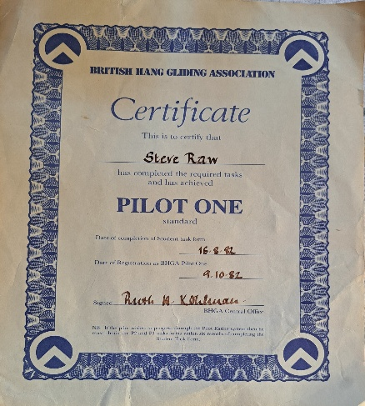
Source: Steve Raw www.leadershipintheraw.org
Thoughts for the week ahead……..dealing with the unexpected
No matter how good your plan or your foresight, things will crop up that you had not expected. Often these things will have a significant impact on you, your business and yourteam.
The key to dealing with this is to stay calm and not overreact. Take a pace back and assess the true impact and adjust your plans accordingly.
At work, where the situation allows, involve your key people (leaders/managers etc) in this process as soon as you can. Secure their ideas and their support for any changes. Then work with them to implement the new plan and keep positive momentum.
In our volatile world the unexpected will happen. The challenge is to ensure the response is measured and ensures long term success.
Source: Graham Belgum. CEO Helix https://www.ehelix.com/ and Non-Exec Director for Thera South West www.thera.co.uk

The Centre for Army Leadership

Where do you stand on the accountability ladder?

In both operations and everyday life, leadership means owning your decisions and actions, but it doesn’t stop there. A great leader holds themselves accountable and encourages their team to do the same. By setting this example, you empower others to take responsibility, fostering a culture of accountability and trust.

Rather than waiting for problems to resolve themselves, effective leaders actively take charge, making things happen. True leadership is about action, responsibility, and ensuring everyone is aligned to achieve success together.

#Accountability #Leadership #AccountabilityLadder #LeadByExample #Teamwork #Ownership #LeadershipDevelopment

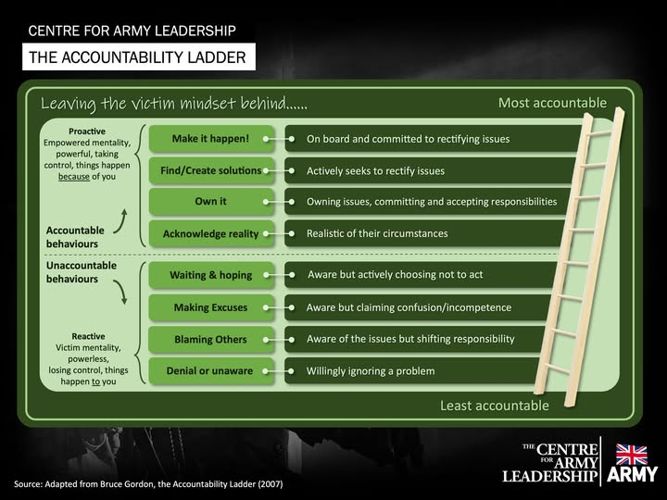
Being Bettina’s Dad: Leaving a Legacy

Bettina and her dad on a Whitby Pier courtesy of Bettina’s ‘tiger mum’, Joyce
Holidaying in Whitby, a historical seaside resort in the North East of England, Bettina and I are slowly reaching a point by the harbour where I always stop for a moment and smile. It is where, over 60 years ago my mum (all of 5’2’’) raised me of the ground by the scruff of my neck and said “Stephen if you don’t start behaving yourself, I am not going to sign your papers to join the Army” (a threat she always used to bring me back into line).
I think we had a unique relationship and even though she passed away 33 years ago, there is not a day goes by that I don’t think of her, and we still repeat some of her phrases. A favourite was “Steve if your backside was decked out with diamonds you would find one that wasn’t polished.” What a legacy she left me, but you don’t have to wait until you die before you leave a legacy!
As a leader you want to make a dent in the world, to make a difference in people’s lives and leave the place where you live and/or work a better place than when you found it. Someone who does this, and from whom I have learned, is Bettina.
“I believe our legacy will be defined by the accomplishments and fearless nature by which our daughters and sons take on global challenges we face” Naveen Jain
Spending a week in our favourite place I thought about how Bettina leaves a legacy and how I can learn from her. These are the ‘Five Takeaways’ – this is Bettina’s legacy:
- Bettina lives her life with honesty. Bettina has an integrity, kindness and generosity and this is profound to the lives she touches.
- Material wealth is not important to Bettina and is not something that she places any value on (I have found that material wealth is not often what you are remembered for)
- People often remember and remark on her determination, commitment to develop and progress, and her work ethic – she is a shining example.
- Bettina is a change maker. If you check out this post, you will see how Bettina changes her world and leaves a legacy
- Bettina’s high standards of politeness and etiquette (she expects these same standards from others too!). They are contagious. She is always remembered by the Hotel staff where we stay and I am sure that’s why she always gets the biggest dessert when it is served!

Bettina and her big sister, Jennifer outside our Whitby Hotel
One of the guests at the hotel in Whitby said to Joyce that “Bettina holds herself so well – we could all learn a lot from her” We are always moved when someone compliments Bettina, it means so much to us that it is not just her family who thinks she is wonderful and that others are affected by her presence and the impact she has stays with them until we see them the following year.
If you want to create an enduring and positive legacy then here are our questions for you:
- What would you like to be remembered for?
- When someone thinks of you when you have moved on what will they say about you?
- Will your legacy be one that is positive?
- Did you change your environment for the better?
- What would people who know you put as your epitaph?
“I’ve learned that people will forget what you said, people will forget what you did, but people will never forget how you made them feel” Maya Angelou
Footnote. After my Mum’s threat I got a grip of my behaviour (I stopped being cheeky until I married Joyce) and at the age of 15 my mum signed my papers to join the Army 53 years ago. Thirty Eight years ago, Bettina was born during our posting in Berlin – and her legacy began.
Acknowledgement. ‘100 Things Successful People Do’ by Nigel Cumberland

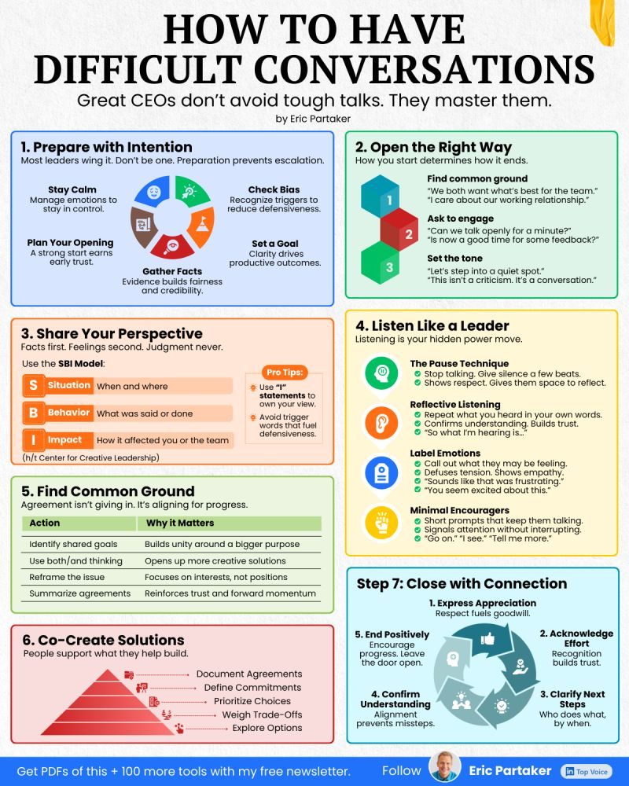

The Day I Had ‘A Lot to Learn’
Time to read: 65 Seconds
Dear Steve
The Day I Had ‘A Lot to Learn’
Dianne Thompson – now Dame Ila Dianne Thompson, DBE was CEO of Camelot Group from 2000 to 2014.
I was invited to host Camelot’s 2001 Conference, and Dianne wrote me an introductory email in advance of the event, which she closed with the words ‘I hear you have a lot to learn’.
OK, I knew I probably wasn’t their first – or even tenth – choice, and I was not known for ‘hosting’ conferences but come on – that phrase struck me to the bone, and it didn’t improve on re-reading.
I decided to put it out of my mind and managed to only think about those four words around ten times a day – and night – in the six weeks leading up to the event.
On the day, I was met by Dianne herself. She shook my hand warmly and we had a great chat. Towards the end, I plucked up the courage to say to her:
“Dianne, one more thing, in your email to me you wrote that I had ‘a lot to learn’”.
Her response astonished me: “Well, you have”
I now began to feel rather weak, as I asked her:
“What do you mean by that, if you don’t mind my asking”
She replied:
“Well, I hear you are doing the whole event completely off by heart – impressive David”
And that was the day I did indeed learn a lot:
No words have any meaning other than the meaning you choose to give them.
Or, as Humpty Dumpty said, 130 years before, "When I use a word… it means just what I choose it to mean – neither more nor less"
With my love and best wishes to Dianne and to you
David
(David Taylor, author, broadcaster, presenter, coach and trainer)
@nakedleader across all social media

GIVING A GREAT SPEECH
- Know your subject inside out. You shouldn’t fear audience questions.
- Use the latest research. It will make you more credible.
- Don’t rush – practice a few times by speaking in front of a mirror
- Only make jokes if you’re actually funny – and never pause for a laugh
- Bring notes with the speech’s key points but don’t look down too often Source: Management Today (magazine)
YOUR ROUTE TO THE TOP: TO VOLUNTEER OR NOT?
Look out for opportunities. Those who never volunteer rarely make it to the top; equally, those who sign up for the wrong things tend not to make it at all.
Establish the facts. Find out as much as you can before you commit: what is expected of you, the level of reporting required, and your resources. This is the best time to get what you need in place or to walk away if the right support isn’t there.
Be selective. Choose projects that are reviewed by the people you want to impress. Use the opportunity to ask for their views and get to know them better.
Think carefully. Consider what you will have to give up if you do volunteer – balance the benefits of taking on something new with the downside of having less time for everything else.
Choose well. Avoid ventures where the best scenario is that nothing goes wrong, like implementing a new e-mail system. If it goes badly, everyone blames you. If it runs well, few notice.
Show your enthusiasm. To get the full benefits of opting in, be seen to be keen.
Delegate. Pass on as much of your everyday work as possible; great opportunities are usually not part of the norm and so require us to free up our time to increase our chances of success.
Give clear instructions. Make sure that those you leave to look after the shop know what to do if things start going wrong, and how to get you back in when they need to.
Volunteer for projects that involve others you rate. Working with impressive people will help you raise your game.
Don’t spread yourself thinly. Do a few things properly rather than too many badly. If you get a reputation as a serial volunteer, you may become known as the fickle one who lacks finishing power.
(The Mind Gym)

BODY LANGUAGE

It’s how you say it – Many leaders know what it feels like to talk when no one is listening. Often, it is not the actual words causing the audience to tune out, but the way the words are communicated.

Use your body – We mainly rely on non-verbal communication to determine other’s intentions when they communicate with us.

Put your body on display – When speaking, step away from the podium; when sitting at a meeting, pull your chair back from the table to display more of your body

Know your psychology – Your audience’s instinctual ‘reptilian’ brain need to see your body to gauge your intentions. The less information they see, the more they simply make those feelings up, and tend to default towards the negative.

Speak from your belly – Place your hands in the TruthPlane, the horizontal plane that extends 180 degrees out of your navel, to show that you can be trusted. This is a vulnerable area so bringing an audience’s attention to it makes them feel like you are confident.

Get them in the palm of your hand – show your palms open with nothing in your hands, to let others know that you mean no harm and are speaking for their benefit. This is universally recognised as a ‘friendly’ gesture.

Listen actively – When someone else is speaking keep your hands in the TruthPlan so that they understand you are open to what they are saying.
Source: Mark Bowden, body language expert and creator of Truthplane (from this month’s ILM Edge Magazine
“Everyone chases after happiness, not noticing that happiness is right at their heels”
Bertolt Brecht
CAREER MASTERCLASS
PUSH YOUR TEAM
Be explicit. Does every team member know the difference between competent and outstanding? Explain clearly what exceptional performance looks like and what the rewards are.
Spot what stops them. Help people identify what’s holding them back. Whether it’s crumbling self-belief (create achievable actions to boost their confidence) or just a chatty neighbour (change the seating plan), fix it together. And fix it fast.
Empower them. Don’t confuse pushing with micro-managing; let those who can handle it reach peak performance in their own way. Use outcome-focused briefs, avoid rigid sets of instructions, and encourage creativity, then watch them drive themselves harder than you ever could.
Inspire. Steve Jobs once said: ‘If you are working on something exciting that you really care about, you don’t have to be pushed. The vision pulls you.’ Explain the dream behind your high standards and rave until they’re also desperate to get there.
Keep talking. Specific, stretching goals will only work if you evaluate them. Meet individuals every fortnight to discuss progress against clear measures. Grafters will be encouraged to try new challenges; coasters will get a wake-up call.
Practise what you preach. Be their role model. Are you pushing yourself as hard as you’re pushing them?
What’s in it for them? People will always strive harder towards their own goals than someone else’s. Help them define their future then show them how it fits into the overall vision.
Create competition. Publicly praise star performers. There’s nothing like a little rivalry to keep the troops on their toes.
Say thank you. Take a moment to celebrate victories before you set your team their next challenge. Host a team lunch, give them an early finish, send a praising email. You can only push a team thanklessly for so long before they push off.
The Mind Gym: Relationships is published by Little, Brown

“There is no trouble so great or grave that cannot be much diminished by a nice cup of Tea” Bernard-Paul Heroux

Ten Ways to SELL AN IDEA
1. Clearly identify what’s needed and why
2. Sound out your idea to co-workers…
3. ….even test it on a friend or relative
4. Gather facts and data to support your argument
5. When presenting, get straight to the point
6. Keep succinct by avoiding jargon
7. Make eye contact
8. Memorise. Don’t read from a script
9. …or worse, bombard listeners with PowerPoint slides
10. Share the credit – acknowledge when others have helped
Source: Management Today

Eleanor Roosevelt said “Ones philosophy is not best expressed in words; it is expressed in the choices one makes…. In the long run, we shape our lives, and we shape ourselves. The process never ends until we die. And the choices we make are ultimately our own responsibility.”
If you want to reach your potential and become the person you were created to be, you must go out of your way to seize growth opportunities as if your future depended on it. Why? Because it does. Growth doesn’t just happen – not for me, not for you, not for anybody. You have to go after it!

