LEADERSHIP AND WELLBEING PACK
January 2026
(established 2006)
The 20th Anniversary Editions

“We often spend January 1st walking through our lives, room by room, drawing up a list of work to be done; cracks to be patched. Maybe this year, to balance the list, we ought to walk through the rooms of our lives... not looking for flaws; but for potential." Ellen Goodman
Happy New Year! and I hope you had a terrific Christmas. Everything about this edition is aimed at supporting you to have the best year ever.
I have included a personal post about making commitments instead of resolutions. I never seemed to be able to keep to resolutions, so I have been making commitments for the last 35 years and you know what? It works for me. Let’s commit to making 2026 our best year yet. There are lots more, so let’s dive in together.
Steve Raw FioL and FCMI
Email: steve.raw@thera.co.uk
Blog: www.leadershipintheraw.org
Instagram: @stephenraw6
Twitter: @SteveRaw836
Blue Sky: https://bsky.app/profile/steveraw.bsky.social
LinkedIn: https://www.linkedin.com/in/steve-raw-72454721/
Facebook: https://www.facebook.com/steve.raw.771/
It’s not about how good you are,
It’s how Good You want to be.
MAKE 2026 THE BEST YEAR YET
2025. On 17 December (2025) Joyce (my wife) and I had our Annual General Meeting (AGM) at a local restaurant. I am Joyce's 'Employee of the Year’ I must admit it wasn’t guaranteed until Joyce announced it during our AGM.

A super meal, a review of 2025 which had included (me) finally retiring, our objectives set for 2026, lots of laughs and I received an award!
It has been 54 years since I entered the world of work. Initially I delivered carpets and beds in my hometown of Stockton-On-Tees followed by two careers: Army, Social Care and then finally having the privilege to work for the Army once more at ‘HQ 16 Air Assault Brigade Combat Team’, before finally retiring earlier this year.
Into 2026 and I want to be better than I was the previous year, to be more and do more for my family and the people I support.
So, at the start of each year instead of making resolutions (who keeps those?), let us change the word to ‘Commitments’ as in “I am going to make some commitments in my life and in my career.” It feels different – using the word Commitment feels like it has a purpose (there is no going back!).
In the days leading up to the New Year I have put down on ‘paper’ what I am going to do, and I thought it might be something that might help you too, to have your best year too. ‘The most difficult thing is the decision to act; the rest is merely tenacity” Amelia Earhart
Related: https://leadershipintheraw.org/2024/12/20/setting-goals-objectives-commitments/

In 2026 believe in yourself:
- If you make mistakes (no one is perfect) accept that you will make mistakes, learn from them, and keep going. “Failures are finger posts on the road to achievement” C S Lewis
- Do not second guess yourself. You can only make the best judgement at the time with the facts in front of you, but do decide (nobody likes a ditherer)
- It is easier to ask forgiveness than it is to ask for permission. Back yourself to do the right thing and do it now. (Nobody likes a procrastinator).
- No matter how busy or how much pressure you are under during your day, do one thing which you enjoy.
- Book yourself a coaching or mentoring session with your coach or mentor. Talk through your dreams and aspirations (try and fix up one of these meetings at least bi-monthly)
- Record your successes and read them through before you start your new week.
- When you are facing a crisis, and you are coming under pressure, tell yourself two things: One. Have you faced this before - How did I deal with it then? And two. In six months, time will this situation be so important. Probably not.
- Reward yourself. Something I picked up from running – if I had a good race, I rewarded myself. It could have been a new pair of running socks or an energy bar, it does not have to be much, but it can make you feel a whole lot better. Give yourself a pat on the back.
- Laugh whenever you can – it is cheap medicine.
- Regularly (daily is best) go for a walk. Take a break- you only need to find 30 minutes in your day. It will refresh you and it will give you the time to think.
My Seven commitments for 2026:
1. To take on as many household responsibilities and duties as possible so that Joyce feels she has retired too. (I want to Joyce to pick me as employee of the year at the end of 2026).
2. I am 70 this year and I am determined to maintain my fitness (it is also essential for my mental health and self-esteem) So I will make time to go for a run: - four sessions a week. Each morning core strength training (sit-ups and press ups etc). Formulating a programme that is: ‘viable and sustainable’ that focuses on quality not quantity.
3. Write a monthly blog post alternating between leadership and the lessons I have learned from Bettina (my daughter who copes with a learning disability and autism).
4. Publish a weekly e-newsletter which includes tips, a podcast, articles, music, and cake, for my mailing list (btw are you on my mailing list? If not and would like to be?).
5. Publish a monthly leadership & wellbeing e-magazine. 2026 will be the publication’s twentieth anniversary.
6. Health and Well Being. This year I am going to:
- Improve my sleep patterns - working towards getting at least seven hours sleep every night. (So, no cups of tea for me after 7pm and no looking a ‘blue screens after 7pm)
- Drink at least one bottle of water every day.
- Stand up more instead of sitting down – especially when using my laptop.
- Practice balancing on one leg at a time at least once a day (I got that one from Joyce)
- Practice Mindfulness at least once a day (I have learned this from Bettina)
- Loose 10lbs in weight (according to my running magazines this will knock 1.5 minutes of my 5KM time!)
7. Eliminate Waste. Look at every part of my life and eliminate waste – what am I wasting time on? What am I duplicating? What savings (financially) can I make that will not affect my performance and the difference I want to make in other people’s lives?
And not to forget to live my life well https://leadershipintheraw.org/2016/09/26/living-your-lifewell/
“Don’t judge each day by the harvest you reap, but by the seeds you plant.”
Robert L Stevenson
In 2026 I will repeatedly take a step back and I will think about what I have in my life and be grateful for everything that comes my way. So, I am going to wake up in gratitude every morning:
Related: https://leadershipintheraw.org/2015/09/09/being-bettinas-dad-taking-the-time-to-be-grateful-andshowing-gratitude/
“If you woke up this morning in a nice warm bed, if all your loved ones are safe and happy and you have food/water - why wouldn't you be grateful?”
Joyce Raw
If it happens to be a failure, I will see it as my first and second step towards my next success. I will understand that failure is not permanent, and neither is success, so I will prepare for both this year.
Related: https://leadershipintheraw.org/2014/08/11/fail-and-fail-big/
On 31 December 2026 I am going to read this again to see how I got on before I make a new set of commitments for 2027.
Source: Steve Raw www.leadershipintheraw.org
Weeding – necessary to improve the garden and mind? (Originally published in January 2020)
Damian Piper CBE

I’ve spent a few hours out in the garden today. Whilst not much is growing it’s a good time to tidy things and generally prep for Spring. I say not much is growing, despite it being winter there still seems to be plenty of weeds. That’s the thing with those unwanted plants. They seem to pop up and establish themselves wherever there is space.
It’s not just the garden that we need to give consideration to when it comes to unwanted things. Our mind is definitely somewhere we can find things that are unwanted. Just like the garden, we can quickly find we have a whole heap of thinking that detracts from what we would really like.
My lack of experience as a gardener often means my ability to tell what’s a weed could be better. I ask myself is this plant wanted? To answer this, I run through a few other questions. We can adopt a similar approach when it comes to our thoughts. Depending on which study you want to believe people are having between 60,000 to 80,000 thoughts a day. I’m really not sure about the validity of those types of stats. I do accept it’s a big number though. I also accept that people have stacks of thoughts that they either don’t want or don’t serve them. Working through the complexities of this topic goes beyond this article. There are however some things we might consider to raise our awareness and help ourselves.
Why does this matter? The thoughts in our minds invoke our feelings. These are two sides of the same coin; often feeding off each other. We do have a choice about whether to engage with the thoughts we have. The choice of getting ‘lost’ in thought is often at the expense of living in the present moment. So how do we go about weeding out the thoughts to engage with and those to drop? As always with these articles, I’ll look to provide some practical suggestions. Here are three questions that build on each other:

- Do I want this thought? This simple question is a powerful one. I say simple, although to use it when we probably most need it is not easy. Chances are the answer to this question for a vast amount of times you ask it, will be a big fat ‘no’. A common cause of the thoughts we don’t want is overly emotional/irrational thinking. And typically, these thoughts are dwelling on the past or projecting into the future. Deliberately shifting our thinking to something more constructive is possible. For example, focusing on our breathing or listening to the sounds around us can help bring us back to the present.

- How is this thought serving or hindering me? If the answer to question 1) was yes, question 2) helps go further to understand what might be going on. Despite making us feel uncomfortable there may well be helpful information in the thought, in which case it is serving you; this may not be obvious. For example, helpful thoughts could be anxious thinking about a task, an indication that you to establish greater clarity about what you actually need to do. Hindering thoughts might be about things you have little to no control over, for example, whether someone likes you or not.

- What will I do as a result of this thought? Are you going to do something as a result of your thinking? If you’re not, then it’s likely the thought served no real purpose. For example, some work you have asked to be completed has fallen short of what you expected. Negative thoughts about the person who did the work or the circumstances you now find yourself in that just whir around your head is not helpful. You have three choices of what you can do:

  - Change the situation through some (hopefully positive) action
  - Accept the situation for what it is and genuinely move on
  - Remove yourself from the situation

You might want to think about these questions as putting yourself in the driving seat of your thinking and use the CAR mnemonic as a way to help remember them.
Whilst it might be challenging and, in some cases, overwhelming to think about our thinking, I’m confident with some effort and understanding it is possible to make positive progress. Unchecked we are capable of making up all sorts of unhelpful stories. Raising our awareness and doing a spot of ‘thought weeding’ might just mean we allow ourselves to grow and bloom.
As always I’m interested in how you get on if you explore the content of the article. Drop me a line on damian@effectivechallenge.com
If the article has resonated, you might like to check out my podcast which explores topics which are aimed at improving your performance and results www.effectivechallenge.com/podcasts
Until next time,
Damian
damian@effectivechallenge.com | effective challenge podcast | LinkedIn | Instagram
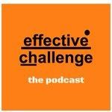
The Centre for Army Leadership
Empathy and compassion are essential leadership skills, especially when it comes to 'knowing your people,' a cornerstone of the Army Leadership Framework. It’s about understanding others’ emotions and genuinely seeking to improve their situation.⁠
⁠But there's more to it: familial care, the deep bonds formed in high-pressure environments like training and operations, which create a kinship between leaders, followers, and peers.⁠
⁠While there’s a leadership 'sweet spot' that balances empathy with rational decision-making, both are crucial when courageous action is needed.⁠
⁠How do you strike the right balance between empathy and decisive leadership?
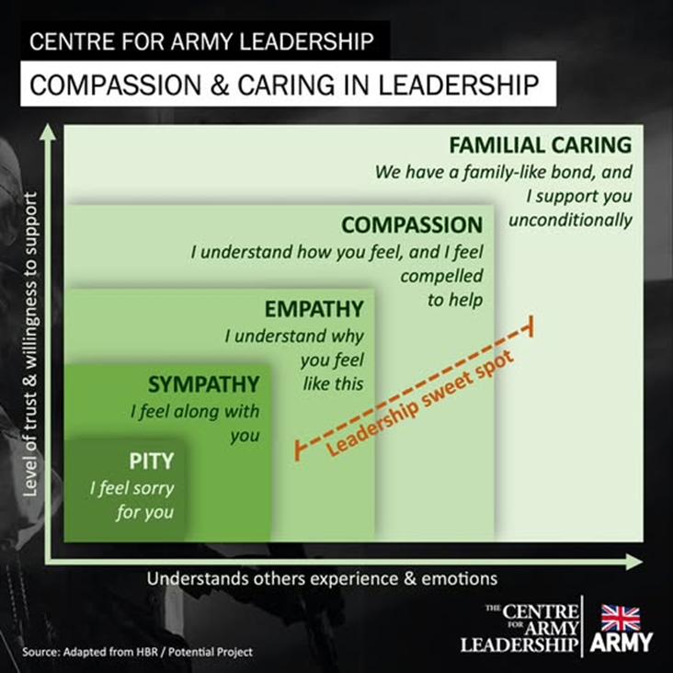

Ten Ways to… TOUGHEN UP in 2026
- Don’t take it personally.
- Believe in yourself.
- Accept it’s ok to make mistakes…
- …. but don’t make too many.
- Keep your focus.
- Hold your nerve.
- Don’t compare yourself to others.
- Let go of anger.
- Take a few risks.
- Learn to switch off.
Source: Modern Management (magazine)

TEN TIPS TO HELP YOU THINK MORE POSITIVELY in 2026
- Become a more conscious thinker and observer. Try to become more aware of your thinking and mental decision-making process; what sorts of triggers or stressors do you react to; how can you become more responsive and less reactive.
- Become more strengths – focused. Strengths based leadership, as its name suggests, is where you focus more on strengths – yours and those of your colleagues – things people are good at, to get things done.
- Focus on solutions rather than problems. Recognise this must not be at the expense of ignoring risks, dangers, or threats. Recognise, too, if focusing on something nominally “negative” gets you closer to a goal or solution, then it’s not really negative after all.
- Develop your emotional intelligence. It is possible to invest in online tools as well as workplace – based training in this area. Developing your listening, conversation and communication skills can also help you become reflective.
- Use mindfulness or meditation exercises. Again, there are many techniques you can find online. But it is important to choose one that works for you.
- Take a moment each morning to positively ‘set’ your day. This can help to make you feel more in control of events, your decisions, and behaviours.
- Take responsibility. Instead of always looking for things or people to blame when things go wrong, focus on the choices you have, the positive ways you can respond.
- Set yourself clear goals. This will make you less likely to feel you are constantly being buffeted by ‘events. And don’t be afraid to reset them if they are becoming unattainable or unrealistic.
- Relax. Get properly away from work to recharge your batteries, reflect and, if necessary, get back in touch with your more positive self.
- Smile more. Make a point of actively trying to be more polite, cheerful, and positive. After a time, it will become second nature and may give you are more positive perspective on things going on, and people, around you.
Source: Nic Paton ‘The Power of Positivity’
"Live your life and forge yourt age." - Norman Vincent Peale
KICK-START YOUR LIFE IN 2026
The partying is over, and it is time to get stuck into work. If you are feeling less than motivated on the threshold of 2026, business consultant Michael Breen has the following advice to help you kickstart yourself:
- Start by knowing what you want to be motivated about. It’s no good having a vague idea about ‘just being more motivated to do more stuff and do that stuff better.’ That won’t do. Sit down and work through exactly where you are now and where you want to be. Make a checklist of all the benefits and positive consequences you want from being more motivated.
- Make your vision of a more motivated you as rich and clear as possible. If it isn’t clear, work harder at it. Don’t go alone, work through your motivational journey with a partner, friend, or colleague. Maybe even your boss.
- Finish unfinished business. Incomplete tasks take up too much mental space; you need all the brain capacity you can muster for your new motivated self.
- Make some choices: no more whining, self-pity, reasons why you can’t do things, turning to booze or drugs. Be aware that goals can affect each other. Sorting out your fitness level could make you happier, more energetic, and more able to deal with your family commitments and take on a more exacting role at work.
- Now really is a good time to make a commitment to change but then it always is. It is easier said than done and you may need help. Just because you can move a piano from one side of the room to the other doesn’t mean you can shift it to a new house. You need help. Go get it.
- Once you have thought of the content of your new future make it realistic. If you’ve made a clear enough mental representation of where you are going, you will want to achieve success in the shortest possible time.
- Find some allies, people who can support you and want you to succeed. They should be your personal cheerleaders (without the frilly skirts and pom-poms); people who will share your goal path and with whom you feel comfortable talking about your successes. They are not mentors but fellow travellers who are willing to give you moral and practical support.
- Develop yourself as an ‘obstacle dealer.’ Tell yourself, I’m just the sort of person who deals with obstacles.’ If an emergency crops up it doesn’t make the goal impossible…. reconfiguring goals is called ‘life.’
- Start with what you’re good at. When I work with people on motivation, we start from where they are, from what they already do well, with competence and confidence. Highly motivated performers in business have very clear ideas about what they are good at. They also know when to ask for help. This is not failure; it is very smart.
(Michael Breen – www.mbnlp.com )
Source: ‘Professional Manager’ member magazine for the CMI)
No act of kindness, no matter how small, is ever wasted. –Aesop

THREE FOUNDATIONS OF A HEALTHY LIFESTYLE IN 2026
1. Eat Well
A balanced diet will not only boost your immune system and help to keep coughs and colds at bay, but it can also improve levels of concentration and make you more mentally alert. The following foods are particularly beneficial for the brain, says dietician Nigel Denby
- Pears – boron, a mineral found in pears, may help electrical activity in the brain.
- Sesame seeds – rich in omega 6 fatty acids needed for nerve impulses and may improve memory function.
- Wholemeal bread and cereals – give slow released energy and B vitamins to nourish the nervous system.
- Celery – contains special nutrients called phi halides which calm the nervous system.
- Oily fish – full of omega 3 fatty acids, essential for nerve function
- Ripe bananas – high in potassium, inadequate potassium can lead to mental confusion.
- Lean red meat – provides iron for haemoglobin production, Haemoglobin transports oxygen to the brain, vital if you want to work efficiently.

2. Sleep Soundly
A good night’s sleep is essential to maintain your health and sense of wellbeing, says Rodney Epstein of Relax. Most of us need between six and eight hours to perform at our peak, and if we don’t get enough sleep, concentration and memory start to suffer.
- Develop a regular sleep routine.
- Take regular exercise, but not within three hours of your bedtime.
- Make your bedroom dark and neither too hot nor too cold
- Take the TV out of your bedroom – make it a place for sleep only.
- Keep a pen and paper beside your bed to write down anything troubling you.
- Avoid caffeine – drink warm milk or herbal tea instead. Milk contains tryptophan, which induces sleep.
- Make evening meals light and not too late.
- Try a drop of lavender essential oil on your pillow or take Passiflora – readily available in tablet form. It is non-habit-forming and aids sleep.
- If you are lying awake, get up and have a drink or do something involving your head and your hands, like a jigsaw puzzle or the ironing.
3. Get Some Exercise
Keeping fit doesn’t have to mean running a marathon. Even if you’re short of time, it’s easy to incorporate exercise into your daily routine. Try:
- Taking the stairs instead of the lift
- Getting off the bus or train one stop earlier and walking the rest of the way
- Parking at the furthest side of the car park
- Walking over to speak to your colleagues rather than relying on e-mails and phone calls.
- Going for a walk at lunchtime
- Buying a bike and cycling to work
- Ask your organisation to subsidise the membership of a local gym.
“Life is like a mirror. Smile at it, and it smiles back at you.” Peace Pilgrim

YOUR ROUTE TO THE TOP- HOW TO GET YOUR WAY IN 2026
Keep your enemies close. Let the other person speak first. You’ll gain invaluable insights into their true concerns, and they’ll be more likely to listen when it’s your turn.
Delve deep. Ask questions to find out what’s driving them. Whether they want to be inspired or to be given irrefutable facts, you can adapt your approach once you know their motivations.
Engage them. Be clear about what’s in it for them: ‘This project will involve working closely with several different people. I believe this will appeal to your social side.’ People make decisions for their own reasons, not yours.
Choose your words carefully. Use phrases like: ‘let’s….’ or ‘shall we try…?’ If you’re pushy, they’ll be less likely to comply.
Flattery will get you everywhere. To get a colleague to adopt the next proposal, explain what was good about the last one and why: ‘The PCP examples worked really well, and I like the humorous tone.’ If they feel favourably towards you, they’ll be more open to persuasion. Just don’t overdo it!
Guide them. People are most likely to agree to something if they feel they’ve come to the conclusion themselves. In My Big Fat Greek Wedding, the protagonist’s mother uses gentle questioning to get her way. It’s so effective that the daughter leaves to follow her dreams, and her father thinks it was his idea.
Make your case. State all the facts, and be clear about the pros and cons. Offer solutions that will resolve their concerns and open a debate to incorporate their views. Focus on areas where it’s easier to adept without damaging the integrity of what you’re trying to achieve.
Be prepared to compromise. Is your way really the best way? Present your proposal as a first draft to work on together. A collaborative solution is more likely to lead to a positive outcome for everyone.
Source: ‘The Mind Gym. Give me time’

"Those who do not believe in magic will never find it".
Roald Dahl

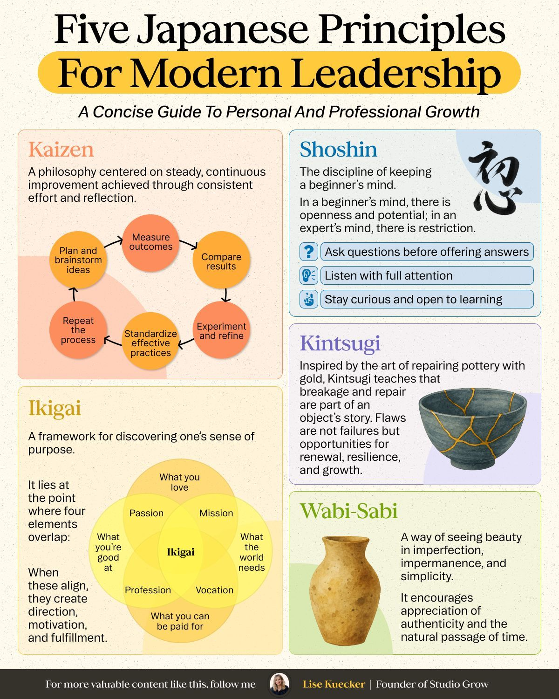

Six Confidence Boosters to take into 2026.
- Greet others with a smile and look them directly in the eye to convey confidence born of self-respect.
- Always show real appreciation for a gift of a compliment. Don’t downplay expressions of affection or honour from others.
- Don’t brag. A confident person is genuinely modest.
- Don’t make your problems the centrepiece of your conversation. Talk positively about your life and the progress you’re trying to make. Be aware of negative thinking and take notice of how often you complain.
- Respond to difficult times by increasing your level of productive activity. Don’t sit around and fall victim to paralysis by analysis.
- Choose to see mistakes and rejections as opportunities to learn. Failure might result from something you’ve done – and you might fail again. But failure doesn’t define you.
Source: Denis Waitley read in my ‘Success’ Magazine
“Feelings are just visitors. Let them come and go” Mooji

HAPPY NEW YEAR -8 WAYS TO MAKE YOUR RESOLUTIONS A REALITY
- Write it down. You’ve heard it before, but the truth is writing down your goals forces you to get clear about what you want. Use a pen and paper (you can transfer it to your computer later). That simple physical act helps cement the desire in your brain.
- Find a replacement. In The Compound Effect, Darren Hardy explains one way to break a bad habit is to replace it with a good one. What can you choose to add to your life that will fill the void by eliminating a bad habit? For example, replace TV time with family time, sweets with fresh fruit, talk radio with inspiring audios.
- Tell someone. Talking about your goal-even if it seems huge and impossible-allows others to encourage and help you by providing resources and information you may need.
- Take baby steps every day. Even small steps taken toward your goal consistently will move you in the right direction. Once you experience a few small wins, taking bigger steps becomes easier.
- Take some BIG steps. Don’t take all year to do what you can accomplish in a day. Once you’ve written down your list of goals for the year, figure out which goals could be accomplished this month-or even today.
- Decide and act. Mental hurdles may keep you from making decisions and taking action. Get over it! Make a list of all the reasons you want to accomplish your stated goal. Refer to that list when indecision or inaction threatens to take control.
- Team up. Even if you don’t share the same goal, having a “success buddy” can keep you accountable. Meet weekly (in person or by phone) to check in on and encourage each other.
- Celebrate your successes. Every time you reach a milestone, acknowledge your accomplishments in a positive way. For example, if you drop a dress size, buy a new outfit. If you pick up a new customer, have dinner with a mentor. Celebrating your success will keep you focused on the larger goal.
Source: USA’s ‘Success’ magazine

“Every man should be born again on the first day of January. Start with a fresh page. Take up one hole more in the buckle if necessary, or let down one, according to circumstances; but on the first of January let every man gird himself once more, with his face to the front, and take no interest in the things that were and are past” Henry Ward Beecher

And finally, for 2026……. Think lucky!
Psychological research suggests that leaders who embrace the concept have a better chance of inspiring those around them. Richard Wiseman a psychology professor has identified the following key characteristics of people who are more than usually ‘lucky’.
- They tend to have networks of friends and are good at spotting opportunities.
- They back their hunches and have good intuition.
- They expect to be lucky and create self-fulfilling prophecies.
- They adopt a resilient attitude that helps transform bad luck into good.
"The right to do something does not mean that doing it is right." - William Safire

