LEADERSHIP AND WELLBEING PACK
February 2026
The 20th Anniversary Editions
Welcome to this month’s edition. Highlights include:
Damian Piper CBE our Resilience Coach starts this month edition with: problems for puzzles “Every morning, millions of people sit down with their coffee and open Wordle. We intentionally seek out a challenge, a five-letter problem designed to stump us. When we fail to guess the word in six tries, we might feel a brief sting of defeat, but we usually return the next day, ready to try again…….”
Being married to Joyce – a model for ‘Integrity’ (and why it matters) “I have had the good fortune to have had two exciting and I think successful careers. My good fortune includes working for inspiring leaders and managers whom I sought to learn from at every opportunity. Integrity was something I always looked for in those who would lead me. The person I have learned the most from (and continue to learn) is Joyce, my wife……”
From The Centre for Army Leadership Servant Leadership “True leadership is a balancing act. Command authority drives task completion, while leadership supports team and individual needs. The real skill lies in knowing when to shift focus to meet the demands of the moment……”
Being Bettina’s Dad – Bettina’s Kind Heart “Bettina sits quietly in class alongside other pupils. There is a boy sitting next to her who is becoming increasingly distressed. Without turning Bettina reaches out to him and strokes his hand, despite verbal language being a challenge for Bettina, she soothingly says “it’s ok” …….
There is lots more in this month’s edition so let’s dive in together……
Steve Raw FioL and FCMI
Blog: www.leadershipintheraw.org
Instagram: @stephenraw6
Twitter: @SteveRaw836
Blue Sky: https://bsky.app/profile/steveraw.bsky.social
LinkedIn: https://www.linkedin.com/in/steve-raw-72454721/
Facebook: https://www.facebook.com/steve.raw.771/
It’s not about how good you are,
It’s how Good You want to be.
problems for puzzles
Basis for the article
- Highlight the success of apps like wordle – puzzle solving
- Everyone faces problems – what if we approached them as puzzles to be solved
- What’s the difference. Our worldview influencing the outcome we are pursuing. Puzzle to solve (wordle) or expectation to be met (real world problem)
- The reality that our expectations are something we set. Often then reality is outside our control. Therefore, setting up an unsolvable puzzle.
- What would wordle be like if there wasn’t a solution
- How about we treat our problems as puzzles to be solved.

The Wordle Mindset: Solving everyday problems without the stress
Every morning, millions of people sit down with their coffee and open Wordle. We intentionally seek out a challenge, a five-letter problem designed to stump us. When we fail to guess the word in six tries, we might feel a brief sting of defeat, but we usually return the next day, ready to try again.
Yet, when we encounter a budget shortfall, a delayed project, or a team conflict at work, our reaction is rarely one of playful curiosity. Instead, we feel stress, we feel resentment, or general frustration that can lead to helplessness.
What if the difference between a "puzzle" we enjoy and a "problem" we dread isn't the difficulty level, but our worldview?

The Expectation Trap
In the workplace, we tend to operate based on expectations. We expect the software to launch on time; we expect the budget allocation to go our way; we expect our team members to get on. The issue is that expectations are internal benchmarks we set for a reality we cannot fully control. When reality doesn't align with our expectations, we view it as a failure or a personal affront. We aren't solving a problem; we are mourning the loss of the reality we wanted.
By holding onto rigid expectations, we often inadvertently set up an unsolvable puzzle. You cannot "solve" a situation where the primary requirement is for things to be different than they actually are.

The Wordle Effect: Puzzles vs. Problems
Imagine if you played Wordle, but there was no actual word to find. No matter what you typed, the squares stayed grey. The game would be infuriating because it lacks a path to resolution. Clearly the number of people playing would drop off.
This is how many leaders approach their daily struggles. They treat real-world problems as "unsolvable" because they are measuring them against an impossible ideal.
However, when we shift our mindset to treat a problem as a puzzle, the energy shifts:
- Puzzles imply a solution exists. This keeps the team in a growth mindset rather than a defensive one.
- Puzzles invite curiosity. Instead of asking "Who messed up?”, we ask "What piece are we missing?"
- Puzzles allow for experimentation. In a puzzle, a wrong guess (or a failed pilot program) is just data that narrows down the correct answer.

Reframing Your Leadership Approach
As a leader, your role is to set the tone for how your organisation processes difficulty. And for me a leader is the top of an org chart. At the very least we are all leaders of ourselves. How could you move from the weight of expectations to the agility of puzzle-solving? Here’s three ideas to explore:
- Identify the "Unsolvable" Expectation: When you feel frustrated, ask yourself: "Am I upset because of a solvable obstacle, or because reality isn't meeting my pre-set expectation?"
- Strip Away the Ego: Puzzles aren't personal. When a Wordle guess is wrong, you don't feel like a bad person; you just look for a different vowel. Treat business obstacles with that same clinical, creative detachment.
- Gamify the Solution: Encourage your team to view roadblocks as levels to be cleared. Use language like, "Okay, the project timescale has shifted, that’s a new constraint in our puzzle. How do we solve for X now?"

The Path Forward
We will always face problems. That’s the inevitability of life. The choice we have is whether to meet them with the rigidity of expectation or the flexibility of a puzzle-solver. When we treat our challenges like a game of Wordle, we stop fearing the "grey squares" and start focusing on the satisfaction of the eventual "green."
How about the next time your team hits a wall, don't look for a culprit. Look for the next move?
As always I’m interested in how you get on.
Damian
Damian Piper CBE
damian@effectivechallenge.com | effective challenge podcast | LinkedIn | Instagram
Being married to Joyce – a model for ‘Integrity’ (and why it matters)

Joyce Raw a role model for integrity
Joyce smiles at me as I enter her office, her desk faces the entrance to the department she is part of and therefore she is the first person I meet. I have found another excuse to speak to her (although my excuses are becoming more transparent as to my true motive).
The more I get to know her, the more I want to spend time with her, and if she is not interested in me romantically, I would quite like to work for her. Why? because she is a model of ‘integrity’ and I will explain why that matters.
I have had the good fortune to have had two exciting and I think successful careers. My good fortune includes working for inspiring leaders and managers whom I sought to learn from at every opportunity. Integrity was something I always looked for in those who would lead me. The person I have learned the most from (and continue to learn) is Joyce, my wife.
What Integrity means to me and why it matters:
Integrity is the quality of being honest and having a consistent and uncompromising adherence to strong moral and ethical principles and values. Integrity is regarded as honesty and truthfulness in one's actions.
It is a personal quality of fairness which we all aspire to — unless you are a dishonest and or an immoral scoundrel. Having integrity means doing the right thing in a reliable way (even when no one is watching). It is a personality trait that I admire, since it means a person has a moral compass that does not waver.
‘Integrity is important in building relationships and is the foundation upon which many other qualities for success, such as respect, dignity, and trust, are built.’
John C. Maxwell
Joyce’s integrity
- Principles – Core Values Joyce has a consistent set of principles and standards of behaviour; of what is important in life. A set of moral principles that help her to decide what is right and wrong, and how to act in various situations. It is a philosophy that is meaningful to us as a family.
- Responsibility. Joyce takes her responsibility as the leader of our gang (family) seriously. She is someone who always a take step forward in every event and situation.
- Culture – the way we do things around here. Cultures are a sense of identity, tradition, history, and structure Our culture has developed through rituals, beliefs, legends, and values. Joyce role models this culture everyday with unwavering consistency.
- Trust. Joyce is someone whom you can believe in and rely on. We trust Joyce to turn up every day with her ‘A Game.’
- Honesty Joyce will always tell you the truth! (I know, I built those two careers on it).
- Protecting Privacy Joyce is a confidante for her family members and friends. They share sensitive information with her because they know she will honour and protect what is private to them.
‘If people like you, they'll listen to you, but if they trust you, they'll do business with you.’
Zig Ziglar
Six lessons I have taken from Joyce’s integrity.
- Actions match words. The importance of reliability. To always follow through on your actions. You do what you say you are going to do.
- Excellence. ‘Near enough is good enough’ is no longer an option for me. I must always deliver to the best of my abilities on every occasion.
- Steady when it matters. Whatever the situation or crisis, take a beat and then continue. Several years ago, Bettina (our daughter who copes with a learning disability) had her first seizure it was a shock and there was no warning and we did not know at that time she had epilepsy. I felt a type of panic I had not felt before even though I had supported people with epilepsy as part of my work. Joyce was cool, calm and in control – how she is every day. Joyce was truly inspirational in how she reacted and how she supported Bettina.
- Own it. taking responsibility and accountability for one's actions What does "Own It" mean? The term "own it" An affirmation of one's actions or qualities, whether positive or negative. When you truly "own" something it means taking responsibility for one's actions, especially mistakes or errors. it encourages self-acceptance and accountability, both essential for personal growth.
- Fair decisions – You are transparent about why. It should never be “because I said so” there is always an explanation and reasoning of why you came to this decision.
- Not having a personal agenda. During Joyce’s time as a CEO of a Carers Centre I observed Joyce’s leadership style, towards her team and her charity. Her agenda for the wellbeing and meeting the aspirations of her colleagues and the people who were supported by her charity, Joyce’s needs were secondary. I have endeavoured to follow Joyce’s lead.
In 2025 I finally retired and got my wish! Joyce is now my full time ‘Boss,’ and I could not be happier. Joyce told me you are now in the R.A.W not the RAOC (Royal Army Ordnance Corps (British Army)) and our motto is… “Close enough is not good enough.”
40+ years I continue to learn and try to emulate Joyce’s principles of integrity.
Joyce says: To me the primary action of integrity is not so much consistency, but discipline. Very often it can be tempting to let people “drift” or figure it out for themselves. However, if you are known for having integrity 24/7 then this is not an option. Besides, I will always err on the side of imparting my wisdom – wanted or not! Coming from a large family, where your voice can get lost in a sea of much stronger voices, integrity is the one thing which underpins your survival. Do people always appreciate this side of your nature? No. Will they always come back to you again? Yes. I do not expect more of others than I expect of myself and that’s okay with me.
If you would like to read a little more about Joyce:
https://leadershipintheraw.org/2017/10/06/being-bettinas-mum-why-not-me-why-not-you/
https://leadershipintheraw.org/2016/07/20/positive-vibes-a-way-of-life/
https://leadershipintheraw.org/2021/05/11/managing-my-mental-health-landlord-and-tenant/
https://leadershipintheraw.org/2023/03/01/being-married-to-mrs-funny-bones/
Steve Raw www.leadershipintheraw.org
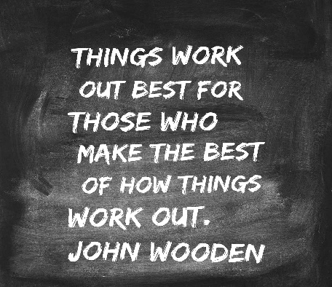
I recently noticed from my www.leadershipintheraw.org analytics several people were in the USA were viewing the principles of my blog. With the support and help of Thera www.thera.co.uk I started writing articles for the website in 2014. 355 articles and 53,500 views later I thought I should check out the original principles too:
Principles of this blog
What is this blog about?
- Leadership stuff I have learned throughout my career
- Supporting people with a learning disability
- Being a parent to someone with a learning disability
- Dosh Financial Advocacy (I retired from Dosh June 2024, I continue to be a strong supporter of their work)
- Top tips on working more effectively
What are the objectives of this blog?
- To engage with others and share ideas
- To share my experience with the aim of helping others to be great leaders and fantastic colleagues
- To provide a personal insight into being a parent of someone with a learning disability
- To make a difference in people’s lives whether that be business leaders, parents or people with a learning disability
- Promote Dosh Ltd – a not-for-profit company that provides financial advocacy to enable people to take control over their own money
- To engage with others and share ideas
- To promote Guest Blogs from people that inspire me
What to expect
- Lots of personal experiences
- Positive stories that aim to inspire
- Interesting stories and features from people that interest me
- Nothing political, negative or offensive to others
- No campaigning, debating or criticism of others’ views – everyone has a valid voice!
I hope you enjoy my blog as much as I enjoy writing it! Keep in touch – I love to receive emails! (I continue to adhere to these principles, and I still love receiving emails.)

MANAGEMENT SPEAK - WHAT DOES IT MEAN?

DUE DILIGENCE

In the thrill-seeking world of US accountancy, due diligence’ is the procedure of scrutinizing the books before any corporate transaction. Originally, diligence’ meant a task you ‘delight’ in, but by the 17th century lawyers used it to mean the opposite: obligation’. An alliterative, tautologous catchphrase first recorded in Shakespeare’s Pericles, it became a staple of British and US law courts. It now constitutes a defense against charges of
negligence - the real reason for all those due diligence meetings.
The Centre for Army Leadership
The British Army’s Servant Leadership philosophy flips traditional hierarchies, as shown in the Royal Military Academy Sandhurst's motto: Serve to Lead.
True leadership is a balancing act. Command authority drives task completion, while leadership supports team and individual needs. The real skill lies in knowing when to shift focus to meet the demands of the moment.
In the best teams command, leadership, and management work seamlessly together. But leadership is never a destination - it’s a lifelong journey of growth.
What does “Serve to Lead” mean to you?
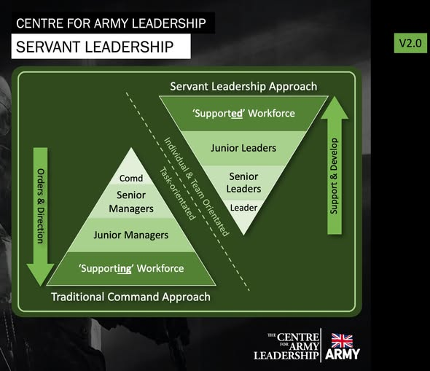

Being Bettina’s Dad – Bettina’s Kind Heart
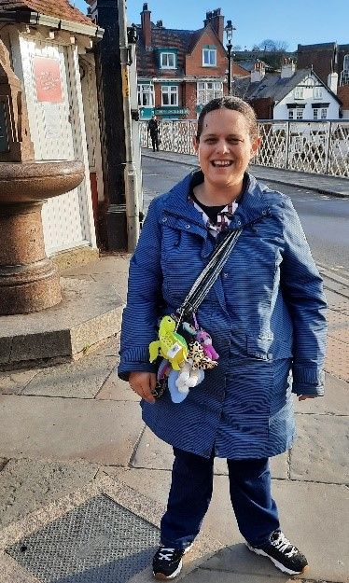
Bettina sits quietly in class alongside other pupils. There is a boy sitting next to her who is becoming increasingly distressed. Without turning Bettina reaches out to him and strokes his hand, despite verbal language being a challenge for Bettina, she soothingly says “it’s ok” “it’s ok” as her school mate calms, he says “thank you Bettina”.
This is an example of Bettina’s kindness to someone else in need.
“A kind word to one in trouble is often like a switch in a railroad track….
An inch between wreck and smooth sailing”
Henry Ward Beecher
If you have previously followed the “Being Bettina’s Dad” series, you will know that Bettina has a diagnosis of autism, a learning disability, and copes with epilepsy. The traditional traits and perhaps ‘labels’ of autism are often:
- Autistic people often have difficulty ‘reading’ other people – recognising or understanding others’ feelings and intentions – and expressing their own emotions. This can make it very hard to navigate the social world. Autistic people may:
- appear to be insensitive
- seek out time alone when overloaded by other people
- not seek comfort from other people
- appear to behave ‘strangely’ or in a way thought to be socially inappropriate
- find it hard to form friendships.
While some of these traits were true of Bettina in her early years, with the support and love of her family, and a wonderful school https://www.marketfieldschool.co.uk/ her personality constantly shines through, breaking through those stereotypes. Bettina’s qualities of being gentle, caring, and helpful, light up the worlds of people who come into contact with her and her acts of kindness are long lasting in their memories.
Bettina’s kindness is given for free, there are no conditions, and she has no expectations of favours in return.
Related: Being Bettina’s Dad: Bettina’s Code of Conduct – Leadership in the Raw
5 random acts of kindness Bettina spontaneously makes:
- Bettina is incredibly polite: “how are you Bettina?” “I am fine thank you” I have known people to go out of their way to ask Bettina how she is, just to get this response.
- Bettina senses when you are worried or upset and puts her arm around you. There have been times when Bettina has kissed my arm when I wasn’t expecting it and for me the world feels right again.
- Recently on a trip together in Frinton-on-Sea, a horse fly bit my face, just under my eye and I was even more shocked when Bettina stopped, put her arm around me and steered me towards a bench to recover my composure. In a moment our roles were reversed, and Bettina became my ‘carer’. I was so grateful for her kindness and compassion.
- As soon as I mention we are going to the beach, the night before Bettina raids the fridge for our lunch, choosing things she thinks I will like. (Bettina always nails it)
- Bettina acts without prejudice, bias, or cynicism. Bettina is always authentic with her kindness.
Related: Being Bettina’s Dad: Be your authentic self – Leadership in the Raw
5 reasons to be kind this year – because:
- It will make the world go round
- Everyone is fighting a hard battle especially with everything that has happened with Covid.
- There will be plenty of events that we will not be in control of in the coming months and perhaps years, but we can control how we behave towards other people.
- It will make you feel better about yourself if you are kind to someone else and it will encourage them to do a kindness for another person next time. (I have found kindness to be contagious).
- You have the opportunity to make life less difficult for another person, a great privilege.
Never, if possible, lie down at night without being able to say:
“I have made one human being at least a little wiser,
Or a little happier,
Or a little better this day.”
Charles Kingsley
And 5 spontaneous acts of kindness you can make in 2022:
- Smile and remember to say please and thank you when shopping and when you purchase your coffee.
- Stop and speak to someone who looks downcast, worried, and desperate – your kinds words could be the ones that save them.
- Pause and let another motorist or pedestrian have your right of way. (smile when you do). Give up your seat on a bus or a train for a person who needs it more than you. Open the door for another person.
- Acknowledge someone’s hard work with a compliment
- Never say “I am too busy” – ask someone “can I help?”
As Joyce (Bettina’s mum) comes towards the end of her ‘Hidato’ quiz book, Bettina’s notices and immediately stops what she is doing and goes into another room to find a new book for her. Bettina’s knows Joyce will enjoy completing her new puzzles. Joyce has not asked or expected Bettina to do this – Bettina does it because she is kind.
Joyce: “Aren’t you kind”
Bettina: “I don’t mind”
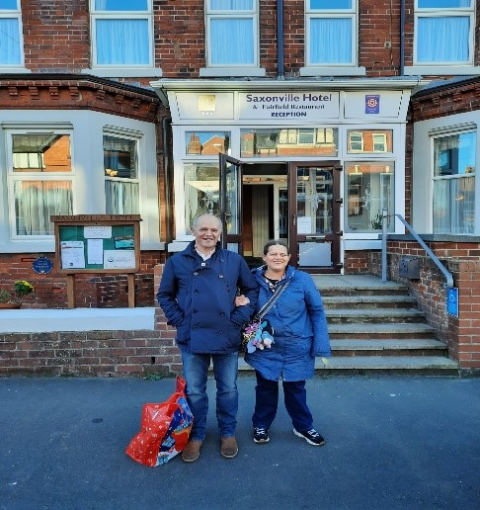
Bettina and her super proud Dad.
“Sometimes miracles are just good people with kind hearts”
Steve Raw www.leadershipintheraw.org
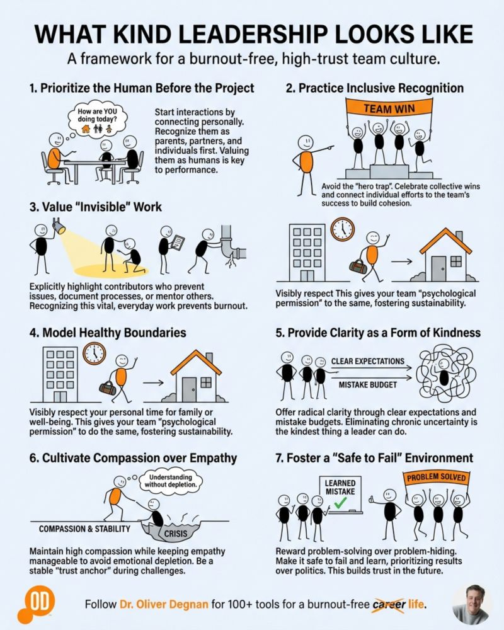
6 Actions That Make Your Organisation Unstoppable in 2026
Time to read: 26 Seconds
Dear Steve
6. Use the Formula for Guaranteed Success in everything you do
Why? It works and gives a uniform approach to success across your organisation.
5. Unleash the strengths, passions and ideas in everyone
Why? It makes you a self-leading organisation – and for UK organisations facing the impending Employment Rights Law you won’t have to recruit.
4. Human First – AI in Support
Why? Human Intelligence is unlimited in this business age of the Human Being.
3. Identify the 10% of projects bringing in 90% of your value and stop doing everything else
Why? Simplicity, Agility, Focus, Wellbeing, Growth and as one CEO said to us “Duh”.
2. Have a niche/client offer so irresistible they would be mad not to work with you
Why? You will be able to choose not to chase your clients, and you will have no competitors.
1. Always ensure your supplier partners in change/coaching/consulting guarantee a delivery of at least 3 X More than you invest with them – especially in IT and HR
Why? No more endless change, slow coaching and dependancy driven consulting - Hallelujah!
To receive NakedLeader one pagers on any of the above email hello@nakedleader.com
With my love and best wishes to you
David
(David Taylor, author, broadcaster, trainer)
Previous Naked Leader Weeks
sign up to receive this blog - unsubscribe anytime
@nakedleader across all social media

My favourite 3 Video Presentations for February……..

GOT A WICKED PROBLEM? FIRST TELL ME HOW YOU MAKE TOAST
Making toast doesn’t sound very complicated — until someone asks you to draw the process, step by step. Tom Wujec loves asking people and teams to draw how they make toast, because the process reveals unexpected truths about how we can solve our biggest, most complicated problems at work. Learn how to run this exercise yourself and hear Wujec’s surprising insights from watching thousands of people draw toast. (Source: Ted.com)
http://www.ted.com/talks/tom_wujec_got_a_wicked_problem_first_tell_me_how_you_make_toas t

Elizabeth Gilbert: Success, failure and the drive to keep creating
Elizabeth Gilbert was once an "unpublished diner waitress," devastated by rejection letters. And yet, in the wake of the success of 'Eat, Pray, Love,' she found herself identifying strongly with her former self. With beautiful insight, Gilbert reflects on why success can be as disorienting as failure and offers a simple — though hard — way to carry on, regardless of outcomes. (Source Ted.com)
http://www.ted.com/talks/elizabeth_gilbert_success_failure_and_the_drive_to_keep_creat ing
Richard St. John: 8 secrets of success
Why do people succeed? Is it because they're smart? Or are they just lucky? Neither. Analyst Richard St. John condenses years of interviews into an unmissable 3-minute slideshow on the real secrets of success. (source Ted.com) http://www.ted.com/talks/richard_st_john_s_8_secrets_of_success
“The Loyalty of your men is a sacred trust you carry. It is something which must never be betrayed, something you must live up to” Sir Ernest Shackleton

Leadership from a different perspective – Edgar A Guest
At the time when you may be thinking of giving up on that New Year resolution, that dream you have started, or someone you know is talking about giving up… DON'T QUIT
by Edgar A Guest
When things go wrong, as they sometimes will, when the road, you're trudging seems all uphill, when the funds are low and the debts are high,
and you want to smile but you have to sigh,
when care is pressing you down a bit – rest if you must,
but don't you quit.
Life is queer with its twists and turns. As every one of us sometimes learns.
And many a fellow turns about when he might have won had he stuck it out.
Don't give up though the pace seems slow – you may succeed with another blow.
Often the goal is nearer than it seems to a faint and faltering man.
often the struggler has given up when he might have captured the victor's cup;
and he learned too late when the night came down,
how close he was to the golden crown.
Success is failure turned inside out – the silver tint of the clouds of doubt,
and when you never can tell how close you are,
it may be near when it seems afar.
so stick to the fight when you're hardest hit – it's when things seem worst,
you must not quit.
Remember, if you believe in yourself, or in someone else, or in anything, enough, keep going. Do something, and if that doesn’t work, then do something else, and if that doesn’t work, then do something else… and it will be when you are at your lowest ebb, when you feel ready to give up, that you are about to achieve your biggest leap forward.
GET THE BUZZ: Listen carefully to other people’s voices and gauge the impact they have on you. Now record your own voice and try and gauge the impact this has on others. Encourage your colleagues to be honest with you. Does your voice sound positive? A POSTIVE HEART WILL LEAD TO A POSITIVE VOICE
BEAT THE CYNICS
Doom and gloom are contagious. Deal with cynics before they stress you out. To ensure you stay positive.
DON’T ARGUE BACK. Confront them with an assertive statement; you’ve made your decision and won’t be side-tracked.
DEFLECT PERSONAL PUT-DOWNS. A short response such as ‘You may be right’ will stop them dead.
RE-CHARGE THROUGHOUT THE DAY. Strengthen your immunity by giving yourself uplifting moments such as a dip into amusing quotes.
RECALL YOUR SUCCESSES. Use motivational symbols of past achievements to keep negative thoughts at bay.
Gael Linderfield, author, and lecturer. Taken from Management Today.

