LEADERSHIP AND WELLBEING PACK
March 2026
The 20th Anniversary Editions
Welcome to this month’s edition. Highlights include:
Damian Piper CBE our Resilience Coach starts this month edition with: The Invisible Leak: Why Leaders Need a Personal Energy Audit “In the heart of London, beneath the bustling streets of the Square Mile and the quiet residential rows of Kensington, a silent crisis flows. For the 2023–2024 reporting year, Thames Water reported losing approximately 570 million litres of water every single day…”

One Year On - Ready for the Next Challenge (Rocking Retirement). “Well, the day had finally come, this time last year I left my post with HQ 16 Air Assault Brigade Combat Team and formally retired. I had a 24-year career with the Army followed by a second career in social care, supporting adults with a learning disability which lasted for 28 years….”
There has recently been a spike in views on my blog for an article I was inspired to write last autumn, following a visit to see my former colleagues at www.dosh.org so I have decided to include this piece again about ‘No Blame Culture(s)’
Being Bettina’s Dad and Being ‘Significant The final article in this month’s edition is about my daughter, Bettina who copes with a learning disability, autism and epilepsy “… when it comes to significance and what being significant means, I cannot think of a better role model than my daughter Bettina! Bettina is significant in all aspects of her life. How?
“Thanks Bettina yet again you significantly change the way I lead my life.”
There is lots more in this month’s edition so let’s dive in together……
Steve Raw FioL
Blog: www.leadershipintheraw.org
Instagram: @stephenraw6
Twitter: @SteveRaw836
Blue Sky: https://bsky.app/profile/steveraw.bsky.social
LinkedIn: https://www.linkedin.com/in/steve-raw-72454721/
Facebook: https://www.facebook.com/steve.raw.771/

It’s not about how good you are,
It’s how Good You want to be.
The Invisible Leak: Why Leaders Need a Personal Energy Audit

In the heart of London, beneath the bustling streets of the Square Mile and the quiet residential rows of Kensington, a silent crisis flows. For the 2023–2024 reporting year, Thames Water reported losing approximately 570 million litres of water every single day.

To put that into perspective, that is just under 150 litres per property, lost to aging Victorian infrastructure. These 19th-century cast-iron pipes are brittle, struggling to bear the weight of modern traffic and the demands of a 21st-century city. But here is the most striking part: 95% of these leaks are underground. They aren’t dramatic bursts flooding the high street; they are invisible, detectable only through acoustic sensors.

As leaders, we often operate exactly like London’s water network. We focus on the "burst pipes", the obvious crises, the missed targets, or the difficult HR interventions, while remaining completely oblivious to the massive, invisible energy leaks occurring beneath the surface of our daily lives.

The Cost of Unmanaged Energy
Energy is the most precious currency of leadership. It dictates our ability to think strategically, regulate our emotions, and inspire those around us. Yet, many of us treat our energy as an infinite resource until the moment we hit a wall.

Unmanaged energy is just like those underground leaks. It is "invisible" because it is often unconscious. We might notice we feel "off" after a particularly challenging day or a disturbed night’s sleep, but these are just the surface symptoms. The real depletion happens in the subtle, daily interactions and environments that we’ve become numb to. When I work with leaders on performance and resilience, we will often conduct a Personal Energy Audit. This isn't about time management; it’s about managing the fuel that makes time useful.

Energy Builders vs. Energy Sappers
Before we can fix the leaks, we must identify them. An energy audit begins with a simple realisation: everything in your life is either an Energy Builder (enhancing your capacity) or an Energy Sapper (depleting your stores).

Most leaders are experts at identifying "work" as a sapper, but that is too broad. To truly find the leaks, we must look deeper into the four specific categories of our "infrastructure."

1. People
We have all experienced people who are "builders" or "sappers." Some people leave us feeling inspired, challenged in a healthy way, or supported. Others leave us feeling emotionally hollowed out.

- The Leak: Are you spending a disproportionate amount of time managing a single "high-sapping" individual? Are you neglecting the "builders" in your network who replenish your perspective?

2. Our Environment
Just as London’s pipes are pressured by modern traffic, our environment is pressured by our physical and digital surroundings.

- The Leak: Is your workspace a site of constant interruption? Does your digital environment, the endless pings and the "always-on" culture, act as a constant acoustic hum that drains your focus? Often, we have become so used to a cluttered or chaotic environment that we no longer realise how much energy it takes to tune it out.

3. Thinking Patterns (The Internal Victorian Infrastructure)
Sometimes, the leak is within the "pipes" themselves, our habits of mind. Victorian-era pipes crack because they are no longer fit for purpose. Similarly, leadership mindsets that served us ten years ago (like the need to be the smartest person in the room or the inability to delegate) may be causing internal friction today.

- The Leak: Perfectionism, ruminating on past mistakes, or the "invisible" energy spent worrying about things outside of your control are the equivalent of high-pressure cracks in your system.

4. Physical Foundations
We cannot ignore the "smart meters" of our own bodies.

- The Leak: Are you ignoring the subtle signs of depletion—the brain fog, the irritability, or the reliance on caffeine—until a "burst" occurs in the form of burnout or illness?

Conducting Your Own Audit
If 95% of leaks are invisible, how do we find them? We need the leadership equivalent of an acoustic sensor. Over the next week, I encourage you to keep a high-level log of your energy levels. At the end of each day, ask yourself:
- Where did the energy go? Which interaction or task felt like it was "cracking the pipes"?
- Where was the pressure highest? Was it a specific person or a specific environment?
- What built the reservoir? What moment made me feel more capable than when I started?

Conclusion
London’s water problem is a massive engineering challenge that requires digging up the past to secure the future. I see this often as I ride my bike around London as Thames Water are looking to replace the infrastructure. It takes time and resources. One site I ride by regularly has taken well over a year to complete. Your leadership energy is no different. You cannot afford to lose 150 litres of "potential" every day to invisible leaks. You need to invest in updating for life in the 2020s.

By consciously auditing your energy builders and sappers, you move from being a leader who is simply "getting through the day" to one who is intentionally managing their most vital resource. Don't wait for a burst pipe to start paying attention to what’s happening beneath the surface.
As always, I am interested in how you get on.
Damian
damian@effectivechallenge.com | effective challenge podcast | LinkedIn | Instagram

One Year On - Ready for the Next Challenge (Rocking Retirement).
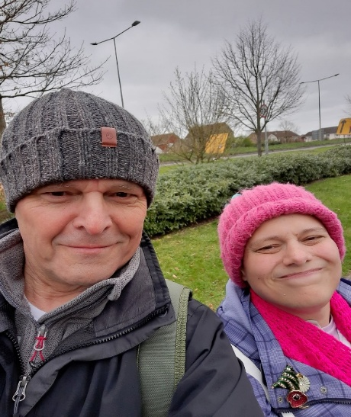
Retirement means more time with Bettina.
“Well, the day had finally come, this time last year I left my post with HQ 16 Air Assault Brigade Combat Team and formally retired.
I had a 24-year career with the Army followed by a second career in social care, supporting adults with a learning disability which lasted for 28 years. The highlight was 15 years as the Managing Director of Dosh (Financial Advocacy) Ltd www.dosh.org
In 2024 I had the opportunity of returning to the Army where I got to work with some amazing people. I am one lucky chap.

HQ 16 Air Assault Brigade Combat Team. From work coffee mug to gardening coffee mug
My motivation for retirement was Bettina aka ‘B,’ having a seizure and I was not there to help ‘B’ and support Joyce, my wife. As much as I enjoyed working with my military colleagues and being part of something special, I wanted to be there for Bettina’s next seizure.
What Retirement looks like for me, or one thing leads to another?
- Stepping up and taking some of the load from Joyce with our caring responsibilities for Bettina and the housework. It is super important to me that Joyce feels the benefits of retirement too. My retirement present from Joyce was a new hoover, and this was my surprise Christmas present from Joyce:

- Running 4 x sessions a week. My long-term goal this year, is to be the fastest 70-year-old in Colchester over 5KM.
- Writing articles on www.leadershipintheraw.org weekly leadership & wellbeing newsletters and a monthly leadership publication which I share with my network, and on social media platforms (which Joyce regularly tells me I spend far too much time on!). The blog has 355 articles and has had 54,000+ views from around the world (23rd February 2026)
- Weekly day out with Joyce, tomorrow is Frinton on sea (Essex, UK).
- “Gregging it” is now a thing! Coffee at Greggs (the best thing to come out of Newcastle). It happens every morning before we do our shopping.
Related: https://leadershipintheraw.org/2024/06/14/one-thing-led-to-another/
Still Contributing and Making a Difference
Retiring does not mean you need to give up ‘work.’ I have found you can still have influence, and you can still contribute:
- Coaching and Mentoring. I feel honoured to be asked to coach and or mentor former colleagues. It is an opportunity to support people who went the extra mile for me during my careers.
- Sharing knowledge and experiences I enjoy writing articles about Leadership and the lessons in life I have learned from my youngest daughter Bettina (‘Being Bettina’s Dad series) on my blog. Here is one I wrote recently: https://leadershipintheraw.org/2025/11/24/being-bettinas-dad-support-through-change/
- Having a social media presence. This involvement is on a wide range of social media platforms, it enables me to maintain relationships with my previous professional networks, opportunities to promote the organisations I worked for, so more people know about the difference they make and keep up to date with important topics I am interested in within Social Care, Defence and Leadership.
- Contributing and making a difference. Early on in my retirement I was invited to meet local authority commissioners. They were planning to introduce a new day service for people with disabilities. I was able to contribute with my experiences as both a parent carer and my previous involvement in ‘community support’ for people with a learning disability. I was flattered to be asked.
Related: https://leadershipintheraw.org/2024/06/14/one-thing-led-to-another/
My top five retirement take aways:
1. Prepare and Plan not just for now but in the future. I went into retirement with a plan that had aims and objectives. I also set five weekly objectives I want to achieve by the end of each week. They keep me focused and I enjoy the sense of achievement when I have met those priorities.
Related: https://leadershipintheraw.org/2024/12/20/setting-goals-objectives-commitments/
2. Routines and Rituals. What a routine means to me? It stops me from going into ‘free fall’ (feeling that I do not have control) and it stops me from drifting aimlessly throughout my day. How often do we say there are not enough hours in the day to get stuff done? Over time our routines refine and improve our life efficiencies. More on this take away in: https://leadershipintheraw.org/2024/10/27/the-importance-of-routine/ Set new rituals, did I mention ‘Gregging It? And on the 28th of each month Joyce and I have a ‘date lunch’ to celebrate retirement, we call it ‘Endex’ (a nod to my army career).

Date lunch with Joyce.
3. Eliminate waste. Now is a suitable time to self-audit. Over time you will have built up a lot of stuff in your home that you no longer need or use. With the additional free time, this is an opportunity to ‘get rid.’ The sense of freedom this feels is worth the effort. 15 minutes a day I do shredding and fortnightly we do a skip run.
4. Fit and A Healthy Diet. Maintaining your fitness and health could be the best investment you can make for yourself and those who are significant in your life. It will help you be more and do more. It is never too late to start. This is an area of my life I try to constantly improve on. Although I know I will never be able to give up chocolate.
5. A youthful mindset. My father and his generation felt they should fit a societal norm for older people whether it was their outlook on life or even how they dressed. This is no longer the case; you can continue to stay relevant whether you have retired or not. My mantras continue to be ‘look smart – feel smart’ & ‘look the part – feel the part.’ So yes, I am going to continue to buy my clothes from ‘Fatface’ and ‘Crew Clothing.’ (Joyce gave me a ‘Fatface’ voucher for Valentines Day and I can’t wait to spend it)
Top Tip: ‘Old’ is 15 years after whatever my current age is.
And if you are not ready for retirement yet and instead you wish to change careers as I did from the Army to Social Care then my personal tips may help you too: https://leadershipintheraw.org/2018/07/20/transitioning-from-one-career-or-job-to-another/
Source: Steve Raw www.leadershipintheraw.org

MIND + HEALTH

SUPER BOWL
A bowl of breakfast cereal may reduce your chances of suffering a stroke, according to new research. The study of more than 100,000 adults looked at the intake of wholegrain foods and the incidence of ischemic stroke – a brain blood clot that occurs due to a lack of oxygen and nutrients – over 25 years. It was found that wholegrain cold breakfast cereal (possible because of the folic acid content) and bran (high in dietary fibre) lowered the risk of ischemic stroke
. Source: Runner’s World
Inside the mind of a master procrastinator (courtesy of Ted.com) https://www.ted.com/talks/tim_urban_inside_the_mind_of_a_master_procrastinator
Tim Urban knows that procrastination doesn't make sense, but he's never been able to shake his habit of waiting until the last minute to get things done. In this hilarious and insightful talk, Urban takes us on a journey through YouTube binges, Wikipedia rabbit holes and bouts of staring out the window — and encourages us to think harder about what we're really procrastinating on, before we run out of time.
Leadership and followership are two sides of the same coin, bound by shared purpose, values, and standards - though shaped by distinct responsibilities. The effectiveness of any team hinges on how followers engage and think independently, typically falling into five behavioural styles:
🔹 Exemplary (Stars): Proactive, independent, mission focused.
🔹 Alienated (Cynics): Critical and detached, often undermining progress.
🔹 Passive (Sheep): Lacking initiative, avoiding responsibility.
🔹 Conformist (‘Yes’ People): Eager to please but unable to challenge poor decisions.
🔹 Pragmatist (Survivors): Self-serving, adapting to survive rather than contribute.
As a leader, creating an environment where people feel safe to share their views and create constructive challenge improves cohesion and allows everyone to contribute to their full ability.
Interested in learning more? Check out the Army Leadership Doctrine on our website!
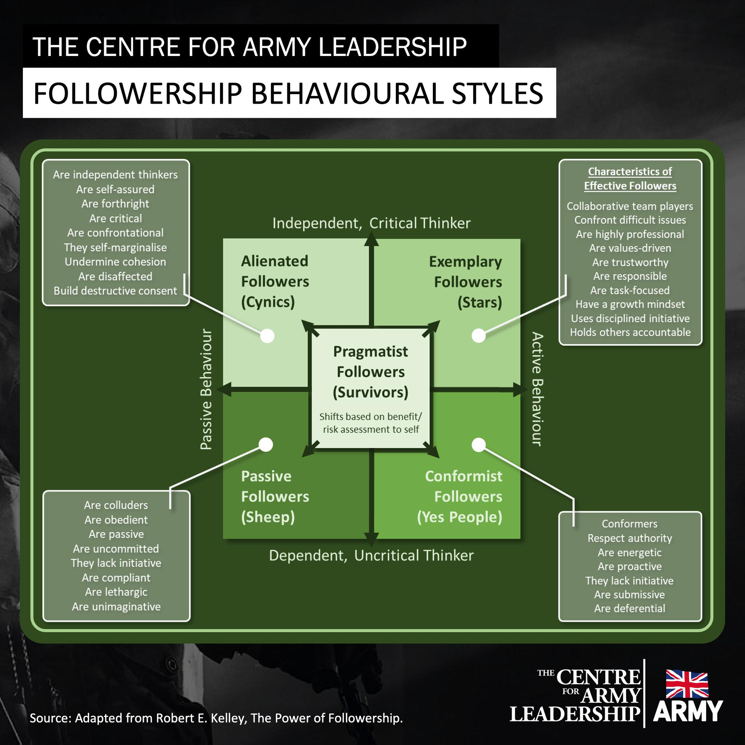
From Worry to Wonder in 1 minute flat…
Time To Read: 25 Seconds
Time To Do: 60 Seconds
Dear Steve
Last week I promised this blog would be – ‘the only scientific way of removing The Imposter Syndrome’
This solution is permanent and scientific – in the sense that it always works, with anyone, anywhere anytime.
Negative thoughts and worry are not real. They are not a natural part of you.
They are imagined. And imagined things can only be released through imagination — not force, logic, or resistance.
Science shows that fighting a thought or reasoning with it makes it stronger. Instead, do this:
Close your eyes.
Welcome the thought in fully
Now, with love, warmth, and certainty. Say silently: “Thank you.” Slowly – 3 times.
You’ll feel the thought complete itself, dissolve, and disappear — replaced by a beautiful emptiness of calm silence.
Finally, say to yourself “I allow this moment to be as it is”
That’s right
Very good
Thank you.
David
Please share your thoughts and comments on this NLweek here
Previous Naked Leader Weeks
sign up to receive this blog - unsubscribe anytime
@nakedleader across all social media
No Blame Culture(s)
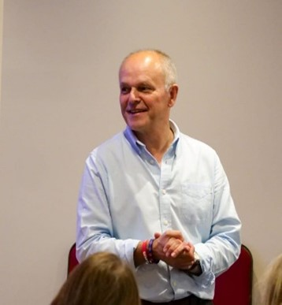
Driving onto the A1 from what feels like the world’s smallest slip road and avoiding oncoming lorries, I managed to manoeuvre my car onto the dual carriageway. I started to think about the people I had just been with. They were former colleagues who were at a conference centre for their training and development day.
In 2024 I retired from being a Managing Director for Dosh Ltd www.dosh.org where I had the honour of being their Managing Director for 15 years. Dosh supports people with a learning disability to have better control over their money. They believe that everyone should have an equal opportunity to make important decisions that affect their life. As a parent/carer for an adult with a learning disability I continue to be a dedicated supporter of their work.
This was the first time since my retirement that I had met up with them. Just being in their presence again I could see the same motived, empowered, and accountable team.
As I was driving home, I thought about what essential ingredient encourages ‘empowerment’ and ‘accountability’ within an organisation, a company, and a team?
This comes from ensuring there is a ‘No Blame’ culture, which is inherent within a team’s culture (‘the way you do thinks around here’).
There are numerous academic articles online about no-blame cultures, so for this article I wanted to come from a different angle! My experience(s) of working within a no blame culture, how it worked for my colleagues and me.
Related: https://leadershipintheraw.org/2016/03/01/the-culture-within-you/
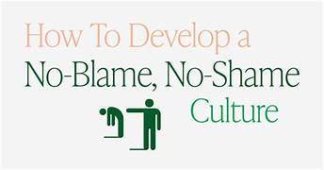
What ‘No Blame Culture’ means
A no blame culture is an organisational approach that emphasises learning from mistakes rather than assigning blame. The goal is to create a workplace where continuous improvement is prioritised over fault-finding, helping to drive innovation and team collaboration. Where everyone shares accountability and no one individual is singled out to blame.
‘Why No Blame’ mattered to our organisation:
- In the company I worked for, errors had the potential to be catastrophic for the people we supported, especially when it involves social care and peoples’ finances. It can be dangerous to operate in an environment where colleagues do not feel able to report errors that have been made. These organisations and companies are known as High Reliability Organisations (HROs) and include workplaces such as hospitals, airlines, and submarines.
- We believed mistakes are seen as part of human nature and where people are encouraged to aim high without fear of falling.
- If you are a company that wants to: innovate, achieve growth, retain your best staff, recruit, surround yourself with talent.
Related: Related: https://leadershipintheraw.org/2022/04/14/the-3rd-leadership-lesson-i-learned-surround-yourself-with-talent/
- Provide an environment that is a safe place to work for your colleagues.
- We wanted an organisation where people felt valued and supported.
How it works – what do you need to do to make a no blame culture work
- It must start from the ‘top’ of an organisation. The CEO, MD, and Senior Management must lead from the front by communicating your (no blame) culture and how it works around here. And then practicing it so it is not just words on a paper until something goes wrong.
- Your starting point is a shared recognition that people do not come into work to do a bad job – everyone is doing their best.
- Recognising that your colleagues may come from different employment backgrounds where blame has been part of their everyday work and people have been scapegoated. One of the most rewarding anecdotes I heard was when a new team member who had made a mistake, had been told by a long term (and much experienced) colleague not to be afraid, be open and report it. He said we are a team, and it is the team which takes responsibility.
- A recognition that mistakes often are usually the result of a systemic failure rather than one individual solely responsible for the mistake, accident, or incident.
- A company and/or organisation has a hierarchy loose enough that they empower and enable those who are highly skilled in a specific area/subject to lead on operational issues where appropriated by the negative consequences of experimentation (such as failure).
- A no blame culture does not mean that you do not acknowledge mistakes especially to external stakeholders. The difference is rather than scapegoating an individual, the team, company and or organisation takes collective responsibility.
Related: https://leadershipintheraw.org/19/07/16/the-dosh-leadership-code/
- A no blame culture must show up in the daily language and practices for all employees. To become a culture, the no blame approach must be introduced, continually, reflected upon, and improved.
A no blame culture does not apply if an employee shows intent to sabotage and disrupt your company’s operations.
I found the benefits of a no blame culture to be:
- Mistakes are not hidden, and reporting errors can be rectified swiftly,
- Reduces workplace stress.
- A learning culture develops. Employees are more likely to speak up about issues or suggest improvements when they are confident their input will be met constructively.
- No blame cultures value and incentivise honesty. Colleagues are open and honest with each other.
- Accountability eliminates the time we spend on unproductive behaviour, increases the value we place on our workload and encourages ownership of the things we can influence. All these things are, of course, critical to personal and organisational success. accountability and responsibility are maintained.
- Progress, and growth takes a leap forward. Colleagues are not personally affected in no blame cultures,
- Unlocking innovation by encouraging experimentation.
- If things go wrong, everyone is more likely to understand why it went wrong.
Prepare to be tested on the way you do things. During my journey home, I recalled an occasion when our culture was challenged. It involved a colleague inputting an invoice number instead of a value into our internet banking (it was more serious than it sounds, believe me.) I was informed, we recovered, I apologised, nobody was scapegoated, we put new audit systems in place, and we moved on. Your no blame culture will be compromised if the first time something goes wrong you seek to blame someone.
Steve Raw www.leadershipintheraw.org

“A no blame culture is still so important in Dosh and something I will keep promoting wherever I can. Thank you for establishing this and reminding us again.” Meike Beckford, MD at Dosh Financial Advocacy
“something i have carried with me into my current role. Helps promote a culture where people aren’t afraid to make mistakes, own them and learn from them. Only then can we continuously learn and improve!” Claire Willis, National Projects Manager – Financial Inclusions Team for Scotland (a former Dosh colleague)
OUR ROUTE TO THE TOP
HANDLE TRICKY PEOPLE
Get to the heart. Whether it’s a colleague, client or boss, it’s better to try to understand tricky people than to avoid them. Work out how they see things and then find a way to work comfortably with them.
Control the control freak. If your boss is the anxious type, pre-empt his concerns. To stop him jumping in as your finger reaches for the send button, share your ideas upfront.
Don’t get dumped on. If your manager tends to deliver ‘top priority’ tasks for ‘urgent’ projects and then disappear, help her to focus. Ask her to describe her ideal result: what, when, and how does she want it? By forcing her to think it through, you’ll avoid unreasonable last-minute changes.
Silence the sceptic. When presenting the new talent-management plan, ask questions to understand what makes the doubters tick. Listen carefully. Identify the root of their problem and you can address their real concerns.
Help shy people shine. A silent figure in the team meeting may be confident on a 1-1 basis. If they’re brimming with ideas but can’t articulate in a group setting, why not brainstorm instead? Find a way to communicate that works for them.
Calm the stress cadet. If your colleague is in regular meltdown, concentrate her attention on what can be done here and now. Battling a presentation, pitch and project work? Small steps will lead to significant results.
Resist charmers. Don’t get taken in by empty, eloquent flair. Ask tough questions to keep them on track. Try: ‘What does that mean in practice?’ Help them distinguish between dreams and reality and you’ll get the best of both.
Look again. Whatever behaviour we’re up against, we must be aware of our own impact. Feeling brave? Write a character profile of yourself – which tactics would work for you?
The Mind Gym: Relationships
“There are two ways to face the future. One way is with apprehension; the other is with anticipation” Jim Rohn

CULTURE IS MORE POWERFUL THAN STRATEGY
A great culture is constantly reinforced; each and every one is unique. However much they are studied or measured, the best cultures are hard to replicate.
Leaders must set the vision, purpose and values and then live every element of that culture. Your people watch YOUR behaviour and actions ALL the time.
Strong cultures are more than just words and mission statements. Always catch people doing things right and recognise those whose actions exemplify its standards.
Celebrate success often.
But remember; corporate cultures can keep moving in both directions. Guard against complacency and remain curious and willing to change.
Vibrant cultures breed loyalty; those that don't fit in are quickly found out whilst those that do are rewarded.
Great cultures benefit from a virtuous circle of talent. A better culture fosters innovation and productivity making it a better place to work.
Always look to the future. A strong culture prepares successors and makes any transition less bumpy.
Even when culture has proved more important than strategy, always communicate it. Leaders are crucial to success but also pivotal to failure. Beware the leaders that forget to "walk their talk" and have an inflated sense of their own importance.
Thank You,
Rene Carayol – broadcaster, author and leadership guru
My take ‘The Culture within you’ https://leadershipintheraw.org/2016/03/01/the-culture-within-you/ Steve Raw
“Each generation imagines itself to be more intelligent than the one that went before it, and wiser than the one that comes after it.” George Orwell
Being Bettina’s Dad and Being ‘Significant’
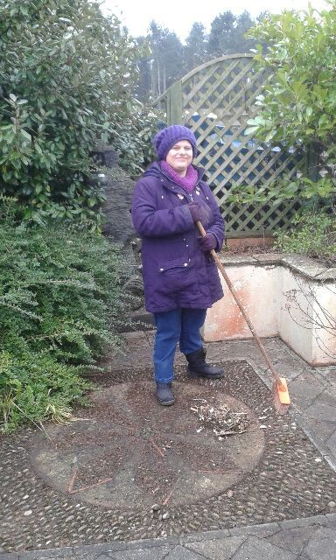
Bettina at work
From a very early age I have often found myself in leadership positions. When I think about it, I suppose it started when I was 6 or 7! I had my own gang, and I also managed my own football team from the age of 13 (it was the only way I was ever going to get a game!). It was not until I joined the Army, entering a Junior Leaders Battalion in 1972 just after my 16th birthday, that I started thinking about leadership and what kind of leader I wanted to be – after all we were regularly told by our instructors we were the army’s future NCO’s (Non-Commissioned Officers). I wanted to be ‘significant’ I wanted my leadership and my life to count for something, but without really thinking about how I would ensure my leadership would have significance.
I have been incredibly lucky (and continue to be!) to have been associated with, and work for, leaders who are significant. However, when it comes to significance and what being significant means, I cannot think of a better role model than my daughter Bettina! Bettina is significant in all aspects of her life. How?
- Bettina is a symbol for good – you could say she has her own ‘brand’. People who know her see her as a source of inspiration. She is a symbol for positivity and kindness, facing adversity every day because of her autism, learning disabilities and her complex communication issues – she continues to smile at the world – and the world smiles back.
- Bettina’s life has meaning – The way Bettina has led her life has influenced people’s attitudes about autism and learning disabilities. People tell me that Bettina helps them get their life into perspective.
- Her work and life are important – Bettina has always been a trail blazer. She was one of the first children at her school with autism and complex needs but who did not attend an autism-specific school which meant the local authority had to think outside the box, and so they built an Autism Resource Base to support the children; she was one of the first people in Essex to have an Individual Budget (so Bettina decides who and how she will be supported) with her own Individual Budget Support Plan (got to be one of the best plan’s ever!!) which is much copied and has been used as a source of inspiration for other parents and care professionals; what she has taught others about her autism has been used in training workshops for the benefit of others and as there was nothing of substance in Colchester in the early 1990s, my wife( Joyce) started a Support Group which evolved into a Carers Centre and I started a second career in Social Care in 1996 all because of Bettina.
- Her Work is Valued –Bettina’s work benefits others and is highly valued whether it is coaching others with her Tai-Chi skills; cooking (her cakes are sublime); pottery most of which decorates our garden, or her strong work ethic at a local Garden Centre.
I came across a YouTube video from Bettina’s school (Market Field School in Elmstead Market near Colchester in the UK) Bettina went there as a 5 year old leaving at 16 years of age. In the video the Head Teacher Gary Smith talks about the school moving to new premises and reflects on his memories before the current building is closed. We were overjoyed as a family to hear that one of those memories was of Bettina and what that memory meant to him. The memory had significance and what she had done had made an impact. Here is the link: https://www.youtube.com/watch?v=gB71K1XLl_w
Bettina’s 5 Rules of Significance – What marks out a Significant Leader?
- You have made a difference in another person’s life
- Your work and the way you live your life influences other peoples thinking for the better
- People quote and reference your work
- You have referability
- People remember you long after you have left. Your work leaves an enduring legacy which people coming through can benefit from
This is the checklist I will continue to use. I will monitor and evaluate my level of significance as a leader. I will do this at least once a week, preferably on a Sunday afternoon before I start again with the coming week – after all you are only as good as your last race.
Thanks Bettina yet again you significantly change the way I lead my life.

Source: Steve Raw www.leadershipintheraw.org

