LEADERSHIP AND WELLBEING PACK
April 2026
The 20th Anniversary Editions
Welcome to this month’s edition. Highlights include:
Damian Piper CBE our Resilience Coach starts this month edition with: The Shadow We Cast: Why my ‘desk dinning’ is setting the wrong environment for me and my team “I was recently giving a talk on resilience to a room full of high-achievers. We were discussing part of my resilience model which I call PRIME and specifically the R element of the model relating to Rest. One participant raised her hand to ask "I know I should take a break. But I don’t. No one in my team does……”
From me: Being Bettina’s Dad – We can work it out “Bettina (‘B’) is looking intently at my face as I crawl backwards into a cave that is more like a pothole. We are in Wales enjoying an outdoor pursuits holiday at the turn of the century. Bettina’s verbal communication and understanding is progressing, but it is still extremely limited…….”
And Keeping a Momentum “…. “What has been my greatest fear in both my careers (and my running)? I always respond with it is the fear of losing my momentum.
In the mid-1970s I was in a job role where I was bored. I was just turning up and no matter how hard I tried I was not stimulated which sent me down a slippery slope, both mentally and physically. I had lost my momentum, and it felt I like I was trudging through quicksand….”
There is lots more in this month’s edition so let’s dive in together……
Steve Raw FioL
Blog: www.leadershipintheraw.org
Instagram: @stephenraw6
Twitter: @SteveRaw836
Blue Sky: https://bsky.app/profile/steveraw.bsky.social
LinkedIn: https://www.linkedin.com/in/steve-raw-72454721/
Facebook: https://www.facebook.com/steve.raw.771/

It’s not about how good you are,
It’s how Good You want to be.

The Shadow We Cast: Why my ‘desk dinning’ is setting the wrong environment for me and my team
I was recently giving a talk on resilience to a room full of high-achievers. We were discussing part of my resilience model which I call PRIME and specifically the R element of the model relating to Rest. One participant raised her hand to ask "I know I should take a break. But I don’t. No one in my team does. If I’m the only one taking time out to eat lunch while everyone else is typing, I feel like I’m falling behind. I often feel guilty. What can I do?". A sea of faces in front of me nodding as she talked suggested she wasn’t the only person in this situation. I wasn’t surprised. It’s so common.
The question being posed is right at the centre of two interrelated topics. Resilience and Productivity. I thought for a moment about how to position my response. I opted to go down the Productivity route. The situation the lady described is what I refer to as the "Productivity Guilt" trap. It is the nagging, anxious sense that unless you are visibly doing, or seen as perpetually "on," you aren’t doing enough. In his 2024 book, Slow Productivity, the Georgetown University Professor Cal Newport identifies this situation as a byproduct of the "pseudo-productivity" era, a world where, because we can’t easily measure the output of a knowledge worker, we fall back on measuring how busy they look.
Before I go on I want to give a disclaimer. I can fall into this trap too. I know I am definitely better when I don’t. So, continue to strive to find ways to avoid it and help others do likewise. And because I know how seductive that trap is, I feel a responsibility to call it what it really is. I suggest as leaders, we have to realise that this guilt isn’t a sign of a "hardworking culture." It is a systemic failure that is actively eroding our team’s ability to do their best work.

The High Cost of the "Always-On" Facade
When a team member skips lunch because "that’s what everyone else does," there’s a high probability they aren't actually being more productive. They are simply performing busyness.
The human brain is not a steam engine; it is a biological organ with limited glucose and cognitive energy. By 2:00 PM, the "lunch martyr" is likely experiencing a drop in executive function. They are more prone to errors, slower at processing complex information, and less creative. Ouch.
But the damage goes deeper than one afternoon’s output. Productivity guilt creates a culture of performative exhaustion. When leaders allow (or worse, model) the idea that "real workers don't take breaks," they inadvertently signal that volume is more important than value. Over half way through the 2020s with the availability of information to evidence the downsides of this it turns out in many workplaces we are still holding on to the Gordon Gekko 1987 line from the film Wall Street, “lunch is for wimps.”.

Why We Feel Guilty?
Cal Newport argues that we’ve lost the "natural pace" of work. Historically, human labour had seasons, sunrises, and sunsets. Knowledge work has none. The "inbox" is never empty. The Slack notifications never stop. The To Do list continues. Despite the illusion and hope that one day this might not be the case.
Because there is no "done," we have fallen into physical presence and rapid responsiveness as a shield against the fear that we aren't doing enough. Or being seen to do enough. Dependent on our outlook we feel varying degrees of guilt taking a walk or a lunch break because those things look like "we are not pulling our weight."

Three Ways Leaders Can Kill Productivity Guilt
If you want a resilient, high-performing team, you have to actively dismantle the guilt. It isn’t enough to tell people "it’s okay to take a break." You have to re-engineer the environment and of course role model what you want to see for others. The shadow our own behaviours cast is often way more powerful than anything we say.

1. Define what “done” means
Productivity guilt thrives in the grey area of "not enough." When a task list is infinite, any moment spent eating lunch feels like a moment stolen from a mountain of work. We stay at our desks because we haven't reached a "finish line" that doesn't exist. The Shift: Move the team’s focus from volume to high-value velocity. In your catch-ups, stop asking "What’s on your plate?" and start asking "What is the one thing that, if finished, makes this week stand out as a success?" When a team member is clear about expectations it helps develop the psychological "permission" to take a full lunch or leave on time becomes a reality because the "Win" has been defined.

2. Model the "Rest" in PRIME
As I mentioned in my disclaimer I can struggle with this too. If we tell our teams to rest, but they see us typing one handed to send an email whilst struggling to eat a sandwich with the other, they will follow our action, not our words. They will assume the "real" rule is to stay chained to the desk. The Shift: Be vocal about your own "PRIME" resets. Use your internal status or a quick mention in a meeting: "I’m stepping away for 40 minutes to recharge—I find my decision-making is much sharper in the afternoon when I actually leave my desk." By explicitly linking your rest to your performance, you reframe the lunch break from "laziness" to "professional maintenance."

3. Audit the "Overhead Tax"
Often, the reason people skip lunch isn't because of their core work—it's because of the "overhead." The meetings about meetings, the endless coordination, and the "ping" culture that eats the time until there’s no time left for a sandwich. This creates a frantic energy that makes a break feel like a luxury they can't afford. The Shift: Lead a "Low-Value Task" cull. Once a month, discuss as a team: "What is one recurring task or meeting we can pause or kill to give everyone some time back?" When you actively remove the clutter, you aren't just prioritising time, you’re developing space for the results that really matter.
What’s your workplace productivity like?
I am curious about workplace cultures and their impact on productivity. Does the topic of this article resonate with you or is your culture doing things that mean you are avoiding the productivity trap? As always, I am interested in what you have to say.
Until next month, I wish you well.
Damian
Damian Piper CBE
damian@effectivechallenge.com | effective challenge podcast | LinkedIn | Instagram
‘Hope is the thing with feathers that perches on the soul. And sings the tune without the words and never stops at all‘ Emily Dickinson

How to stop procrastinating
- Embrace the one-minute rule: if anything takes less than a minute, do it now. This goes for non-work-related tasks too, like responding to easy, direct texts when you read them, or tidying your desk. Warming up with such tasks takes them off your to-do list and makes you feel productive.
- Set tangible rewards for when you finish a task. Try to have one substantial reward per day – whatever you’re craving, be it an episode of a TV show or a sweet treat.
- Being in a place where others are working – a library, café or co-working space – can push you to focus. Sometimes moving to a different space can help signal to yourself that it’s time to get to work.
- Set a timer for work time and breaks. This can make your schedule seem more rigid, encouraging you to stick to it.
- If you still need help, apps like Todist or Any.do help keep track of time and tasks while web blockers like SelfControl or Freedom limit time spent on certain sites.
Source: Cosmopolitan (taken from my ‘THE WEEK’ or as Joyce’s describes it ‘Steve’s comic)
"The real test is not whether you avoid this failure, because you won't. It's whether you let it harden or shame you into inaction, or whether you learn from it; whether you choose to persevere."
Barack Obama
‘Being Bettina’s Dad – We can work it out.’

Bettina works out how to use my laptop.
‘We can work it out.’
Think of what you're saying.
You can get it wrong and still you think that it's alright.
Think of what I'm saying.
(Lennon & McCartney)
Bettina (‘B’) is looking intently at my face as I crawl backwards into a cave that is more like a pothole. We are in Wales enjoying an outdoor pursuits holiday at the turn of the century. Bettina’s verbal communication and understanding is progressing, but it is still extremely limited.
Several years before Bettina had said her first words, she had developed her own systems for working things out. I could tell from her facial expression she was doing this now. Is this safe for me? Am I going to be able to do this? Does Dad know what he is doing (he must do, because he is smiling and the sound of his voice is both confident and soothing).
I have always been fascinated by how Bettina works things out. The systems and processes she has created for herself. The purpose of the ‘Being Bettina’s Dad’ series has always been to share the lessons I have learned from ‘B’ and hopefully they will also help you and the people you support.
Bettina’s early years.
Bettina’s early years could, at best, be described as having a mind-set completely in turmoil. For us as a family, we felt that she did not understand her world and it was as if she had just arrived from another planet and was coming to terms with her new alien world. Whilst coming to terms and supporting Bettina was something we could manage, as we love her unconditionally and she is our beautiful girl, for Bettina it was clear to see she was in a complete ‘daze’ and her nights were often sleepless (screaming and banging her head against her bedroom wall most nights – fortunately we had very understanding neighbours!) and her days spent biting her hand and often others.
Bettina has come a long way since then and has been described as having an “aura of self-confidence.”
Six ways Bettina works things out.
- Through observation, Bettina learns best by watching a demonstration rather than receiving verbal instructions.
- Active listening. Even when we think she is not listening, we have learned she never misses a beat.
- By being tenacious. Bettina is incredibly determined and will work hard and long to meet her objective - completing a difficult jigsaw comes to mind. (if there is a missing piece then she calls on her family to come to her rescue as was the case recently)
- Tackles everything with enthusiasm. One of Bettina’s many gifts is that she is very enthusiastic about all that life offers her. This is a key to working things out.
- Thrives on new experiences and responds to the challenges these offer.
- Bettina concentrates on what is happening in the background rather than the foreground (not looking at your face as most of us do, Bettina is looking at her surroundings for clues)
Six tips on how to support someone work things out.
During my career supporting people with a learning disability, I had the opportunity to use some of the lessons I learned from Bettina (especially when I worked in care homes and through ‘community support’).
- Recognising each person as an individual – it is too easy to assume what works for one person, works for another just because of a label e.g. learning disability, autism.
- Understanding how they see their world (it is probably different from you do) – this was a key lesson for Bettina’s parents in her early years as what we focus on is completely different to what Bettina does. Being empathetic, it was and is key to seeing life through her eyes.
- Patience. Over the years Bettina has developed an inner calm and a capacity to accept and/or tolerate delay, problems, or suffering without becoming annoyed or anxious. A coping mechanism that helps her make sense of a world that constantly changes and throws unexpected drama and disruption into her structured life.
“Rivers know this: there is no hurry. We shall get there some day.”
A.A. Milne, Winnie-the-Pooh.
Related: https://leadershipintheraw.org/2021/02/16/being-bettinas-dad-patience-is-a-leadership-virtue/
- Space. Do not ‘sit on their shoulder’ as they try to work things out. You would not like it. For Bettina we could be in the next room, B is reassured that we are on hand should she need us. (we come zooming in when she say’s “help me” she gets progressively louder until we arrive!).
- Encouragement not waiting until the task is completed but offering encouraging words and sounds periodically.
- Remembers previous Lessons learned. What worked, did not and could be improved on as you customise your support.
Related:
https://leadershipintheraw.org/2024/10/28/being-bettinas-parents-the-importance-of-a-plan/
https://leadershipintheraw.org/2023/07/18/being-bettinas-dad-getting-comfortable-with-being-uncomfortable/
Bettina is working it out.
2022 is the year our wall came tumbling down (courtesy of Storm Eunice). The pictures start with our wall demolished by the storm. Bettina’s beady eye on the bricklayers repairing our wall throughout the build. The supervisor said, “Not to worry if the wall fell down again, she will soon have it backup.”
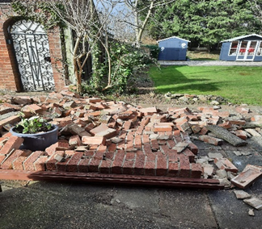


Steve Raw www.leadershipintheraw.org

Keeping a Momentum
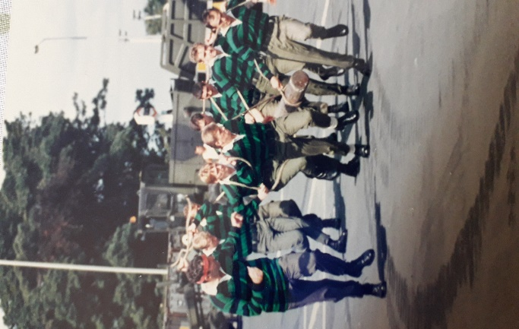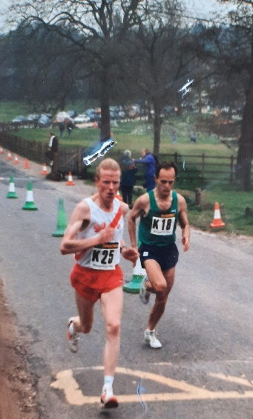
1986 and A loud bang from the starting gun and the Commando Log Race begins. We had always planned a super-fast start and we were able to maintain the momentum throughout the race. We wanted to get to the (tight) corner first and knew that by getting into our stride quickly, we would carry the momentum until we had won. I often use my running experiences as an analogy for my work as it helps me explain my approach to life.
1993 at floodlit athletics track on a cold and wet Thursday night and we have been set a tough session. We start with 800m on the track, each lap must be done in 75 seconds, we then move out of the stadium on to a fast 8-mile road run, returning to the track to complete a further 800m in 2minutes 30 seconds. Why are we experiencing this hell? Our coach wants to simulate the National Cross-Country race we will be competing in Leeds soon. The fast 800m segments will ensure we start and finish with momentum. This session was going to help me get comfortable with being uncomfortable.
Related: 30 leadership lessons from 30 years of running and athletics – Leadership in the Raw
If asked “what has been my greatest fear in both my careers (and my running)” I always respond with “it is the fear of losing my momentum.”
In the mid-1970s I was in a job role where I was bored. I was just turning up and no matter how hard I tried I was not stimulated which sent me down a slippery slope, both mentally and physically. I had lost my momentum and it felt I like I was trudging through quicksand.
I regularly revisit this experience mentally from the far recess of my brain to remind me of how I felt at the time and how difficult it was to recover my momentum, so I do not lose it again.
So, what is Momentum? It is a driving force gained by the development of a process or course of events. The impetus gained by a moving object - and I was going to be that object.

How do you develop and grow your momentum?
- Start with small actions and incremental changes. You are looking for quick wins to build your confidence.
- Develop a sense of urgency in everything you do. A feeling and an attitude that a task must be conducted quickly and with great intensity. We have created this mindset and culture within our company www.dosh.org Engaged colleagues with a sense of urgency can help their companies and co-workers achieve positive, long-lasting change and improvement.
- A culture of self-discipline and commitment. Self-Discipline is a practice and begins with accepting you will not be perfect every day. What is important though is to turn up ready to go each day. So, what changes am I going to make today?
Related: The second leadership lesson I learned – Self Discipline – Leadership in the Raw
- Constantly and consistently having greater goals
Related: Setting 10 Times Goals – Do something Big! – Leadership in the Raw
- Having passion and intensity for what you do (but first you need to understand your passion and what ignites it) I recently re-engaged with a classic Management & Leadership book I bought over 20 years ago. ‘Good to Great’ by Jim Collins. I was reminded of his ‘Hedgehog Concept’.
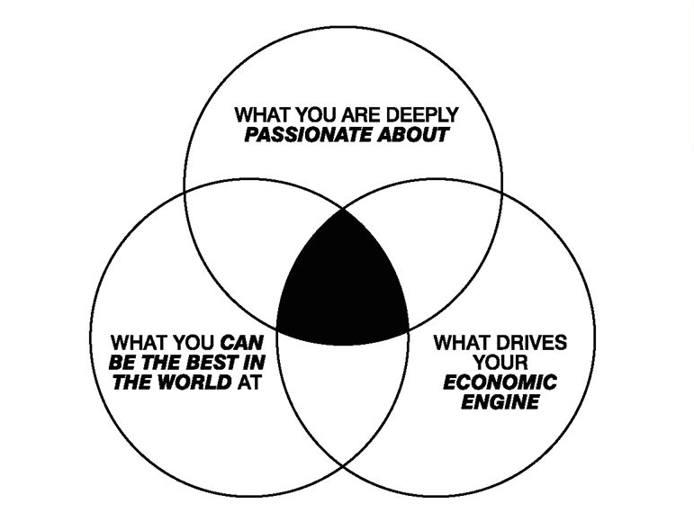
“The Hedgehog Concept” is developed in the book Good to Great. A simple, crystalline concept that flows from deep understanding about the intersection of three circles: 1) what you are deeply enthusiastic about, 2) what you can be the best in the world at, and 3) what best drives your economic or resource engine.” Source: Jim Collins - Concepts - The Hedgehog Concept
I have adapted this concept to my work – when the circles intersect, it feeds my momentum.

Why?
When you understand the “why” behind a particular goal or objective, and more specifically the “why now,” the challenge is to communicate the concept to your colleagues. I find that increasing a sense of urgency around a particular project or goal is much easier when you get peoples' buy-in on the project from the start. Fostering a feeling of ownership and investment in the project makes an enormous difference for those involved. When your team members feel personal involvement, they are naturally more eager to see it come to fruition. Related: https://leadershipintheraw.org/2016/01/11/finding-a-why/
Five reasons why keeping a momentum has been important to me?
- It maintains my competitive edge.
- Because I want to be the best version of myself.
- I want to achieve as much as possible in the time I have.
- When I have momentum new opportunities open up for me.
5. The alternative can be lethargy – it is super hard to regain your momentum once you have lost it. Did I mention my work experience in the mid-1970s?

2026 and I am just back from a run. As I near my 70th birthday, my approach to life and work has not changed, certainly when it comes to maintaining my momentum.

While fast starts to races are beyond me now, I can still manage a fast finish! I have a goal of (again) finishing first in my age group at our local Park Run (5km).
I can only do this if I maintain my momentum.
Source: Steve Raw www.leadershipintheraw.org
Dad: Rose, people are. Who they are. Daughter: Then they should change! People should do things for themselves, not wait for everyone else to change things for ‘em! Dad: You can’t beat your luck, love. Daughter: No, you have to be your luck. There’s nothing else. There’s just you. From Cloudstreet by Tim Winton

A Life Lesson I Learned From...
Time to read: 64 Seconds
Chess
Most people analyse the games they lose.
“What mistake did I make?” “How did I mess that up?”
I did that.
Result: I simply proved to myself how many mistakes I was capable of making.
Not exactly confidence building.
Then I came across advice from Bobby Fischer. Study the games you win.
Find out what you did right - understand why it worked.
Repeat it. So, I did that - my rating went from 1100 to 1203 on chess.com.
Not world champion. But proof the principle works.
Exception:
If you hang your queen in three moves…you probably should look at that as well.
Applied to Your Organisation
When a project fails we ask:
What went wrong? Who approved this? How did we miss it?
Results: Blame culture; Lower morale; More caution next time
Do this instead: Study, analyse and celebrate the projects that succeed.
Ask:
What did we do right? Who made it happen? What should we repeat?
Results: More successful projects; Better outcomes; Higher ambition.
Exception:
If the project is mission critical - safety, legal, patient impact, national infrastructure etc of course analyse failure properly.
Just don’t make failure analysis your management philosophy.
Applied to You
When something goes wrong we replay it in our heads - Again., and again, and again:
Each time reliving it as if it was happening anew every time
Do this instead: Keep a Happy Book
Every day write down something you did well: A good decision; A kind act; Something you handled better than last time.
Your brain slowly starts scanning the world for what works.
Exception:
If you hurt someone — apologise, learn, move forward
The Overall Lessons I learned
Yes – learn from mistakes
But the real acceleration in life, teams and organisations comes from studying success.
Find what works and do more of it.
One Last Thought
Most people study failure.
The very best study success.
One makes you cautious.
The other makes you brilliant.
Choose carefully.
With my love and best wishes to you
David
Previous Naked Leader Weeks
sign up to receive this blog - unsubscribe anytime
@nakedleader across all social media
Perhaps the ultimate test of a leader is not what you are able to do in the here and now - but instead what continues to grow long after you're gone -
Tom Rath

PEACEFUL PERSUASION
Have a plan. Consider the route that you are going to take and how to deal with resistance. But be ready to change it.
Know your audience. Discover their real concerns and interests, whether that might be wanting a promotion or to close a deal quickly.
Put them in a good mood. Gentle flattery is surprisingly effective. They will be more open to persuasion if they feel favourable towards you.
Choose your moment. Be conscious of their frame of mind – just after a difficult team meeting is probably the wrong time. Seize the good moments as they appear.
Do as they do. Match their body language (if they lean forward, do the same). This will put them at ease and encourage a stronger emotional connection.
What’s in it for them? Show that it’s in their best interest to agree with you. Convince them that they are on to a good thing, where you’ll both share in the success.
Describe the end result. Be sure to demonstrate how the new situation will be better than the present one.
Get them to do the work. Ask questions that guide them to your conclusion. People are more likely to agree if they feel that they’ve come to the conclusion – at least partly – themselves.
Make your case. State all the facts; be clear about the pros and cons. Offer solutions that will resolve their concerns and turn weaknesses into strengths.
Do them a favour. Tell them what you will do for them in return. They might well feel indebted to you and therefore more likely to agree.
Use your allies. Refer to the views of someone whose opinion they care about. People are more likely to think or do something if others they respect do too. The Mind Gym
Make Sure Opportunity Knocks - For You
GRASPING the nettle with both hands might not be a good idea when you’re standing in a field. Unless there’s a dock leaf or two around of course!
Seizing an opportunity when it arrives is important, though, and can impact on our personal success.
It’s not necessarily about ability or training. Determination to grab that chance to get on is the key. Making sure you are in the right place at the right time, mentally as well as physically.
Having positivity in our outlook can help bring about the right environment for these opportunities to arise. Negative thoughts can close them off. And thinking positively will help reach out to others, enabling them to be successful and content. True success can be measured by the impact we have on the lives of others. Greet people with a smile for starters and truly care about their lives, troubles, goals and achievements.
Remember, it is not enough to do just enough. Because ultimately, that will never be enough. It won’t all be plain sailing so we have to build in over-achievement in our actions so that there will always be enough. That way we will be happy and breed happiness among those with whom we share our lives.
So, expect success. Share it with others and you will receive in abundance.
Based on an extract from The Greatest Personal Success Tips in the World)
YOUR ATTITUDE & YOU
REMEMBER
MY ATTITUDE
↓
AFFECTS
↓
MY BEHAVIOUR
↓
AFFECTS
↓
YOUR ATTITUDE
↓
AFFECTS
↓
YOUR BEHAVIOUR
↓
AFFECTS
↓
MY ATTITUDE

Source: Harvey Falcon (Trainer and Presenter)

Values at the core of British Army Leadership
Being values-based isn’t just a principle—it’s the foundation of effective leadership. These enduring virtues shape attitudes, behaviours, and decisions daily:
Courage: Physical and moral strength to do what’s right, even when it’s tough.
Discipline: Self-control and professionalism to maintain focus under pressure.
Respect for Others: Embracing diversity and treating all with dignity.
Integrity: Building trust through honesty and truthfulness.
Loyalty: Creating cohesion while staying grounded in other values.
Selfless Commitment: Putting the mission and team above personal interests.
Leadership starts with living these values.
