LEADERSHIP AND WELLBEING PACK
May 2026
The 20th Anniversary Editions
Welcome to this month’s edition. Highlights include:

Damian Piper CBE our Resilience Coach starts this month edition with: AI is not your saviour | Time to take responsibility for our productivity “I’ve recently been researching the current shifts in productivity habits for knowledge workers. This is a topic I find fascinating, and it links strongly to my work on personal resilience and effectiveness. I’ve thought for some time that we are in a period of change when it comes to how productive we can be…”

From me…The opportunities you think you missed. (The 13th Leadership lesson I learned) “I had a wonderful second career in Social Care, supporting adults with a learning disability which lasted 28 years, but I must admit I was not always successful at job interviews. The feeling of disappointment and rejection hurt….”

Courtesy of the Centre for Army Leadership ‘Communicating the ‘WHY’ – Purpose & Vision’ “Great leaders don’t just tell people what to do, they explain why it matters. When leaders communicate the purpose behind the task, the vision, or the mission, they inspire others to follow because they believe in it, not just because they have to….”
I have always been fascinated by ‘cultures’ within teams and organisations. This is my take…. The Culture within You “Lying on my bunk on the Liverpool to Belfast ferry in 1977, I started to think about what was ahead of me in the coming hours. I was heading towards Northern Ireland at the height of the ‘Troubles’ for a two-year tour…..”
There are lots more in this month’s edition so let’s dive in together……
Steve Raw FioL
Blog: www.leadershipintheraw.org
Instagram: @stephenraw6
Twitter: @SteveRaw836
Blue Sky: https://bsky.app/profile/steveraw.bsky.social
LinkedIn: https://www.linkedin.com/in/steve-raw-72454721/
Facebook: https://www.facebook.com/steve.raw.771/

It’s not about how good you are,
It’s how Good You want to be.

AI is not your saviour | Time to take responsibility for our productivity
I’ve recently been researching the current shifts in productivity habits for knowledge workers. This is a topic I find fascinating, and it links strongly to my work on personal resilience and effectiveness. I’ve thought for some time that we are in a period of change when it comes to how productive we can be. Driven by what I read and see, I am thoughtful about the impact of always-connected technologies; without the right supporting personal guardrails and organisational culture, we are at risk of eroding our effectiveness, not enhancing it. Reading some of the research in this area, one could argue that for some people, it is already too late. The erosion has begun.
The knowledge worker is an interesting concept when it comes to what it means to be productive. For me, there’s a dangerous badge of honour worn by the always-on professional. We have all met them; perhaps we see them in the mirror. They are the managers and colleagues who speak with a degree of pride about their responsiveness, for example claiming that whether it dawn or midnight, they are available if their team needs them. Yet, these same individuals often simultaneously voice a familiar frustration: they have no capacity for the important work they need to progress, let alone for looking after their own health and wellbeing.
This situation is not a coincidence; it is a symptom of a workplace culture that has allowed the boundaries of the working day to blur and, in some cases, disappear. This has been happening over the last couple of decades but has been accelerated by COVID and, more recently, by the availability of AI tools to ‘support us’. Recent data suggests that we are no longer just working from home or at the office; we are, in fact, working in a digital office that never closes its doors.

The Data of the Digital Dawn and Dusk
According to the 2025 Microsoft Work Trend Special Report, which draws on telemetry data from over 300 million users of its Office 365 suite, the traditional workday has been replaced by a fragmented, 24-hour cycle of connectivity. The statistics are a stark reminder of how deeply email (and other messaging tools) has permeated our resting hours.
The report reveals that 40% of users who are online at 6:00 AM are not checking the news or personal messages; they are reviewing work emails. Before the first morning drink is finished, nearly half of the workforce has already tethered their cognitive focus to the demands of work.
This trend does not dissipate at the other end of the day. The report highlights that meetings scheduled after 8:00 PM are up 16%. For me, even more concerning is the activity late at night: after 10:00 PM, nearly a third (29%) of active users dive back into their inboxes. The average employee now sends or receives more than 50 messages outside of core business hours. Of course, the Office 365 data only covers Microsoft apps, so there is a fair chance this is a conservative number if you also include other tools, personal messages, and interaction with social media.

The Illusion of Productivity
The justification for this constant connectivity is often flexibility or responsiveness. And this, of course, is true. We no longer need to treat the office as a modern-day factory, restricted to all working at the same time. However, there is a significant difference between flexible work and endless work. When we check emails at 6:00 AM and 10:00 PM, we create an illusion of productivity that masks a deeper inefficiency.
When a leader says, "My team knows I’ll respond day or night," they aren't just demonstrating commitment; they are creating a culture of urgency that ripples downward. If the boss is on email at 10:30 PM, their team can feel compelled to be there too. This leads to workload creep. We find ourselves working at a faster pace and extending work into more hours of the day, often without being asked to do so, simply because the digital door is always ajar.
In some organisations, people are aware of this trend. As one example, the well-meaning email signature block that became popular during COVID: "I am sending this at a time that suits me; please respond at a time that suits you." I think this falls short of what is required. Often, the ping and distraction of not knowing what is in a message is enough to lift our cortisol levels and trigger anxiousness. Also, given it is a signature block, the recipient has usually read the content before getting to the instruction. Perhaps the signature block is merely a mechanism to ease any guilt the sender may feel?
This always-on state has a physical and mental price. The body does not distinguish between professional stress and personal time. By occupying our early mornings and late nights with digital correspondence, we are trading our recovery time for incremental gains in inbox management, a trade that is leading to cognitive fatigue, weakened decision-making, and a growing number of physical & mental health-related issues. None of which, I think most people could agree are not the route to productivity increases.

Will Technology Save Us?
There’s a growing hope from some that Artificial Intelligence will act as a digital saviour, summarising our inboxes and drafting our early-morning replies to save us time. Yet, early research suggests the opposite may be true. A study reported in the Harvard Business Review found that AI tools often intensified work rather than reducing it. As tools make it easier to send messages, the volume simply increases.
Data from ActivTrak, which assessed 443 million hours of work, showed that after gaining access to AI tooling, the time employees spent on email and messaging apps more than doubled. Technology is making us faster, but instead of using that speed to reclaim our evenings, we are using it to cram even more communication into the fringes of our day.

Establishing Personal Boundaries
If technology won’t save us, and organisations struggle to measure the productivity of knowledge work, the responsibility falls on the individual. I’d suggest that we must recognise that being always on is not a productivity strategy; it is a route to effectiveness erosion.
Reclaiming the hours before 7:00 AM and after 8:00 PM is not about being less committed. It is about protecting the cognitive resources required to do higher-quality work. Again, I’d suggest productivity is not measured by how many messages we process, but by the value we create when we are fully present and well-rested.
Ask yourself: is the 10:00 PM email truly moving the needle, or is it just a habit born of anxiety? Sustainable productivity requires us to set boundaries and generate the required discipline that the technology around us refuses to acknowledge. It is time to close the laptop, silence the notifications, and remember that work is something we do, not something we are.
What boundaries are you setting and how effective are they? What’s going on in your organisation when it comes to an "always-on" culture? Have you found a better balance?
As always, I am interested in your thoughts.
Damian
Damian Piper CBE
damian@effectivechallenge.com | effective challenge podcast | LinkedIn | Instagram
“Don’t wait for everything to be perfect before you decide to enjoy your life” Joyce Meyer

Ten Ways to Ask Questions
- Begin broad………………
- …. but keep your core query in mind
- Build rapport
- Watch your tone
- Don’t try to be clever
- Keep it simple
- Avoid too many ‘whys’
- Be sincere
- Listen
- Be ready for unexpected answers
Source: Modern Management
The opportunities you think you missed.
(The 13th Leadership lesson I learned)

I had a wonderful second career in Social Care, supporting adults with a learning disability which lasted 28 years, but I must admit I was not always successful at job interviews. The feeling of disappointment and rejection hurt. I often hear or read about similar feelings from people who have received the dreaded call “I am sorry you have not been successful on this occasion.” If this is you, then I have written this blog post especially for you.
Listening to BBC’s Radio 5 drivetime with my favourite presenters Jane Garvey & Peter Allen several years ago, Jane and Peter were talking about the opportunities people think they have missed only to later find it was the best thing that could have happened to them. Jane was not selected for a position at 'Jackie', a magazine targeted at teenagers, but she shortly found employment with the BBC, where she later became a host for several programmes. A story which immediately resonated with me. As I travelled home, I recall feeling disappointed each time a job rejection came my way, but in hindsight, those setbacks paved the way for opportunities that proved to be much more fulfilling and valuable.
Four examples of opportunities I thought I had missed:
- My first job application, shortly before leaving the Army (my first career), had been for a Team Leader position with an Autism Support Company. Despite mentioning I was carer for my daughter who copes with autism & a learning disability, I was not shortlisted for an interview. I received a rejection letter informing me I did not have enough experience! (I was more amused than disappointed). A couple of weeks later I secured a position as a Team Leader with the NHS, supporting people with a learning disability – I was on my way!
- Applying for a job as an administrator with a local education authority, which would have diverted me away from my chosen career path, in hindsight I was glad I was not successful. A few weeks later I became a Registered Care Home and Hostel manager for some wonderful people with a learning disability. A position that was so rewarding.
- Applying for an internal (senior) position within my organisation. I failed a nightmare assessment centre but within months I had secured a senior position with another organisation which had more prospects for further career development.
- Applying for a Director role but offered a similar position at a different Group company. 17 years later I am still incredibly grateful this happened!
Related: https://leadershipintheraw.org/2023/08/01/career-development/
My six lessons (& tips) from ‘The opportunities you think you missed.’
- Use the rejections to refine your application and interview techniques. To use an analogy from my athletics ‘career’ you can do lots of training and preparation, but what will improve your performance and win your race is competing.
- Be patient and think long-term when searching for your next job; several times I realised that roles I had previously applied for (and thankfully did not get) would not have been suitable, potentially wasting my time and the organisations time.
- Was what you applied for really what you wanted to do? Find the right organisations that meet your values and aspirations. Early in my social care career I concluded I could only work for a ‘not for profit’ company as opposed to a commercial organisation.
- Be Tenacious! “Tenacity. This is what many people think of when they think of resilience – the ability to stick with a goal even when it is tough. A great approach is ‘realistic optimism’, when you know the path will be tough, but you’re hopeful regardless” Rebecca Alexander https://leadershipintheraw.org/2021/03/22/6-domains-of-resilience-by-rebecca-alexander/
- Do not close your mind to opportunities just because they were not in your original plan. Be prepared to go down a different path. Leading up to my retirement from my first career I always thought I would become a Chief Clerk in a Solicitors Office. We had a child with a learning disability who changed my outlook on life, and I now knew I wanted to make a difference for other people with a learning disability.
- ‘Do the work you were always meant to do’: The opportunity that is meant for you is out there; it is just waiting for you to apply. Life is short and as my wife, Joyce, often reminds me, you are in work a long time, so it is important that you are happy doing what you do. Here are some questions you should ask yourself if you are going to do the work you were always meant to do:
- What is it that you are enthusiastic about?
- Do you want your work to have influence?
- What will it take to make you feel fulfilled?
- What skills, experiences, knowledge, gifts, and capabilities do you have?
Related: https://leadershipintheraw.org/2016/07/27/do-the-work-you-were-always-meant-to-do/

It is not always about work when I think about the opportunities I think I may have missed. Lining up in a handover pen at the National 12 Stage Road Relays in Birmingham I was in the same pen as Richard Nerurkar who had just won the World Marathon Cup. I could not believe it.
I loved football and dreamed of being in my school team - or any team - but no matter how hard I tried I was a hopeless footballer. I found running and athletics by accident in my mid-twenties and went on to compete at an elite club level, with a national and county medal for my efforts, representing Colchester. This was beyond my wildest dreams.
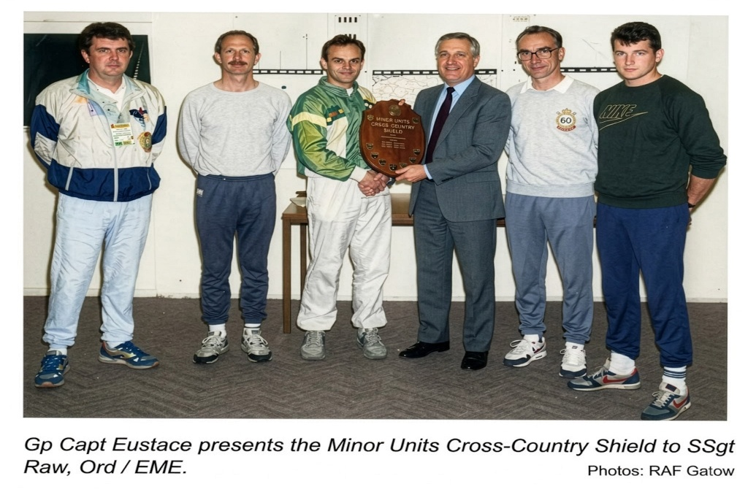
Picking up another trophy – fortunately, I do not have any pictures of me playing football.
Source: Steve Raw www.leadershipintheraw.org

Ten Ways to Deal with Flak
- Don’t take it personally…
- ……but do take stock: are the jibes fair?
- Act on them only if they are
- Don’t rush to respond
- Use it as a chance to self-examine
- Change what doesn’t work
- Celebrate what does
- Thank the critic for helping you
- Learn the lesson
- Move on
Source: Modern Management magazine
‘Communicating the ‘WHY’ – Purpose & Vision’
Great leaders don’t just tell people what to do, they explain why it matters.

When leaders communicate the purpose behind the task, the vision, or the mission, they inspire others to follow because they believe in it, not just because they have to.

The ‘why’ fosters trust, loyalty, and a deeper connection between leaders and their teams. It builds a shared belief and strengthens the bond that drives success.
So, next time you're leading a project or rallying your team, remember as Simon Sinek puts it, "Start with why.”

Interested in learning more? Check out the Army Leadership Doctrine on our website!

https://www.army.mod.uk/support-and-training/our-schools-and-colleges/centre-for-army-leadership/

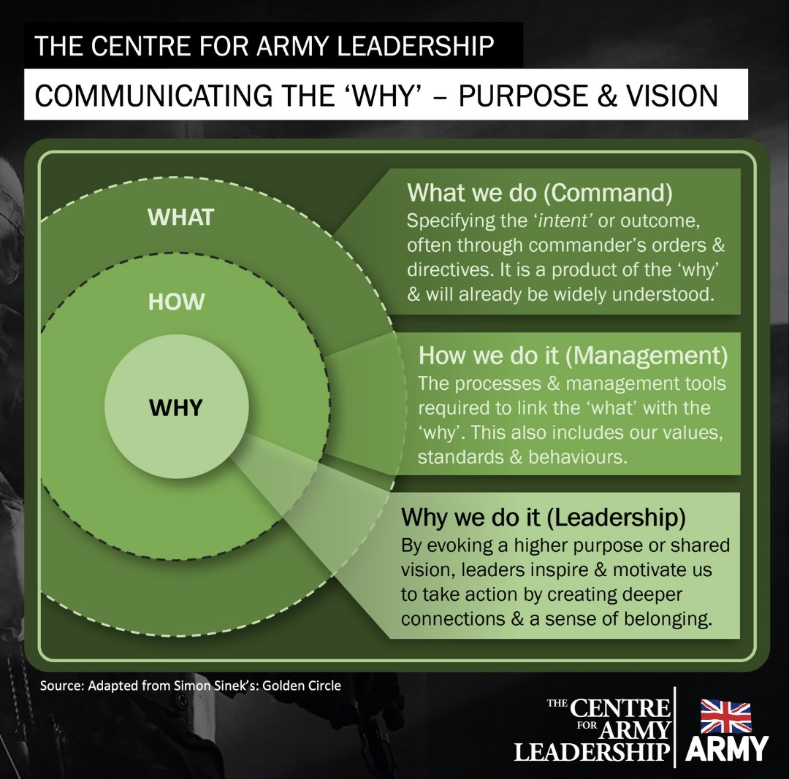
The culture within you

Northern Ireland 1977 shortly after my arrival.
Lying on my bunk on the Liverpool to Belfast ferry in 1977, I started to think about what was ahead of me in the coming hours. I was heading towards Northern Ireland at the height of the ‘Troubles’ for a two-year tour. I was 20 and had no fear, but I was nervous about how I would fit into the ‘culture’ of the Royal Signals unit I was joining. I had heard they loved ‘Drill’ ‘Discipline’ & short haircuts! It was all that!!
In 1984 I was joining a Royal Marines Commando Squadron, and I was excited as during the previous couple of years I had shared a room with a Royal Marine who had caught my imagination about their ‘culture’. He told me that their culture was one of positive attitudes, adventure, fitness and humour. It was all that!!
Then exactly 20 years ago I arrived at the offices of Thera for my first day. I knew I was going to have to up my game. I had done some checking, and their ‘culture’ was (and is) that it is all about people with learning disabilities; hard work; commitment and innovation. If you don’t have plenty of enthusiasm, energy and momentum you are not going to cut it. It all sounded right up my street!!
I have always been fascinated by ‘cultures’ within teams and organisations:
- What they are? Cultures are a sense of identity, tradition, history and structure
- How has culture developed? Cultures develop through rituals, beliefs, legends and values
- What difference can you make as a Leader and developing a culture? Let’s see….
Developing the Culture within your team and organisation
My 10 tips and recommendations are based on what has worked for me:
- Be open and talk about what you are about – and do it often so it becomes entrenched in people’s minds. People then can decide at the outset if they want to be part of this culture
- The culture must fit and match your organisations values, aims and objectives
- If you want to change the culture it is better (and it works) if you start with making small changes over a period. It is tempting at the outset to go big with change but, believe me, it will fail.
- Cultural change requires long term investment for the people you support and for me it is a life-long commitment
- Recruit people. not just for their competencies, but also for their values, attitudes and beliefs
- Knowing the culture of your team and organisation – the best leaders are those who adjust their style to suit – they are all different.
- Develop a ‘can do’ attitude that becomes shared – we say “yes” then get busy finding out how to do it.
- Just like your ‘vision’ you must live your culture everyday – there are no days off. As Leaders there is no putting your feet up and thinking “today I feel like being negative, idle and miserable”.
- Always remember culture is led from the top but grows from the bottom!
- At the outset tell everyone that we are going to have ‘fun’ and mean it.
“Culture eats strategy for breakfast”
Peter Drucker
What does a great culture look like for me? (working for Dosh Financial Advocacy www.dosh.org 2009 – 2024)
My Top 10
- We have great stories that inspire (we share those stories with each other)
- The culture doesn’t need to be written down – it is in people’s minds
- We have a dynamic culture that changes and develops
- We know who we are and what we stand for – We have a sense of identity
- We are proud about what we do – our culture is that we want to make a difference
- We have a common language, rituals and routines “how things are done around here”
- We have a “no blame” culture
- Managers are close to the people on the ground and they care about them – it matters that people are happy
- There are no surprises – everyone knows what is coming next – because we all talk to each other – trust and integrity
“The thing I have learned at IBM is that culture is everything”
Louis V Gerstner Jr
During my time as the Managing Director for Dosh Ltd I wrote about our culture in ‘Leadership the Dosh Way’ I hope it inspires you.
So as a leader have you considered the culture within your leadership team and organisation recently? Now that I have your attention what are you going to do to develop it?
Source: Steve Raw originally published on 1st March 2016 updated yesterday.

CONTAGIOUS SMILES
I begin most of my lectures by asking the audience to break up into pairs. Then I say this:
“Over the course of your life, you will have excelled in part because of your impressive self-discipline. I want you to take all of the self-discipline you’ve been cultivating for the past couple of decades to do the following. For the next seven seconds no matter what our partner says or does, I want you to show absolutely no emotional reaction. Go completely blank.”
I then ask the other person to simply look into his or her partner’s eyes and smile. I have done this experiment hundreds of times in corporate settings across the world, with everyone from nervous newbies to cantankerous lifers. The result is always the same. Virtually no one can refrain from returning their partner’s smile and most break into laughter almost immediately.
The mysterious force is the foundation of the ripple effect – the idea that your positive attitude and behaviour quickly ripple out, increasing the happiness of everyone around you, changing the way your colleagues work and eventually shaping your entire organisation.
Try this out for yourself. Spend a day smiling genuinely at every person you pass. Take note of their responses and watch the happiness factor spread throughout the room.
Source: Shawn Achor author of ‘Before Happiness” from USA’s Success Magazine
You cannot avoid pain, but you can choose to overcome it. –
Paul Coelho
Please - Only Benchmark Against... 
Time to read: 1 Minute

Dear Steve
Please – Only Benchmark Against…
…yourself.
Seriously. Stop peeking over the fence.
That “successful” person, business, or organisation you’re benchmarking against? You’ve no idea what’s really going on.
Smoke. Mirrors. So often the wrong conclusion.
Benchmarking sounds clever. It isn’t. It’s lazy thinking dressed up as strategy.
Because the only meaningful question is this: what did you say you wanted— and how are you doing against that?
Your dreams. Your outcomes and most of all your progress.
Of course, when someone you know has achieved an outcome you really want to achieve go ask them how they did it – they will love to tell you – and do what they did. That’s not ‘benchmarking’, that’s copying, or in the words of Neuro Linguistic Programming – Modelling!
To benchmark is to compare with little real evidence.
So, be you and go fulfil that promise of your first few seconds.
With my love and best wishes to you
David
Previous Naked Leader Weeks
sign up to receive this blog - unsubscribe anytime
@nakedleader across all social media

YOUR ROUTE TO THE TOP - GO FROM BUDDY TO BOSS
Face facts. The sooner you accept that you’re no longer ‘one of the gang’ the sooner you will flourish in your new role.
Make a deal. Create verbal contracts with ex-buddies early on. Set ground rules for working together and discuss likely problems. Cement your new dynamic by leading the conversation.
Be fair. According to psychologists, impartiality is a challenge for new managers. If a friend demands special treatments, ask yourself if you’d do the same for others. If not, say no. Firmly.
Keep it in. Disastrous meeting? Impossible targets? Feel like ranting at a friend? Tough. Emotional outburst erodes credibility and respect. Save the tears and tantrums for home.
Fill the void. Your new role will mean withdrawing from familiar behaviour. Combat uncertainty by recognising what you miss (brainstorms) and what it provided (a stimulating exchange of ideas), then find a substitute (a book club).
Watch your ego. Author Jim Collins found that the most successful companies have a humble CEO.
Engage your new team by welcoming their views and publicly praising their contributions. Remember: you’re the manager, not the messiah.
Tame your talk. There’s a fine line between sharing information and compromising confidentiality. If chats become inappropriate, remind the group of your position. If it’s you who has the loose tongue, stop talking and get out.
Recapture confidence. Plagued by self-doubt? Write down five things people have praised you for in your new role and reread whenever you need a boost
Remember the bad times. It’s easy to look back with rose tinted lenses. List the frustrations of your old role, then what you love about the new one. Still miss the good old days?
Celebrate. You got this job because you deserve it.
Source: The Mind Gym
And something from me ‘My 20 Top Tips for New Leaders’:
https://leadershipintheraw.org/2019/09/27/20-top-tips-for-new-leaders/
YOUR ROUTE TO THE TOP
SMART NEGOTIATION
Talk to the big cheeses. Negotiations are pointless without the right people present. Find out who holds the real power and make sure they (or their best alternatives) are at the table.
Listen up. Small talk reveals big issues. As you settle, ask questions to gather facts about their business, motivations and challenges.
Grow the pie. Present your ideas as a starting point to improve on together, not something you have to defend. Find opportunities for mutual gain to seal the relationship.
Dig deep. Explore both parties’ interests in detail. You decide it’s time to overhaul your direct marketing system, they show you that your real needs are more reliable contact information and to save time and money by cleaning up your database.
Show your human side. Mention a hobby, reveal a concern, make a joke. Rapport and trust oil the wheels of negotiation.
Use your negotiables. First, concede things that are of high perceived value to the other party but low value to you. Hold back on what you plan to offer, otherwise your concession is made. Instead, frame the concession as: ‘if you…then I will…’
Show them your options. Build up your best alternative to the negotiation and play this back to the other party.
Keep schtum. The first to break the silence is usually the first to concede
Source: The Mind Gym
Liberty means responsibility. That is why most men dread it. –
George Bernard Shaw
CRASH COURSE IN……..
LEADING BY EXAMPLE
As Albert Einstein put it: ‘Setting an example is not the main means of influencing another, it is the only means.’ Willie Walsh is asking BA staff to follow him in working a month unpaid, and leaders are now expected to offer model behaviour. So how do you lead by example?
You don’t have a choice. ‘From the moment you take up a leadership role, people will be watching you,’ says Donna Ladkin, senior lecturer in organisational learning at Cranfield School of
Management. ‘So you are leading by example; the question is whether it’s the example you want to set.’
Be strategic. Identify the behaviours you want people to emulate. Some of these are driven by your organisation’s values, others by the business context. ‘If you ask your people to work unpaid, they’ll expect to see that this is consistent with a broader business strategy and not a fad,’ says Andrew Day, an organisational psychologist at Ashridge Business School. “They need to see a rationale, and that this is not just a heroic gesture.’
Walk the talk. Leading by example means you don’t ask others to do what you are not prepared to do yourself’ says Steve Newhall, vice president of talent management consultancy DDI. “The whole idea is heavily linked to integrity, and people’s antennae are tuned to hypocrisy right now”
Show your tough side. It’s not all about self-sacrifice. Says Day: giving tough feedback to people who are not performing – in a developmental way – may be the behaviour you want people to emulate.
Be visible. ‘Leaders need to lead,’ says Day. ‘It’s not enough to retreat to the office/boardroom and tell people what you want them to do. You need to meet people face to face, rather than avoiding anxiety-provoking situations.’
Validate. ‘The best way to find out what people are really thinking is to talk to them’
Do say: ‘The leadership that we show now during hard times will be remembered for years to come.’
Don’t say: ‘I’m going to be holidaying in Tuscany instead of the Caribbean this year and I expect you all to do the same’
Source: Alexander Garrett - Modern Management

