LEADERSHIP AND WELLBEING PACK
June 2026
The 20th Anniversary Editions
Welcome to this month’s edition. Highlights include:
Damian Piper CBE our Resilience Coach starts this month edition with: You can’t be a TOP performer if you are not happy. “Oxford researchers De Neve and Ward, writing in their recent HBR Press book, Why Workplace Wellbeing Matters, observe that most of us spend a third of our waking lives at work and yet whether work is making us happy rarely gets serious attention….”
I believe leaders and therefore their teams often fail because they have not been ‘curious.’ Being Bettina’s Dad – A case for ‘Curiosity. Bettina is looking at the array of medication on the sideboard in our dining room; from a distance her parents can see she is picking up one box after another trying to read the labels…….”
Phyllis Maynard a Non-Exec Director for Dosh (Financial Advocacy) www.dosh.org shared this with us from Deana Towersey “A quick reminder that strong workplace culture doesn’t start with strategy. It starts with people feeling safe, supported, valued, and connected…..
One of my favourite sources for my leadership learning is ‘The Centre for Army Leadership’ This month it is ‘The British Army Core Values – CDRILS’
KEEPING A PERSPECTIVE – THIS TOO SHALL PASS “It is snowing outside, and I am carrying an injury. I have flu-like symptoms, and I am about to go for a nine-mile run. Joyce, my wife tells me I should give it a miss today……”
There are lots more in this month’s edition so let’s dive in together……
Steve Raw FioL
Blog: www.leadershipintheraw.org
Instagram: @stephenraw6
Twitter: @SteveRaw836
Blue Sky: https://bsky.app/profile/steveraw.bsky.social
LinkedIn: https://www.linkedin.com/in/steve-raw-72454721/
Facebook: https://www.facebook.com/steve.raw.771/

It’s not about how good you are,
It’s how Good You want to be.
You can’t be a TOP performer if you are not happy.

Oxford researchers De Neve and Ward, writing in their recent HBR Press book, Why Workplace Wellbeing Matters, observe that most of us spend a third of our waking lives at work and yet whether work is making us happy rarely gets serious attention. Research from Alight's 2025 Employee Mindset Study adds a striking data point to that question, 85% of workers have access to a wellness programme, yet only a third use it.

Are workplaces responsible for our happiness and wellbeing?
From what I have seen, workplaces that look to force wellbeing on people have mixed success. No doubt there are a range of reasons for this, however my hypothesis is that the corporate wellbeing programmes are often seen as Care Washing. Where real world expectations on people are at odds with the mantras and content of the, no doubt well intentioned wellbeing programmes.

What happiness actually means
A part of our wellbeing be it professionally or personally is our perceived level of happiness. I use the word perceived as it’s only really us that can determine what makes us truly happy. When coaching people the question of happiness is something people will often only have a superficial view of. It’s common that many of the drivers of happiness are external, possessions, people, events. They all matter, however, we are susceptible to unhappiness when these things don’t go the way we’d like. And when we are unhappy we leave ourselves vulnerable to not performing at our best.

I’d argue you can't sustainably perform at your best if you're not happy. Not because happiness makes you work harder, but because unhappiness is a drain on the cognitive and emotional resources that performance requires. Our performance foundations are stronger when we are looking after ourselves. I call this PRIMEing ourselves for success. Where PRIME™ is a mnemonic that stands for:

- Physically looking after ourselves,
- ensuring we are well Rested,
- managing our Intake (the foods we eat and the drinks we drink),
- giving enough attention to managing our Mind and emotions
- being aware of our Energy.

When these five areas are being managed well, I’ve never met anyone whose happiness doesn’t increase and as a result their ability to deal with what comes their way. Then their performance improves along with the results they would like to see.

Getting specific about happiness
Most people are unclear about what happiness actually means to them. They're chasing a vague feeling rather than something specific and achievable. A bit like having a vague destination on a journey. OK to a point, however, there comes a time when the specifics matter. Getting beyond the vague and really thinking about what it means for us to be happy is time well invested. As an example, living in alignment with our values is one route to move beyond the vague. And yet when asking people what their values are, a common response is I’ve never really thought about them. Being more deliberate about what happiness actually means and then designing a sustainable approach to living like that is something I’ve never seen anyone regret. I include myself in this and know that just like the majority of people I fall short of what makes me happy when I am not paying enough attention to it.

The happiness delay trap
Many people are delaying happiness. This is another common situation I see. "I'll be happy when...". This sets us up with a gap that is unbridgeable. When delaying happiness we fuel ourselves with feelgood neurotransmitters, such as dopamine, which increase as we pursue the thing we want. When achieving the thing, we quickly adapt to it being the norm and therefore the happiness is often short lived. We are left with a hole as those feelgood feelings dissipate. We want them back, so we then set ourselves up with another thing to pursue. And so the cycle begins again. In 1971 psychologists Brickman and Campbell coined the phrase the hedonic treadmill to describe this situation where we are running to standstill. Shifting our focus on inward can provide sources of happiness that are not reliant on some future plans or success. This is not to say those things are not important. They are. However, if our happiness is delayed for them we are likely to be disappointed. To conclude this section I’ll leave you with a stat from a Deloitte study in which 89% of C-suite executives surveyed reported that improving their well-being is a top priority for them. This makes me thoughtful about what priority happiness and wellbeing have been earlier in their careers before they reached the C-Suite.

Designing the conditions for happiness
Happiness needs the right conditions. Despite what toxic positivity might suggest, I don’t think you can just decide to be happy. Or if you can this risks suppressing a whole lot of other emotions which will only come back stronger. Once we have our view of what happiness means to us we can begin designing and implementing the conditions that make it more likely. Shaping our environment is a critical component of this. Being clear on what we can control, influence and need to accept are critical. Of course being clear is not enough. We then need to take action.

Making happiness a priority
And this brings me back to the beginning of this article. I’d argue taking action on our happiness is not something to outsource to a corporate wellbeing programme, another person or physical thing. If we really want to be a TOP performer then, doing that from a place of solid foundations with an environment designed for you, by you are essential components to that everyday happiness that we need if we are to successfully deal with what comes our way. Why delay making this a priority like those C-Suite executives?
As always, I am interested in your thoughts.
Damian
damian@effectivechallenge.com | effective challenge podcast | LinkedIn

Damian Piper CBE is a performance, productivity and resilience coach who works with ambitious professionals and leaders who are capable of more but keep getting in their own way. Drawing on over 30 years of self-development, senior leadership experience, including a role in delivering a safe and secure London 2012 Olympic Games, and a coaching framework built from the ground up, Damian helps people understand what's actually driving their performance and build a bespoke approach that works sustainably. You can find more of his thinking at effectivechallenge.com or connect with him on LinkedIn.

Being Bettina’s Dad – A case for ‘Curiosity.’
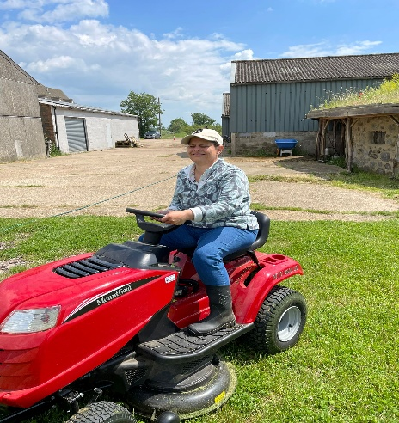
Surely this cannot be that difficult to drive.
Bettina is looking at the array of medication on the sideboard in our dining room; from a distance her parents can see she is picking up one box after another trying to read the labels. I recently had an eye operation and Bettina has noticed me going into the room with my wife, Joyce, to administer the prescribed eye drops. Bettina’s curiosity once more kicks in.
If you have previously followed the “Being Bettina’s Dad” series, you will know that Bettina has a diagnosis of autism, a learning disability, and copes with epilepsy. We are convinced that Bettina’s curiosity has played a significant part in her progress and development.
But it is not just Bettina who benefits from her curiosity, the lessons I have learned from Bettina helped me in both my work and my personal life.
How Curiosity has worked for Bettina (aka ‘B’):
Life was bewildering for Bettina in her early years but so many people around her could see B’s potential and believed in her, not just her family. As Bettina came to terms with her autism (we could see it was quite painful for her) we saw how she started to work things out for herself.
Related: https://leadershipintheraw.org/2026/03/16/being-bettinas-dad-we-can-work-it-out/
‘B’ reached a state of being curious and wondering about her complicated world through:
- Observing. Bettina takes an active interest in what is going around her. Bettina is constantly looking for clues and explanations of how and why things happen and how they may have an impact on her.
- She is eager to learn. What has been wonderful for her parents is that Bettina has not settled on what is comfortable for her. We see this with her hunger to learn new things. An example is with her reading; it would have been comfortable for Bettina to have settled after finishing ‘education.’ Bettina has demonstrated her curiosity to learn more with the books she buys.
- Engaged. Bettina is a busy person and when she is on task, she is totally committed.
- Poking around. Bettina is usually the first to excuse herself from our dining room after our evening meal. Much to our amusement, we can hear her poking around in the kitchen. We hear doors opening and closing, sometimes the odd “ah ha.” It is not only our kitchen Bettina explores, but we also often hear her footsteps when we are downstairs, and Bettina is upstairs in our bedroom and her big sister’s bedroom.
- Open minded. One of Bettina’s qualities, is that she is not influenced by any kind of bias or prejudice. This enables her to explore her curiosity with a freedom of thought.
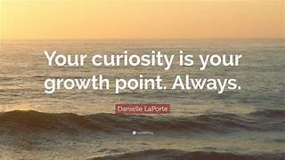
Bettina lives in the moment, seeing the world with new eyes, here are five lessons I have learned from Bettina’s curiosity:
- By being persistent and persevering. Bettina never gives up and she will often return to a thing she is curious about.
- ‘Let your curiosity be greater than your fear’ Pema Chodron. ‘Because for Bettina what is courage without fear’ related: https://leadershipintheraw.org/2018/12/10/being-bettinas-dad-what-is-courage-without-fear/
- Finding lots of things to be curious about – this brings about innovation. Bettina is incredibly creative.
- People curiosity. Why do people do what they do? What can we learn from them?
- To see without judgement. To observe without trying to fix or control. This is what Bettina does.
Providing an environment of curiosity, both at home and work:
- Having a shared curiosity – you are all curious (and challenge each other) and this is ok.
- Providing space and time to explore – allowing people to be innovative and creative.
- To question – not expecting people to obediently follow your instructions or what they perceive as your wishes.
- Opportunities to experiment – through having a ‘no blame culture.’
Related: https://leadershipintheraw.org/2025/10/23/no-blame-cultures/
- Encouraging people to stay curious when others get defensive. Ask yourself, "what am I missing?" instead of proving your point.
Leaders and therefore their teams often fail because they have not been ‘curious.’
And finally…
At the weekend Bettina and I went to the beach in Frinton on Sea (Essex, England). Bettina loves collecting seashells for our garden but unfortunately on this occasion the tide was in. This was not going to defeat her! Walking along the promenade Bettina suddenly runs to the back of a row of Beach Huts, I hurry off after her, Bettina needs to satisfy her curiosity, will she find seashells there? She has not looked behind the huts before, but she thinks it is worth a try – and is successful with her find.
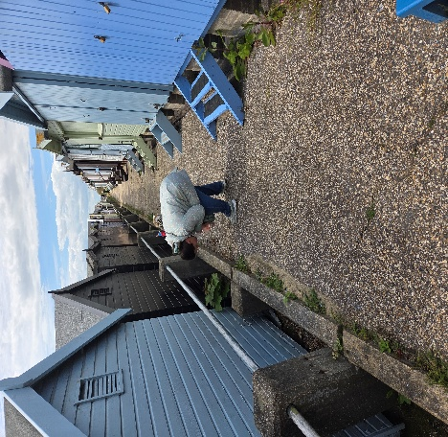
Source: Steve Raw www.leadershipintheraw.org
Phyllis Maynard Non-Exec Director of Dosh (Financial Advocacy) www.dosh.org shared:
Deana Towersey • 3rd+Workplace Culturologist | Mental Health First Aider | Mental Health Advocate | Work-Life Coach | Hypnotherapy & Counselling Student5d • Edited •
A quick reminder that strong workplace culture doesn’t start with strategy. It starts with people feeling safe, supported, valued, and connected.
Inspired by a recent NHS leadership post that adapted Maslow’s Hierarchy of Needs to the NHS environment. I’ve taken this (and AI’d it) to fit “any” workplace or team environment, as an important reminder that thriving teams are built from the foundations up.
Highlighting that these building blocks can be applied to any business, whether it be in healthcare, education, corporate settings, or small organisations, the same principles apply:
✔ Basic workplace needs must be met
✔ Psychological safety matters
✔ Belonging drives collaboration
✔ Recognition builds confidence
✔ Purpose inspires performance
When leaders only focus on outcomes without putting in the foundations, burnout, disengagement, and disconnection set in all too soon.
But when employees feel psychologically safe, included and appreciated, workplaces become healthier, more productive, and more sustainable.
This adapted version explores how Maslow’s framework can be applied across modern workplace settings, not just leadership teams…but in any organisation wanting to create environments where people can genuinely thrive.
Like I mentioned earlier… credit and inspiration goes to the original NHS post on leadership concept adapting Maslow’s Hierarchy of Needs for their teams and leadership.
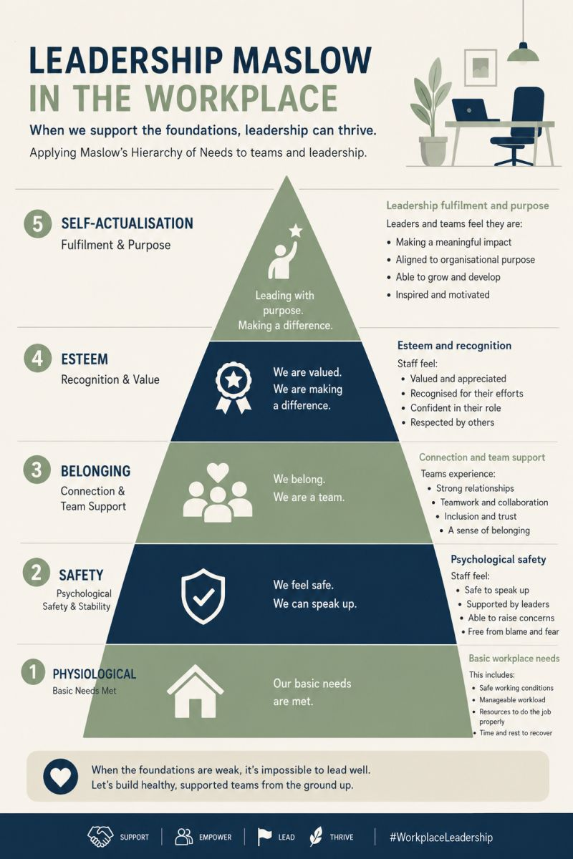
Values at the core of British Army Leadership
Being values-based isn’t just a principle—it’s the foundation of effective leadership. These enduring virtues shape attitudes, behaviours, and decisions daily:
Courage: Physical and moral strength to do what’s right, even when it’s tough.
Discipline: Self-control and professionalism to maintain focus under pressure.
Respect for Others: Embracing diversity and treating all with dignity.
Integrity: Building trust through honesty and truthfulness.
Loyalty: Creating cohesion while staying grounded in other values.
Selfless Commitment: Putting the mission and team above personal interests.
Leadership starts with living these values
Interested in learning more? Check out the Army Leadership Doctrine on our website at https://www.army.mod.uk/.../army-leadership-publications/
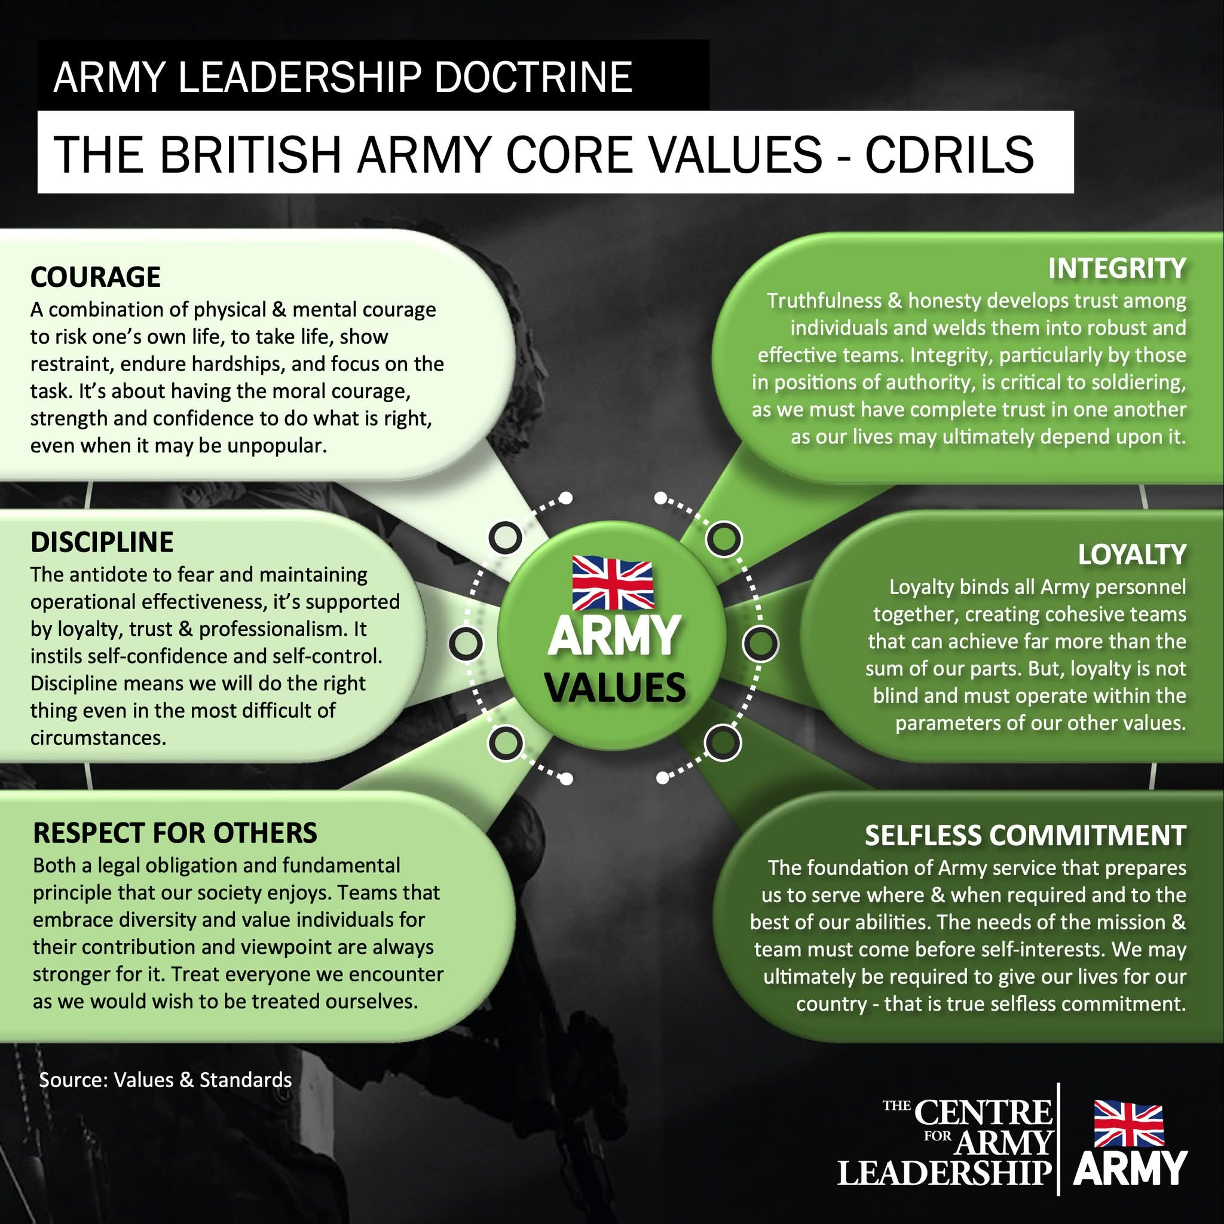
KEEPING A PERSPECTIVE – THIS TOO SHALL PASS
Steve Raw
It is snowing outside, and I am carrying an injury. I have flu like symptoms, and I am about to go for a nine-mile run. Joyce, my wife tells me I should give it a miss today. “But Joyce you don’t understand if I miss a run it is going to affect my time when I race at the weekend; the team need the points; there is a trophy on the line and I am the captain.” I am pretty sure I hear Joyce murmur “Diva” and then “Prima Donna” This was some years ago when I was an athlete for both Colchester Harriers and my Army unit.
Joyce and I recently recalled this example of losing my perspective when something had not been done at work. I was becoming anxious and I was not focusing on conversations going on around me. My sense of perspective had gone out the window and I really had to get things back into perspective, which was difficult as I felt that this was something beyond my control.
Do you have trouble keeping a perspective? I have been thinking about maintaining a positive perspective recently, especially having gone through Covid19 and all that this has entailed not just for my family, but other people’s experiences - some of them tragic.
Who is this article for? (apart from myself)
- If you are feeling under pressure
- You are spinning lots of plates (both at home and work)
- Dealing with unexpected events (big or small)
- Constantly worrying and feeling overwhelmed
- you feel there is no end in sight of your current situation

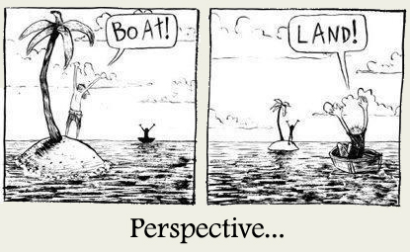

Five Lessons I have learned about keeping a perspective (and often must re-learn):
- Will this situation matter in six months’ time? I think I first learned this lesson when I was a Registered Care Home Manager over 20 years ago. There always seemed to be an emerging crisis, when I took a step back (usually on my drive home) I often thought “in six months will this be a vague memory or a valuable experience?”
- Share how you feel with someone who is not involved in the situation, so you have an independent observation. Mentors are good and help you keep a cool head. I am super lucky, I have Joyce. You would be surprised how quickly I calm down when Joyce asks me if World War 3 has broken out?
- To look at the whole "picture", keeping things in proportion to everything else that is going on around me. I found stepping back from the issue I was concerned about enabled me to gain more clarity, or objectivity.
- Ask yourself this question – What is the worst that could happen? Then write it down. I find that when I see it in ink, I can gain a sense of proportion.
- To slow things down and be mindful. Taking a walk with nature can be soothing and rejuvenating, so you are ready to tackle the situation that had previously felt so insurmountable.
Related: Being Bettina’s Dad: Bettina transforming my life with mindfulness – Leadership in the Raw
“If you woke up this morning in a nice warm bed, if all your loved ones are safe and happy and you have food/water - why wouldn't you be grateful?” Joyce Raw
And one thing to remember:
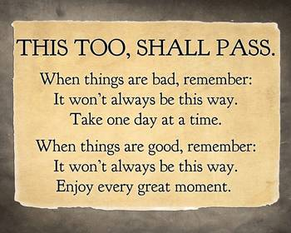
Five things I need to do when the next time I think I am about to lose my perspective:
- Laugh at myself – take your situation seriously but don’t take yourself seriously
- Take some time out (if only for 30 minutes), this afternoon I went for a run in a nature reserve where I have been training for the last 30 years and thankfully is often deserted. I came away refreshed and with lots of ideas – one of which is the subject for my next blog post!
- Remember the last time you felt like this? What did you do that worked? Do that!
- Remember you came through this before – back yourself to do so again.
- Take time to be grateful for everything you have. Gratitude gives you the ability to overcome worry, confusion, frustration, resentment, and dark moments in your life.
Related: Being Bettina’s Dad – Taking the time to be grateful and showing gratitude – Leadership in the Raw
And one thing to remember: Have a cut off time (in a normal working week for me it is 7pm) when you switch off your laptop and stop looking at your smartphone. You are exhausted and if you are making decisions when you are tired, they may be the wrong ones!
And finally……
I went for that run, hardly seeing one foot in front of me as I ran head down against the driving snow - you could say I had lost my perspective. I was young(er), foolish and (according to Joyce) a bit of a diva. Now? Now I have no excuses, the next time I start to lose my perspective…….
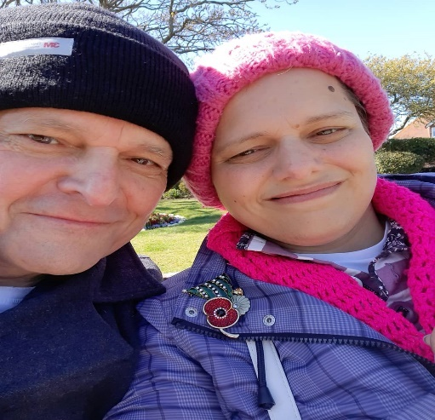
I think of the challenges Bettina has faced her whole life it puts anything I face into perspective, thanks ‘B’
Source: Steve Raw www.leadershipintheraw.org

The Greatest Risk?
Time To Read: 21 Seconds
Time To Do: Now, or Now, or Never…
Dear Steve
The Greatest Risk?
To be seen, as you truly are, and encourage others to do, and be the same
Removing our masks is exposing, yet it is where identity, connection and unlimited potential is unleashed.
When you choose to be Yourself – your Spiritual, Everlasting Loving Self, you fulfil the promise of your first few seconds, which in turn helps others to do the same.
With my love and best wishes to you and those whose lives you touch
David
Previous Naked Leader Weeks
sign up to receive this blog - unsubscribe anytime
@nakedleader across all social media

FASTRACK TO…….

MANAGING UP
It might seem unnatural to manage those above you in the top-down world of business, but mastering this skill is exactly what you must to do excel in any organisation. Managing up is not about brown-nosing or becoming the boss’s favourite, but about learning how to work within the confines of an organisation to get what you need, while helping your boss meet their objectives.
Decode your boss’s management style Take time to observe how your manager uses authority, the way they relate to others, and their communication style as a leader. You’ll find that most bosses generally fall into one of the following categories; dictatorial, laissez -faire, bureaucratic, or consultative. Once you determine the type of manager you’ve been handed; you can then study ways to work most effectively with this type of leader.
Be aware of your own communication style Understanding your own style of communication will allow you to more easily adapt to the situation at hand. For example, if you are the type of person who feels the need to provide background information all the time, you may consider practicing how to be succinct before meeting with a busy boss. If you prefer to communicate via text and your boss prefers face-to-face communication, then adjust your style, as it’s unlikely your boss will readily adjust theirs.
Play office politics In every organisation, there is always a round of politics being played somewhere, whether it’s the boardroom or the backroom. Politics isn’t just about manipulation; it’s about using power effectively. Observe how work really gets done in your organisation, then practice following the unwritten rules. This will allow you to move swiftly to obtain scarce resources, approval of prized projects and promotions.
Don’t be afraid to boast Forget what others have told you about bragging. You have to make enough noise so people in the organisation take notice of who you are and what you are able to accomplish at work.
Master the art of influence Influencing is about communicating with a goal in mind. Skilfully exercising influence will increase acceptance of your ideas and improve your chances of obtaining scarce resources. Focus on building trust and respect in the organisation and you will be well on your way to getting exactly what you need to succeed.
Source: ILM’s Edge Magazine
Top tips on……
MEETING EVALUATION
Time to address the issue of meeting effectiveness.
Once the last coffee cup has been cleared away, the biscuits polished off and the lights turned out, as the chairperson you need to ask yourself:
- Did all present contribute positively, according to their roles?
- Was the discussion lively but good tempered throughout?
- Were all relevant aspects of the subjects properly explored? • Was consensus reached on all major decisions?
- Did the meeting cover the subjects within the time allotted?
- Did all leave with a clear knowledge of what had been achieved, and their responsibilities for future action?
We’re all familiar with ‘happy sheets’ questionnaires given out at the end of workshops but such evaluation forms can also be invaluable to assess the success of meetings and help those who participated to perhaps perceive their own weaknesses and do better next time.
Setting a rating from 1 – Poor, to 5 – Good, the form could include the following questions, asking to what extent:
- Were the objectives clear?
- Was the meeting well-prepared?
- Did it stick to the point?
- Were vital matters covered?
- Were clear decisions reached?
- Was people’s knowledge used?
- Did people speak?
- Did you contribute?
- Did the Chair control the meeting?
It is important to remember that ineffective or unnecessary meetings can waste time and money, exacerbate divisions and bad feeling and produce poor decisions.
Source: Professional Manager
‘To believe in something , and not live it, is dishonest’ Mahatma Ghandi
IMPROVING YOUR MEMORY
Identify your memory type – are you visual or auditory? When people picture things in their minds, they draw on their vision or hearing. It’s important to know whether sight or hearing dominates when you conjure up a mental image
Transform ideas into images – the mind remembers images better than abstract ideas. It will be easier for you to remember information if you give it a form that is evocative and true to life.
Use your natural aptitude – some types of information are easier to retain than others. Numbers, names, places, stories and itineraries are easier to remember, so mentally arrange things using the mnemonic system that suits you best.
Be selective – unless you’re well trained, it is almost impossible to retain a large amount of information in a limited space of time. Prioritise what is most important.
Stay calm – stress limits your capacity to memorise information. Your memories works best when you are relaxed and feel confident and positive, so try not to fret
Concentration is critical – the more effort you make to remember information, the more likely you are to retain it
Understand your information – we need to understand what a piece of information means in order to properly remember it. Sometimes this might mean asking for clarification
Source: From the ILM’s Edge Magazine
‘The meaning of life is to find your gift. The purpose of life is to give it away’
William Shakespeare

Think lucky
Psychological research suggests that leaders who embrace the concept have a better chance of inspiring those around them. Richard Wiseman a psychology professor has identified the following key characteristics of people who are more than usually ‘lucky’
- They tend to have networks of friends and are good at spotting opportunities
- They back their hunches and have good intuition
- They expect to be lucky and create self-fulfilling prophecies
They adopt a resilient attitude that helps transform bad luck into good

