LEADERSHIP AND WELLBEING PACK
July 2026
The 20th Anniversary Editions
Welcome to this month’s edition. Highlights include:
Damian Piper CBE our Resilience Coach starts this month edition with: When the Right Words Are the Wrong Fit “When coaching, my aim is always to develop a sustainable approach that meets people where they are and enables them to achieve what they want. There are certain approaches and phrases that feel universal, so they often form part of what we develop….”
Being Bettina’s Dad: Bettina’s approach to relationships. “Sitting on the decking of our holiday lodge taking in the evening view, as the sun gently goes down, Bettina puts her arm around my shoulder. We are on our family holiday and life could not be better…”.
From the author broadcaster and trainer, David Taylor: Do This Radical Alternative? Do This Radical Alternative? Or of course, don’t… “If something isn't working out for you...”
Something I shared for Fathers Day in June: Being Bettina’s Dad: Being a Dad “I have now been a Dad for just over 40 years; I have become practised in all the demands and responsibilities of the ‘post’. Being a dad was something I always wanted to be and I had prepared fully for the role long before I became one in exactly the same way I had when I decided I would aspire to be a leader…..”
This month’s piece from The Centre for Army Leadership ‘Active Listening Skills’
There are lots more in this month’s edition so let’s dive in together……
Steve Raw FioL
Blog: www.leadershipintheraw.org
Instagram: @stephenraw6
Twitter: @SteveRaw836
Blue Sky: https://bsky.app/profile/steveraw.bsky.social
LinkedIn: https://www.linkedin.com/in/steve-raw-72454721/
Facebook: https://www.facebook.com/steve.raw.771/

It’s not about how good you are,
It’s how Good You want to be.
When the Right Words Are the Wrong Fit
When coaching, my aim is always to develop a sustainable approach that meets people where they are and enables them to achieve what they want. There are certain approaches and phrases that feel universal, so they often form part of what we develop. Yet, while there is real benefit here, there is also hidden risk. In this article, I want to unpick an example of how a single piece of language landed unexpectedly with a client, because I suspect their experience is not unique, and the lesson could benefit others.
When looking to narrow down what someone will do to make progress, I often ask what their "non-negotiables" are. It is a phrase I picked up from a great coach I worked with earlier in my career, and it is intended to do specific psychological work. It is meant to eliminate the on-the-day negotiation with yourself, the bargaining that happens when you are tired, busy, and looking for a reason to let something slide. Said with conviction in an objective frame of mind, it works. It gives you clear criteria to use when your resilience is being tested.
The issue for this particular individual was exactly that: it only worked in an objective frame of mind.
As I always say, the real progress happens between our sessions, where individuals experiment with what we discuss. This client described how, whenever they fell short of a non-negotiable, it had a disproportionate impact. It generated a feeling of immediate failure, which then fed into a spiral of negative self-talk and undermining behaviours. Language designed to help became a stick to metaphorically beat themselves with.
The language hadn't failed in a general sense. It had failed for this person, in this moment. This raises a much more interesting question than whether "non-negotiables" is a good or bad phrase: if the same words can be both a foothold for one person and a trigger for collapse in another, what does that tell us about how language actually works on us?
My first instinct, watching this play out, was to fix the phrase. If "non-negotiable" was too absolute, we needed something that retained the conviction but lost the cliff edge. We settled on "high-integrity commitments."
Initially, it felt like an improvement. It pointed at the purpose of the commitment rather than just the rigidity of keeping it, and it made room for a commitment to be renewed rather than simply broken.
It took a few more conversations to notice what we had quietly done. If the commitment itself is what constitutes high integrity, falling short doesn't just mean missing a target, it implies you were low-integrity in that moment. For someone already prone to harsh self-judgment, that isn't a softer landing. It is the exact same cliff, just with a different name on it. We had swapped one phrase for another, built with the same good intentions, but it still wasn't tuned to this individual's actual situation.
I think of it like borrowing someone else's glasses. If a friend hands you their new glasses and tells you they have transformed how they see, you would likely not expect the same result. Their prescription was built for their eyes. Put them on, and your world doesn't sharpen; it blurs. The glasses aren't faulty. They were just never built for you.
Language works the same way. A phrase like "non-negotiables" is simply someone else's prescription to get them doing what they want. For the person who created it, it corrects exactly the right thing, maybe a tendency to talk themselves out of commitments, or a need for a hard line to push back against other people's demands. But put that same phrase on someone who has an excess of self-judgment, and it doesn't correct anything. It distorts. The absoluteness that gives one person clarity gives another a cliff edge, somewhere to fall from every time life gets in the way of what they say they want.
Here is why this is so hard to spot: the discomfort of using the wrong language rarely arrives labelled as a mismatch.
Someone you respect shares a phrase that genuinely, helpfully, and enthusiastically changed how they operate. When it doesn't do the same for you, your natural conclusion isn't that the phrase was poorly suited to you. The conclusion is that you are somehow doing it wrong, that you aren't committed enough, or that you are wired differently than the people who manage it fine.
It is worth being precise about what makes a phrase "fit," because fit isn't one-dimensional.
There is logical fit: whether the words accurately describe what you are trying to achieve and the reasoning stands up to scrutiny. "Non-negotiable" is logically tidy. "High-integrity commitment" is tidier still. But there is also emotional fit: how the words land in your body when you fall short, not just when you are succeeding. That is much harder to test in a coaching session, where we are more likely to be in a calm, objective frame of mind. Because we are not emotionally static, the weight of a phrase changes under pressure. When things go wrong and resilience is tested, a well-intentioned phrase can turn into something it was never intended to be. A phrase might pass logically but fail emotionally, and you won't appreciate that until it has been tested by a bad day or a difficult week.
So, what does this mean for you?
I am not proposing a simplistic, five-step framework for choosing better language. Instead, I offer questions worth sitting with: where in your own internal dialogue, the words you use on yourself when things slip, might you be using someone else's prescription?
Where have you adopted a phrase, a rule, or a standard because it worked for someone you respect, without checking what it actually does to you when you fall short? And when you discover it doesn't fit, can you allow that to be information about the phrase, rather than evidence of a flaw in you?
As always, I'm interested in your thoughts. Have you ever adopted a popular productivity or self-development phrase only to find it did more harm than good?
Damian

damian@effectivechallenge.com | effective challenge podcast | LinkedIn

Damian Piper CBE is a performance, productivity and resilience coach who works with ambitious professionals and leaders who are capable of more but keep getting in their own way. Drawing on over 30 years of leadership experience, including a role in delivering a safe and secure London 2012 Olympic Games, and a coaching framework built from the ground up, Damian helps people understand what's actually driving their performance and build a bespoke approach that works sustainably. You can find more of his thinking at effectivechallenge.com or connect with him on LinkedIn.

“Attention is the rarest and purest form of generosity.”

Simone Weil, quoted in The Philadelphia Citizen

Being Bettina’s Dad: Bettina’s approach to relationships

Sitting on the decking of our holiday lodge taking in the evening view, as the sun gently goes down, Bettina puts her arm around my shoulder. We are on our family holiday and life could not be better. Bettina has come a long way from the days when she couldn’t tolerate eye contact, avoiding physical contact, with a simple form of affection such as a hug being too painful for her. Bettina was unable to verbally communicate until she was 11, due to her severe autism and also her complex communication difficulties.
Bettina always needed to, and still does, work harder than the rest of us with her relationships as she makes connections to express her feelings and relate to people. Where do you start when your world was a ball of confusion, and you are not sure why and what you can do about it? We know this because her family have been by her side, every day of her life (and we always will be).
“When someone loves you, the way they talk about you is different. You feel safe and comfortable.”
― Jess C. Scott, The Intern
For those who know Joyce (my wife) and me, it probably won’t come as a big surprise that a few months after we were married, we sat around our dining table in our new home in Plymouth and discussed the relationship we would have with our future children (and hopefully the relationship they would have with us) We had this discussion before they were even born! In our minds we were always going to have children, and we were determined to have:
- A family philosophy (we now have a hashtag for this #livelikearaw and a similar Twitter handle)
- A culture (how we do things around here) which is democratic. I was asking Jennifer our oldest daughter her opinions from a very early age. On one such occasion, a brother-in-law listening into a conversation we were having said “Steve she is only two”
- A set of rules that would apply equally to each of us that covers: Respect, privacy, good manners, etiquette and positive regard for each other
- A set of standards which both Joyce and I would honour: Primarily our children would come first and be at the heart of everything we did (this has included: Career decisions, house moves, types and locations of holidays and budget decisions). Our world truly revolves around our daughters
We had a plan and (since 1985) we have kept to it with only a few tweaks when Bettina was diagnosed with autism and a learning disability when she was 18 months old. Fundamentally nothing has changed in our family relationships.
We think we have got it right (so far) but that doesn’t mean we can’t learn about relationships, especially about making connections and we are constantly learning something new from Bettina, which enriches our lives.
Bettina’s connections, feelings and relating to people
So how does Bettina form relationships, make connections and express her feelings to those who are significant in her life? How does Bettina relate to the people she wishes to have a relationship with? Bettina achieves this by:
- Bettina has no pre conceived views or prejudices towards people who come into her life. So it really is down to you to make an impression if you are going to get her attention
- Relationships have never come naturally to Bettina, so she actively seeks them out
- Bettina will always need to have someone by her side, so how did our relationship evolve over the years so that new experiences no longer fazed her? I believe it had everything to do with ‘trust’ see my blog post Being Bettina’s dad: Trust is a gift you must earn
- Bettina does not hold back her emotions. If she warms to you she will express this with her smile and her eyes smile too
- Bettina has an unconditional love for the people she has relationships with. You only have to see Bettina’s reaction when her PA (Donna) arrives at our home to support her
- Bettina is emotionally intelligent. She is super sensitive to your feelings, can pick up on how you are feeling and works hard to self-regulate her own behaviour. Bettina has a gift for empathy and empathises with those she has bonded with.
“Why is it,” he said, one time, at the subway entrance, “I feel I’ve known you so many years?”
“Because I like you,” she said, “and I don’t want anything from you.”
― Ray Bradbury, Fahrenheit 451
We had the best family holiday, we are a happy family, and we are great friends too. So how do you follow a good holiday? Well apart from booking another holiday, you do more fun stuff together in between. This weekend we paired off. Joyce and Jennifer took in a show in London (Jennifer’s birthday present for Joyce) and Bettina, and I hit the beach, shops, cafés and a restaurant in Essex.
It was lovely to see the reactions of people to Bettina when we visited the seaside town together. Some of the people whom she has formed relationships with and who had not seen her for a few weeks were so pleased to see her.
“You can talk with someone for years, every day and still, it won’t mean as much as what you can have when you sit in front of someone, not saying a word, yet you feel that person with your heart, you feel like you have known the person for forever…. connections are made with the heart, not the tongue.”
― C. JoyBell C.

When I look back on my life and think about what I was most proud of, it probably won’t be about: the positions I achieved in my careers, the size of my house, how much money I earned. It will be about the quantity and quality of my relationships. I think I can also speak for Joyce (especially as Joyce proofreads, and edits, my blog posts). Our proudest achievement is the relationship we have with our daughters and their relationship with us.

Source: Steve Raw www.leadershipintheraw.org

“You never know what is enough unless you know what is more than enough”
William Blake
Do This Radical Alternative?
Time To Read: 38 Seconds
Dear Steve
Do This Radical Alternative?
Or of course, don’t…
If something isn't working out for you...
In your life.
In your relationships.
In your organisation.
Do the complete opposite of what you are currently doing.
For example:
Life
If you spend all day worrying about tomorrow...
Spend today enjoying today.
Relationships
If you aren’t being understood...
Try understanding someone else first.
Organisations
If you've launched your 27th change initiative and people still aren't changing...
Stop managing change and start creating choice
It might not work.
But then again...neither is what you're currently doing.
And if you've read this and think it is complete nonsense...
Do the complete opposite of everything I’ve suggested.
With my love and best wishes to you
David
The Holy Grail of Leadership
The root cause of ALL organisation’s problems is simple: Your people don’t always choose to do what you really need them to do. Sort this - sort anything. After many years of trial and error, we know exactly what to do.
We go to market with this on Monday 3 August, NL Week subscribers can find out in advance - email me : davidultra@nakedleader.com and we can start a conversation.
Please share your thoughts and comments on this NLweek here
sign up to receive this blog - unsubscribe anytime

@nakedleader across all social media

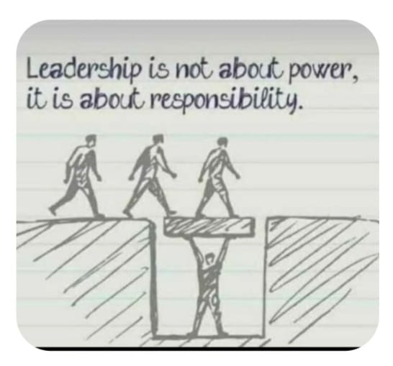

Courtesy of Joyce Raw
Being Bettina’s Dad: Being a Dad
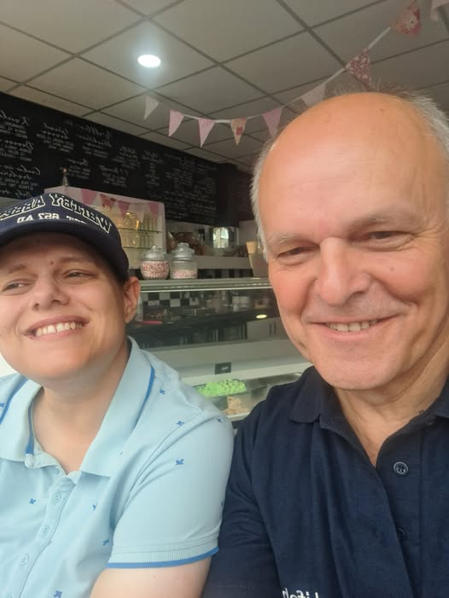
A typical Friday afternoon in the 1990s involved me driving to Colchester station with a number of young soldiers (male and female) so they could catch their train to their family homes – it saved them ordering, waiting and paying for a taxi. I recall the journey usually included some sage advice from me to them about several areas of their lives and careers. One Friday as they collected their baggage from the boot of my car one of them turned round and said “thanks Dad” with a straight face! As I was a Warrant Officer (WO2) in the British Army at the time, I should have been annoyed but I held it together until I was out of the station and laughed all the way home!
It was not the first time someone had said this to me in the Army. I was coming towards the end of my career, and I was too old to change my leadership style and why should I? It had always worked for me no matter what kind of unit or posting or where I was. After all, isn’t it always about performance and results that you are judged on? My teams were always successful (especially the sporting ones) and I always got results! I still have the trophies to prove it. And if your team members are happy, why change your style of leadership?
I have now been a Dad for just over 40 years; I have become practised in all the demands and responsibilities of the ‘post’. Being a dad was something I always wanted to be and I had prepared fully for the role long before I became one in exactly the same way I had when I decided I would aspire to be a leader.
This post is about on being a Dad to Bettina and how it has helped me with my leadership skills and hopefully to become a better leader (and a better person). For those who know me really well, especially my wife, Joyce, how I am at home with both my daughters is not really any different from how I operated in the Army and in my (second) Social Care career of 28 years. Good news – the skills and attributes of being a parent are transferable!
Bettina is a woman who has always coped with learning disabilities and autism which come with additional challenges for her but also present opportunities for me to constantly raise my game, this is how…

Being Bettina’s Dad to Being a Leader
- Bettina does not make allowances for my age. She does not understand that I might not be able to give her a piggyback anymore on the beach when she sees a dog coming towards her (she will continue to try though). She does not understand the concept of getting older. I have to be just as quick on my feet now as when she was a young girl. So keeping fit and alert is a must (for the rest of my life)
- Lots of energy and enthusiasm. Bettina’s Dad loves life. I think this is contagious and Bettina has definitely got the bug too.
- I love this quote from the sadly departed Carrie Fisher “There is no point at which you can say, “Well I’m successful now. I might as well take a nap.” I can never rest on my laurels. I must be better than I was yesterday.
- To be effective and to be successful you need to be passionate about what you do. If you are not, it will be spotted!
- Do what you say you are going to do! Bettina will become distressed if I deviate from the agreed plan without prior warning. If you promise her something, then you must deliver.
- I thought with a 24 year career in the Army, discipline would be built into my DNA. However there is always room for improvement. You need to be organised and on your toes 24/7 – yes, even when you think you are sleeping (or dozing on the settee which allegedly I do) – tight discipline gets stuff done and sets you free to do more.
- Respect and Trust does not come with a title. It is something to be earned every day. As soon as Bettina wakes in the morning then that is when I start again, earning her respect and trust. Just because I had it yesterday does not automatically mean I will have it today
- Bettina (and her big sister) come first for both her parents in every part of our lives. It is about recognising that those who depend and or rely on you come before you.
- We do nice things for each other – I give up my seat and I always open the door for her, it is about standards. Often if my lunch box is left out in the kitchen, she will fill it with things she thinks I will like. It is about standards
- Bettina would become anxious, confused and desperate if I had mood swings or I was contrary. There are no days off from being all singing and dancing. It’s about being consistent
- Inspire – but I don’t have to be the one that is always inspiring! Bettina inspires me every day with her courage and doing something that I was not expecting. This could be some new speech or an accomplishment that didn’t come easy for her
- I understand that being Bettina’s Dad is an honour and privilege. I am very proud to walk with her
These are just 12 of the expectations (and requirements) that Bettina has for me as her Dad – are they any different from the expectations of a leader?

So deciding what kind of parent you aim to be is not much different (in my experience) to deciding what kind of leader you want to be. Once you have your plan stick with it.
Source: Steve Raw www.leadershipintheraw.org

PS my oldest daughter is truly awesome. As well as Bettina’s expectations, two things I must specifically do for Jennifer and which stand me in good stead within my leadership role too:
1. Think through what I am going to say to her before I say it! I have been doing this since she was 12. She is incredibly sharp and witty and will catch me out if I fluff my lines. If I get something wrong, she is all over me like a rash (and Joyce joins in too)
2. Truly listen to her, most people don’t listen.
Source: Steve Raw www.leadershipintheraw.org

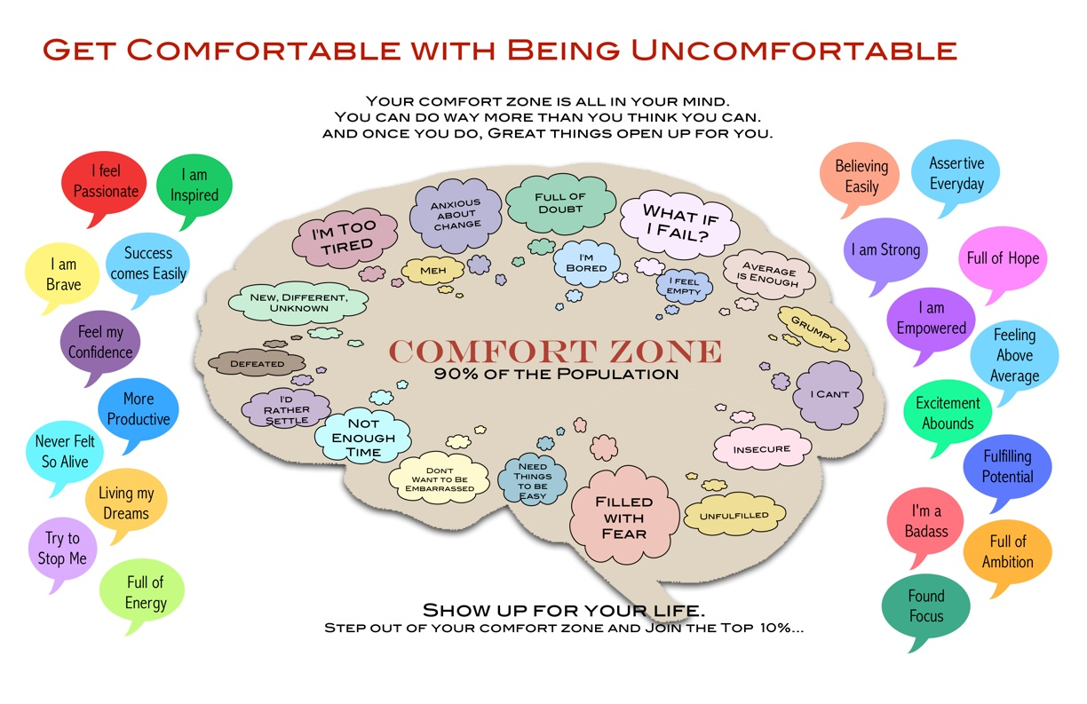

https://leadershipintheraw.org/2023/07/18/being-bettinas-dad-getting-comfortable-with-being-uncomfortable/
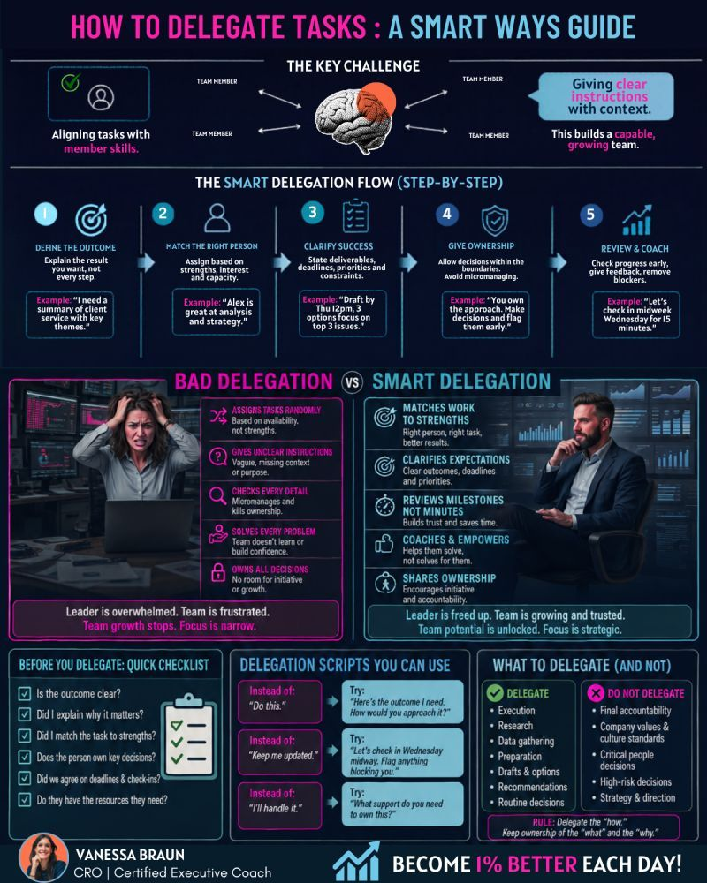

In leadership, the ability to listen well isn’t just a courtesy, it’s a force multiplier. Active listening builds trust, strengthens relationships, diffuses conflict, and fosters genuine understanding. Yet, too often, leaders fall into the trap of interrupting, assuming they know the answer, or rushing to fix problems instead of truly hearing what’s being said.
Great leaders resist the urge to dominate the conversation. Instead, they listen with intent fully present, without distraction. They ask thoughtful questions, challenge assumptions, and empower others to explore their own solutions. Leadership isn’t about having all the answers; it’s about creating the space for growth, collaboration, and critical thinking.
Active listening isn’t a passive act, it’s a skill honed through practice and discipline. Master it, and you won’t just improve your leadership, you’ll transform the way people engage with you.
Interested in learning more? Check out the Army Leadership Doctrine on our website at https://www.army.mod.uk/.../army-leadership-publications/

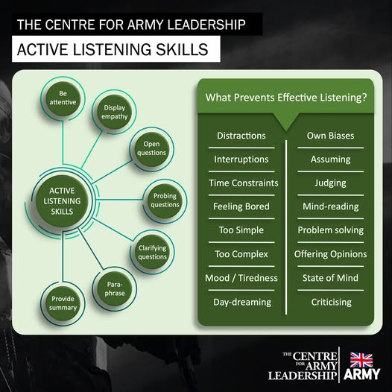

YOUR ROUTE TO THE TOP

BECOME A BRAVE LEADER

Feel the fear. Helen Keller once said: ‘Life is either a daring adventure, or nothing.’ Courageous leaders experience as much fear as others; they just don’t let it paralyse them. Replace ‘I can’t’ with ‘I will.’
Say it like it is. Authentic communication can be a challenge, especially when the message is tough, or you don’t believe in it. But what people want is the truth. This doesn’t mean being perfect, it just means doing your best to be real, warts and all.
Have hope. Randy Pausch, a professor at Carnegie Mellon University, was diagnosed with pancreatic cancer. His last lecture could have been a depressing experience; instead, it was life-affirming. Look to the future, no matter how turbulent the current circumstances. As Pausch himself said: ‘Brick walls are there to remind you how much you want something.’
Talk to yourself. Challenge your catastrophic fantasies. Give answers to your ‘what ifs?’ Scrutinise any unhelpful thoughts.
Don’t give up. From M&S’s Sir Stuart Rose to Pret’s Julian Metcalfe, turnaround champions and entrepreneurs alike agree on one thing: persistence lies at the heart of success.
Stand tall. In a world of consensus-building and endless collaboration, brave leaders inspire their followers with decisive action. To be brave is to be in control. Put an end to dithering and offer clear direction to your team.
Live a vital life. Great athletes tend to project enormous vitality. So do great leaders. Create an infectious mood and win over the cynics – as well as invigorating the evangelists.
Be humble with success. In his book ‘Good to Great’ Jim Collins demonstrates a negative correlation between the fame of a CEO and their business performance. Ask for honest feedback, let others shine and selectively share weaknesses. Top leaders build enduring greatness through professional will and personal humility.
‘The Mind Gym: Give me time’ is published by Time Warner Books
“Education is the most powerful weapon which you can use to change the world” Nelson Mandela
TEN WAYS TO……
Win more Business
1. Know your field
2. Offer consistent quality
3. Market astutely
4. Deliver on time
5. Get feedback from commissioners
6. …….and act on it
7. Set the right price
8. Have a decent website (eventually!)
9. Network
10. Think: do we need more?

Source: Management Today

TIPS FOR BEHAVING ASSERTIVELY
To start the process towards assertive behaviour, there are a range of actions to take. Some of these will come naturally but with some you may have to make an extra effort. Be prepared to feel uncomfortable at times when you begin to use assertive behaviours that are new to you. Here are some examples:
- Take one step at a time – rather than trying to instantly become fully assertive, in all situations with all people, look for occasions to use and develop the skills
- Work at developing the best level of assertiveness for the situation, rather than using it all the time. It’s a skill to use when the circumstances and timing are right.
- Take the time to develop your responses – it’s easy to get into the habit of instantly answering questions you’re asked, rushing to provide help when requested. To develop assertive behaviour, sometimes you need to take time before responding instant answers are more likely to be passive or aggressive.
- Use assertiveness to make others aware of your feelings – in an awkward situation, people often respond aggressively (which is likely to harden the feelings and attitudes of all those involved) or passively (when others simply won’t know how upset, frustrated etc. the other person might be). Assertiveness helps others to understand your feelings and to do something to improve the situation.
- Use brief explanations – long, detailed ones, especially in awkward situations, don’t tend to help. They can confuse the listener or become repetitive.
- Avoid “I’m in charge” behaviour – you may be an individual’s team leader, supervisor, manager etc. but this behaviour is likely to be interpreted as aggressive.
- Consider the other party’s reactions – remember assertive behaviour should be a two-sided coin. But, when considering using it, analyse both the occasion and circumstances. You must be sure that your assertiveness doesn’t increase aggression in others.

SPEAK ASSERTIVELY
There are several simple steps you can take to develop this skill:
- If you have the opportunity, prepare, and rehearse
- Never present your ideas apologetically or apologise for holding an opinion
- Express your feelings in your words. If you have a strong belief, then let the audience know – along with your lucid reasoning
- If you are undecided, say so. Then you can present both sides of the argument, and listen as others debate (and help you reach a conclusion)
- Don’t insult others’ views (whether offered or yet unspoken) when offering your own
- When it’s important to do so, be willing to state your opinion without being asked. An example would be a meeting chaired by an aggressive person; one who knows you are likely to disagree so simply tries to exclude you from the discussion.
THE ADVANTAGES
Here are the positive ways that assertiveness is beneficial – both to yourself and those who come into contact with you:

- You are taking control of both your life and its individual activities
- Others respect you – and you have a high level of self – respect
- It allows and encourages others to respond assertively to you
- You demonstrate the respect you have for others
- There’s less likelihood of conflict, anger or aggression being a disruptive factor in your life
- You develop a high level of self-esteem: your aim is to live up to the standards you set for yourself, rather than trying to guess and work to other people’s expectations of you
- You allow other people to be in control of their lives. You give them room to manoeuvre in awkward situations.
Source: ILM
“Pressure is a privilege…..it’s what you do with it that matters”
Billie Jean King
CRASH COURSE
Creating a culture of innovation
How many times since you arrived have you been told: “That’s not how we do things here”? This place needs shaking up. It needs…. A culture of innovation.
You mean ideas? Ideas are just the starting point. ‘Innovation is an outcome, it’s the end result – not an activity in itself,’ says Cris Bewick, author, speaker, and strategic adviser on innovation. And it’s not just about new products and services. ‘Innovation is about solving problems and finding new approaches, in any facet of an organisation whether that be the business model, logistics or recruitment.’
Be inclusive. ‘It’s hard to predict who or where or when innovation will come from,’ says Matt Kingdon, co-founder of innovation consultancy? WhatIf!. ‘Innovation can take any form and come from anybody in the organisation – the lawyer, the actuary or the health & safety officer.’ Make sure everyone knows that.
Change the culture. ‘Encourage people to explore alternatives,’ says Kingdon. ‘Make sure the need for change is understood, try to inject a sense of excitement and get people to ask them whether your products and services are good enough.’
Promise support. ‘Let people know they won’t be marked down for trying things out, that if they put their hand up they’ll be taken seriously, and that you’ll put resources behind good ideas,’ says Kingdon. Establish a process for harvesting ideas, prototyping implementation.
Motivate. Find out what will drive people to contribute. ‘Money doesn’t cut it – it encourages behaviour that is counter to innovation as it tends to nurture competitiveness,’ says Bettina von Stamm, of the Innovation Leadership Forum ‘Recognition will take you much further in one leading company the boss invited the people who came up with the best ideas to his home and cooked dinner for them.’
Give it context. ‘tell your people what you are looking for. ‘Rather than just asking for ideas, pose problems and challenges that are in line with the business strategy,’ says Beswick. ‘That way you’ll get answers that could lead to valuable innovation.’
Cast your net. ‘Analogies from different industries are an important source of innovation,’ says Beswick. Great Ormond Street learned important lessons about transferring babies to incubators from working with Formula One pit-stop teams. Look at what start-ups in our industry are doing.
Co-create. ‘Bring your customers into the process at an early stage – they will tell you what works and what doesn’t work,’ says Beswick.
Lead the way. ‘Leadership is critical to innovation, leaders don’t need to be creative people, but they need to understand the conditions where innovation can happen,’ say von Stamm.
Source: Alexander Barrett - MT Management Today (magazine)
Do Say
‘Everyone has the freedom and the ability to contribute to innovation in this organisation’
Don’t say
‘We’ve never bothered with innovation before, why should we start now?’

