LEADERSHIP AND WELLBEING PACK
August 2026
The 20th Anniversary Editions
Welcome to this month’s edition. Highlights include:
Damian Piper CBE our Resilience Coach starts this month edition with: Are You Showering Your Mind? “As I write this it's been hot, properly hot for the UK. In fact in recent weeks we’ve recorded record breaking temperatures. One of the things that helps me and I am sure others when it’s sweltering is a shower. That moment when the water hits, cooling us down and of course washing the ‘grime’ away. We leave the shower cooler, refreshed and somehow reset….”
The 13th Leadership Lesson I learned – identifying a key player. A person of significance “Joyce (my wife) and I were watching ‘Manhunt’ on tv last night, a limited series based on DCI Chris Sutton’s memoirs. There was something we noticed within the dynamics of his leadership and team…..”
From: The Centre for Army Leadership “Great leaders don’t just tell people what to do, they explain why it matters. When leaders communicate the purpose behind the task, the vision, or the mission, they inspire others to follow because they believe in it, not just because they have to…..”
Being Bettina’s Dad – Bettina’s Kind Heart “Bettina sits quietly in class alongside other pupils. There is a boy sitting next to her who is becoming increasingly distressed. Without turning Bettina reaches out to him and strokes his hand, despite verbal language being a challenge for Bettina, she soothingly says “it’s ok” “it’s ok” as her school mate calms, he says “thank you Bettina…..”.
There are lots more in this month’s edition so let’s dive in together……
Steve Raw FioL
Blog: www.leadershipintheraw.org
Instagram: @stephenraw6
Twitter: @SteveRaw836
Blue Sky: https://bsky.app/profile/steveraw.bsky.social
LinkedIn: https://www.linkedin.com/in/steve-raw-72454721/
Facebook: https://www.facebook.com/steve.raw.771/
It’s not about how good you are,
It’s how Good You want to be.

Are You Showering Your Mind?
As I write this it's been hot, properly hot for the UK. In fact in recent weeks we’ve recorded record breaking temperatures. One of the things that helps me and I am sure others when it’s sweltering is a shower. That moment when the water hits, cooling us down and of course washing the ‘grime’ away. We leave the shower cooler, refreshed and somehow reset.
Grime is a deliberate word. Not sweat. Not dirt. Grime. The stuff that clings. The stuff you don't notice building up until you finally rinse it off and realise how much fresher we feel in its absence.
Here's the question. How often are we showering our minds?
Because we collect grime there too.
- The meeting that didn't go well.
- The conversation where you said something unhelpful in the heat of the moment.
- The near-term impact of a long-term goal suffering a setback.
On their own, none of these matter much. One unhelpful meeting is just an unhelpful meeting. Say the wrong thing once and the world keeps turning. A setback is just information. The problem isn't the single event. It's what happens when we don’t appropriately manage these things or more specifically how we think about them. Which drives how we feel about them and ultimately act.
Unmanaged the mental grime builds quietly, then not so quietly. And the buildup starts doing something the individual events never could on their own: it really hinders our outlook. It clouds how we think, colours how we feel, and shapes what we're willing to attempt next. Mental Grime doesn't just sit there. It plays an active role in getting in our way.
None of this means washing away helpful experience. The lessons, the positive pattern recognition, in short, the things that are worthy of carrying forward. That's not grime, that's insight, revealed by deliberate conscious thought.
But unmanaged, insight and grime get tangled up together. And when they do, the useful will often get overshadowed by the unhelpful as our egos try to protect, determine and predict what has or is likely to happen. We can find that when we have things that have not gone as we’d like we don't get to see and learn the constructive meaning. So this is a double hit. Not only do we hold on to the unhelpful we miss out on the opportunity to move forward with more wisdom.
So the question worth sitting with this week: what's your equivalent of the shower for your mind?
Not a five-step how to framework. Just, what helps to make sense of things to help you become, conscious, fresher and more able to stretch what’s possible. A conscious focused walk, a conversation, writing things down. Whatever it is, the point is the same as standing under water on a hot day: you don't do it because you're told to. You do it because you know what carrying the grime feels like, and quite frankly you'd rather not.
As always, I am interested in your thoughts.
Damian
damian@effectivechallenge.com | effective challenge podcast | LinkedIn

Damian Piper CBE is a performance, productivity and resilience coach who works with ambitious individuals who are capable of more but keep getting in their own way. Drawing on over 30 years of self-development, senior leadership experience, including a role in delivering a safe and secure London 2012 Olympic Games, and a coaching framework built from the ground up, Damian helps people understand what's actually driving their performance and build a bespoke approach that works sustainably. You can find more of his thinking at effectivechallenge.com or connect with him on LinkedIn.
You may not control all the events that happen to you, but you can decide not to be reduced by them.” Maya Angelou
The 13th Leadership Lesson I learned – identifying a key player.
A person of significance
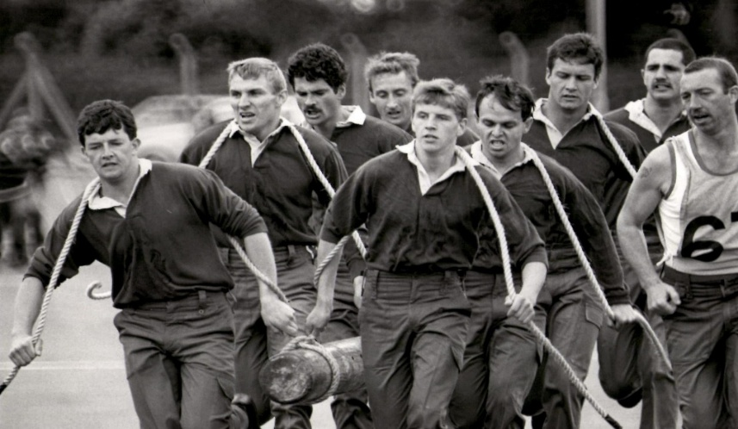
Commando (Royal Marine) Log Race. ‘Engine stokers’ who drove this winning team forward.
Joyce (my wife) and I were watching ‘Manhunt’ on tv last night, a limited series based on DCI Chris Sutton’s memoirs. There was something we noticed within the dynamics of his leadership and team. We picked up that he seemed to focus on one police officer (who was junior in rank) for advice, a sounding board for his thinking and then asked him to draft an important email that would secure investigative funding. This prompted a conversation between us and a sharing of leadership experiences where we had recognised a key player within the team. Joyce used the term an ‘engine stoker.’
(Engine stoker: a person who tends the fire for the running of a boiler or powering a steam engine.)
During my careers in the Army and Social Care, I identified a key player/engine stoker within all my teams, and I was to benefit as a leader and manager from their support, competency, and skills.
I have based this article on several former colleagues I had the privilege to work with in both my careers:
Who is the ‘engine stoker’ and how do you identify them?
- They are quite happy to stoke the boiler – the position they are employed in is not necessarily senior in ‘rank’ but is significant in ‘role’ for the functioning and movement of the company.
- They are respected for their integrity by their colleagues. They provide continuity within the organisation.
- They have often worked in other fields and may have held down senior positions and therefore possess a wide range of experience(s). They may have a particular specialism and or skill that is invaluable to the organisation.
- Often not seeking seniority or overly ambitious in their current employment. Doing an excellent job to their best capabilities is more important to them.
- They do not have hidden agendas; they are transparent in their dealings. You know when you seek their advice or opinion, what they tell you is in the best interests of the operation, not their best interests,
- They may have been with the company a long time and they are committed to the values and ethos of the organisation.
What do they bring to your team:
- They act for the greater good. They care passionately about what your team are trying to achieve for their customers.
- They identify potential issues before you do – they often have ready-made solutions to those problems.
- They are happy to share their knowledge and experience to progress your team’s vision and mission.
- They have a unique perspective on the situation, through having a freedom of thought which is not burdened by the weight of leadership and management responsibilities.
- They retain the trust and respect of their colleagues.
- I found having their support with a proposal and or project adds credibility to your initiative.

How to encourage a culture that recognises and celebrates their contribution.
- Involvement ‘they have a seat at the table.’ Make sure you invite them to all your project and management meetings.
- Delegate responsibility for tasks that match their talents and experience.
- Feedback – regularly ‘check-in’ with them for their feedback. Be prepared that it might not be what you want to hear! But do know their feedback is coming from a good place.
- Recognition – Highlight their contributions both in meetings and reports.
- Reward. Find ways that are meaningful to the individual to reward their contribution, a small token can make a big difference.
During my army career I had the opportunity of serving within a Royal Marine Commando Regiment for 30 months. One of the differences I noted was the way ‘Royal’ senior ranks and officers highly respected and valued the long serving and experienced ‘Marine’ who was not going to progress within the ranks during their career. They were sought out for their advice, experience, and knowledge. They were highly valued!
This was leadership lesson which stayed with me and something I benefited from during my second career in Social Care.
Source: Steve Raw
The ‘Leadership Lessons I learned’ series (1 – 12) can be found on www.leadershipintheraw.org ‘Home Page’.
We all have two lives. The second one begins when you realize you only have one.” ~ Confucius
RISK APPETITE
The only people who are really hungry for risk are those unfortunate sensation-seekers who need near-death experiences to brighten up their otherwise colourless lives, but this is not what risk managers mean by this increasingly popular phrase. Rather, their concern is how much risk you are prepared to bear to reach your goals. This is much more sensible but leads towards three nasty truths about risk. One is that we are lousy at-risk calculus. Even professionals who operate in the eye of risk blizzards, such as surgeons and politicians, find it hard to compute the loss/probability equation. Two, risk calculus requires you to have lots of observations to give you a meaningful statistic, yet many of the most important risks are one-offs. You can’t be 10% dead after surgery. Three, the more we want something, the more we are likely to adjust our risk assessments optimistically. Human passion, as ever, clouds the rational picture. Risk appetite? Just the starter and the cheese, please – make too much of a meal of it and you could wind up seriously sick.

Source: Nigel Nicholson is professor of organisational behaviour at the London Business School.
The Centre for Army Leadership
Great leaders don’t just tell people what to do, they explain why it matters.
When leaders communicate the purpose behind the task, the vision, or the mission, they inspire others to follow because they believe in it, not just because they have to.
The ‘why’ fosters trust, loyalty, and a deeper connection between leaders and their teams. It builds a shared belief and strengthens the bond that drives success.
So, next time you're leading a project or rallying your team, remember: as Simon Sinek puts it, "Start with why.”
Interested in learning more? Check out the Army Leadership Doctrine on our website!
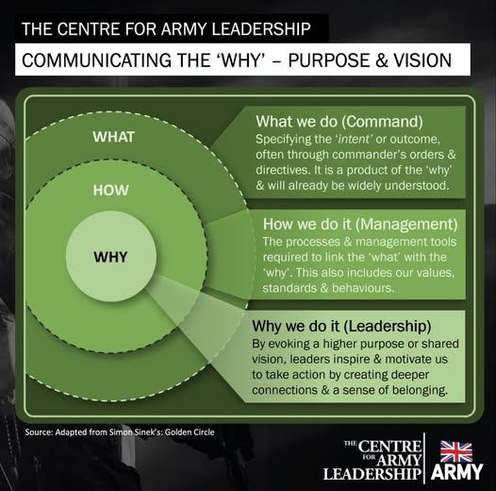
Being Bettina’s Dad – Bettina’s Kind Heart
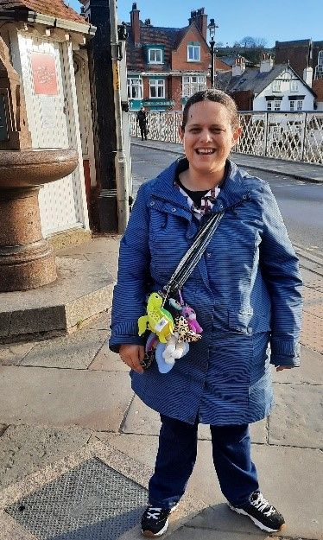
Bettina sits quietly in class alongside other pupils. There is a boy sitting next to her who is becoming increasingly distressed. Without turning Bettina reaches out to him and strokes his hand, despite verbal language being a challenge for Bettina, she soothingly says “it’s ok” “it’s ok” as her school mate calms, he says “thank you Bettina”.
This is an example of Bettina’s kindness to someone else in need.
“A kind word to one in trouble is often like a switch in a railroad track….
An inch between wreck and smooth sailing”
Henry Ward Beecher
If you have previously followed the “Being Bettina’s Dad” series, you will know that Bettina has a diagnosis of autism, a learning disability, and copes with epilepsy. The traditional traits and perhaps ‘labels’ of autism are often:
- Autistic people often have difficulty ‘reading’ other people – recognising or understanding others’ feelings and intentions – and expressing their own emotions. This can make it very hard to navigate the social world. Autistic people may:
- appear to be insensitive
- seek out time alone when overloaded by other people
- not seek comfort from other people
- appear to behave ‘strangely’ or in a way thought to be socially inappropriate
- find it hard to form friendships.
While some of these traits were true of Bettina in her early years, with the support and love of her family, and a wonderful school https://www.marketfieldschool.co.uk/ her personality constantly shines through, breaking through those stereotypes. Bettina’s qualities of being gentle, caring, and helpful, light up the worlds of people who come into contact with her and her acts of kindness are long lasting in their memories.
Bettina’s kindness is given for free, there are no conditions, and she has no expectations of favours in return.
Related: Being Bettina’s Dad: Bettina’s Code of Conduct – Leadership in the Raw
5 random acts of kindness Bettina spontaneously makes:
- Bettina is incredibly polite: “how are you Bettina?” “I am fine thank you” I have known people to go out of their way to ask Bettina how she is, just to get this response.
- Bettina senses when you are worried or upset and puts her arm around you. There have been times when Bettina has kissed my arm when I wasn’t expecting it and for me the world feels right again.
- Recently on a trip together in Frinton-on-Sea, a horse fly bit my face, just under my eye and I was even more shocked when Bettina stopped, put her arm around me and steered me towards a bench to recover my composure. In a moment our roles were reversed, and Bettina became my ‘carer’. I was so grateful for her kindness and compassion.
- As soon as I mention we are going to the beach, the night before Bettina raids the fridge for our lunch, choosing things she thinks I will like. (Bettina always nails it)
- Bettina acts without prejudice, bias, or cynicism. Bettina is always authentic with her kindness.
Related: Being Bettina’s Dad: Be your authentic self – Leadership in the Raw
5 reasons to be kind this year – because:
- It will make the world go round
- Everyone is fighting a hard battle especially with everything that has happened with Covid.
- There will be plenty of events that we will not be in control of in the coming months and perhaps years, but we can control how we behave towards other people.
- It will make you feel better about yourself if you are kind to someone else and it will encourage them to do a kindness for another person next time. (I have found kindness to be contagious).
- You have the opportunity to make life less difficult for another person, a great privilege.
Never, if possible, lie down at night without being able to say:
“I have made one human being at least a little wiser,
Or a little happier,
Or a little better this day.”
Charles Kingsley
And 5 spontaneous acts of kindness you can make in 2022:
- Smile and remember to say please and thank you when shopping and when you purchase your coffee.
- Stop and speak to someone who looks downcast, worried, and desperate – your kinds words could be the ones that save them.
- Pause and let another motorist or pedestrian have your right of way. (smile when you do). Give up your seat on a bus or a train for a person who needs it more than you. Open the door for another person.
- Acknowledge someone’s hard work with a compliment
- Never say “I am too busy” – ask someone “can I help?”
As Joyce (Bettina’s mum) comes towards the end of her ‘Hidato’ quiz book, Bettina’s notices and immediately stops what she is doing and goes into another room to find a new book for her. Bettina’s knows Joyce will enjoy completing her new puzzles. Joyce has not asked or expected Bettina to do this – Bettina does it because she is kind.
Joyce: “Aren’t you kind”
Bettina: “I don’t mind”

Bettina and her super proud Dad.
“Sometimes miracles are just good people with kind hearts”
Steve Raw www.leadershipintheraw.org
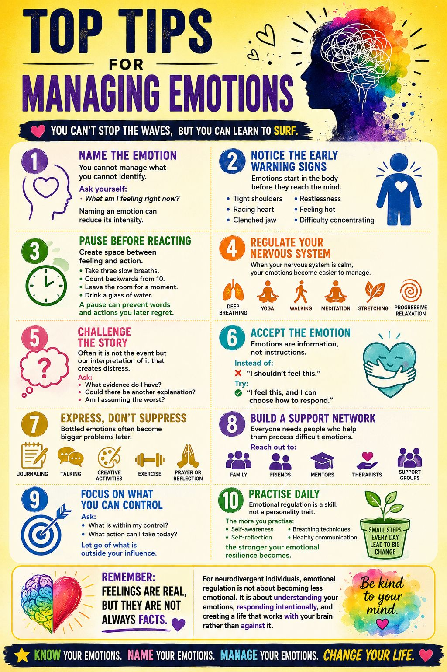
FAST TRACK TO….. DE-CLUTTERING YOUR MIND
With so much going on in our lives how can we clear our minds and gain real clarity in order to become less stressed and more productive? Jamie Smart shows us how:
Recognise the source of all mental clutter; Thinking
All mental clutter is created from thinking. While it can seem as though mental clutter is coming from your to do list/email inbox/staff/balance sheets/colleagues etc. none of those things can take up space in your head without you thinking about them.
Discover your minds self-clearing capacity
A survey of senior executives asked “When do you get your best ideas?” The top three responses were in the shower, on holiday and travelling to and from work. Why is this?
Your mind is a self-clearing system; clarity is the set point it’s designed to return to. So what gets in the way? - The outside-in misunderstanding.
Acknowledge the outside-in misunderstanding
We’re always living in the feeling of our thinking, moment to moment but it often appears as if our feelings are coming from something other than thought (e.g. our circumstances, past events, other people, the future etc.). This ‘outside-in’ misunderstanding fills up our heads with extraneous thoughts.
Benefit from the power of insight
The moment you realise you’re feeling, you begin thinking in the moment and your mind’s selfclearing process starts kicking in. Insight is a natural function of the mind and the source of innovative ideas and creative solutions.
Stop trying to clear your mind
When you try to clear your mind using techniques it blocks your self-clearing function. Just as a muddy pond clears because clarity is the water’s natural state, your mind will clear because clarity is your mind’s natural state.
Follow your intuition, your inner guidance system
If it occurs to you to take a break or go for a walk, great! That’s your intuition, your inner guidance system, helping you get clarity. As you get more attuned to this inner guidance system you’ll find yourself intuitively knowing how best to support your mind’s self-clearing function.
Realise you have what you need within you
Clarity of mind is the gateway to the ‘deep drivers’ behind success in business and in life. These drivers (such as presence, resilience, authenticity and innovation) are innate qualities. They’re available to each of us when our mind isn’t cluttered with misguided, outside- in thinking.
Understand the principles behind clarity
Clarity is the key to high performance and the results that come with it. When you’ve got nothing on your mind you’re free to give your best. The key to having more clarity more of the time is simple; get a better understanding of the principles that govern your mind’s self-clearing capacity.
Source ‘Clarity: Clear Mind, Better Performance, Bigger Results by James Smart is out now (John Wiley and Sons Ltd)) and the ILM’s Edge Magazine.
“It’s a good maxim to trust a person entirely or not at all” Henry Fielding
5 ways to be more confident in your decisions
Overanalysing every decision you make is a terrible habit to fall into that we’re all guilty of. If you feel uncertain about choosing, guess what? You’ll just keep thinking about it.
The first step is taking control.
This week, take advantage of your ability to make better decisions. Instead of overthinking every detail, possibility and outcome, learn when to trust your gut:
1. Don’t Sweat It This week, cut the small, time-sucking decisions from your routine. Plan your meals and outfits the night before and allow yourself to focus on more important tasks.
2. Decompress Struggling with a particularly difficult problem? Step away from it and try something else, racking your brain will only increase stress and decrease productivity.
3. Just Go Do you overanalyse even the smallest decisions? Stop waiting and make the first move. There will always be opportunities to adjust along the way.
4. Remember Your Why Write down the best decision you’ve ever made. Put it somewhere visible, such as on your nightstand or bathroom mirror. Remind yourself of the choices that brought you to where you are today.
5. Practice Happiness Jot down the top three uplifting things that happened today. Do this for three days and take note of your increased ability to see the positive side of every situation.
To Your Success (and Growth),
Source: The SUCCESS Team (USA’s Success Magazine)
“Life is not like water. Things in life don’t necessarily flow over the shortest possible route” Haruki Murakami

THE LEADERSHIP COMPASS
Professor Jonathan Perks’ compass model represents his eight ingredients for leadership – and followership:
1. IQ represents not just conventional intelligence, but also wisdom. Perks says: “It’s not just about being academically bright; it’s also about how you tap into the wisdom of the people around you and your own experience.”
2. Presence is next on the compass, and means an individual’s personal power, “If you’re present with everybody you’re with and fascinated by them, they’ll think you’re amazing and remember you long after you’ve gone.” Perks explains
3. EQ represents emotional and social intelligence. “It’s really about common sense.” Perks says. “It’s about your ability to deal with stress, read yourself and other people, and manage relationships well.”
4. Appreciation is next, and means appreciating your own strengths and those of others. “It’s not about sugary over-pumped-up appreciation it must be genuine,” explains Perks.
5. MQ represents moral quotient, which means your integrity values and beliefs. “Leaders without any integrity or honour are not leaders,” Perks says “People will never trust them.”
6. Passion is the extent to which leaders inspire their followers by demonstrating passion.
“(Passionate Leaders) inspire people to do things they wouldn’t otherwise want to do,” Perks says
7. SQ, or spiritual quotient, is “not about God,” says Perks. “It’s about creating meaning and purpose, and giving the people they’re with a sense of why they’re doing what they’re doing.”
8. Service is the final point of the compass and is about serving to lead, says Perks “If you have a sense of service for your customers, you will be a great leader.” From CMI’s house magazine ‘Professional Manager
"I would like to be remembered as someone who did the best, she could with the talent she had."
J.K. Rowling
Ten steps to getting someone to make the decision you want
1. Be absolutely clear on your point. Many people try to influence on too many things and lose focus.
2. There are three ways to influence: delivery of fact, persuasion by showing benefits, then true influencing which involves honesty and negotiation.
3. Start with basic delivery of fact if it’s more comfortable.
4. True influencing involves helping decision-making, so both sides win. People don’t like to be persuaded; they feel they’ve given in.
5. Empathy is vital. Ask open questions, listen and try to truly understand the person. You need to know what makes the person tick, so engage.
6. Remember the benefits, not the features. Link appropriate benefits to inspire them.
7. Confidence makes decisions easier: Believe in yourself and your proposal and build their confidence in you and in their decision.
8. Make it the easiest decision they’ve ever made. Complication puts people off.
9. When communicating any point, three and five are magic numbers. Anymore and people go cross-eyed.
10. Don’t give a single option, they’ll have to choose yes or no. Give them three options – human behaviour dictates they’ll take the comfy middle one, not the cheap and risky one or the posh and expensive one.
By Catherine Adam, Management Consultant for the Chemistry Group
How to win an argument
• Many arguments are made with minimal understanding or based on false premises. Simply asking for more detail and forcing someone to take you through their thinking step by step can expose this.
• It’s not enough just to give evidence that something is false. To convince the other party, provide an alternative explanation to fill the gap (barristers do this when they point to an alternative suspect in a trial).
• If you attack someone’s entire ideology in one discussion, their defences go up. Try to disentangle their various beliefs, or show how changing one might support others.
• In general, people are much more rational and willing to own up to the limits of their knowledge if they are treated with respect and kindness in an argument.
• Encourage your opponent to view the argument from another’s perspective – a stranger, or a person from another country if the argument is political. This can make them more receptive to the facts.
Source: The Observer (and my copy of ‘The Week’)
“So, what does perseverance mean? It means that one possesses persistence, tenacity, determination, and staying power. This in turn means, when applied to a problem or issue that needs to be resolved, that the individual never gives up, never quits and never sees defeat until the problem, challenge, project, obstacle is resolved to a satisfactory level.”
Byron Pulsifer
SIX WAYS TO SHINE IN THE SPOTLIGHT:

- Do your homework – minimise the risk of being blindsided in an important meeting by thinking in advance about the questions you are likely to be asked
- Buy time – win vital thinking space by asking for the question to be repeated, or repeating it back to the questioner as part of your answer
- Don’t make statements you can’t back up – you might get away with it the first time, but inaccuracies and falsehoods will catch you up eventually
- Ask questions back – is money an issue? What’s the timescale? What’s your ideal outcome? It can help to clarify your response.
- Be honest – if you don’t know something, admit it, or ask for more time to answer and move on.
- Don’t panic – breath slowly and deeply and stand up straight. Speak steadily and when you’ve made4 your point, stop talking

“If in any given moment we have two options: to step forward into growth or step back into safety”. Albert Maslow

CAREER MASTERCLASS
BEAT CHINESE WHISPERS
Polish your halo. A spotless reputation is the best defence against hearsay. Smash deadlines, exceed targets, honour promises and keep your nose clean. Rise above suspicion and watch the rumour mill bypass you.
Make a pre-emptive strike. Want a whisper-free workforce? Up your internal comms. Whether its weekly meetings, email newsletters or flyers on desks do whatever it takes to bring your team into the loop. They won’t huddle and hypothesis if they already know everything there is to know.
Stop stirrers. Identify them and ask them to explain themselves. If they’re genuinely worried (‘I just wanted to warn people about the restructure I think is coming’), reassure them; if they relish causing unrest, tell them enough is enough.
Distract them. If your team has time to gossip, perhaps their goals aren’t stretching enough. There’s nothing like a little pressure to focus minds and still wagging tongues.
Turn the tide. Psychologist Anthony Pratkanis argues the best way to kill a rumour is to ‘steal its thunder’. Spread a new (true) story, explaining why the rumour exists. If you can’t beat them…….
Share critical news early. Don’t wait until you have all the answers. That day may never come and in the meantime the whispers will be growing in number (and inaccuracy).
Ask the audience. Once you have delivered your message, encourage people to share their worries and ask questions. Be honest and if you don’t know something, promise to find out.
Keep talking. Stop a secondary wave of post-news whispers by making yourself readily available to your team. Make sure they share lingering concerns with you, not the water-cooler coven.
Rise above it. Sometimes, engaging with rumours (even to deny them) only fuels the fire. If the gossip circulating is petty enough to ignore, do just that. It will soon run its course.
The Mind Gym: Relationships is published by Little, Brown
“I am always doing that which I cannot do, in order that I may learn how to do it” Pablo Picasso
How to say level-headed
The mental-health campaigner Ruby Wax shares her tips on dealing with anxiety
• Realise that your ‘inner critical voice cannot be silenced completely’ – an ‘internal nag’ will always be there. Once you’ve accepted that, it’s easier to keep negative thoughts in perspective.
• It’s a cliché, but exercise really does help. It doesn’t have to be high intensity – slow activities such as Pilates or tai chi allow you to ‘connect your mind with the sensations in your body’. This will lower your cortisol and adrenaline levels, reducing stress.
• Find something that will ‘always take you back to your base line’. Listening to a song; looking at a photograph; even ‘thinking about the feeling of your feet on the floor’.
• Breaking your mind’s routine is a good way of exercising the brain. It needn’t be a big change: just walk to work a different way or sit in a different seat. ‘Mental work-outs keep your brain sharp and fit and have been proven to stave off depression.’
Source: The Sunday Telegraph and ‘The Week’
HOW TO SUSTAIN THE GRIND
•Breathe
•Exercise
•Eat healthy
•Stay positive
•Feed your mind
•Get around good people
•Remember why you started
Brad Lea
5 WAYS TO BOUNCE BACK FASTER WHEN LIFE KNOCKS YOU DOWN
Life is not linear. No matter how well-thought out your plans are, they will eventually be interrupted. Lean into the curves when life doesn’t unfold as you’d hoped, and you will bounce back more quickly.
1. Mind Your Language
Your words create your reality. Describe your situation as a nightmare and you’ll experience just that. Describe it as exciting, and it will shift the emotions you feel and the actions you take. Don’t talk about your problems using dramatic language but describe your situation in a way that places you in a position of power.
2. Align Your Wheels
When a car gets regular tune-ups, it goes farther on less gas and rarely breaks down. We aren’t all that different. Take time to refuel and realign your thinking so you can handle life’s trials with more ease and less stress. Listen to music. Play with your dog. Go to yoga.
3. Don’t Let Your Problems Be Your Identity
No one likes to have his or her business fail, or heart broken. But although our setbacks can shape us, they don’t have to define us. When life deals you a tough blow, be vigilant about not letting your adversity become your identity.
4. Lean On Your Tribe
The stronger your support network, the better you will cope with challenges and the faster you will recover from them. Don’t be too proud to reach out and ask for help because you’re afraid of appearing weak or needy.
5. Choose Optimism
Just because you can’t see the light at the end of the tunnel doesn’t mean it’s not there. Our hardest times can be a catalyst for greatness, introducing us to the inner strength that otherwise lies dormant.
Source: Margie Warrell, author of Make Your Mark (read in my Success Magazine)

“Take responsibility for your own energy; where you left it, how you share it and where you get it from”.
Elysia Skye

