LEADERSHIP AND WELLBEING PACK
September 2026
The 20th Anniversary Editions
Welcome to this month’s edition. Highlights include:
Damian Piper CBE our Resilience Coach starts this month edition with: Enjoy: Two Outlooks on the Same Word “Nobody argues against enjoying life. Ask anyone whether they'd rather do things they enjoy or things they don't, and you'll get the same answer every time. It's one of the few things we all agree on.”
Supporting you with some tactics to control your nerves “Thirty-five years ago…. I am sitting in a parked car at the Military Corrective Training Centre (MCTC) in Colchester (some of my older readers will know that the MCTC was known as the ‘Glass House’ where soldiers who had ‘sinned’ were rehabilitated and returned to their units as “better” people)……”
The Centre for Army Leadership “Effective leadership isn’t about jumping straight to advice – it’s about listening and asking the right questions…….”
Finding Dory – it was a team effort! “August 2026. Joyce points out a large helium balloon drifting over our house and wonders about the child who may have lost their balloon. Joyce then mentions “there is probably a dad at this moment jumping into his car to drive after the balloon.” Me: “who would do that?.......”
How to Develop a 90-minutes Virtual Training Session on Having Effective 1:1s - What is a 1:1 and What Do Effective 1:1s look like? BOLA OWOADEBOLA OWOADE “I've been designing and developing a 90-minute session on how to have effective 1:1 meeting….”
20 Leadership Lessons - A Week in Whitby with Bettina For the last 24 years Bettina, Joyce, Jennnifer and I have spent a week in Whitby in August. I get to spend lots of time with Bettina each day during our holiday and it involves lots of walking and lots of fun!
There are lots more in this month’s edition so let’s dive in together……
Steve Raw FioL
Blog: www.leadershipintheraw.org
Instagram: @stephenraw6
Twitter: @SteveRaw836
Blue Sky: https://bsky.app/profile/steveraw.bsky.social
LinkedIn: https://www.linkedin.com/in/steve-raw-72454721/
Facebook: https://www.facebook.com/steve.raw.771/
It’s not about how good you are, It’s how Good You want to be.
Enjoy: Two Outlooks on the Same Word

Nobody argues against enjoying life. Ask anyone whether they'd rather do things they enjoy or things they don't, and you'll get the same answer every time. It's one of the few things we all agree on.

The environment you live in knows the drivers for enjoyment all too well. Every day we're hit by triggers designed to point us towards more enjoyment, a new hobby, a new purchase, a new experience, a new way to feel good. Adverts, apps, algorithms, well-meaning friends driving our behaviour and mindset to the need to find more, try more and enjoy more.

There's nothing wrong with any of that on its own. But it's worth noticing what tends to happen when "enjoyment" becomes something we're constantly chasing. Particularly when it’s short-term in nature. Sometimes the things we enjoy become the things we can't stop doing, even when we want to. The line between enjoyment and dependency is thinner than we like to admit.

It’s common that that the thing which once drove enjoyment fades faster than we expect. What gave us a lift the first time barely registers the tenth, so we look for more of it, or something stronger.

There is also a category of things we do to ‘enjoy’ that we are really doing to fit in, or to dampen some short-term discomfort we'd rather not sit with. The enjoyment is a cover story we use for others and if we are honest, with ourselves too.

I want to be clear: none of this is an argument against doing things you enjoy. That's not what this article is about. What I want to talk about is a different kind of enjoyment, one that gets a lot less airtime possibly because the elements of this sort of enjoyment are less glamourous and conversation grabbing.

This kind of enjoyment isn't about finding something new. It's about what we can do within our control, right now, with what's already in front of us. It's about finding more enjoyment in the things we do every day, the tasks, the routines, the obligations that, on the surface, most people wouldn't file under "enjoyment" at all. The commute. The admin. The chores. The meetings.

The suggestion I'm making is a shift in where we put our energy. Instead of spending it all on finding more things to enjoy, what if we invested some of it into finding ways to enjoy what we're already doing? Could it be that we would need less of those externally driven solutions if we shifted our attention in this way? There are a few ways into this, and none of them require you to change what you're doing. Only how you're doing it.

One is the environment. The same task can feel completely different depending on the conditions you do it in. Better light, some music, opening a window to improve air quality, a pre task tidy-up, a change of location, hopefully you get the idea. None of these change the task itself, but it changes your relationship to it while you're doing it.

Another is combination. Some tasks become more enjoyable not because they change, but because of what you pair them with. A dull task alongside a podcast you like. A walk that doubles as a phone catch-up. A chore done alongside someone whose company you enjoy. You're not making the task easier, you're changing what surrounds it.

The third, and probably the most powerful and present in all that we do, is how we manage our thinking about the task itself. The same piece of work can be framed as a burden or as something with a purpose you value. That's not a trick of positive thinking, it's a genuine choice about which true thing you focus on. Most tasks have more than one honest story attached to them. We tend to default to the flattest one. Or more specifically our ego does.

None of these approaches are complicated. They don't need new equipment, new time, or new circumstances. They work with what's already there. Whatever this means for you, and whatever the task in front of you happens to be, I'm confident you can find a way to make it more enjoyable. Not because you're pretending it's something it isn't, but because you're paying attention to a part of it you'd stopped noticing.

We spend a lot of energy looking outward for more to enjoy. It might be worth spending a little more of it looking at what's already ours to work with.
As always, I am interested in your thoughts.

Damian

damian@effectivechallenge.com | effective challenge podcast | LinkedIn

Damian Piper CBE is a performance, productivity and resilience coach who works with ambitious individuals who are capable of more but keep getting in their own way. Drawing on over 30 years of self-development, senior leadership experience, including a role in delivering a safe and secure London 2012 Olympic Games, and a coaching framework built from the ground up, Damian helps people understand what's actually driving their performance and build a bespoke approach that works sustainably. You can find more of his thinking at effectivechallenge.com or connect with him on LinkedIn

Supporting you with some tactics to control your nerves
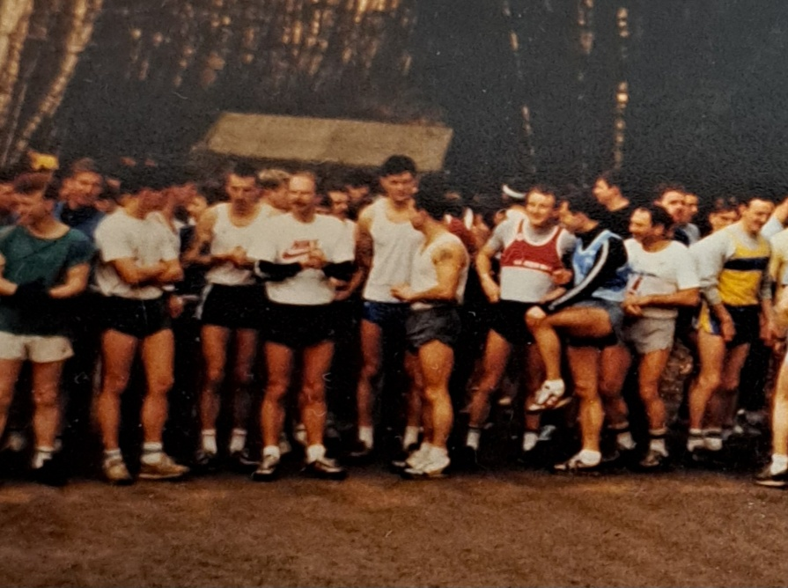
Trying to control my nerves before a race – I am on the front row with my leg raised.
Thirty-five years ago…. I am sitting in a parked car at the Military Corrective Training Centre (MCTC) in Colchester (some of my older readers will know that the MCTC was known as the ‘Glass House’ where soldiers who had ‘sinned’ were rehabilitated and returned to their units as “better” people). The person marching towards me is the Regimental Sergeant Major (RSM). I haven’t done anything wrong – yet! I am about to take my driving test and the RSM is a Qualified Examiner. Now, there was a time when I would have been experiencing extreme nerves at the prospect of something like this (an RSM coming towards me and/ or taking my driving test) but now I was calm and in control. I was even looking forward to getting started.
So, what changed and how was I able to control my nerves?
Do you suffer from nerves? If so, I am hoping my article will help you in the workplace and before your next event. (if you are a runner? Then this will be a bonus too)
Forty minutes before my driving test I went through the normal routine I would perform before an Athletics Race – much to the amusement of my driving instructor who was taking me to the examination centre.
It consisted of:
- Getting out the car and sitting down on the grass and completing a visualisation exercise, closing my eyes and visualising driving well and passing my test
- Deep breathing exercises and imagining my heartbeat slowing down – and then it does!
- Stretching exercises from my head to my toes – I know that it must have been a spectacle for anyone passing by, but it worked for me.
- Making sure I was wearing my favourite clothes, and they were the right attire for the occasion.
A pre-race routine would also involve going for a 1-mile jog, 10 x 100m strides and going to the toilet at least twice!
So, what are my Five Top Tips for controlling nerves before the big event?
- Give yourself a good talking to! Breakdown what it is you are about to do then ask yourself what would you be nervous about? What is the worst that could happen if you failed? Have you been through something similar which is important to you, if so, how did you get through it? You can do this.
- A Routine. My pre-race routine is not much different from the routine I go through before any presentation I am delivering, or workshop I am facilitating. Do it often and consistently and it will become the norm. Having a routine that works for you is also calming.
- Change your mental attitude. Rather than saying “I will see how it goes” or “I will do my best and see what happens”. Change the mantra to “This is the result I am aiming for”. Writing it down and/or telling others will cement your commitment.
- Relentless focus on what you are about to do cuts out any distractions to the point they just become background noise.
- When you wake up in the morning imagine how your day is going to pan out in a positive and inspiring way. Then repeat this an hour before the actual event.
A Post It for tackling your nerves:
- Prior Planning and Preparation Prevents a P**S Poor Performance (the 7 x Ps). Put this down on a ‘post it’ and look at it often
You will neutralise your nerves if you follow a routine that works for you methodically on every occasion. Beating your nerves is something you can WIN.
I passed my driving test. Typically, of the Army, my Boss knocked on my door and said he had fixed me up with a course on the Tuesday and that my Test would be on the Friday “and you had better pass it!”
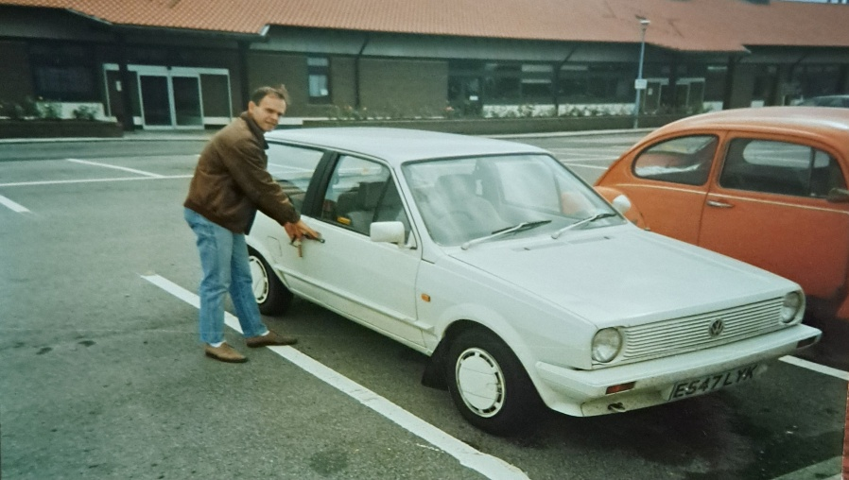
Shortly after I passed my driving test with my first car.
The Centre for Army Leadership
Effective leadership isn’t about jumping straight to advice – it’s about listening and asking the right questions.
When we quickly offer solutions, we stop others from exploring their own ideas and solutions. It can make them feel like they don’t have the answers, and that we’re the ones with all the solutions. This can stifle their growth and creativity.
Instead of rushing to give advice, try asking insightful questions. It encourages independent thinking and helps others find their own solutions, building their confidence and resilience.
Interested in learning more? Check out the Army Leadership Doctrine on our website.
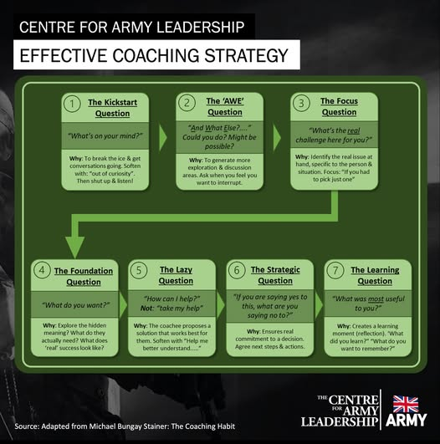

Finding Dory – it was a team effort!
August 2026. Joyce points out a large helium balloon drifting over our house and wonders about the child who may have lost their balloon. Joyce then mentions “there is probably a Dad at this moment jumping into his car to drive after the balloon.” Me: “who would do that?”
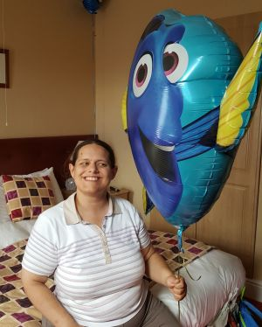
August 2016 Last night both Joyce and I looked over (amused) at the Finding Dory balloon which is still suspended by a small weight in our sitting room. It’s Bettina’s and it has so far lasted 26 days but between you and me, it is her second Finding Dory balloon.
Finding Dory, as you may know, is a Pixar film which we all enjoyed as a family on a visit to the cinema. This was especially a favourite of Bettina’s as we had watched the trailers on YouTube numerous times. During our recent holiday in Whitby, we took the opportunity to buy Bettina a Finding Dory balloon filled with helium. She was very proud of it, taking it back to her hotel room where it floated above her bed.
On our last night on holiday, we had completed our packing and Bettina, eager to ensure that it was not left behind, walked over to her luggage and attempted to tie her balloon to the handle of her bag. I could see how important it was to her – it was definitely going home!
At the end of holidays, it is my job to pack the luggage into our car, which was going well until…. you guessed it… I had Bettina’s bag with the balloon. To cut a long story short I put the bag down beside the car when the balloon escaped from my reach.
You can’t imagine how sick and panicked I felt as it ascended skywards. First, it headed towards the sea – I will run after it. Then it changed direction towards the North Yorkshire moors – I will drive across the moors to rescue it. I wasn’t thinking straight because this was about Bettina and how I had let her down. Later Joyce and Jennifer (her big sister) could see the funny side “how on earth was he going to get the balloon down from the sky, let alone reach it” I think the word “typical” was also included in their sentence.
Now I had to go back to the hotel and explain it Joyce and face Bettina. I felt dreadful. Straightaway we started to think of how we would break the news to Bettina and, if possible, how were we going to resolve (and recover) the situation. It might sound a trivial situation to you, and I must admit on paper I have faced more serious crises, but this was for our much-loved daughter who copes with Autism and a Learning Disability.
Bettina’s senses are always at a high level she immediately detected something was wrong and I could see this by the looks she was giving me “where is my balloon? I thought it was going to sit with me on the back seat? Have they put it in the boot?” Bettina has total trust in her family to do the very best for her which made me feel very guilty. Honestly, I was still looking up at the sky to see if Dory would come back, I was that desperate!
We were about to start our five-hour drive home and our Leader, Joyce, had a plan which she was about to put into operation! The Plan was:
- Joyce would text Jennifer who was at home to inform her of the situation
- Jennifer would be asked to go into town to buy a Finding Dory Balloon if possible
- As Jennifer is Bettina’s ‘Hero’ she was not going to let her down and I am confident she would have not given up until she found a shop that had one. After all, this was Bettina and she would run through walls for her. Joyce and Jennifer discussed possible, and acceptable, alternatives
- Typical of a hero, Jennifer found an exact replica of the balloon and walked through the town centre with the inflated Finding Dory balloon without the slightest thought or care what other people would think. After all this was Bettina (more about Jennifer and being a Role model on https://leadershipintheraw.org/2015/12/09/being-bettinas-dad-a-role-model-for-bettina/
With an hour to go before we reached home we got the confirmation we needed. Jennifer had arrived home and the balloon was in a prominent position in our sitting room waiting for Bettina.
On arriving home, Bettina walked into the house, and her face lit up with happiness and joy and exclaimed “There you are Finding Dory”!
We are certain that Bettina had assumed that Finding Dory, just as in the film, had found her own way home. I could now stop beating myself up over the lost balloon and how I had failed Bettina.
So what did I learn from this team experience?
- Time involved in preparation is never wasted. I should have double checked the balloon was tied securely to the bag
- Prioritise – the balloon should have gone in the car first before the rest of the luggage
- Don’t Panic! we all face events and it is how we react to them that matters
- Have a Recovery Plan – plan your way out of a situation
- Celebrate – you got through your crisis so now celebrate your achievement.
We do wonder, though, what happened to her original balloon flying across the moors. There is a secret (ish) NATO early warning station on the North Yorkshire Moors, so it was possibly heading in that direction, and it is entirely possible that Finding Dory came up on their radar! Sorry about that!!

Whitby where Dracula is buried and Dory floated away
Source: Steve Raw www.leadershipintheraw.org
How to Develop a 90-minutes Virtual Training Session on Having Effective 1:1s - What is a 1:1 and What Do Effective 1:1s look like?
BOLA OWOADEBOLA OWOADE
Published Aug 17, 2026
I've been designing and developing a 90-minute session on how to have effective 1:1 meetings. Previously I discussed the session's structure and introduced the learning objectives for the session. My goal for this session and the other ones I will develop subsequently is for them to be short (90 minutes + a 10 minute break), practical and engaging.
Here, I'm going to explore the next two segments of the session (the topics for the course are broken down into segments). These segments are:
Segment 2 - What is a 1:1 meeting?
Segment 3 - What does a good 1:1 meeting look like?
Segment 2 - What is 1:1 meeting?
When I develop sessions like this I always like to start from the basics hence answering the question - What is a 1:1 meeting?
So, I start out segment 2 with a question and answer chat activity where I ask the participants to write down their definition in the chat window. There's space in their workbooks to first note down their definition if they want to.
They have 3-minutes to write down their definitions and when the time is up, I read out as much of their definitions as possible and then display a slide to to share my definition with them which I allow them to read or I can read out the definition to them. Then we move on to segment 3 to discuss what a good 1:1 meeting looks like.
Segment 3 - What does a good 1:1 meeting look like?
The goal of segment 3 is to help the participants identify what a good 1:1 meeting looks like. To achieve this goal, I have created two demo conversations which they will observe and then determine afterwards which is the better 1:1 conversation and what makes it better.
First, I will ask for a volunteer to demonstrate the conversations with me. The two conversations include a manager and team member and both focus on the same scenario. The scripts for the conversation are in both the facilitatior's guide and the workbook. Also, in the workbook is space for the participants observing to note down what they have observed which should highlight the 1:1 conversation they believe is better and why.
I will go ahead and do both demos with the volunteer back-to-back and afterwards ask the observers to write in the chat window which 1:1 conversation was better and what made it better.
First, I will read through some of their answers quietly as they write them down and then read them out loud later after they've finished writing their answers and validate them with some points of my own in the facilitation guide. Later in the session I will come back to the answers they wrote in the chat window.
At this point, the participants would have seen an example of a poor and good 1:1 and should have an idea of what to do to have a good 1:1. In the next segment, we will build on that by discussing the 'do's and don'ts of 1:1 meetings'.
Next, in the training I will discuss segment 4 and 5. Segment 4 (mentioned above) will explore the 'do's and don'ts of 1:1 meetings and segment 5 will lay the main foundation for the course by introducing the participants to a 1:1 meeting framework called OPEN which they can use to structure their 1:1 meetings to make them more effective.

Leadabytes

90 Minutes Virtual Session For Leadership, Management and Skills Development

Newsletter Published weekly
J Leadabytes | LinkedInoin to Subscribe


Your Strategy Will Only Happen Because of This…
Time To Read: 31 Seconds

Dear Steve
Your Strategy Will Only Happen Because of This…
Successful strategies don't just happen – they’re a chain of critical events…
That always begin and end with people – and what they personally choose to do
Your people buy in - you succeed
Your people don’t - you fail
They are the ones that decide
If your strategy isn't working, ask this question:
Why?
Because behaviour isn't what happens after strategy - behaviour IS strategy.
David
Previous Naked Leader Weeks
sign up to receive this blog - unsubscribe anytime
@nakedleader across all social media

How to stay level-headed
The mental-health campaigner Ruby Wax shares her tips on dealing with anxiety:
- Realise that your inner critical voice cannot be silenced completely – an internal nag will always be there. Once you’ve accepted that, it’s easier to keep negative thoughts in perspective.
- It’s a cliché, but exercise really does help. It doesn’t have to be high intensity – slow activities such as Pilates or Tai Chi allow you to connect your mind with the sensations in your body. This will lower your cortisol and adrenaline levels, reducing stress.
- Find something that will always take you back to your base line. Listening to a song; looking at a photograph; even thinking about the feeling of your feet on the floor.
- Breaking your mind’s routine is a good way of exercising the brain. It needn’t be a big change: just walk to work a different way, or sit in a different seat. Mental work-outs keep your brain sharp and fit and have been proven to stave off depression.
Source: The Sunday Telegraph and ‘The Week’

FAST TRACK TO….. DE-CLUTTERING YOUR MIND
With so much going on in our lives how can we clear our minds and gain real clarity in order to become less stressed and more productive? Jamie Smart shows us how:

Recognise the source of all mental clutter; Thinking
All mental clutter is created from thinking. While it can seem as though mental clutter is coming from your to do list/email inbox/staff/balance sheets/colleagues etc. none of those things can take up space in your head without you thinking about them.

Discover your minds self-clearing capacity
A survey of senior executives asked “When do you get your best ideas?” The top three responses were in the shower, on holiday and travelling to and from work. Why is this?
Your mind is a self-clearing system; clarity is the set point it’s designed to return to. So what gets in the way? - The outside-in misunderstanding.

Acknowledge the outside-in misunderstanding
We’re always living in the feeling of our thinking, moment to moment but it often appears as if our feelings are coming from something other than thought (e.g. our circumstances, past events, other people, the future etc.). This ‘outside-in’ misunderstanding fills up our heads with extraneous thoughts.

Benefit from the power of insight
The moment you realise you’re feeling, you begin thinking in the moment and your mind’s selfclearing process starts kicking in. Insight is a natural function of the mind and the source of innovative ideas and creative solutions.

Stop trying to clear your mind
When you try to clear your mind using techniques it blocks your self-clearing function. Just as a muddy pond clears because clarity is the water’s natural state, your mind will clear because clarity is your mind’s natural state.

Follow your intuition, your inner guidance system
If it occurs to you to take a break or go for a walk, great! That’s your intuition, your inner guidance system, helping you get clarity. As you get more attuned to this inner guidance system you’ll find yourself intuitively knowing how best to support your mind’s self-clearing function.

Realise you have what you need within you
Clarity of mind is the gateway to the ‘deep drivers’ behind success in business and in life. These drivers (such as presence, resilience, authenticity and innovation) are innate qualities. They’re available to each of us when our mind isn’t cluttered with misguided, outside- in thinking.

Understand the principles behind clarity
Clarity is the key to high performance and the results that come with it. When you’ve got nothing on your mind you’re free to give your best. The key to having more clarity more of the time is simple; get a better understanding of the principles that govern your mind’s self-clearing capacity.

Source ‘Clarity: Clear Mind, Better Performance, Bigger Results by James Smart is out now (John Wiley and Sons Ltd)) and the ILM’s Edge Magazine.

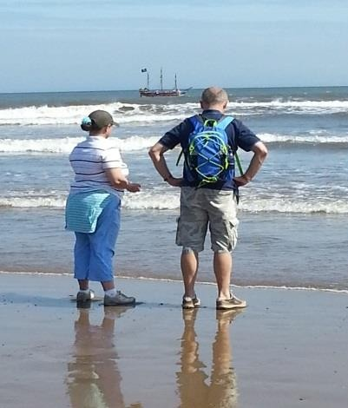

20 Leadership Lessons - A Week in Whitby with Bettina
For the last 24 years Bettina, Joyce, Jennnifer and I have spent a week in Whitby in August. I get to spend lots of time with Bettina each day during our holiday and it involves lots of walking and lots of fun!
While we were there, Joyce and I talked about the lessons Bettina teaches us every day when we are together; about what is important in life, and leadership. I could come up with more than twenty examples but twenty is a nice round number to be going on with.
Bettina’s 20 Leadership Lessons (in no particular order because each one is equally important to her):
- Loyalty: Loyalty from Bettina is something that has to be earned. Loyalty towards Bettina happens because of who she is as a person. You do not get loyalty simply because of a position or an appointment
- Inspiration: By her deeds, Bettina captures my imagination which makes me feel I can be more and do more - not just for Bettina but for those I am involved with.
https://leadershipintheraw.org/2014/11/06/where-do-you-get-your-inspiration-from-its-alot-closer-than-you-think/
- Gratitude: Bettina is so thankful for everything that comes her way and she shows her gratitude to all those around her – you feel good inside because you have made a difference and you want to do more for her https://leadershipintheraw.org/2015/09/09/beingbettinas-dad-taking-the-time-to-be-grateful-and-showing-gratitude/
- Expectations: Both my daughters (Bettina and Jennifer) have very high expectations of me which I am happy to meet – but woe betides you if you take your foot off the pedal!
- Respect and Trust: This is something to be won, it is something to be earned and just because you had it yesterday doesn’t mean you have it today.
https://leadershipintheraw.org/2015/07/28/being-bettinas-dad-trust-is-a-gift-you-mustearn/
- Team Work: Each one of us is dependent on the other and we each have our roles and together we make a great team. Bettina’s input is imperative to our success https://leadershipintheraw.org/2016/09/29/finding-dory-it-was-a-team-effort/
- Influence: Bettina is a change maker. (She has influenced me to start a second career in supporting people with learning disabilities!) People who spend time with her (teachers, teaching assistants, Personal Assistant etc.) tell me that she has influenced the way they see life. https://leadershipintheraw.org/2017/08/15/being-bettinas-dad-influence-a-force-forgood/
- Significance: Her life and her actions are important to all those who are significant in her life. https://leadershipintheraw.org/2015/04/01/being-bettinas-dad-and-being-significant/
- Confidence: Confidence for Bettina comes from doing things often and doing it well. The more often she does something, such as going to Whitby, she progresses which makes her feel more confident, and that is the same for me.
https://leadershipintheraw.org/2015/09/24/being-bettinas-dad-bettinas-lessons-inconfidence/
- Communication: Expressing her needs; how she feels and understanding what you are saying has always been a great challenge to Bettina. Bettina works very hard to communicate with you and it is important you repay the courtesy and be an active communicator https://leadershipintheraw.org/2015/02/12/being-bettinas-mum-care-tocommunicate/
- Likability: You will get so much more from people (and life) if you are likeable. People fall over themselves to do stuff for Bettina and not just those who have known her a long time
- Consistency: Bettina needs you to be the same person every minute, hour and day – you cannot indulge yourself in moods/behaviours – this is a great discipline to live by. There is always an air of calm in the RAW household!
- Discipline: Discipline can mean lots of different things to different people. For Bettina (and for me too) it is about how you use self-control, how you plan ahead and your responses.
- Empathy: Building a relationship with Bettina involves trying very hard to see the world through her eyes and you need to understand that for a person who copes with Autism this is very different. Bettina returns your efforts by being empathetic towards you too which is always very humbling.
- Self-Regulation: Bettina is no different from anyone else – she gets frustrated and angry - but she consciously controls her behaviour.
- Standards: Bettina sets very high standards for herself and expects the same from others. Being Bettina’s Dad means there will never be complacency from me.
https://leadershipintheraw.org/2018/01/25/being-bettinas-dad-bettinas-code-of-conduct/
- Manners: Bettina never leaves home without them! Her good manners are important to her, as your good manners are too. Bettina is a good role model for those around her and always evidences that good manners are contagious!
- Anticipation: Bettina not only needs to know what is happening now, she is anticipating the next few steps afterwards, so there are no surprises and she has time to plan how she will react. https://leadershipintheraw.org/2018/03/06/anticipate-your-way-to-success/
- Humour: Bettina’s ability to make us laugh (and her effort to make us laugh) is a winning trait that I have found in all great leaders, especially when you are up against it. Bettina will do this even when she is tired or if the weather is a bit bleak and if she feels you need a lift
- Courage: No matter how much I want to protect her as her Dad, Bettina faces fear every day because of her learning disability, autism and her complex communication difficulties. Life can be a maze, and Bettina does feel the fear, but she does it anyway!
https://leadershipintheraw.org/2018/12/10/being-bettinas-dad-what-is-courage-withoutfear/
Summary
Before our holiday I didn’t have these lessons in mind and I would not be surprised by Bettina if I was able to come up with a fresh 20 the next time I spend a whole week in her company. However, when I look at this ‘Top 20’ it sums up what leadership means to me – each one is imperative to the role of a leader.
What about your Top 20?
Source: Steve Raw www.leadershipintheraw.org

