LEADERSHIP and WELLBEING PACK
October 2026
The 20th Anniversary Editions
Welcome to this month’s edition. Highlights include:
Damian Piper CBE our Resilience Coach starts this month edition with: How Much Commitment Do You Actually Need? “I was coaching someone recently, they had a goal they wanted to pursue, and we were looking at what might get in the way. I made the point that, whatever they were working towards, time spent consciously considering the setbacks that might come is time well spent….”
From me: The ‘Rock’ within your team and or company and its importance “I arrived in my new appointment as a Managing Director in 2009. Moments after meeting my new colleague Angela Atkin, the nerves disappeared, I knew I was going to be working alongside a super professional and someone who I would enjoy working with. Someone who I came to depend on for 15 years and someone who continues to be a ‘Rock’ for the company I worked for long after I retired……”
I have included two pieces from one of my favourite Leadership resources ‘The Centre for Army Leadership’ ‘Followship Behavioural Styles’ and ‘The Army Leadership Code’
Being Bettina’s Mum & Dad: Discovery & Endurance By Joyce Raw “Most parents will agree that having children has changed their lives. A child can change your perceptions of the world, your attitudes towards others and a sense of mortality that you may have previously ignored! However, having a child with a disability brings an enhancement to those areas and can challenge every aspect of your world, including your own strengths and weaknesses…”
There are lots more in this month’s edition so let’s dive in together……
Steve Raw FioL
Blog: www.leadershipintheraw.org
Instagram: @stephenraw6
Twitter: @SteveRaw836
Blue Sky: https://bsky.app/profile/steveraw.bsky.social
LinkedIn: https://www.linkedin.com/in/steve-raw-72454721/
Facebook: https://www.facebook.com/steve.raw.771/
It’s not about how good you are,
It’s how Good You want to be.

How Much Commitment Do You Actually Need?
I was coaching someone recently, they had a goal they wanted to pursue, and we were looking at what might get in the way. I made the point that, whatever they were working towards, time spent consciously considering the setbacks that might come is time well spent. This helps shift us from the motivation we feel when we set a goal to real commitment to what's required.
Then they asked me a question: "How much commitment do you think I need?"
It's a great question, and one I'd typically get the coachee to explore themselves, because it builds awareness and ownership. This time my intuition suggested I answer it directly, using a line I picked up years ago:
"Your commitment needs to be 1% greater than your excuses."

Commitment isn't a one-off
Most of us treat commitment as a decision. We make it once, usually with some energy and a bit of ceremony. New year, new project, new role. We say "I'm committed" and assume the work is done. Spoiler alert: it isn't.
Commitment is something you draw on throughout the day, and the day will test you. Something will land in your diary, a colleague will need "five minutes" that turns into an hour, you'll be tired, or you'll have had a rough morning, or the conditions won't be quite right.
Each of those moments is an opportunity to drift or, if the New Year's resolution stats are to be believed, to be completely derailed. If we let those moments influence us, we start to explain ourselves, first to others and then, more dangerously, to ourselves. I didn't have time, the team let me down, I've had a bad day so I don't feel like it.
Whilst these things might be true, we take them and turn them into excuses. They usually sound perfectly rational, which is why they work. To quote something I heard Stephen Covey say at a CIPD conference in the nineties: "Watch out for the rational-lies we tell ourselves."

Enough isn't fixed
This is why the 1% matters. There's no fixed amount of commitment that's "enough". It's dynamic. A week with a clear diary and good energy needs less. A week with a difficult stakeholder, a looming deadline and a bad night's sleep needs more. The excuses get bigger, so the commitment has to as well.
The 1% reminds us that we don't have to be heroic. We don't have to defeat every obstacle by a mile. We just have to be slightly stronger than whatever is in front of us today. Over weeks and months, those small margins decide who gets there and who doesn't.
It also changes how we read a setback. A setback isn't proof that what you want can't be done. Often, it's just the moment the excuse briefly won. That's data, not a verdict. Look at the people who make progress, in their careers, their health or their leadership. They aren't the ones who never have setbacks or dips. Everyone has them. They're the ones who keep re-entering. They miss the run on Tuesday and are out on Thursday. They put off the hard conversation and then have it. They don't treat the lapse as the end of the story.
Arguably, that's where the real commitment lies. Not in the first decision, but in the coming back.

Excuse or reason?
I need to be careful here, because there's a risk this turns into something I don't believe in: the relentless, never-let-up, no-excuses culture that ends in burnout. I've seen plenty of leaders burnout that way, and I don't want to add to it.
So let me draw a line. There's a difference between an excuse and a reason.
A reason is real: you're ill, a family member needs you, you've taken on more than any person could reasonably deliver and need to renegotiate. Honouring those isn't a failure of commitment. It is the commitment, to the right things.
An excuse is a story we tell to make ourselves comfortable about something we've already decided to avoid.
Here's the thing: we know the difference. We always do, particularly when we're explaining ourselves to someone else. You can feel the difference as you say it. Even when we don't say it out loud, there's a moment where part of us knows which one we're dealing with.
Learning to spot the difference by listening to tap into your feelings and gut is, I'd argue, one of the most useful skills we can build. Treat everything as a reason and you'll never change anything. Treat everything as an excuse and you'll drive yourself into the ground. The skill is in the honest sort.

Experiments to explore
If you want to test your own commitment, or sharpen your ability to tell excuses from reasons, explore these experiments.
Name the excuse out loud. When you feel the pull to skip, delay or quit, say what it is. Literally say it. "I'm putting this off because I'd rather not have a difficult conversation." It's harder to hide behind something once it's been said aloud. Then ask: what's the 1% commitment that beats this? Not the full solution. Not a total reset. Just the smallest step that tips the balance. Ten minutes instead of an hour. One call instead of the whole list. The email drafted rather than sent.
If you want something sharper, experiment with the £1m test. Use your judgement to ask yourself: could I do this if £1m rested on it? Or, if it's more meaningful for you: could I do this if the health of someone I care about depended on it? Slow down your head and tap into your feelings and intuition, you'll know the answer almost instantly. If the answer is yes, you could have done it, and the honest question is whether it matters enough to you today. Sometimes the answer is no, and that's fine, as long as you say so rather than dressing it up. If the answer is no, you've probably found a genuine reason, and that deserves a different response. Either way, you've learned something quickly, and honestly.

Let me know how you get on
If you try it, I'd like to hear how it goes. And if you have your own ways of lifting your commitment when it's under pressure, send them over. I'm always happy to learn from what other people do.
Damian

Damian Piper CBE has been coaching for over a decade, working with people from a range of backgrounds who work hard, deliver, and want to work out why they sometimes still get in their own way. Drawing on more than 30 years of working on himself, and a senior leadership career that included helping deliver a safe and secure London 2012 Olympic Games, he helps them get behind what's really driving how they think, feel and act, and develop a way of working they can sustain. You can find more of his thinking at effectivechallenge.com or connect with him on LinkedIn.

‘A happy person is not a person in a certain set of circumstances, but rather a person with a certain set of attitudes.’
Hugh Downs

GIVING A GREAT SPEECH
- Know your subject inside out. You shouldn’t fear audience questions.
- Use the latest research. It will make you more credible.
- Don’t rush – practice a few times by speaking in front of a mirror
- Only make jokes if you’re actually funny – and never pause for a laugh
- Bring notes with the speech’s key points but don’t look down too often
Source: Management Today (magazine)

The ‘Rock’ within your team and or company and its importance
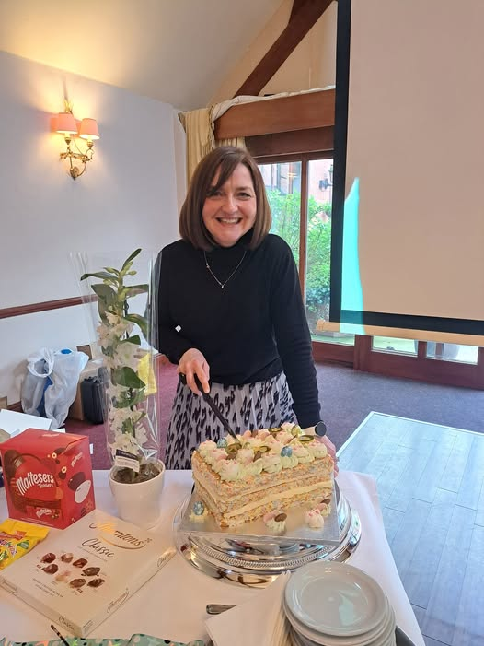
Angela Atkin, Manager, Leader, first and longest serving team member for www.dosh.org and a world class cake cutter.
I arrived in my new appointment as a Managing Director in 2009. I was going to be leading what was a new company, doing something different for people with a learning disability. I had previously been involved in direct care; this was going to be completely different! To say I was a little nervous is an understatement.
Moments after meeting my new colleague Angela Atkin, the nerves disappeared, I knew I was going to be working alongside a super professional and someone who I would enjoy working with.
I have had the good fortune and privilege to work with several ‘Rock’s during my careers, for this article I have based this piece on Angela, who I worked with and depended on for 15 years and someone who continues to be a ‘Rock’ for the company I worked for long after I retired.
What is a ‘Rock’?
They are the anchor within a team and or company, providing continuity.
They have a strength of character, presence and are good communicators.
They have a depth of knowledge about how your team and organisation works and this quickly becomes evident.
Someone who has your back when you are up against it.
Why a ‘Rock’ is important to you and your team.
You cannot always be there, not just when you are absent on leave, you may be delivering training or attending conferences. You need someone who you can trust and depend on to steady the ship (if needed) and keep it sailing in the right direction.

Ten attributes of a ‘Rock’?
- They are resilient. As you would imagine, in the early years of our company, things went wrong, not everything we tried worked out first time and a much-needed restructure needed to take place after my first year. Angela seamlessly adapted, adjusted, and quickly returned to pre-crisis status.
- They are role models for your colleagues especially those who are new to your team. Angela sets herself extremely high standards of conduct and has a strong work ethic.
- They are calm, no matter what the situation or crisis which then a calming influence on those around her has including me! It was not unusual after a long drive from a across the country, a regular conversation on my arrival at the office, would be “this has happened and this is what we have done about it.”
- They can consistently influence colleagues and teams within the wider organisation to the mutual benefit of your team.
- They have their own networks which benefit the team and company.
- They are loyal but will challenge and question. You knew you might not have got it right when Angela raised her eyebrow and tilted her head – this was code for “that’s probably not your best idea Steve.”
- Excellent organisers and facilitators. Turning up for a team development day after travelling over 150 miles from home to find everything was set up waiting to go.
- They are leaders and managers - they do not need a title. However, you should do everything within your power to recognise and reward their contribution and the difference they make. If there is an opportunity to promote this person into a leadership and or management position, so much the better. They should be an integral part of your ‘succession management’ strategy.
- They have ‘integrity.’
Related: My other ‘Rock’ https://leadershipintheraw.org/2026/01/19/being-married-to-joyce-a-model-for-integrity-and-why-it-matters/
- They have a sense of humour. I rarely left the office for a long journey home without a smile on my face and usually a chuckle after a parting shot from Angela.
Related: https://leadershipintheraw.org/2019/10/25/find-people-who-make-you-better-part-2/
I have always judged teams and organisations on what happens when you are not there. It helps when you have a ‘Rock’ within your organisation. Thanks Angela.
So, do you have a ‘Rock’ in your team that you can all count on?

Source: Steve Raw www.leadershipintheraw.org

Adversity has the effect of eliciting talents which, in prosperous circumstances, would have lain dormant.’ Horace
The Centre for Army Leadership

Leadership and followership are two sides of the same coin, bound by shared purpose, values, and standards - though shaped by distinct responsibilities. The effectiveness of any team hinges on how followers engage and think independently, typically falling into five behavioural styles:
Exemplary (Stars): Proactive, independent, mission focused.
Alienated (Cynics): Critical and detached, often undermining progress.
Passive (Sheep): Lacking initiative, avoiding responsibility.
Conformist (‘Yes’ People): Eager to please but unable to challenge poor decisions.
Pragmatist (Survivors): Self serving, adapting to survive rather than contribute.
As a leader, creating an environment where people feel safe to share their views and create constructive challenge improves cohesion and allows everyone to contribute to their full ability.
Interested in more? Check out the Army Leadership Doctrine on our website.

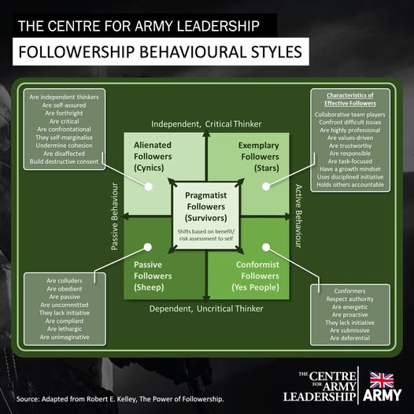
Being Bettina’s Mum & Dad: Discovery & Endurance
By Joyce Raw
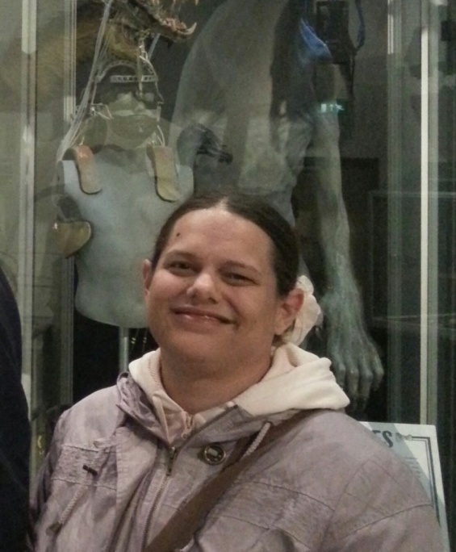
Visitors to Steve’s blog site will have seen several posts of mine which relate to being Bettina’s mum. Some of the blogs are by Steve on being Bettina’s Dad. We have had many compliments/comments on these posts as they give an insight into our world and, for some people, strategies which they feel they could apply to their own situations.
For Steve and me, it has been good to revisit some of the earlier days with Bettina, especially as time goes by so quickly you tend to forget some of the achievements and some of the forks in the road you have to take.
In an earlier post Being Bettina’s Mum: Care to Communicate https://leadershipintheraw.org/2015/02/12/being-bettinas-mum-care-to-communicate/ I wrote that finding ways to help Bettina to communicate taught us a lot about ourselves. In many ways, it has shaped who we are today, but faced with such adversity it has also helped us discover who we are and tested our endurance.
Most parents will agree that having children has changed their lives. A child can change your perceptions of the world, your attitudes towards others and a sense of mortality that you may have previously ignored! However, having a child with a disability brings an enhancement to those areas and can challenge every aspect of your world, including your own strengths and weaknesses.
So, what has being Bettina’s Mum and Dad taught us about ourselves?
Moral Courage: Whilst this is something that most people will say they have, it is only when this is tested to the limit that you are able to recognise just how much moral courage is there. Bettina was one child amongst a growing cohort of children with similar needs which meant, from nursery school age, taking the decision to raise our heads above the parapet in order to help Bettina; help others; raise awareness and highlight areas of need. This does not make you popular with budget holders! A knee-jerk reaction to a request for something which is not already provided, and may have a severe and immediate budget implication, is understandable and usually provokes a one-word answer (mostly “no”) but that does not mean you should simply accept that answer and walk away, and Steve and I found that we could not simply walk away either. Having meetings with people who are already under pressure from other directions can be difficult, even hostile, and it takes enormous amounts of moral courage to insist that you are not going anywhere until the matter is sorted out. Furthermore, we knew we could not just procure help for our child (which would have been much simpler), we needed to ensure that the children coming through the system after our child had the same support secured. Since those early days, we have continued to move forward, helping to make positive changes to our daughter’s life and the lives of others with our moral courage still intact – and in some areas we still remain unpopular!
Stamina: Many people consider the word “stamina” to relate only to physical strength and ability, For example, you may need stamina to make that all-important spurt during the last leg of a race to win. Or you may need a certain amount of stamina to stay out all night partying! But in this case, stamina to Steve and I meant maintaining a high level of dedication in many areas, sustained over many years, to continually meet Bettina’s needs. It was not just a case of having enough energy to chase after her (Bettina would have made a great world champion athlete when she was younger!) but having the stamina to stay up most of the night looking after her and then stay awake all the next day too! At her worst, Bettina could stay up for a straight 48 hours without any sleep and still be bright as a button and in full mischief mode throughout. Naturally, over time we discovered ways and means of fine tuning our ways of dividing the night shift and is probably why most people are amazed at how Steve can work long hours without showing signs of fatigue! Stamina also meant not folding when confronted with new issues and sticking to our guns where Bettina’s needs were not being met by external sources, and it meant ensuring that our oldest daughter’s life was not affected by Bettina’s high level of support. Stamina meant not allowing our family life to be compromised and insisting on doing the same activities as other “normal” families despite the challenges. To Steve and I stamina meant not casting ourselves in the role of victims, but in the role of champions for Bettina and her friends.
Knowledge: Very early on Steve and I realised that being able to research and arm ourselves with the right sort of knowledge was in invaluable tool! We became (and still are) experts at reading and interpreting local and government legislation around the rights of an individual, especially in Bettina’s case where legislation was specific and, where legislation was ambiguous, exploiting the loopholes. Being in possession of the right knowledge is very empowering and is a super-power all parents should possess! We also found that being able to demonstrate that we were knowledgeable induced an enhanced level of respect from professionals which resulted in more productive meetings. We also experienced more and more families turning to us for advice and support. Today, knowledge (whether it is background or substantive) is still something we feel is an important part of our holistic approach to caring for Bettina and, we have discovered, is something we actually enjoy.
Expert Opinion: Over the years, our experience and knowledge has moved towards the natural acceptance that we are now considered to be of “expert opinion” – not always meant as a compliment! As many people know, expert opinion is called in when there is doubt or an in-depth explanation is needed. However, Steve and I have always tried to use this for the greater good and, in many cases, this has been successful. We have discovered over the years that our experiences and strategies can be transferred or modified to make life easier for others.
Reflection: Family life goes at such a fast pace these days that is is sometimes difficult to find the time to stop and reflect, especially where there are some difficult times you would rather forget. However, Steve and I have found that taking the time to reflect every now and again is good practice and can be cathartic. It can help you put things into little boxes in your mind and, where necessary, bring closure. Steve and I have found this comforting, and sometimes humorous and gives you the confidence to deal with any future problems in the secure knowledge that you will be able to look back at this at a later date and measure any progress.
Endurance: One of the most important things Steve and I have discovered about ourselves is the confidence to endure. Being Bettina’s mum and dad has always meant having to find that extra reserve – whether that be stamina, strength, humour, knowledge, or ability – and coping mechanisms for when things go wrong. But we are now at that point in life where we know that wherever the challenges take us, we will endure. Over the years we have had to endure much, but the legacy of that is knowing and understanding the kind of people we have become and how our experience has shaped who we are.
Being able to reflect on who you are and how you have got to that point is not limited to just those with additional responsibility. Reflection and recognition is an important part of your journey through life. If you were to do an audit today of the lessons in life you have learned, what would the results be? What does your list of discovery and endurance look like?
Joyce
www.livelikearaw.wordpress.com
It’s Time to Face the Facts About You
Time To Read: 42 Seconds
Dear Steve
Time To Read: 42 Seconds
It’s Time To Face The Facts About You
However frightening they may be…
Here are seven extraordinary facts about every human being, including you
You have the power to CHOOSE.
You have the power to CHANGE.
You have the power to LEARN.
You have the power to CREATE.
You have the power to CARE.
You have the power to CONNECT.
You have the power to ACT.
None requires permission and all are completely free.
And none belongs only to the gifted, the powerful or the privileged.
And here’s the frightening bit:
You already have them.So perhaps the biggest question in life isn’t “What can I do?”
It’s “What am I choosing to do with everything I’ve got?”
Because being human isn’t our limitation.
It’s our superpower.
With my love and best wishes to you – you magnificent human
David
sign up to receive this blog - unsubscribe anytime
@nakedleader across all social media

The Centre for Army Leadership

How many of the behaviours from the Army Leadership Code do you demonstrate in your workplace? And would you add or change anything?
L.E.A.D.E.R.S isn’t just a catchy acronym – it’s based on research from Bangor University, which identified transformative behaviours in Army instructors. When leaders embody these traits, they can make a real difference in team and individual performance.
These seven behaviours are expected of all Army leaders, from Private to General, regardless of cap badge, branch or unit. Regardless of rank the way in which leaders behave and interact with their teams should be the same, as the fundamentals of effective team leadership are applicable from the very highest strategic level down to the smallest operational unit.
Interested in more? Check out the Army Leadership Doctrine available for free on our website.

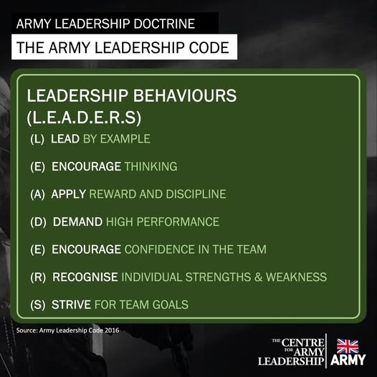

BODY LANGUAGE

It’s how you say it – Many leaders know what it feels like to talk when no one is listening. Often, it is not the actual words causing the audience to tune out, but the way the words are communicated.
Use your body – We mainly rely on non-verbal communication to determine other’s intentions when they communicate with us.
Put your body on display – When speaking, step away from the podium; when sitting at a meeting, pull your chair back from the table to display more of your body
Know your psychology – Your audience’s instinctual ‘reptilian’ brain need to see your body to gauge your intentions. The less information they see, the more they simply make those feelings up, and tend to default towards the negative.
Speak from your belly – Place your hands in the TruthPlane, the horizontal plane that extends 180 degrees out of your navel, to show that you can be trusted. This is a vulnerable area so bringing an audience’s attention to it makes them feel like you are confident.
Get them in the palm of your hand – show your palms open with nothing in your hands, to let others know that you mean no harm and are speaking for their benefit. This is universally recognised as a ‘friendly’ gesture.
Listen actively – When someone else is speaking keep your hands in the TruthPlan so that they understand you are open to what they are saying.
Source: Mark Bowden, body language expert and creator of Truthplane (from this month’s ILM Edge Magazine
Adversity has the effect of eliciting talents which, in prosperous circumstances, would have lain dormant.’ Horace

Sweat the Small Stuff

It was over 18 years ago when I sat reading a case file in a hot claustrophobic porta cabin in Peterborough. I was there to chair a serious disciplinary hearing. This was my eighth case in a number of investigations I had been asked to complete as there was a back log of cases that had built up over a lengthy period. As I looked at the stories in the file, I recognised a common denominator of all these disciplinaries which pointed to events having got out of control. The managers concerned had not ‘sweated the small stuff’, if they had only dealt with these situations when they were small, I would not be having to deal with someone’s future.
What is sweating the small stuff?
Diligence. “Sweating the small stuff” is a phrase that refers to paying attention to the details and minor aspects of a project or task. It is often used in the context of business, where it is believed that paying attention to small details can lead to better results and outcomes. I have found it has helped me in both my careers (Army and Social Care) and in all aspects of my personal life. I would also add it is also about anticipation - predicting what comes next.
Related: https://leadershipintheraw.org/2018/03/06/anticipate-your-way-to-success/
When you need to sweat the small stuff:
- When you recognise a pattern(s) of behaviour – where have I seen this before?
- When your gut feeling tells you that this could get bigger.
- When you need to take charge no matter how senior you think you are – get involved!
- When you are tempted to ignore or put off dealing with a situation, that is the time you need to deal with it.
- When people tell you that you are getting the situation out of proportion – do not be put off. E.g., so called ‘banter’ between colleagues of different genders that can quickly become or perceived as inappropriate or threatening.
The benefits of sweating the small stuff.
- Dealing with a situation when it is small is often when you still have control, when it is big it is often out of your hands, and you have lost control of the outcome.
- You only have a finite amount of time as a leader and a manager – you must not waste your time on events that could have been avoided.
- It is important for businesses to pay attention to the intricate details. Doing so can help improve the quality of work, increase efficiency, and lead to better results.
- Paying attention to detail also means learning as much as you can about your colleagues as individuals, not just as prospects. This creates an environment for you to cultivate the “know, like and trust” relationship that is so often the difference-maker.
- It will make your team and/or company stand out. These are the things your customers remember, and these are the things they mention to their networks about your company.
Create the culture (the way we do things around here) and the environment:
- Tell your team that you all sweat the small stuff, so it becomes a mantra. You know it has been adopted when they quote the phrase back at you.
- Take the time to explain what this means and why you all need to do this.
- By creating culture of high standards Related: Doing what is right over doing what is easy – Leadership in the Raw
- By all means delegate, but do not lose the accountability for everything that happens within your team.
- Have a sense of urgency and a laser-like focus to everything you are responsible for
Forbes (American business magazine) suggests that:
“Small things add up to create culture” and that “it is the seemingly ‘small’ stuff that can really impact workplace culture”.
Related: https://leadershipintheraw.org/?s=culture+within+you
Think like an athlete:
During the 1980s and 1990s I considered myself to be a track athlete. I wanted to be as competitive my limited talent would allow, and I was going to do this by sweating the small stuff. I knew from my coach, and running magazines, that athletes addressed the small stuff before they even stepped onto the track to compete. So, I would work from the top of my head down to my toes:
- A short haircut (I no longer need to worry about that now).
- Light running kit – I would wear a sleeveless vest even in winter for a race.
- Cut my toenails so that my feet are comfortable in tight racing shoes.
- The right weight – 1lb over and it could cost me a second per lap.
- The right footwear for the conditions – the lighter the shoes the better. For 10km races I had a pair that only weighed 150 grams. Have I got the right length of spikes on my trainer? E.g., 5mm for track and 9mm for Cross Country.

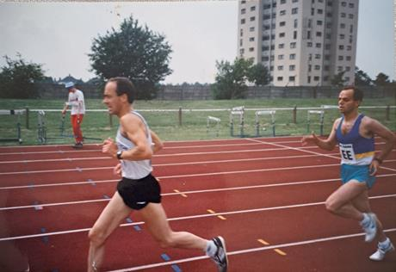
Now I am ready to race. (5000m in 1990something)
These may seem trivial things to consider, but each one made a difference to my efficiency and performance.
Finally:
When I was looking for inspirational quotes for Sweating the Small stuff. I found a substantial number of articles which said ‘Don’t Sweat the Small Stuff’ which is fine if you are just looking at lowering your blood pressure. However, if you are looking to create something new and revolutionary my recommendation is to sweat the small stuff.
Have I made my case?
Source: Steve Raw www.leadershipintheraw.org

