LEADERSHIP and WELLBEING PACK
November 2026
The 20th Anniversary Editions
Welcome to this month’s edition. Highlights include:
Damian Piper CBE our Resilience Coach starts this month edition with: Fed up with the ‘small stuff’ getting in your way? Most of us treat resilience as something for the ‘big stuff’. A redundancy, a bereavement, a crisis at work. I don’t think it works like that. Resilience is something we can learn to access, and it pays off every day, in how we feel and what we get done…..”
Being Bettina’s Dad – “Very Very Proud of You “Bettina is an amazing woman who brings joy to everyone she meets. Spend a few moments with her and you will never forget the experience. Yes, she really is that awesome….”
From a former colleague: Let's talk about delegation by BOLA OWOADE “In this issue I focus on the subject of effective delegation and I explore the following:
• A framework for effective delegation
• Delegation Essentials training”
My running experience 1981 – 2026. One Step (or Stride) at a time. “Five years ago I was asked by a former colleague (a senior manager for Thera East Anglia www.thera.co.uk ) if I would share my running experience for their ‘fitness week’. I was a young 65-year-old then. Fast forward to 2026 and I thought I should update my article.,,,”
From the Centre for Army Leadership article: ‘Compassion and Caring Leadership’
There are lots more in this month’s edition so let’s dive in together……
Steve Raw FioL
Blog: www.leadershipintheraw.org
Instagram: @stephenraw6
Twitter: @SteveRaw836
Blue Sky: https://bsky.app/profile/steveraw.bsky.social
LinkedIn: https://www.linkedin.com/in/steve-raw-72454721/
Facebook: https://www.facebook.com/steve.raw.771/
It’s not about how good you are,
It’s how Good You want to be.

Fed up with the ‘small stuff’ getting in your way?
Three skills for turning daily irritations into resilience training
Most of us treat resilience as something for the ‘big stuff’. A redundancy, a bereavement, a crisis at work. I don’t think it works like that. Resilience is something we can learn to access, and it pays off every day, in how we feel and what we get done. Our resilience training ground is the ‘small stuff’, the things that so often steal our mornings.
The ‘small stuff’ taking us away from being at our best
Let’s get some examples of what I mean. The cancelled train, the slow Wi-Fi, the person on your commute playing ‘hilarious’ Instagram reels through their phone speaker, or the colleague who lets you down and makes you late. An article on this topic can’t ignore the irritations we make for ourselves. The overuse of the snooze button, the difficult email we keep not writing, the dishwasher that needs emptying, which we’ve decided to ignore. You’ll have your own version of these examples.
None of these are a big deal on their own. Here’s the thing, together they chip away at us, draining focus and energy, and our lovely imaginations build them into feeling far bigger than they are. I’m not immune, a delayed train on a recent trip initially put me in a grumpy mood, for a weekend that was barely affected.
I know it’s not the train itself; it’s the story I tell myself about the train, unmanaged on repeat. How hard is it to get a train to run on time? Why now? Why didn’t I get the earlier one? That’s a natural stress response, but it burns emotional energy and, importantly, doesn’t make the train run. All of it comes from the same gap between what I expected and what I got.
‘Small stuff’ doesn’t need to be a drain
Nobody walks into a gym and lifts the heaviest weight on day one. You build gradually, with manageable resistance, consistently. So, the cancelled train is five minutes of resistance training. The ‘inconsiderate’ commuter is thirty seconds of endurance work. I’d still have preferred the train to run on time, and the aim isn’t to enjoy it. It’s to see these moments as low-stakes practice for the high-stakes ones that will come, because they will.
This isn’t positive thinking. I’m not saying everything is fine if you decide it is. I’m saying you can use the discomfort rather than suppress or endure it. If you can’t hold your composure when the Wi-Fi drops, you’ll struggle when something that significantly matters goes wrong.
I think there are three skills to support a different ‘small stuff’ response.
1. Take a breath
Most of us have an autopilot for when reality doesn’t match expectation. The jaw tightens and we’re already reacting. The fix is simple but not easy: take a breath. The breath is a pause, and the pause creates a gap between stimulus and response. It might only be a few seconds, but it’s the same mechanism you’ll need when the setback is serious. You’re developing your ability to create space to move to the next skill.
2. Shift the perspective
Once you have the space, bring some perspective to the situation. I often use a 1 to 10 scale with clients, and for this you have to give the scale a currency. Make 10 death. Now where does the delayed train sit?
Almost always it’s low. Not because your frustration isn’t real, but because a broken shoelace isn’t a broken bone, and someone cutting you up at a junction isn’t a car crash. Get some perspective and the severity usually drops. Then you can decide how to respond, not simply react.
3. Solve it creatively
Plans meet reality and sometimes lose. Adaptability means treating the setback as a change of plan rather than the end of one.
My delayed train is the example. I’d been wondering where I’d find the time that week to sketch out my next piece of work. Then the delay handed me an unplanned window. I took a breath, told myself it was a delayed train and I’d still get away, and then asked a better question: what’s the best use of this time? I got the laptop out.
An experiment to explore
As ‘small stuff’ irritations show up, see them as an opportunity to practise your resilience skills.
- Pause. Take one breath before you do or say anything.
- Put a number on it. Where does this sit on a scale of 1 to 10, where 10 is death?
- Ask what else is possible. What’s one thing you could do with this situation, or this time, that you wouldn’t have planned?
Then write down a line for each: what happened, the number you gave it, and what you chose to do. It takes a minute. At the end of the week, read it back. Did the pause get easier? Did the numbers come out lower than the initial feeling suggested? What did the setbacks provide that you didn’t expect?
The point
These things will keep happening. Trains will be late and people will do things you don’t want. The aim isn’t a life without friction, it’s to stop treating each bit of friction as an ambush, and start using it as an opportunity to build resilience reps.
Do that daily and you’re not waiting for resilience to appear when you need it. You’ve been building and developing your ability to access it all along.

Damian
In your corner

 www.effectivechallenge.com | Effective Challenge Podcast | Connect on LinkedIn

Damian Piper CBE, work with people from a range of backgrounds who work hard, deliver, and want to work out why they sometimes still get in their own way. He’s in their corner, drawing on more than 30 years of working on himself, and a senior leadership career that included helping deliver a safe and secure London 2012 Olympic Games. He helps them get behind what's really driving how they think, feel and act, and develop a way of working they can sustain.
"Passion is energy. Feel the power that comes from focusing on what excites you." Oprah Winfrey
Being Bettina’s Dad – “Very Very Proud of You”
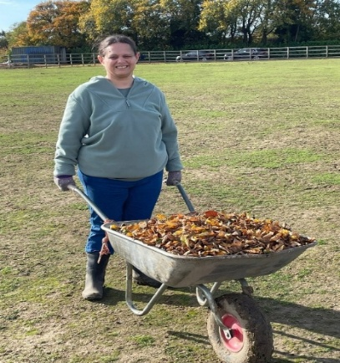
Bettina waits patiently for me to enter our sitting room to greet her. Today she is in her work uniform, and she has already pinned her name badge to her T-shirt.
Me: “Good Morning Bettina”
Bettina: “Good morning, Dad” Bettina holds up her name badge and says “Bettina -Volunteer” then pauses waiting for my response
Me: “Daddy Very Very Proud of You” Bettina smiles and gives me a thumbs up.
This is an exchange we have before Bettina sets out to go to her voluntary work at the farm.
Bettina is an amazing woman who brings joy to everyone she meets. Spend a few moments with her and you will never forget the experience. Yes, she really is that awesome. To use a much-used cliché she has ’been on a journey’ from childhood: unravelling carpets, stripping wallpaper from my parents’ bedroom (after they had just wall papered!) to not being able to use verbal communication until she was 11 years old.
If you have not previously followed my ‘Being Bettina’s Dad’, series, Bettina is a woman who copes with a learning disability, autism, epilepsy, and a complex communication disorder. Most importantly though she is a courageous and inspirational person that her family are immensely proud of.
Proud means:
For me it is a feeling of pleasure and satisfaction because you or people connected with you have done or got something good. It is about having respect for yourself, or in this case Bettina, and showing those feelings of pride.
Bettina’s challenges
Some of the challenges Bettina battles with every day include:
- People who cope with autism often have difficulty ‘reading’ other people – recognising or understanding others’ feelings and intentions – and expressing their own emotions. This can make it extremely hard to navigate their social world.
- Bettina’s autism involves coping with sounds that ‘hurt’ and ‘frighten’ her e.g. Bettina can become quite distressed if I cough. (I become distressed when Joyce and Jennifer look at me with daggers because I have upset Bettina because of my coughing).
- Being understood especially in her early years because she was ‘non-verbal’ I can only imagine how difficult it must have been for her to make herself understood. Bettina’s verbal communication and understanding are progressing.
- Understanding what people are saying to her. Bettina has always relied on the rhythms and sounds of people’s speech without necessarily understanding the words said. Her family need to be care with their tone of voice especially when we are discussing something serious.
- Having to depend on her family anticipating her needs and worries. Fortunately, her ‘tiger mum’ is a ‘Bettina Whisperer’: https://leadershipintheraw.org/2016/04/21/being-bettinas-dad-and-being-married-to-bettinas-whisperer/
- Her vulnerability, Bettina needs someone to be with her when she leaves home.
What makes us proud of Bettina in ten ways.
- Never gives up by being tenacious. Bettina is incredibly determined and will work hard and long to meet her objective – completing a difficult jigsaw comes to mind. (if there is a missing piece then she calls on her family to come to her rescue as was the case recently)
- Courageous Bettina teaches her family and friends so much about life and what is courage without fear. Bettina does not allow herself to stay in a fearful state, she immediately plunges straight back into action (it is that kind of courage that her family admire in Bettina so much) Related: https://leadershipintheraw.org/2018/12/10/being-bettinas-dad-what-is-courage-without-fear/
- Takes Responsibility. Bettina is integral to the workings of our household. Bettina actively seeks responsibility taking on tasks we have not asked her to do. Bettina sees something that needs doing and does it.
- Progress. Bettina does not stand still. It is incredibly exciting for her family to see how Bettina has progressed over the years. If someone had told Joyce and I what Bettina would achieve and be in adulthood it would have been beyond our expectations. With the love, support of her family and Bettina’s strong will we continue to be excited by what she will achieve.
- Strong work Ethic. Her strong work ethic is something that is often commented on by those who work with her and something we observe every day. Bettina takes pride in her work and getting the job done.
- Community Respect and Involvement Taking a seat in our favourite café in Frinton on Sea, Bettina and I wait for our cake. Our server comes up to Bettina and says, “when I see your smile it makes me feel so happy.” During our last Whitby holiday, one of the assistants from a shop we popped into on our arrival, spoke to Bettina “hello I remember you, how have you been.” I was flabbergasted! Out of all the thousands of visitors that must have visited their shop and she remembered Bettina! Related: https://leadershipintheraw.org/2023/11/16/being-bettinas-dad-community-engagement-what-it-has-meant-for-bettina/
- Sense of Humour. There is a healthy competition to make each other laugh in our house and it is a delight to see Bettina joining in and often is the instigator.
- Caring and Kind nature Bettina’s qualities of being gentle, caring, and helpful, light up the worlds of people who encounter her, and her acts of kindness are long lasting in their memories. Related: https://leadershipintheraw.org/2021/12/24/being-bettinas-dad-bettinas-kind-heart/
- Assertiveness. Bettina has confidence and self-assurance without being aggressive in her interactions and how she secures from us what she needs and more & more showing her feelings. I have just come back from our Sunday afternoon walk with Bettina. I wanted to go a different route to avoid a dangerous dog whose owner finds it difficult to control. Bettina was ok about a small detour but soon directed me back to the direction of travel she wanted to take on our journey home. she was quite firm about it too!
- A Kind Heart. Bettina sits quietly in class alongside other pupils. There is a boy sitting next to her who is becoming increasingly distressed. Without turning Bettina reaches out to him and strokes his hand, despite verbal language being a challenge for Bettina, she soothingly says, “it’s ok” “it is ok” as her school mate calms, he says, “thank you Bettina.” This is an example of Bettina’s kindness to someone else in need: https://leadershipintheraw.org/2021/12/24/being-bettinas-dad-bettinas-kind-heart/
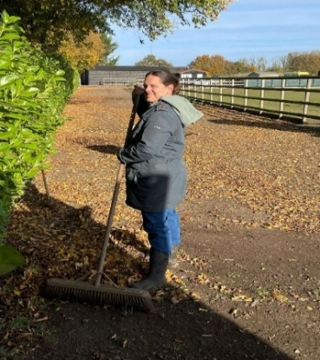
I am indeed very very proud of my daughter, Bettina, sometimes I think I will burst with pride.
Her parents share their stories, experience, and lessons from being parents and carers for Bettina to help inspire you no matter what your circumstances.
Source: Steve Raw www.leadershipintheraw.org
You Me And We Are Not Just This
Time To Read: 28 Seconds
Dear Steve
We Are None Of Us Just One Thing
Kind. Selfish. Brave. Afraid. Generous. Jealous. Loving. Angry. Confident. Vulnerable.
Which one are you?
All of them.
We are none of us just one thing.
That’s why human beings are totally unpredictable — and predictably so.
We change with circumstances, people, pressure, possibility, and choice.
Yet relationships fail when we label people by one moment. Organisations fail when they put people in boxes. And lives shrink when we do it to ourselves.
So stop asking, “What kind of person are they?”
Ask, “Who are they choosing to be, right now?”
Because we contain multitudes.
And our greatest human power is choice.
With my love and best wishes to you
David
David Taylor (author, trainer and broadcaster)
Comment here@nakedleader across all social media

Let's talk about delegation



BOLA OWOADE

Senior Learning and Development Advisor at Jewish Care
October 27, 2026

In this issue I focus on the subject of effective delegation and I explore the following:

- A framework for effective delegation
- Delegation Essentials training

A framework for effective delegation

Delegation is a term we hear a lot when it comes to management and it is a very important skill for managers to have. It holds many benefits such as:

- Can give you time to focus on more strategic work when you delegate work better done by team members
- Help you develop team members and even identify people who can step into other posts
- Puts decisions closer to the people who hold the detail, often giving better decisions
- Increases engagement, because most people want stretch, not just tasks
- It can also help to increase trust between a manager and team members

Despite these benefits, lots of managers still don't delegate. The question is why? Some reasons why managers refuse to delegate are:

- “It's faster to do it myself”: true in the short term, false in the long term
- Fear of losing control or quality
- Discomfort with not being the one holding all the detail
- A quiet worry that delegating makes you less indispensable
- Belief that team members don't have the right skills

Honestly, none of the barriers is unreasonable, which is probably why they persist. The intention isn't for managers to stop feeling them but to recognise them and find a way to overcome them.

One of the things that can help with this is having a repeatable framework managers can follow when they want to delegate. A simple yet effective framework can help to take away the anxieties that surround delegating. It can help managers to have good delegation conversations that increase the probability of achieving a positive outcome from the delegation.

I am sure there are many delegation frameworks out there but a simple and straightforward one that managers can use is what I call the OASC framework. Okay, the acronym doesn't exactly form a nice pronounceable word but it will make more sense when I describe it. Here's what OASC stands for:
- O is for Outcome: This is about defining clearly the outcome you want from the delegation. Ask yourself - What does 'done' actually look like? You should be specific about the result, not the method. Say what good looks like and by when the delegated task should be completed.
- A is for Authority: Clearly define the amount of decision-making power that the person has. The question to ask yourself is - How much decision-making power do they have? You should clarify when they can they decide and act and when they need to check with you first? For example, 'decide yourself unless the cost goes over £10k'.
- S is for Support: Discuss what support the person will have access to as they complete the task. What resources, access or help can they draw on? For instance, who can they talk to, what resources can they access. This will also include how they can come and ask you for help.
- C is for Check-in: When and how will you follow up with them? You should agree this upfront. Make sure check-ins are spaced to match the person's experience, so they support the work rather than undermine it. You don't want to micro-manage the person and at the same time you don't want to leave them alone for too long causing them to struggle.

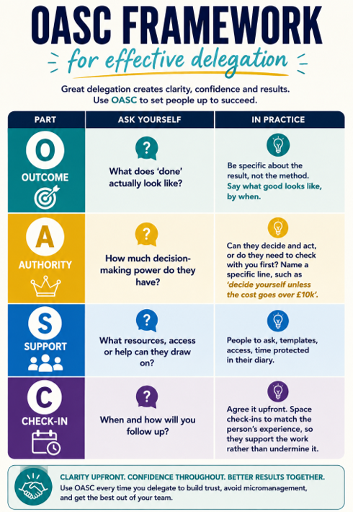
Following are examples of a poor delegation conversation and a good one using OASC.
Without using OASC
- Sarah: Could you sort out the supplier contract for me, please?
- James: Sure. Are we using one of our existing suppliers, or do you want me to look for someone new?
- Sarah: I'm not too fussed. Just see who's out there and find someone decent. We need to get it sorted fairly quickly.
- James: Okay. Do we have a budget to work to?
- Sarah: There should be something in the budget. Have a look at what we've spent before and see what you can get.
- James: All right. I'll get a few quotes. If I find someone suitable, can I go ahead and agree the terms with them?
- Sarah: Yes, just use your judgement. You know what we're looking for.
- James: Okay. And when do you need it by?
- Sarah: As soon as you can, really. We don't want this dragging on.
- James: No problem. I'll have a look and see what I can find.
- Sarah: Great, thanks. Just keep me posted.

Using OASC
- Sarah: I'd like you to take over running the weekly stand-up from next Monday. I want to make sure we keep it to time, everyone gets a chance to share their updates, and we finish with clear actions, so people know what they need to do. (Outcome)
- James: Okay, sounds good. Am I free to change the format a bit, or would you prefer me to stick to yours?
- Sarah: It's completely up to you. You're leading the meeting, so feel free to change the agenda or try a different approach if you think it'll work better. If something comes up that you can't resolve, or the team needs my input, just let me know. (Authority)
- James: Great. Could you send me your current agenda? It'll give me something to work from before I make any changes.
- Sarah: Of course. I'll send it over today. And if you want to talk through anything before Monday, just grab me. (Support)
- James: Thanks. I'll have a look and get something ready. I'll make sure we finish with the actions and who's picking each one up.
- Sarah: Perfect. Let's have a quick chat after Friday's stand-up to see how the first week has gone and whether there's anything you'd like to change or need help with. (Check-in)
- James: Sounds good. I'll give it a go and see how the team responds.
- Sarah: Brilliant. It's yours to run, so make it work for you and the team. We'll have a quick review on Friday.

The OASC framework can help managers delegate effectively and overcome the barriers we discussed earlier about why managers don't delegate. If you are a manager reading this and you need to delegate a task, why don't you give it a try.

Delegation Essentials Training
If you find the OASC framework useful and believe it is something beneficial for your managers, then I have developed a short blended learning virtual training session (if you prefer face-to-face then let me know) called Delegation Essentials.
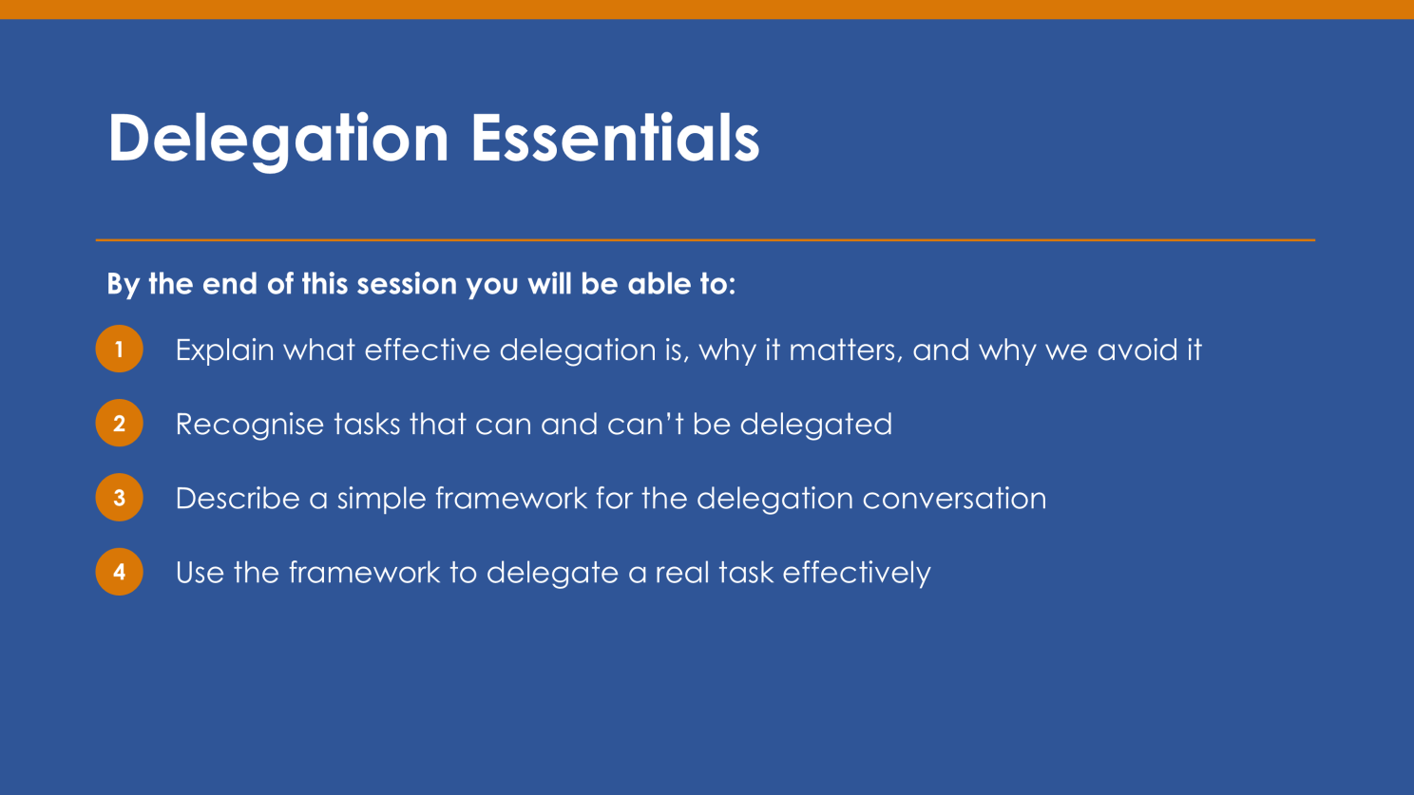

The session consists of two parts:
- Part 1 is pre-session prep where the participants for the training do some reading and complete activities before coming to the session. This is done through a participant workbook which they will also use during the live session.
- Part 2 is the life session which lasts for a total of 100-minutes (90-minutes training + 10-minutes break). In the session, the preparation work will be reviewed and then the focus will be on practical work looking at how to apply the OASC framework.
I have developed three resources to deliver the session which are a facilitation guide that has all the instructions for the trainer to deliver the training, a presentation with six slides that complements the facilitation guide and a participants workbook (mentioned earlier) which contains the pre-session preparation activities, reference notes for the participants and also activities that will be used during the life session.
You don't need to be a certified trainer to use the resources. If you are interested in improving your managers or colleague' capabilities around delegation, then this short session is for you.
You can get the resources on here.
The Centre for Army Leadership
Empathy and compassion are essential leadership skills, especially when it comes to 'knowing your people,' a cornerstone of the Army Leadership Framework. It’s about understanding others’ emotions and genuinely seeking to improve their situation.
But there's more to it: familial care, the deep bonds formed in high-pressure environments like training and operations, which create a kinship between leaders, followers, and peers.
While there’s a leadership 'sweet spot' that balances empathy with rational decision-making, both are crucial when courageous action is needed.
Interested in learning more? Check out the Army Leadership Doctrine on our website!

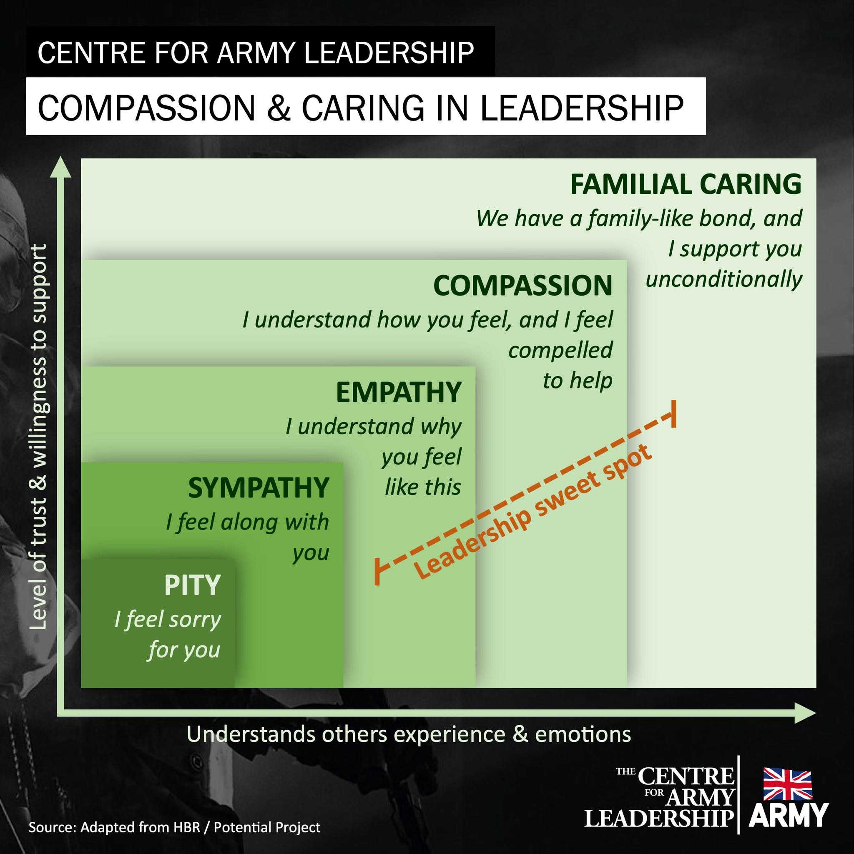
My running experience 1981 – 2026.
One Step (or Stride) at a time.
Five years ago I was asked by a former colleague (a senior manager for Thera East Anglia www.thera.co.uk) if I would share my running experience for their ‘fitness week’. I was a young 65-year-old then. Fast forward to 2026 and I thought I should update my article.
- HOW IT STARTED (in 1981)
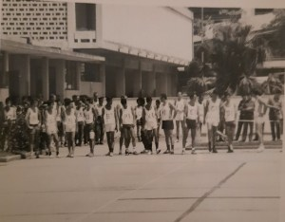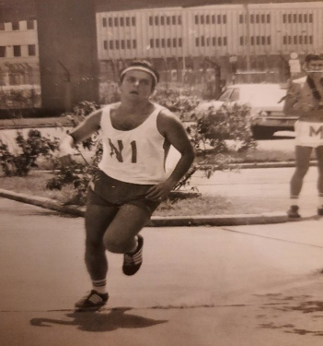
Hong Kong waiting to start and racing circa 1981
Sweat beads are rolling down my neck, my running vest is already damp, and I haven’t started running yet. A typical hot day in downtown Kowloon. I am standing on the start line waiting for the start of the inter department 2-mile relay at the Ordnance Depot, Hong Kong. There is a crowd gathering from the local factories to watch. We are a mixture of British soldiers, Hong Kong-Chinese soldiers, and Chinese civilians. I am not sure how I will do as I am relatively new to running as a sport and I think I have been chosen for my youth (early 20s) and I play football (badly).
I do surprisingly well and I am part of a winning team. My time is just over 12 minutes which is not bad given it is 36c and 95% humidity. I am thinking I could be quite good at this, and I love going up to pick up my trophy – something my wife, Joyce, will tease me with for ever more.
Five Lessons I learned that day:
- A sense of accomplishment, completing something I was not sure I would be able to achieve.
- A sport I could do as part of a team and as an individual. After the race and for the remainder of my two-year tour in Hong Kong, I would regularly go out for runs and take in some of the sights of Hong Kong from a different angle.
- I didn’t need talent, just hard work, effort, and commitment, to accomplish my goals.
- It doesn’t cost much! My kit for my first marathon included a pair of running shoes which cost £5 in China, a pair of Hawaiian beach shorts and an old orienteering vest.
- A sport that could easily fit in with my personal and work life, if I did a little planning first – I just needed to work out a routine and stick with it.
Related: https://leadershipintheraw.org/2017/07/28/project-management-project-managing-your-life/
- HOW IT WENT
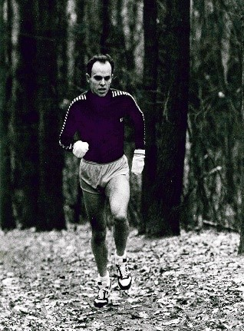
Running through Spandau Forrest near the Berlin Wall
New Year’s Day 1987 early in the morning, it feels a little surreal as I run ankle deep through spent fireworks from the night before as I head towards Spandau Forrest which will reach out to the Berlin Wall. It is the first day of our family posting with the Army. During our two -year tour I will compete in Cross Country Championships, win 5000m track races, complete a marathon, a 25km finishing in the Olympic stadium, half marathons and come 3rd in a Berlin 10km. You could say I got the running bug after Hong Kong.
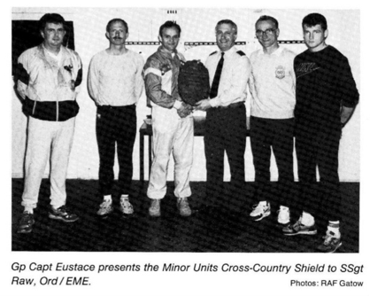
Seven Lessons I learned as a runner
- Running would open new possibilities to travel. Before arriving in Berlin, I had completed marathons in London, Edinburgh, Newcastle, and Manchester; countless 10Kms and half marathons in Belgium, Germany, and Holland. Later I completed a two -day ‘Original Mountain Marathon’ (OMM) in the Brecon Beacons, Wales.
- You can train and run anywhere! During my posting with the Royal Marines, we would often be aboard ship for long periods but that didn’t stop us from going for a run, we just utilised the car deck (although it was an incredibly boring route).
- You get to join a special community of like-minded people who are both supportive and fun to be around. When I played football, players shouted at me (I was that bad) whereas fellow runners and athletes shake your hand at the end of a race (or laughed when I completed a 110m Hurdles for my club).
- You learn from different cultures and nationalities. During my time in Berlin, I joined a civilian club (LG Spandau) and before arriving in Berlin I was part of a Belgian Club which included runners from 16 nationalities.
- You have the opportunity to help others become better at their sport. I also coached, captained, and managed running and athletic teams. Sharing my knowledge and the lessons I have learned is something I enjoy doing.
- You could use your running fitness to try new activities and sports. During the 1980s and 90s I was involved in Hang Gliding (qualifying as a pilot), rock climbing, canoeing and tried – to varying degrees of success – biathlons (in Norway) and a triathlon in Germany.
- To maximise my performance, I needed to consider what I consumed. So, lots of fruit, fresh food and cancelling alcohol were the order of the day.
Related: 30 leadership lessons from 30 years of running and athletics – Leadership in the Raw
HOW IT IS GOING
I am now 70 and I am pleased to say I still enjoy going out for a run (three times a week). I am lot kinder to myself now regarding intensity and mileage. I no longer race, my last event several years ago was a ‘Parkrun’ in Colchester coming first in my age category.
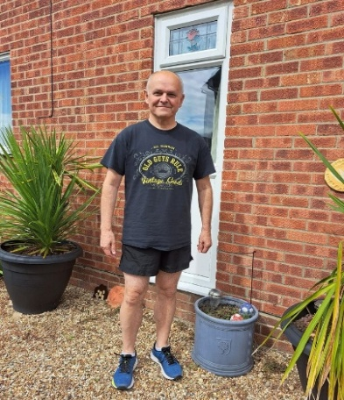
(just back from a recent run, rocking my ‘Oldguysrule’ TShirt)
I still have goals:
- To keep fit and be able to run after my daughter, Bettina who copes with a learning disability and autism. Bettina has no concept of age, I think she still thinks I am 35.
- To be able to keep up with my wife, Joyce aka ‘pocket rocket’ when we go out for a walks
- To maintain my boyish good looks and physique. (if you bump into me, please remember to say “omg you don’t look 70).
- Training for our annual family holiday in Whitby, where I go for a run at 7am each morning. As I run along the beachfront, I take the time to be grateful and show my gratitude.
Related: Being Bettina’s Dad – Taking the time to be grateful and showing gratitude – Leadership in the Raw
My Top Tips for Getting Started and how to keep motivated when you really don’t feel like doing it.
- Build up slowly. For my first marathon I started with 5-minute runs, slowly increasing mileage by 10% each week. Every third week I would do 10% less, so my body recovered. I recommend this tactic to avoid injuries.
- To get the best out of your running (for me) it is about three things:
- Breathing – getting a rhythm that you are relaxed enough to be able to talk with your running partner when you are running – can’t talk? You are going too fast.
- What is going on in our head – don’t neglect your mental health – find ways to make your mind healthier and stronger so you can execute under pressure.
- Miles in the bank. Early on a fellow soldier I admired for his running said I could be as good as him if I trained as hard – so I did. It is one of the few sports you get out what you put in. (I could have played football all day and still be rubbish at it).
- Lay your running kit out the night before – you are now committed.
- Remember the hardest bit about running is your first step out of the house. The rest is just tenacity.
- Seek out a running partner preferably someone who is a bit better than you. Joining and running with athletes from Colchester Harrier’s during the 1990s helped me smash my personal bests (PBs).

Source: Steve Raw www.leadershipintheraw.org

